UNIT – 3
EXPERIMENT-1
AIM : Overload Unary, and Binary Operators using member function.
Description:
Operator overloading allows you to redefine the meaning of operators (+, -, ++, etc.) for user-defined types (like classes).
- Unary operators → act on a single operand (e.g., ++, --, -, !).
- Binary operators → act on two operands (e.g., +, -, *, /).
When overloaded using member functions, the operator function is defined inside the class with the keyword operator.
- Unary operators require only one operand.
- Example: Overloading ++ to increase object data, or - to negate values.
- Member function syntax:
returnType operator op();
Algorithm:
- Define a class with private data members.
- Write a constructor to initialize the values.
- Define a member function operator op() for the unary operator.
  - It operates on the calling object (this).
- Return the modified object or result.
- In main(), create objects and apply the overloaded operator.
PROGRAM :
#include <iostream>
using namespace std;
class Number
{ public: int value;
Number(int v = 0) // Constructor
{
value = v;
}
void operator++() // Unary operator overloading (increment)
{
++value;
}
Number operator+(Number obj) // Binary operator overloading (addition)
{ Number temp;
temp.value = value + obj.value;
return temp;
}
void display()
{
cout << "Value: " << value << endl;
}
};
int main()
{ Number n1(5), n2(10), n3;
cout << "Before Unary Operation:" << endl;
n1.display();
// Unary operator overloading
++n1;
cout << "After Unary Operation (++n1):" << endl;
n1.display();
// Binary operator overloading
n3 = n1 + n2;
cout << "After Binary Operation (n1 + n2):" << endl;
n3.display();
return 0;
}
OUTPUT :
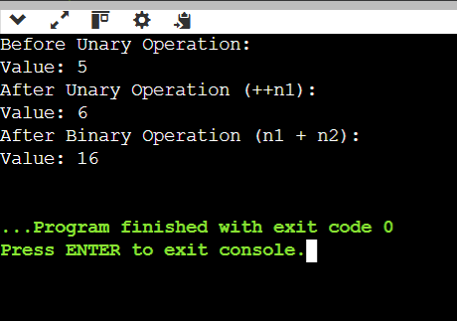
Conclusion:
In conclusion, operator overloading in C++ allows programmers to extend the functionality of operators for user-defined types, making objects behave more intuitively. By overloading unary and binary operators, classes can support customized operations that mirror built-in types. This enhances code readability, usability, and expressiveness, enabling more natural and meaningful interactions with objects.

EXPERIMENT-2
AIM : Overload Unary, and Binary Operators using friend function.
Description :
Operator Overloading using Friend Functions
A friend function is a non-member function of a class that has access to its private and protected members.
We can use it to overload operators that either:
- Need symmetric access to both operands (like +, -).
- Or where we don’t want to use this pointer.
- · Unary operators (-, ++, --, !) operate on a single object.
- · Using a friend function, we pass the object as a parameter.
Syntax: friend returnType operator op(ClassName obj);
Algorithm:
Define a class with private data members.
Write a constructor to initialize the object.
Declare a friend function inside the class: friend returnType operator op(ClassName obj);.
Define the function outside the class.
- It receives an object.
- Performs the operation and returns a new object.
In main(), create objects and use the overloaded operator.
Program :
#include <iostream>
using namespace std;
class Number
{ public: int value;
Number(int v = 0) // Constructor
{
value = v;
}
// Friend function declarations
friend Number operator++(Number &n); // Unary
friend Number operator+(Number n1, Number n2); // Binary
void display()
{
cout << "Value: " << value << endl;
}
};
// Unary operator overloading (prefix ++)
Number operator++(Number &n) {
n.value++;
return n;
}
// Binary operator overloading (+)
Number operator+(Number n1, Number n2) {
return Number(n1.value + n2.value);
}
int main() {
Number n1(5), n2(10), n3;
cout << "Before Unary Operation:" << endl;
n1.display();
// Unary operator overloading
++n1;
cout << "After Unary Operation (++n1):" << endl;
n1.display();
// Binary operator overloading
n3 = n1 + n2;
cout << "After Binary Operation (n1 + n2):" << endl;
n3.display();
return 0;
}
OUTPUT :
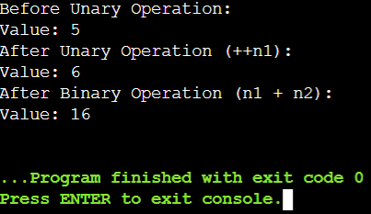
Conclusion:
In conclusion, overloading operators using friend functions in C++ allows external functions to access private data members while performing customized operations on objects. This approach combines the flexibility of operator overloading with controlled access to class data. It enhances code readability and usability by enabling intuitive operations on user-defined types, making programs more expressive and maintainable.

EXPERIMENT-3
Aim:
To write programs that demonstrate the different forms of inheritance in C++:
- Single Inheritance
- Multiple Inheritance
- Multi-level Inheritance
- Hierarchical Inheritance
- Hybrid Inheritance
Description:
Inheritance is one of the fundamental features of Object-Oriented Programming (OOP). It allows one class (derived class) to acquire the properties and behaviors of another class (base class). This experiment demonstrates all major forms of inheritance in C++.
Procedure:
- Define appropriate base classes with data members and member functions.
- Create derived classes using different forms of inheritance.
- Access base class properties in derived classes using constructors and member functions.
Compile and run the program to observe the behavior of each inheritance type
Program:
#include <iostream>
using namespace std;
class A
{ public:
void displayA()
{
cout << "This is class A (Base Class - Single Inheritance)" << endl;
}
};
class B : public A // Single Inheritance
{ public:
void displayB() {
cout << "This is class B (Derived from A - Single Inheritance)" << endl;
}
};
class X { public:
void displayX() {
cout << "This is class X (Base Class for Multiple Inheritance)" << endl;
}
};
class Y { public:
void displayY() {
cout << "This is class Y (Base Class for Multiple Inheritance)" << endl;
}
};
class Z : public X, public Y //Multiple Inheritance
{ public:
void displayZ() {
cout << "This is class Z (Derived from X and Y - Multiple Inheritance)" << endl;
}
};
class Parent
{ public:
void displayParent() {
cout << "This is Parent Class (Multi-level Inheritance)" << endl;
}
};
class Child : public Parent //Multi-level Inheritance
{ public:
void displayChild() {
cout << "This is Child Class (Derived from Parent)" << endl;
}
};
class GrandChild : public Child //Multi-level Inheritance
{ public:
void displayGrandChild() {
cout << "This is GrandChild Class (Derived from Child - Multi-level)" << endl;
}
};
class Base
{ public:
void displayBase() {
cout << "This is Base Class (Hierarchical Inheritance)" << endl;
}
};
class Derived1 : public Base //Hierarchical Inheritance
{ public:
void displayDerived1() {
cout << "This is Derived1 (from Base)" << endl;
}
};
class Derived2 : public Base //Hierarchical Inheritance
{
public:
void displayDerived2() {
cout << "This is Derived2 (from Base)" << endl;
}
};
class M
{ public:
void displayM() {
cout << "This is class M (Base of Hybrid Inheritance)" << endl;
}
};
class N : public M //Hybrid Inheritance
{
public:
void displayN() {
cout << "This is class N (Derived from M)" << endl;
}
};
class O {
public:
void displayO() {
cout << "This is class O (Independent Base for Hybrid Inheritance)" << endl;
}
};
class P : public N, public O //Hybrid Inheritance
{ public:
void displayP() {
cout << "This is class P (Derived from both N and O - Hybrid)" << endl;
}
};
int main()
{ cout << "\n--- Single Inheritance ---" << endl;
B b;
b.displayA();
b.displayB();
cout << "\n--- Multiple Inheritance ---" << endl;
Z z;
z.displayX();
z.displayY();
z.displayZ();
cout << "\n--- Multi-level Inheritance ---" << endl;
GrandChild gc;
gc.displayParent();
gc.displayChild();
gc.displayGrandChild();
cout << "\n--- Hierarchical Inheritance ---" << endl;
Derived1 d1;
Derived2 d2;
d1.displayBase();
d1.displayDerived1();
d2.displayBase();
d2.displayDerived2();
cout << "\n--- Hybrid Inheritance ---" << endl;
P p;
p.displayM();
p.displayN();
p.displayO();
p.displayP();
return 0;
}
OUTPUT :
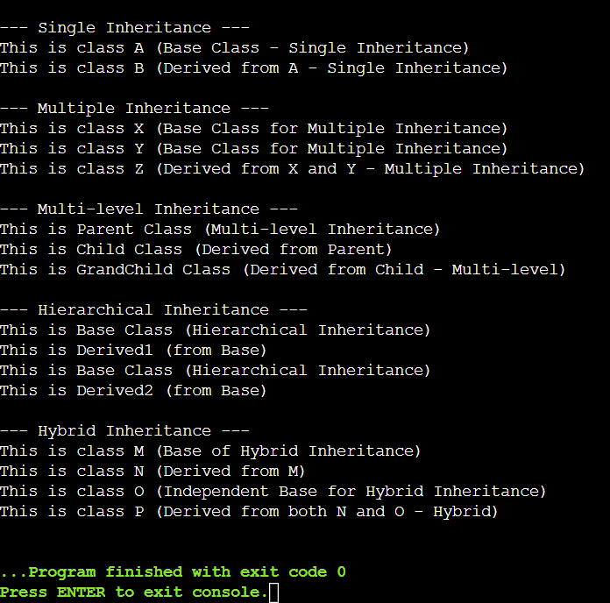
Conclusion:
In conclusion, inheritance in C++ enables classes to acquire properties and behaviors from other classes, promoting code reusability and logical organization. Different types of inheritance—single, multiple, multi-level, hierarchical, and hybrid—offer flexibility in designing class relationships to suit various programming needs. By using inheritance, developers can create modular, maintainable, and scalable code, while reducing redundancy and enhancing functionality across related classes. Proper understanding of inheritance also helps manage complexities such as the diamond problem through techniques like virtual inheritance.

EXPERIMENT-4
AIM : Order of execution of constructors and destructors in inheritance.
Description:
In C++ inheritance:
- Constructors are called from the base class to the derived class (top-down order).
- Destructors are called in reverse order, i.e., from the derived class back to the base class (bottom-up order).
This ensures that when an object of a derived class is created:
- The base class constructor runs first (to initialize base part).
- Then the derived class constructor runs (to initialize derived part).
When the object goes out of scope (or is deleted):
- The derived class destructor runs first (to release derived part).
- Then the base class destructor runs (to release base part).
This mechanism ensures proper initialization and cleanup in inheritance chains.
Algorithm:
For Constructors:
- Start with object creation of the derived class.
- Call base class constructor(s) in the order of inheritance.
- Then call the derived class constructor.
For Destructors:
- When object scope ends (or delete is called), start with the derived class destructor.
- Then call base class destructor(s) in the reverse order of construction.
Program :
#include <iostream>
using namespace std;
// Base class
class Base {
public:
Base() {
cout << "Base class constructor called" << endl;
}
~Base() {
cout << "Base class destructor called" << endl;
}
};
// Intermediate Derived class
class Derived1 : public Base {
public:
Derived1() {
cout << "Derived1 class constructor called" << endl;
}
~Derived1() {
cout << "Derived1 class destructor called" << endl;
}
};
// Further Derived class
class Derived2 : public Derived1 {
public:
Derived2() {
cout << "Derived2 class constructor called" << endl;
}
~Derived2() {
cout << "Derived2 class destructor called" << endl;
}
};
int main() {
cout << "Creating object of Derived2 class..." << endl;
Derived2 obj; // Object creation
cout << "Exiting main..." << endl;
return 0;
}
OUTPUT :
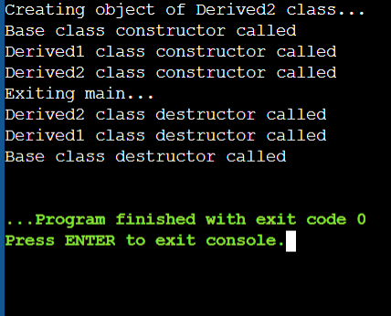
Conclusion:
In conclusion, C++ ensures proper object lifecycle management in inheritance by calling constructors from base to derived classes and destructors in reverse order. This top-down initialization and bottom-up cleanup guarantee that all parts of an object are correctly set up and safely released. It provides reliability and prevents resource leaks, making inheritance both safe and efficient in managing complex class hierarchies.

EXPERIMENT-5
Aim:
To write C++ programs demonstrating:
- Object as a class member
- Pointer to a class
- this pointer
- Virtual Base Class
Description:
- Object as a class member: When an object of one class is a data member of another class. This is known as composition.
- Pointer to a class: We can create pointers to objects of a class and access their members using the arrow (->) operator.
- this pointer: Every object in C++ has access to its own address through a special pointer named this. It is used to resolve ambiguity between data members and function parameters.
- Virtual Base Class: Used in multiple inheritance to avoid diamond problem (duplicate copies of base class members).
Procedure:
- Define separate programs for each concept.
- Demonstrate object as member by including one class object inside another class.
- Use pointer to class to access class members dynamically.
- Demonstrate this pointer inside a member function to access object data members.
- Use virtual base class to remove ambiguity in multiple inheritance.
- Compile and run each program, observe the output.
Program:
1. Object as a Class Member
#include <iostream>
using namespace std;
class Address {
string city;
public:
Address(string c) { city = c; }
void show() { cout << "City: " << city << endl; }
};
class Student {
string name;
Address addr; // Object as a class member
public:
Student(string n, string c) : name(n), addr(c) {}
void display() {
cout << "Name: " << name << endl;
addr.show();
}
};
int main() {
Student s("Ravi", "Hyderabad");
s.display();
return 0;
}
Output:
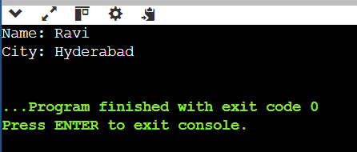

2. Pointer to a Class
#include <iostream>
using namespace std;
class Box {
int length;
public:
void setLength(int l) { length = l; }
void showLength() { cout << "Length: " << length << endl; }
};
int main() {
Box b1;
Box *ptr = &b1; // Pointer to object
ptr->setLength(15);
ptr->showLength();
return 0;
}
Output:
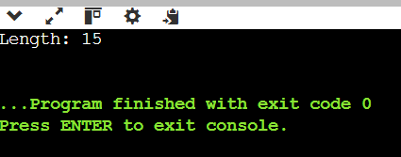

3. this Pointer
#include <iostream>
using namespace std;
class Test {
int x;
public:
Test(int x) {
this->x = x; // Resolving ambiguity
}
void show() { cout << "Value of x: " << this->x << endl; }
};
int main() {
Test t(50);
t.show();
return 0;
}
Output:

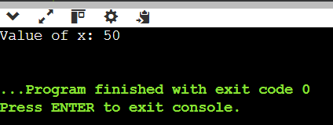

4. Virtual Base Class
#include <iostream>
using namespace std;
class Person {
public:
void show() { cout << "I am a Person" << endl; }
};
class Student : virtual public Person {
public:
void studentInfo() { cout << "I am a Student" << endl; }
};
class Teacher : virtual public Person {
public:
void teacherInfo() { cout << "I am a Teacher" << endl; }
};
class TA : public Student, public Teacher {
public:
void display() {
show(); // Only one copy of Person is inherited
}
};
int main() {
TA obj;
obj.display();
obj.studentInfo();
obj.teacherInfo();
return 0;
}
Output:

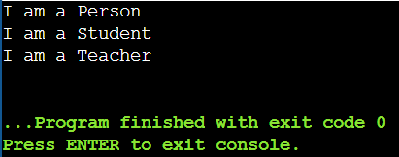
Conclusion:
In conclusion, these advanced C++ concepts—object as a class member, pointers to objects, the this pointer, and virtual base classes—enhance flexibility, modularity, and safety in programming. They allow dynamic access, resolve ambiguities, and prevent issues like the diamond problem in multiple inheritance. Together, they provide powerful tools for writing organized, efficient, and maintainable object-oriented code.

Experiment-6
Aim:
To write a C++ program that demonstrates the use of virtual functions for achieving runtime polymorphism.
Description:
Virtual functions in C++ allow achieving runtime polymorphism.
- When a base class declares a function as virtual, it can be overridden in the derived class.
- A base class pointer (or reference) can call the derived class version of the function at runtime, enabling dynamic dispatch.
- Without virtual, the function call is resolved at compile time (early binding).
- With virtual, the function call is resolved at runtime (late binding).
This feature is widely used in object-oriented programming for implementing polymorphism and is essential in real-world applications such as GUI systems, game engines, and frameworks.
Procedure:
- Create a base class with a virtual function.
- Derive one or more classes from the base class and override the virtual function.
- Use a base class pointer to refer to derived class objects.
- Call the function through the base class pointer and observe the effect of virtual function (runtime binding).
- Compile and execute the program to check outputs.
Program:
#include <iostream>
using namespace std;
// Base Class
class Base {
public:
virtual void display() { // Virtual Function
cout << "Display from Base class" << endl;
}
};
// Derived Class 1
class Derived1 : public Base {
public:
void display() override {
cout << "Display from Derived1 class" << endl;
}
};
// Derived Class 2
class Derived2 : public Base {
public:
void display() override {
cout << "Display from Derived2 class" << endl;
}
};
int main() {
Base* basePtr; // Base class pointer
Base b;
Derived1 d1;
Derived2 d2;
// Base pointer pointing to Base object
basePtr = &b;
basePtr->display();
// Base pointer pointing to Derived1 object
basePtr = &d1;
basePtr->display();

// Base pointer pointing to Derived2 object
basePtr = &d2;
basePtr->display();
return 0;
}
Output:
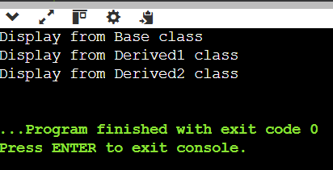

Conclusion:
In conclusion, virtual functions in C++ enable runtime polymorphism by allowing derived class methods to override base class methods. They ensure that the correct function is called through base class pointers or references, achieving dynamic binding. This mechanism enhances flexibility, extensibility, and reusability in object-oriented programming, making it essential for designing robust and scalable software systems.

EXPERIMENT 7
Aim:
To write a C++ program that demonstrates the use of abstract classes and pure virtual functions to calculate the area of different shapes.
Description:
In C++, an abstract class is a class that cannot be instantiated and is designed to act as a base class. A class becomes abstract when it contains at least one pure virtual function.
A pure virtual function is declared by assigning = 0 in its declaration. Derived classes must provide definitions for pure virtual functions; otherwise, they too become abstract.
This experiment illustrates:
- How abstract classes enforce common functionality (e.g., area()) across multiple derived classes.
- How polymorphism allows working with different derived class objects using base class pointers.
Procedure:
- Define an abstract base class Shape with a pure virtual function area().
- Derive specific shape classes like Circle, Rectangle, and Triangle from Shape.
- Implement the area() function in each derived class according to the shape formula.
- Use base class pointer(s) to call area() polymorphically.
- Display the calculated areas for different shapes.
Program:
#include <iostream>
#include <cmath>
using namespace std;
// Abstract Base Class
class Shape {
public: // Pure virtual function
virtual void area() = 0; };
// Derived Class: Circle
class Circle : public Shape {
float radius;
public: Circle(float r) : radius(r) {}
void area() {
cout << "Area of Circle = " << 3.14159 * radius * radius << endl;
} };
// Derived Class: Rectangle
class Rectangle : public Shape {
float length, breadth;
public: Rectangle(float l, float b) : length(l), breadth(b) {}
void area() {
cout << "Area of Rectangle = " << length * breadth << endl;
} };
// Derived Class: Triangle
class Triangle : public Shape {
float base, height;
public: Triangle(float b, float h) : base(b), height(h) {}
void area() {
cout << "Area of Triangle = " << 0.5 * base * height << endl;
} };
int main() {
Shape *s; // Base class pointer
Circle c(5);
Rectangle r(4, 6);
Triangle t(3, 7);
s = &c;
s->area();
s = &r;
s->area();
s = &t;
s->area();
return 0;
}
Output:
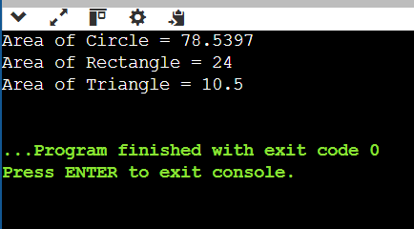
Conclusion:
In conclusion, abstract classes in C++ provide a framework for defining common interfaces while preventing direct instantiation. Pure virtual functions enforce that derived classes implement specific behaviors, ensuring consistency across related classes. Combined with polymorphism, abstract classes allow flexible and uniform handling of different objects through base class pointers, enhancing code reusability, maintainability, and scalability.

