/*

program name:Grade

*/

#include<stdio.h>

int main()

{

char grade;

printf("Enter the grade (S/A/B/Y/F):");

scanf("%c",&grade);

switch (grade){

case 'S':

printf("Super\n");

break;

case 'A':

printf("Very good\n");

break;

case'B':

printf("Fair\n");

break;

case 'Y':

printf("Absent\n");

break;

case 'F':

printf("Fails\n");

break;

default:

printf("Invalid grade entered.\n");

}

return 0;

}

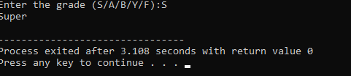**Output:**