/*

program name:loops

*/

#include<stdio.h>

int main()

{

int no;

no=1;

printf("Enter a number");

scanf("%d",&no);

while (no>=1)

{

printf("%d ",no);

no--;

}

return 0;

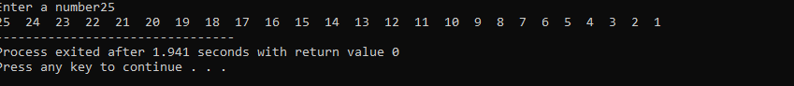}

**Output:**