/\*

program name:loops

\*/

#include<stdio.h>

#include<string.h>

int main()

{

int times,i;

char name[100];

printf("Enter your name:");

scanf("%s",&name);

printf("Enter how many times to display name length:");

scanf("%d",&times);

int length=strlen(name);

for(i=1;i<=times;i++)

{

printf("%d.length of name \"%s\"is%d\n",i,name,length);

}

return 0;

}

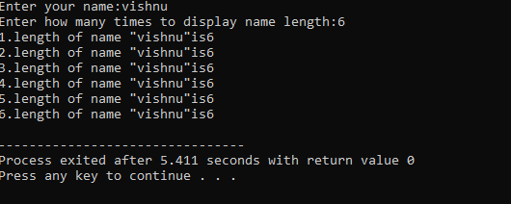Output: