/*

program name:loops

*/

#include<stdio.h>

int main()

{

char ch;

printf("Alphabrts from A to Z are:\n");

for(ch='A';ch<='Z';ch++)

{

printf("%c ",ch);

}

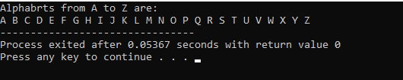return 0;

}

**Output:**