/*

program name:Eligiblity for vote

*/

#include<stdio.h>

int main()

{

int age;

printf("Enter your age");

scanf("%d",&age);

if(age>=18)

{

printf("Congrats your are eligible for voting\n");

}

else

{

printf("Oops you are\"too young\" to vote.\n");

}

return 0;

}

**Output-1:**

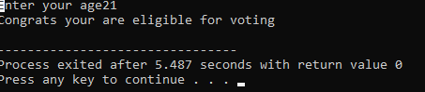

**Output-2:**

