**KEY LOGGER AND SECURITY**

**M.E.T ENGINEERING COLLEGE**

**COMPUTER SCIENCE ENGINEERING**

**OUTLINE:**

* **Proposed System/Solution**
* **System Development Approach**
* **Algorithm & Deployment**
* **Result**
* **Conclusion**
* **Future Scope**
* **Problem Statement**
* **References**

**Problem Statement:**

**KEYLOGGER**

* **In today's digital age, where cyber security threats loom large, one of the significant concerns is the proliferation of key loggers, stealthy software tools designed to monitor and record keystrokes on a user's computer without their knowledge. Key loggers pose a severe threat to individuals and organizations as they can capture sensitive information such as passwords, credit card details, breaches.**
* **The proliferation of key loggers poses a significant and other personal data, leading to identity theft, financial loss, and privacy threat to cyber security, compromising sensitive information by clandestinely capturing keystrokes. Despite advancements in detection mechanisms, key loggers evade traditional security measures, exploiting vulnerabilities in systems and applications. Their covert nature facilitates unauthorized access to confidential data, leading to identity theft, financial fraud, and espionage. Current solutions struggle to effectively identify and mitigate key logger threats, necessitating innovative approaches for comprehensive protection. Addressing this challenge requires the development of advanced techniques and technologies to detect, neutralize, and eradicate key loggers, enhancing cyber security resilience in the digital age.**

**HOW KEY LOGGERS CAN WORKS ?**

* **Key logging can occur through various means, including malicious software installations, phishing attacks, and compromised websites. Once installed on a system, key loggers operate silently in the background, capturing every keystroke made by the user, including login credentials, online conversations, and other sensitive information.**

**PROPOSED SOLUTION:**

* To combat the threat of keyloggers, a multi-faceted approach is necessary, integrating both proactive and reactive measures. This includes implementing robust endpoint security solutions equipped with advanced anomaly detection algorithms and behavior analysis techniques to identify suspicious activities indicative of keylogger activity. Additionally, the adoption of encryption protocols for sensitive data transmission and storage can mitigate the risk of interception by keyloggers. Regular security audits and updates to patch known vulnerabilities in operating systems and applications are essential to stay ahead of evolving threats. Finally, user education and awareness campaigns are crucial to instill best practices for recognizing and avoiding keylogger infiltration attempts, fostering a culture of cybersecurity vigilance across organizations and individuals.

 **SYSTEM  APPROACH:**

* The system development approach for the Key Logger and Security project incorporates a range of technologies carefully selected to ensure efficiency, reliability, and security. Below is an overview of the key technologies used in different components of the system:
* **Python:** Python serves as the primary programming language for the development of the key logger detection and prevention software. Its simplicity, versatility, and extensive libraries make it an ideal choice for rapid prototyping and building robust applications.
* **Tkinter:** Tkinter, a standard GUI (Graphical User Interface) toolkit for Python, is employed for creating the user interface of the application. Tkinter provides a platform-independent means of developing intuitive interfaces, enhancing user experience and interaction.
* **Pynput:** The Pynput library is utilized for capturing keyboard input events and monitoring keystrokes. Pynput offers comprehensive functionalities for handling keyboard and mouse input, allowing seamless integration with our system for monitoring user activities. 
* **JSON:** JSON (JavaScript Object Notation) is utilized for storing and managing the captured keystroke data in a structured format. JSON provides a lightweight, human-readable data interchange format, facilitating easy storage and retrieval of key logger data.

**ALGORITHM:**

* **Keyboard Event Handling:**
  + The system utilizes the pynput library to capture keyboard input events in real-time.
  + Each keyboard event, including key press, hold, and release, is monitored and recorded.
  + This algorithm distinguishes between different types of keyboard events, allowing the system to accurately track user keystrokes.
* **Anomaly Detection:**
  + Anomaly detection algorithms analyze the patterns of keyboard events to identify suspicious activities indicative of key logger presence.
  + By monitoring the frequency, sequence, and timing of keystrokes, the system can detect deviations from normal user behavior.
  + Machine learning techniques may be employed to train models on legitimate user typing behavior and identify anomalies that could signify unauthorized access or malicious activity.
* **Encryption:**
  + Sensitive information, such as captured keystrokes and user credentials, are encrypted using advanced encryption standards.
  + Encryption algorithms ensure that the stored data remains secure and inaccessible to unauthorized parties.

Strong encryption mechanisms, such as AES (Advanced Encryption Standard), are utilized to protect sensitive data from potential breaches or unauthorized access.

**DEPLOYMENT:**

* **Client-Side Installation:**
  + The key logger detection and prevention software is installed on end-user devices, such as personal computers or workstations.
  + The installation process involves deploying the executable or script containing the key logger detection algorithms and user interface components.
  + Users may download and install the software from trusted sources or receive it through enterprise deployment channels.
* **Server-Side Components:**
  + In some deployment scenarios, server-side components may be utilized to enhance the functionality and security of the system.
  + Server-side components may include centralized logging and analysis tools for aggregating and analyzing keystroke data from multiple client devices.
  + Additionally, server-side infrastructure may be utilized for remote management, configuration, and updates of the key logger detection software.
* **Integration with Existing Systems:**
  + The key logger detection and prevention system may be integrated with existing security infrastructure and tools to enhance overall cyber security posture.
* **Cloud Deployment (Optional):**
  + Cloud deployment options provide scalability, flexibility, and accessibility advantages for the key logger detection system.
  + Cloud-based solutions may leverage platforms such as AWS (Amazon Web Services), Microsoft Azure, or Google Cloud Platform for hosting server-side components and data storage.
  + Cloud deployment enables seamless access to the system from anywhere with an internet connection, facilitating centralized management and monitoring of key logger activities.
  + Integration with endpoint security solutions, SIEM (Security Information and Event Management) systems, and threat intelligence platforms enables comprehensive threat detection and response capabilities.
  + APIs (Application Programming Interfaces) and standardized protocols are utilized for seamless integration with third-party security products and services.

**Source code:**

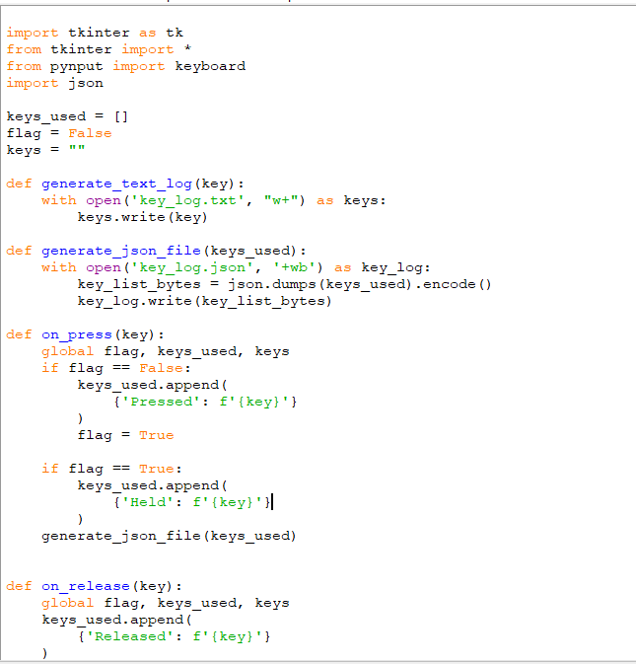 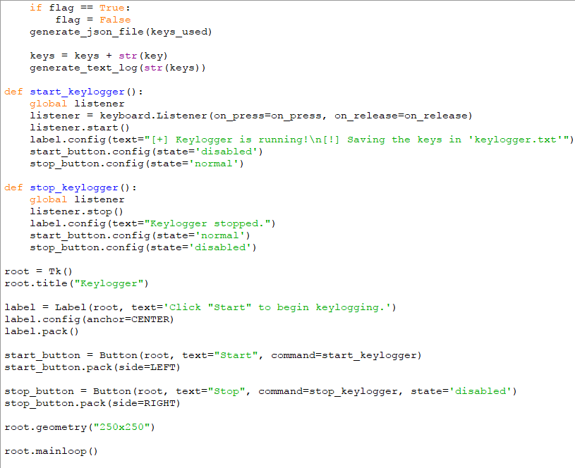

Result and Output:

**GUI INTERFACE**

**LOG File Generated by Key Logger Pro**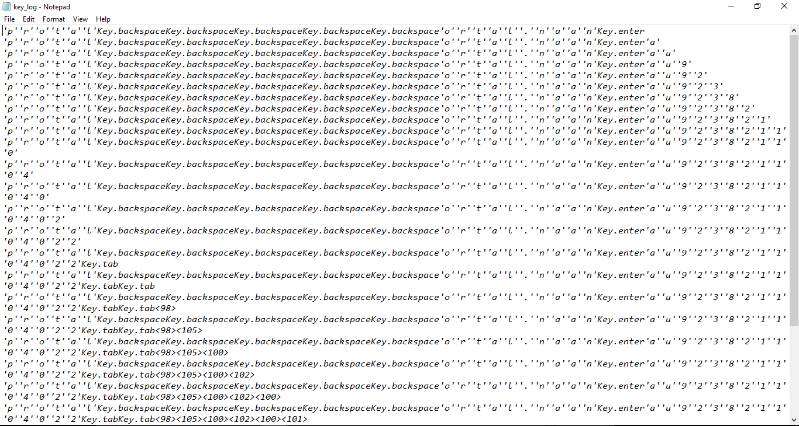

**CONCLUSION:**

* **In conclusion, addressing keylogger threats demands a proactive approach integrating prevention measures, detection technologies, and encryption protocols. User education is vital for cultivating cybersecurity awareness and empowering individuals to identify and mitigate potential risks. Continuous monitoring, updates, and improvement efforts are essential to adapt to evolving threats and uphold the integrity of sensitive information.**

**FUTURE SCOPE:**

* **In the realm of keylogger prevention and security enhancement, future endeavors are poised to integrate advanced anomaly detection techniques, including machine learning algorithms, for more accurate identification of key logger activity. Behavior-based authentication methods, coupled with biometric authentication measures, will bolster security by analyzing user typing patterns and biometric data. Secure input handling techniques within applications and web browsers will be refined to thwart key logger detection and interception, while collaboration with endpoint security vendors will embed key logger prevention features into existing security solutions. Continuous monitoring protocols, incident response frameworks, and robust security awareness training programs will fortify defenses against key logger attacks. Integration with security standards and regulations, alongside ongoing research and development initiatives, will ensure compliance and enable proactive mitigation of emerging threats, positioning organizations to safeguard against the evolving landscape of cyber threats effectively.**

**References:**

* **Python Documentation. (**[**https://docs.python.org/3/**](https://docs.python.org/3/)**)**
* **Tkinter Documentation. (**[**https://docs.python.org/3/library/tkinter.html**](https://docs.python.org/3/library/tkinter.html)**)**
* **Pynput Documentation. (**[**https://pynput.readthedocs.io/en/latest/**](https://pynput.readthedocs.io/en/latest/)**)**
* **JSON Documentation. (**[**https://docs.python.org/3/library/json.html**](https://docs.python.org/3/library/json.html)**)**

**THANK YOU**