**Land Real Estate Registration**

Now-a-days all applications which require huge security are migrating their application to Blockchain as Blockchain inbuilt security for data. All existing techniques were not having any facility to check whether data store at decentralized (same data will be saved at multiple nodes and if one node hack or down then data will be gather from other working node) server is intact or change.

To check data is intact we can use Blockchain technology to maintain land registration details as this technology maintain tree to store each transaction (any data storage will be consider as transaction) and while storing new data then Blockchain verify all transaction hash code and if data is not alter or hack then same hash code will be generated and verification will be successful and new block will be added and if data is changed then different hash code will be generate and verification will be failed which indicate node is hack.

If we manage land registration details in Blockchain then users can verify data from any other working node upon failure of other node. Blockchain also support tamper or alter proof storage as the data store in Blockchain will get verify upon adding new transaction and if any data block alter then verification will be failed and user can understand his data is alter.

1. Blockchain maintain each transaction/storage in blocks
2. All blocks may store inside MERKLE TREE
3. Before adding new block Blockchain will verify all blocks hash code and each block may have link to previous block and current block
4. If any block data alter then its hash code will change and verification will be failed.

To implement this project we have designed following modules

1. Admin: admin user can login to application by using username as admin and password as admin and after login admin can add new land registration details and then can search land details. Admin will issue registration number to each user land.
2. User module: User can search registered plot details by entering plot registering number.

Below screen shots showing code of Blockchain Algorithm

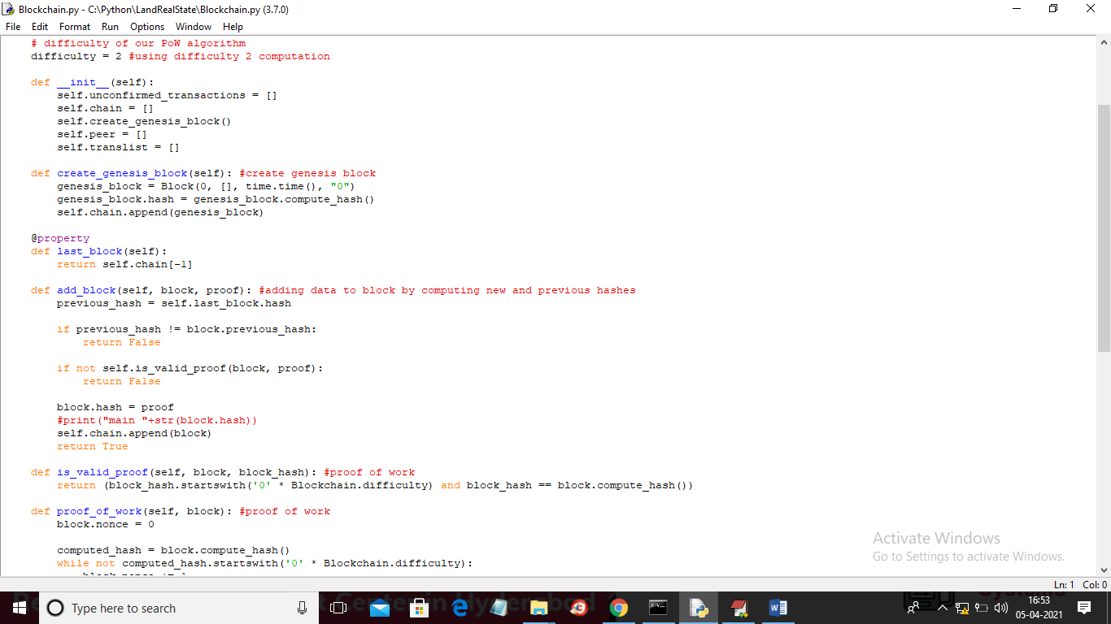

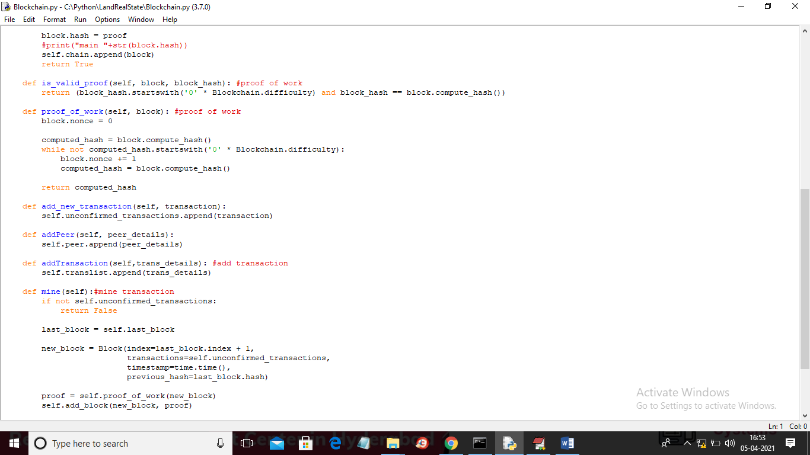

In above screen read comments to understand how genesis block is creating, proof of work, mining and storing blocks/transaction.

SCREEN SHOTS

To run project install python 3.7 and then install DJANGO server and then create Python folder inside system ‘C’ directory and then put ‘LandRealState’ folder inside that C:/Python folder and then start DJANGO server by double click on ‘runserver.bat file. Now open browser and enter URL as <http://127.0.0.1:8000/index.html> and press enter key to get below home page

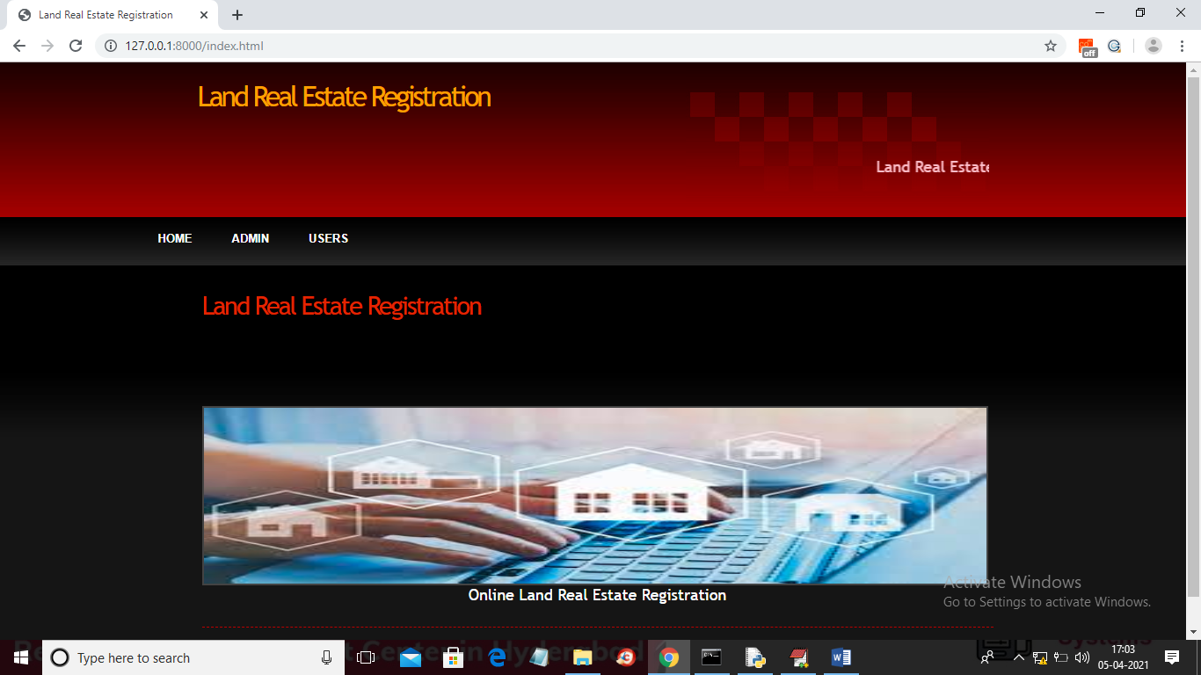

In above screen click on ‘Admin’ link to get below screen

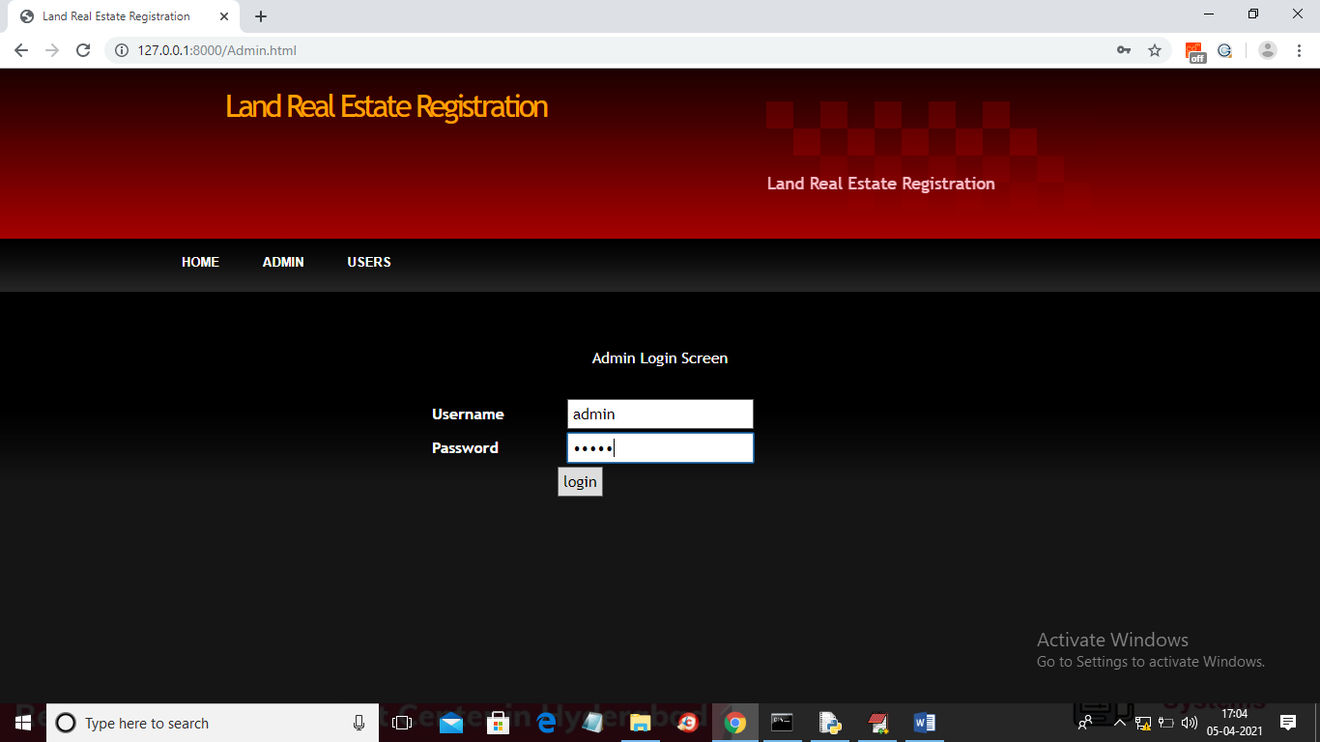

In above screen enter username as ‘admin’ and password as ‘admin’ and then click on ‘login’ button to get below Admin Screen

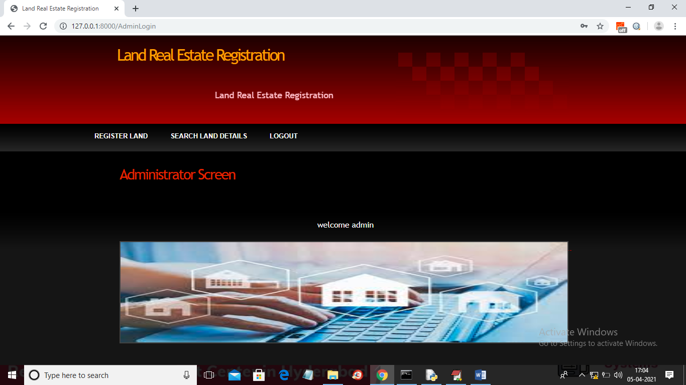

In above screen admin can click on ‘Register Land’ link to add new land registration details

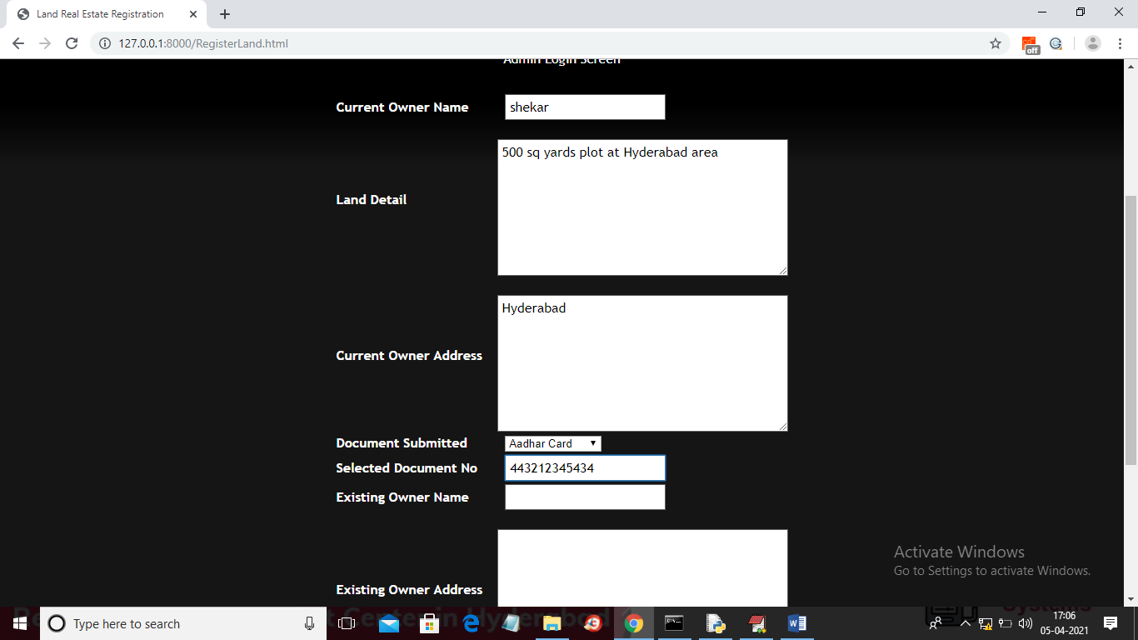

In above screen admin will enter plot details

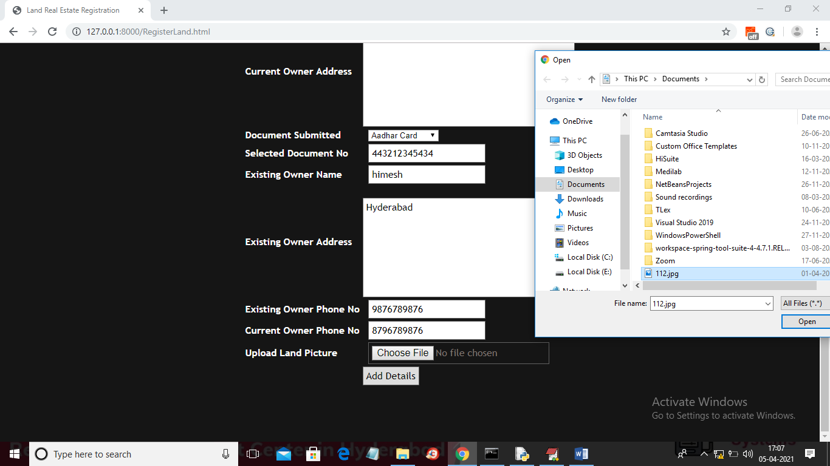

In above screen admin can upload land photo also and then click on ‘Open’ button and then click on ‘Add Details’ button to get below screen

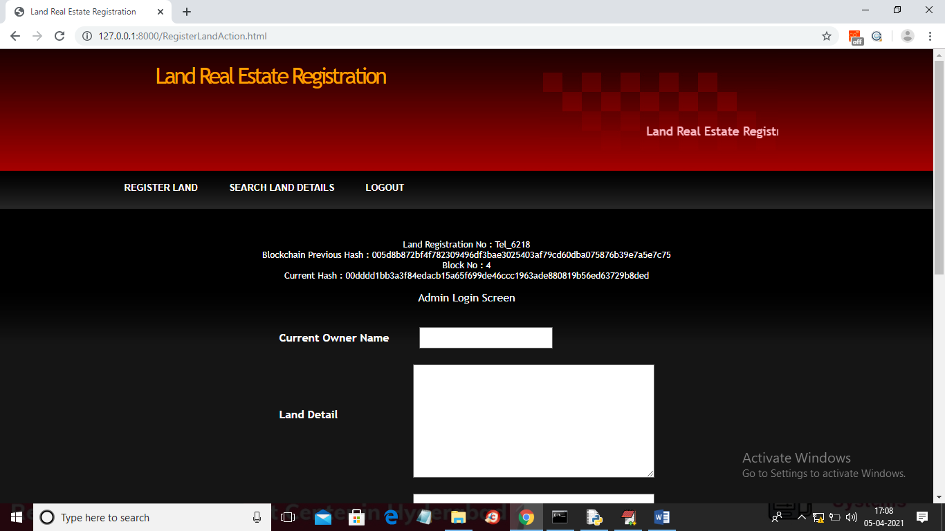

In above screen land details added and we can get land registration number and will get index number of Blockchain at which this land details stored and then will get previous block hash code and current block hash code and for each transaction we can see current block hash code will match with previous hash code of upcoming new transaction. Now data is stored at Blockchain and now admin can click on ‘Search Land Details’ link to get all registered land details

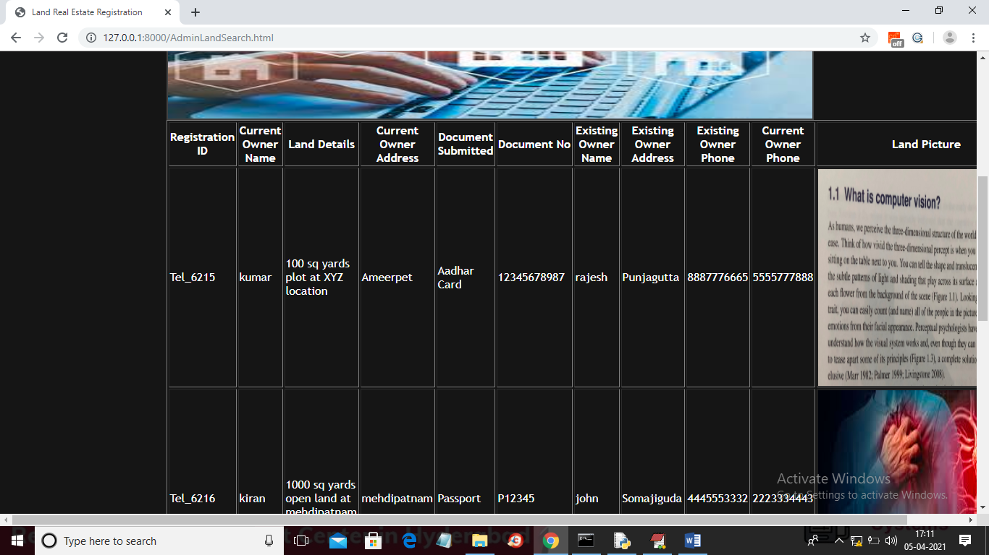

In above screen admin can view all registered plot details and can see land image also as I uploaded some other images so you upload correct land pictures. Now logout and click on ‘Users’ link to get below screen

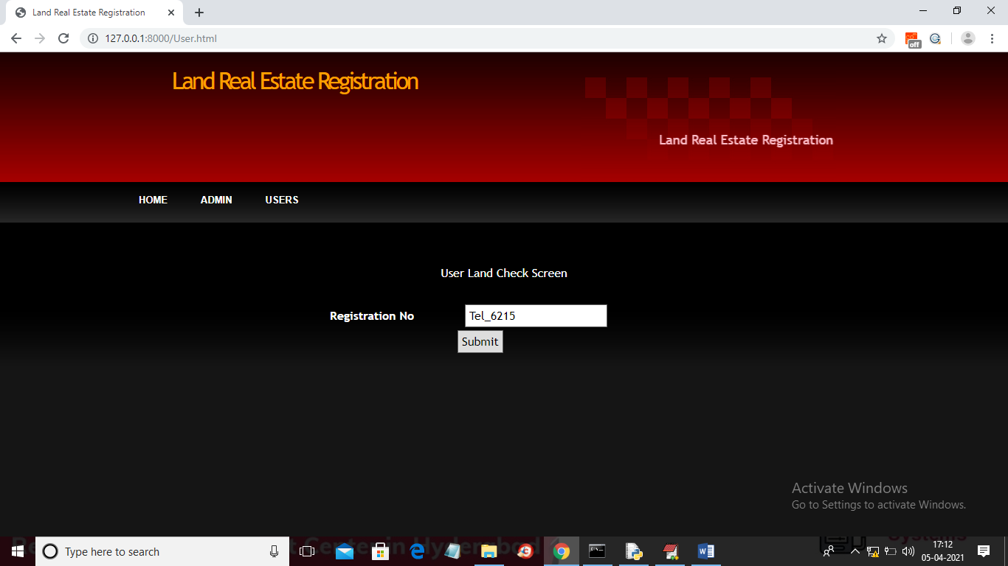

In above screen user can enter his desired land registration number and then click on ‘Submit’ button to get below output

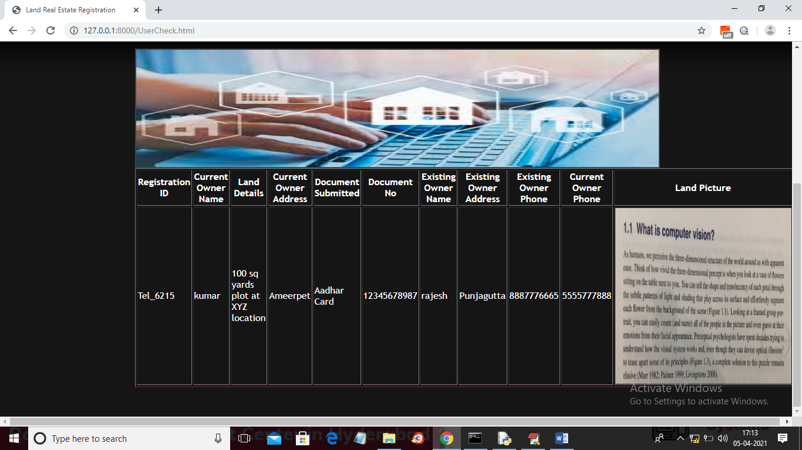

In above screen user can view searched land details. Similarly any number of records you can store and searched from block chain server.