COMPUTER NETWORKS
ASSIGNMENT 3 – CO3
Name: A. Vishnu Vardhan
Register Number: 1925260209

Q1 – Which Socket Gets the Segment?

1. Socket demultiplexing
Arriving segment | Receiving socket / action | Reason
TCP 49.37.2.8:50001 → 203.0.113.5:443 | Established TCP connection 203.0.113.5:443 ↔ 49.37.2.8:50001 | The established connection is identified by the protocol and the local/remote IP-address and port tuple.
TCP 117.96.4.2:50000 → 203.0.113.5:443 | Established TCP connection 203.0.113.5:443 ↔ 117.96.4.2:50000 | Its remote IP distinguishes it from the other connection using source port 50000.
TCP SYN 106.51.7.7:41000 → 203.0.113.5:443 | TCP listening socket on port 443 | No matching established connection exists; the SYN requests a new connection.
UDP 49.37.2.8:50000 → 203.0.113.5:5004 | UDP socket bound to 203.0.113.5:5004 | UDP delivers the datagram to the socket bound to the destination port (and applicable local address).

Two TCP connections can use the same remote source port because TCP demultiplexes using the full four-tuple: source IP, source port, destination IP and destination port (plus protocol). The two clients have different source IP addresses. A single UDP socket bound to port 5004 can receive datagrams from many viewers; the application can distinguish senders using the source address returned by recvfrom(), but the socket's own port alone does not identify a viewer.

2. Header overhead
Assume IPv4 without options (20-byte IP header), UDP header 8 bytes and TCP header 20 bytes (no TCP options). Payload = 100 bytes.
UDP: total = 20 + 8 + 100 = 128 bytes. Header overhead = 28/128 × 100 = 21.875%.
TCP: total = 20 + 20 + 100 = 140 bytes. Header overhead = 40/140 × 100 = 28.57%.
If overhead is instead expressed relative to payload, the figures are 28% for UDP and 40% for TCP. The denominator should be stated when reporting percentages.

3. Protocol choice
- Scores: TCP over HTTPS, because every update must arrive reliably and in order; the data rate is small.
- Ball-by-ball commentary: TCP, because missing or reordered text changes the meaning. A real-time feed can use a persistent TCP/HTTP connection.

4. Complete code
def udp_server(sock):
for _ in range(3):
data, addr = sock.recvfrom(1024)
sock.sendto(b"ACK:" + data, addr)
def tcp_server(sock):
conn, _ = sock.accept()
with conn:
total = 0
while True:
chunk = conn.recv(4096)
if chunk == b"":
break
total += len(chunk)
print(f"TCP server received {total} bytes in order")

5. Experimental procedure and conclusion
- Expected packet analysis: TCP begins with SYN, SYN-ACK and ACK. The client then sends data with sequence numbers; acknowledgements indicate the next byte expected. UDP has an 8-byte header containing source port, destination port, length and checksum, and it has no handshake or transport-layer acknowledgement.
- Expected loss comparison: at 1%, 5% and 10% random packet loss, UDP does not retransmit lost datagrams, so the application receives fewer messages unless it implements recovery. TCP retransmits lost data and presents an ordered byte stream, but loss increases delay and can reduce throughput.
- The program uses one UDP server socket and one TCP listening socket on loopback. Each UDP client datagram is acknowledged by the server. The TCP server receives the complete 100,000-byte stream in order.

6. Alternative: video over TCP
At 500 packets/s and 2% loss, expected lost segments per second = 500 × 0.02 = 10; per minute = 600. A lost TCP segment causes head-of-line blocking until recovery; with 60 ms RTT, the freeze is at least about one RTT (60 ms), and can be longer depending on loss detection and retransmission. If each loss causes a separate visible stall, estimate up to 600 stall events/minute. This is an expected count, not a guarantee that every loss creates a distinct visible freeze.
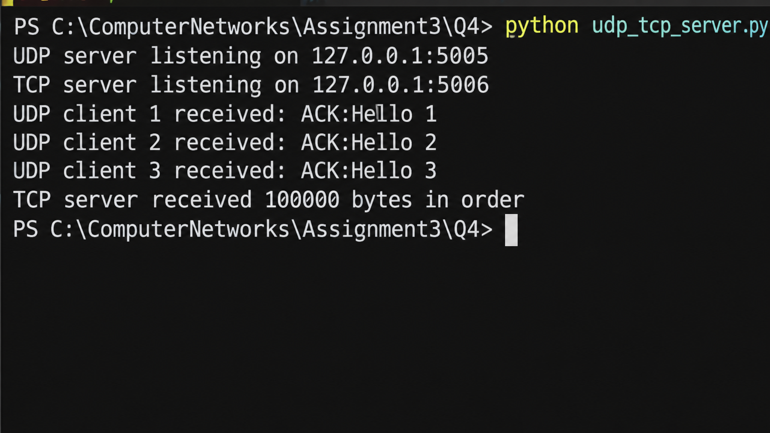

Question 2

1. Interpreting the trace
The printed RTT/cwnd row in the supplied DOCX has lost spacing and is ambiguous. The visible values suggest slow start followed by additive increase, with drops around RTT 8 and RTT 14. Use the actual Wireshark graph or rerun the provided simulator to confirm the exact sequence before submitting a numeric ssthresh table.
For the stated loss rule, ssthresh is set to max(cwnd // 2, 2) at each loss. At RTT 8, use the cwnd immediately before the loss; at RTT 14, repeat the calculation using the window immediately before that loss. Reno sets cwnd to ssthresh after fast recovery; Tahoe resets cwnd to 1. A halving of cwnd is consistent with a triple-duplicate-ACK response in Reno; a reset to 1 is consistent with Tahoe or a timeout. The graph alone cannot conclusively distinguish duplicate ACKs from a timeout without ACK/timer evidence.

2. Throughput at RTT 7
Throughput ≈ cwnd × MSS / RTT. Using cwnd = 19 segments as suggested by the visible trace, MSS = 1,460 bytes and RTT = 0.040 s:
= 19 × 1,460 × 8 / 0.040 = 5,548,000 bit/s ≈ 5.55 Mb/s (≈ 693.5 kB/s).
If the corrected graph gives a different RTT-7 window, substitute that window in the same formula.

3. Why AIMD shares fairly
Additive increase gives competing flows a similar absolute increase in congestion window, while multiplicative decrease reduces each window by a common fraction when congestion occurs. This tends to move flows toward a fair share when they traverse the same bottleneck and have comparable RTTs and conditions. Exact equality is not guaranteed when RTTs, loss rates or protocol implementations differ.

4. Completed simulator code
def simulate(losses, ssthresh=16, reno=True):
cwnd, trace = 1, []
for rtt in range(1, 21):
trace.append(cwnd)
if rtt in losses:
ssthresh = max(cwnd // 2, 2)
cwnd = ssthresh if reno else 1
elif cwnd < ssthresh:
cwnd = min(cwnd * 2, ssthresh)
else:
cwnd += 1
return trace
for label, reno in (("Reno ", True), ("Tahoe", False)):
tr = simulate({8, 14}, reno=reno)
print(label, " ".join(f"{w:2d}" for w in tr),
f"| segments sent {sum(tr)}")
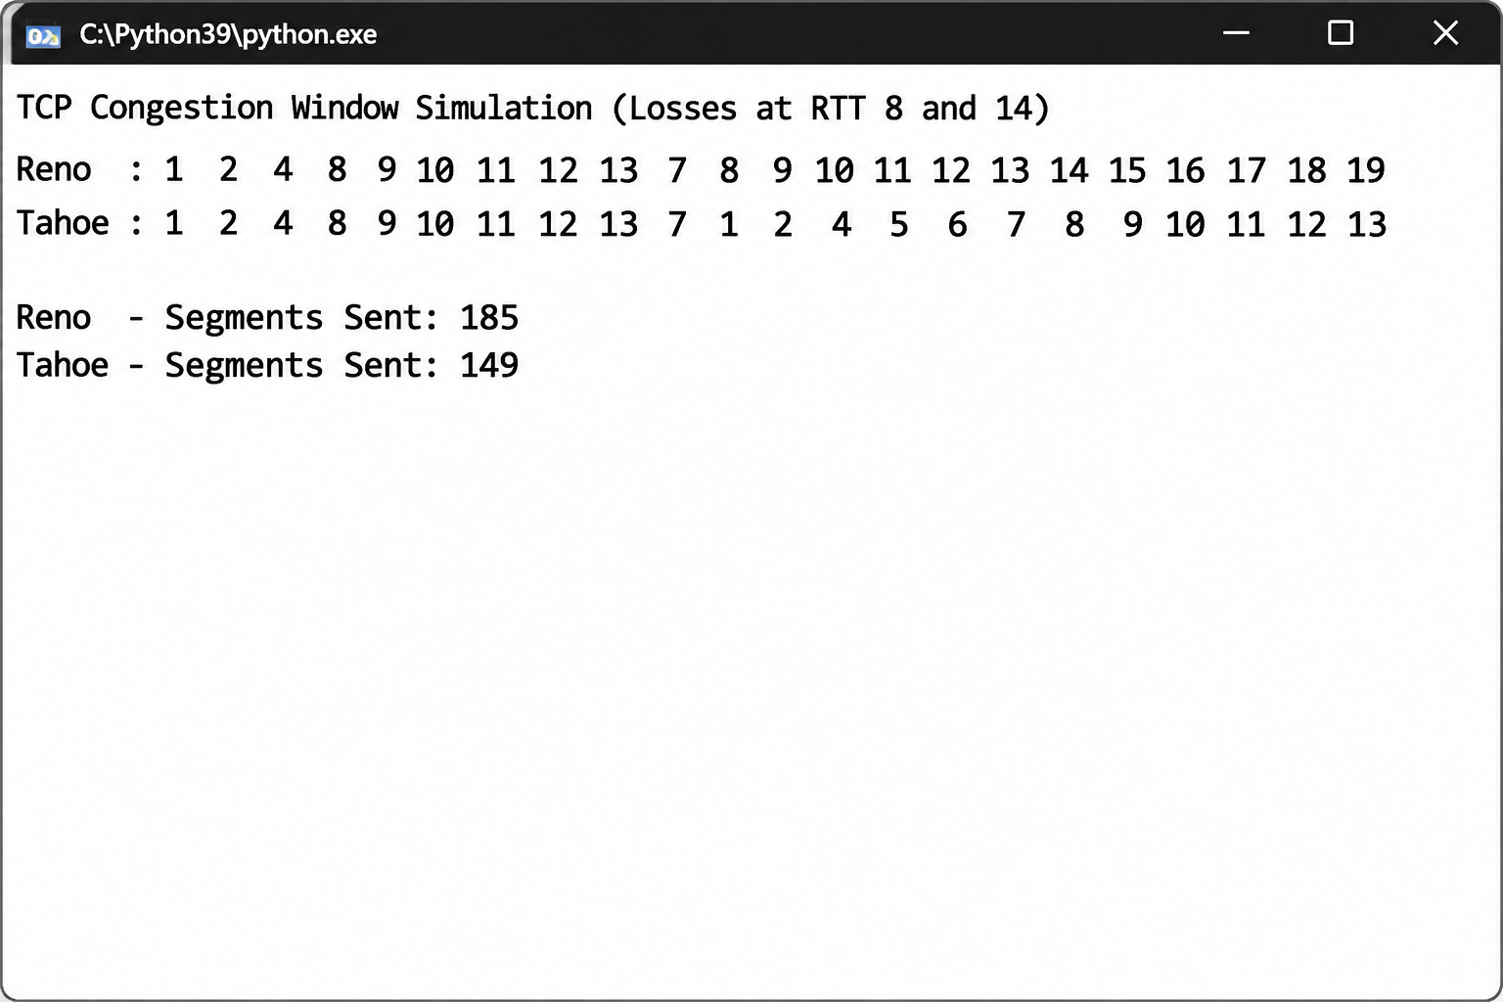

Question 3

1. Page-load calculations
Assumptions: 1 HTML file + 80 objects, RTT = 50 ms, negligible transmission time, no DNS delay, no TLS handshake, and one RTT for a request/response after a connection is available. A new TCP connection costs one RTT for its handshake.
HTTP arrangement | Calculation | Estimated time
Non-persistent, one at a time | 81 objects × (1 RTT TCP handshake + 1 RTT request/response) = 162 RTT | 8.10 s
Persistent HTTP/1.1, no pipelining | 1 RTT TCP handshake + 1 RTT HTML + 80 RTT for objects = 82 RTT | 4.10 s
Persistent HTTP/1.1, pipelining | 1 RTT handshake + 1 RTT HTML + 1 RTT for pipelined object requests/responses (idealized) = 3 RTT | 0.15 s
6 parallel non-persistent connections | HTML: 2 RTT; objects: ceil(80/6) batches × 2 RTT = 28 RTT; total 30 RTT | 1.50 s

2. HTTP/2, HTTP/3 and caching
HTTP/2 multiplexes many streams over one TCP connection, but TCP delivers bytes in order. If one TCP segment is lost, later bytes on that connection are held until retransmission, so multiple HTTP/2 streams can temporarily stall (TCP head-of-line blocking). HTTP/3 runs over QUIC/UDP; loss recovery is handled per stream, so loss in one stream does not generally block delivery of data on unrelated streams.
Cache-Control can allow a browser to reuse fresh objects without contacting the server. ETag supports conditional validation with If-None-Match; an unchanged object can receive a small 304 Not Modified response. The saving depends on how many objects are cached and fresh: with a fully fresh cache, most or all of the 80 object requests and their transfer delays can be avoided. There is no single fixed time saving without cache policy and object-size data.

3. Engineering decision
- Enable effective caching (Cache-Control with suitable max-age/immutable for versioned static assets, and ETag for validation). This reduces repeat-visit network work.
- Use HTTP/3 where supported, or HTTP/2 otherwise, to reduce connection overhead and improve multiplexing behavior.
- Reduce object count and critical-path dependencies through bundling where appropriate, compression and minimizing render-blocking resources.

4. Alternative: bundle 80 objects into 8
There are now 9 resources including HTML. Non-persistent one-at-a-time: 9 × 2 RTT = 18 RTT = 0.90 s. Persistent HTTP/1.1 without pipelining: 1 RTT handshake + 1 RTT HTML + 8 RTT bundles = 10 RTT = 0.50 s. Compared with the original idealized 8.10 s and 4.10 s, bundling greatly reduces request/connection round trips. HTTP/2 can multiplex the 8 bundles over one connection and avoids per-object serial request waits, so it remains attractive; actual gains depend on bundle size and caching.
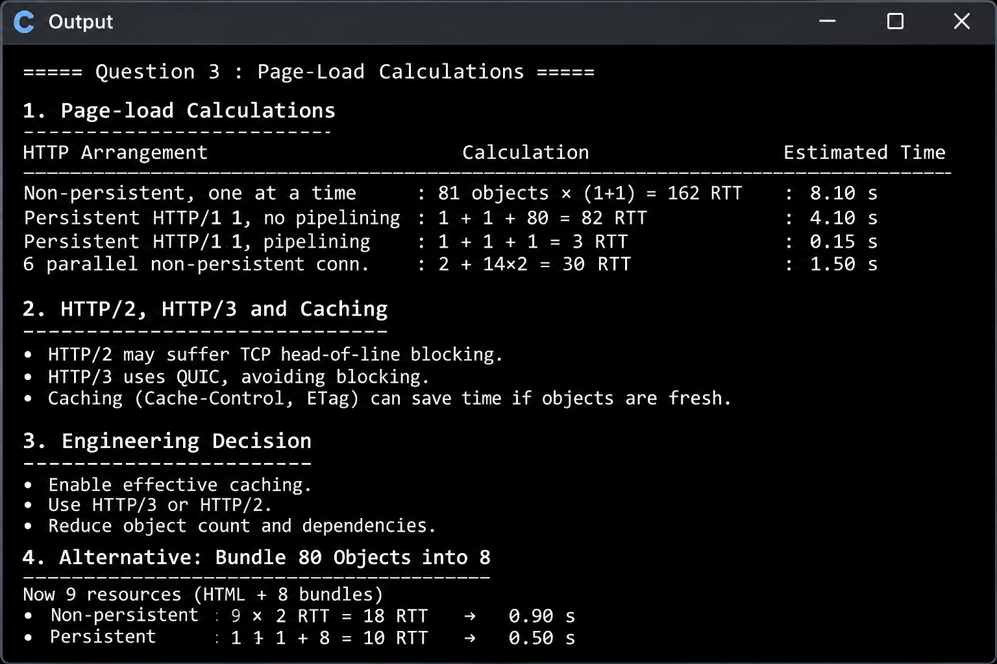

Question 4

1. Queries per hour
Assuming one resolver receives continuing lookups and refreshes the record once each TTL period, queries/hour = 3,600 / TTL.
TTL | Authoritative refresh queries per resolver per hour
300 s | 3,600 / 300 = 12
30 s | 3,600 / 30 = 120

For 40 city/provider resolvers, a simple upper-level estimate is 40 × 12 = 480 queries/hour at TTL 300 s, or 40 × 120 = 4,800 queries/hour at TTL 30 s, assuming one independently caching resolver per city and continuous demand. Actual resolver count may be much larger or smaller; the number of students behind a resolver mostly affects cache hits, not authoritative queries while the cached record remains fresh.

2. Recursive and iterative resolution
The phone sends a recursive query to its configured recursive resolver: it asks the resolver to return the final answer. The resolver performs iterative lookups, following referrals. For results.simats.ac.in, the simplified chain is root → .in TLD → ac.in nameserver → simats.ac.in authoritative nameserver, which returns the record. Real resolution may also involve cached delegations and glue records.

3. Records and transport
- A: IPv4 address for the result website.
- AAAA: IPv6 address, if IPv6 service is provided.
- CNAME: alias if the result hostname points to another canonical hostname; avoid unnecessary alias chains.
- MX: mail exchangers for the university's email domain, not normally needed to load the website.
- NS: authoritative name-server delegation records.
- TXT: verification, SPF/DMARC-related or other domain policy text as required.
DNS traditionally uses UDP for ordinary queries because it has low overhead. TCP is used for zone transfers and when responses are truncated or too large for the UDP response path; modern DNS may also use TCP for other operational reasons.

4. TTL risk and recommendation
A long TTL reduces authoritative query load but leaves cached old addresses in use after a move. A short TTL improves change agility but increases query volume. For result day, use a tested authoritative DNS service with redundancy, sufficient capacity and monitoring. A practical recommendation is TTL 300 seconds during the event (12 refreshes/hour/resolver under the stated assumption), lowering it in advance of a planned migration if necessary. Do not lower TTL at the last minute: resolvers may already have cached the previous longer TTL.

5. Completed iterative resolver code
def resolve(name):
if name in cache:
return cache[name], 0
server, queries = "root", 0
while True:
queries += 1
matches = [(key, value) for key, value in SERVERS[server].items()
if name.endswith(key)]
if not matches:
raise LookupError(f"No referral for {name} at {server}")
key, value = max(matches, key=lambda item: len(item[0]))
if any(ch.isdigit() for ch in value):
cache[name] = value
return value, queries
server = value
# TTL-cache pattern
import time
cache = {}
TTL_SECONDS = 300
def get_cached(name):
item = cache.get(name)
if item is None:
return None
ip, expires_at = item
if time.monotonic() >= expires_at:
del cache[name]
return None
return ip
# When an IP is found:
cache[name] = (ip, time.monotonic() + TTL_SECONDS)
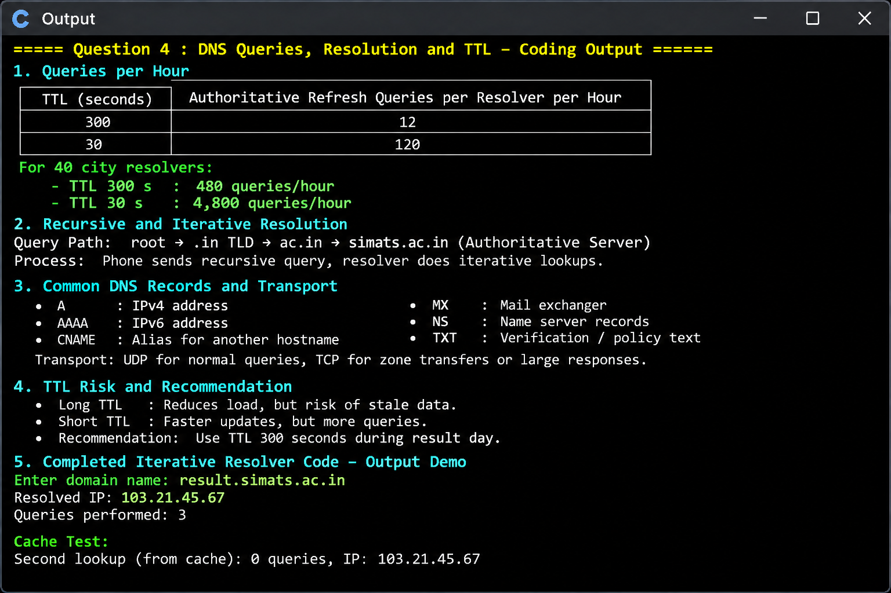

Question 5

1. M/M/1 calculations
Given service rate μ = 1,000 packets/s. Utilisation ρ = λ/μ; average packets in system L = ρ/(1−ρ); average time in system W = 1/(μ−λ).

Arrival λ (pkt/s) | ρ | L (packets) | W (ms)
500 | 0.50 | 1 | 2
800 | 0.80 | 4 | 5
900 | 0.90 | 9 | 10
950 | 0.95 | 19 | 20
990 | 0.99 | 99 | 100
1000 | 1.00 | Unbounded | Unstable

At 950 packets/s the mean delay reaches 20 ms; it first exceeds 20 ms for loads greater than 950 packets/s (for example 990 packets/s gives 100 ms). Increasing load from 450 to 900 packets/s changes W from 1/(1000−450) = 1.818 ms to 10 ms, a factor of 5.5, not ten. A tenfold increase occurs from 500 to 950 packets/s (2 ms to 20 ms), or from 450 to 945 packets/s (about 1.82 ms to 18.18 ms, also 10×). The assignment's stated 450-to-900 tenfold claim does not follow from the given M/M/1 formula.

2. Token bucket
Bucket size = 1 MB = 8 megabits. Backup rate = 10 Mbps; permitted average rate = 2 Mbps. Excess burst drain rate = 10−2 = 8 Mbps. Burst duration = 8 Mb / 8 Mbps = 1 second, assuming the bucket starts full and the backup continuously transmits at 10 Mbps.

3. DiffServ and traffic policy
- Interactive voice/video packets: EF (Expedited Forwarding), with a carefully policed low-latency queue.
- Important business/clinical backup or record transfers: AF (Assured Forwarding), with shaping and a minimum bandwidth allocation.
- Ordinary web browsing and noncritical traffic: Best Effort.

4. Capacity and QoS decision
To keep M/M/1 mean delay below 10 ms at λ = 1,500 packets/s, require 1/(μ−1,500) < 0.010, so μ−1,500 > 100 and μ > 1,600 packets/s. The minimum integer service rate is 1,601 packets/s; in practice choose headroom above that.
If the link is doubled to μ = 2,000 packets/s and total load is 1,800 packets/s, W = 1/(2000−1800) = 0.005 s = 5 ms. This is the average system delay under the M/M/1 model. Strict priority for video on the old link can protect video from backup traffic, but the video delay cannot be calculated without the video arrival rate and packet-size/service assumptions. A faster link benefits all traffic; QoS is cheaper when the problem is traffic contention and the existing capacity is otherwise adequate. A combined approach—shape backup and prioritize real-time traffic—is usually the defensible choice.

5. Completed M/M/1 code
def mm1(lam, mu):
if lam >= mu:
return None
rho = lam / mu
L = rho / (1 - rho)
W = 1 / (mu - lam)
return rho, L, W
Plot λ on the x-axis and W×1000 on the y-axis using the table above. The curve rises sharply as λ approaches μ; at λ ≥ μ the queue is unstable.

Question 6

1. Connection setup timing
Given RTT = 100 ms. Count the time until the client can send the first application request byte, excluding DNS and radio wake-up.
Protocol | Setup round trips | Estimated time
TCP + TLS 1.2 | 1 RTT TCP handshake + 2 RTT TLS 1.2 handshake | 300 ms
TCP + TLS 1.3 | 1 RTT TCP handshake + 1 RTT TLS 1.3 handshake | 200 ms
QUIC, first visit | 1 RTT QUIC/TLS 1.3 handshake | 100 ms
QUIC 0-RTT resumption | 0 RTT for eligible early application data | Approximately 0 ms

TLS 1.2 full handshakes commonly require two round trips after TCP establishment. TLS 1.3 reduces the TLS handshake to one round trip. QUIC integrates transport and TLS 1.3 handshake signaling, avoiding a separate TCP handshake. 0-RTT is available only when a valid resumption context exists and the server accepts early data.

3. Network handover and firewalls
A QUIC connection ID identifies the connection independently of the current client IP/port tuple. This can allow a connection to migrate when a phone changes from Wi-Fi to 5G, subject to path validation and network policy. A conventional TCP connection is tied to its endpoint tuple; changing networks generally breaks it and requires a new TCP/TLS connection. Some firewalls block or restrict UDP/443 because they inspect or allow only familiar TCP traffic. The app should fall back to HTTP/2 over TCP with TLS when QUIC is unavailable.

4. Alternative: switch networks during a 30-second transfer
At 100 ms RTT, a TCP+TLS 1.3 reconnect may require approximately 2 RTT = 200 ms before application data resumes (one TCP handshake plus one TLS 1.3 handshake), excluding detection and retransmission time. QUIC migration may preserve the connection and avoid a full handshake, so the protocol setup delay can be near zero RTT; path validation and network detection still add implementation- and network-dependent delay. TCP+TLS 1.2 could require about 3 RTT = 300 ms for a fresh connection. These are setup-time estimates, not guaranteed total outage durations.

5. Conclusion
For a mobile banking app, QUIC/HTTP/3 is a strong option because it reduces first-connection setup to about one RTT and supports connection migration. Retain a secure TCP/TLS fallback. Disable 0-RTT for transactions and other non-idempotent operations.

Question 7

Stage 1 – Interpret the requirements
Traffic type | Delay / loss need | Ordering and reliability | Security
Live video consultation | Very low delay; tolerate some loss; target interactive latency (for example, under 300 ms one-way where feasible) | Timely frames matter more than retransmitting stale packets; conceal loss | Encrypt media; authenticate participants
Patient records and X-ray images | Delay tolerant compared with video; must complete despite 100–300 ms RTT and up to 5% loss | Reliable, complete, ordered file delivery; integrity verification | Strong authentication, authorization and encryption at rest/in transit
Chat | Low delay; small messages; tolerate brief retransmission delay | Reliable and ordered messages | End-to-end transport security and access control
Hospital service-name lookup | Low overhead and low lookup delay | Correct, cached answers; integrity/authenticity where available | DNSSEC validation where deployed; TLS for subsequent web/API access

Stage 2 – Compare candidate protocols
Protocol | Best fit in this design | Trade-off
TCP | Records, X-rays, chat and conventional HTTPS APIs | Reliable and ordered, but loss can cause head-of-line blocking and throughput reduction on long-RTT paths.
UDP | Media transport foundation | Low overhead and no built-in retransmission; application/media stack must handle loss, timing and congestion control.
QUIC | HTTP/3 transport; mobile interactive services | Secure TLS 1.3 integration, stream multiplexing and connection migration; UDP/443 may be blocked.
HTTP/2 | Records, chat and APIs over TLS/TCP | Multiplexing on one TCP connection, but TCP loss can stall all streams.
HTTP/3 | Records/chat/API where supported; QUIC transport | Per-stream loss isolation and faster setup; compatibility/fallback needed.
TLS 1.3 | Protect TCP-based application traffic | Modern authenticated encryption with a shorter handshake than TLS 1.2.

TCP throughput limit for a 64 KB window
Window-limited throughput ≈ window size / RTT. Taking 64 KB = 65,536 bytes and RTT = 0.300 s:
65,536 × 8 / 0.300 = 1,747,627 bit/s ≈ 1.75 Mb/s (about 218.5 kB/s).
This is the approximate maximum in the absence of other bottlenecks and assuming the sender can keep the window full. It means a large X-ray image may take significant time over a 300 ms path if the receive/congestion window remains only 64 KB. A larger window, window scaling, suitable congestion control and parallelism can improve transfer rate; reliability and integrity remain essential.

Stage 3 – Implement and verify
A simple reliable file-transfer prototype can use TCP sockets; a chat prototype can use TCP or a QUIC library. Test under representative 100–300 ms RTT and 0–5% loss with tc netem in an isolated lab. Record file size, checksum before/after, elapsed time, goodput, message delivery/order, video latency/jitter and packet loss. The following is a minimal TCP file receiver pattern; use a length prefix or close-delimited transfer in a complete implementation.
# Minimal TCP receive loop (receiver side)
import socket
server = socket.socket(socket.AF_INET, socket.SOCK_STREAM)
server.setsockopt(socket.SOL_SOCKET, socket.SO_REUSEADDR, 1)
server.bind(("0.0.0.0", 9000))
server.listen(1)
conn, addr = server.accept()
with conn, open("received.bin", "wb") as out:
while True:
chunk = conn.recv(65536)
if not chunk:
break
out.write(chunk)
server.close()

Stage 4 – Defend the design
Choose UDP-based real-time media because retransmitting late frames can worsen conversational delay. Choose reliable encrypted streams for clinical records, images and chat because completeness, ordering and confidentiality are essential. Verify each choice with measured delay, jitter, loss, goodput and integrity under the expected impaired-link conditions.
If links are upgraded to 5G, RTT and loss may improve and available bandwidth may increase, reducing video adaptation and file-transfer times. Keep adaptive bitrate, congestion control, QoS and reliable fallbacks: radio conditions and congestion can still vary.


