Movie-app :

create foleders

server

server

npm init

npm install

sudo npm install mysql express multer crypto-js

create files

server.js

util.js

db.js

create folders

routes/admin

user.js

movie.js

routes/portal

db.js

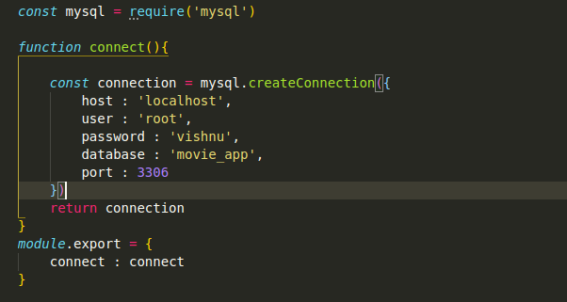

util.js

.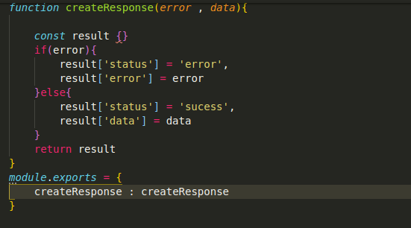

server.js:

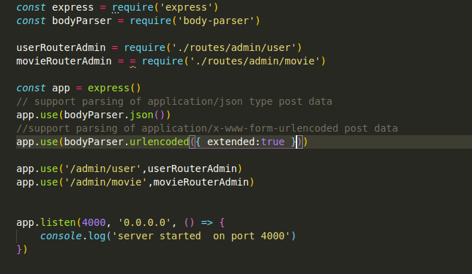

**body-parser extract the entire body portion of an incoming request stream and exposes it on req.body.**

The middleware was a part of Express.js earlier but now you have to install it separately.

This body-parser module parses the JSON, buffer, string and URL encoded data submitted using HTTP POST request. Install body-parser using NPM as shown below.

npm install body-parser –save

Simple explanation to this is http sends your form data in bits and pieces which are intended to get assembled as they reach their destination. So how would you extract your data.

But, why take this pain of every-time manually parsing your data for chunks and assembling it. Use something called “body-parser” which would do this for you.