Spring Assignment ( 10-07-2026)
Assignment 1: Online Food Delivery Application
Scenario
A food delivery company wants to manage different delivery partners using Spring Beans.
Requirements
- Create a DeliveryPartner class.
- Configure it as a Spring Bean using XML.
Create two partners:
- SwiggyPartner
- ZomatoPartner
Retrieve and display partner details using getBean().
Expected Output
Delivery Partner: Swiggy​
Delivery Partner: Zomato

Solution:
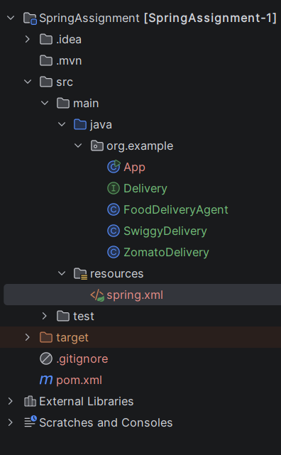
Project Structure:

pom.xml
<project xmlns="http://maven.apache.org/POM/4.0.0" xmlns:xsi="http://www.w3.org/2001/XMLSchema-instance"
xsi:schemaLocation="http://maven.apache.org/POM/4.0.0 http://maven.apache.org/xsd/maven-4.0.0.xsd">
<modelVersion>4.0.0</modelVersion>
<groupId>org.example</groupId>
<artifactId>SpringAssignment-1</artifactId>
<version>1.0-SNAPSHOT</version>
<packaging>jar</packaging>
<name>SpringAssignment</name>
<url>http://maven.apache.org</url>
<properties>
<project.build.sourceEncoding>UTF-8</project.build.sourceEncoding>
</properties>
<dependencies>
<dependency>
<groupId>junit</groupId>
<artifactId>junit</artifactId>
<version>3.8.1</version>
<scope>test</scope>
</dependency>
<dependency>
<groupId>org.springframework</groupId>
<artifactId>spring-context</artifactId>
<version>7.0.8</version>
<scope>compile</scope>
</dependency>
</dependencies>
</project>

spring.xml
<?xml version="1.0" encoding="UTF-8"?>
<beans xmlns="http://www.springframework.org/schema/beans"
xmlns:xsi="http://www.w3.org/2001/XMLSchema-instance"
xsi:schemaLocation="
http://www.springframework.org/schema/beans
http://www.springframework.org/schema/beans/spring-beans.xsd">
<bean id="swiggyDelivery" class="org.example.SwiggyDelivery"/>
<bean id="zomatoDelivery" class="org.example.ZomatoDelivery"/>
<bean id="foodDeliveryAgent" class="org.example.FoodDeliveryAgent">
<property name="foodDelivery" ref="zomatoDelivery"/>
<!-- <property name="foodDelivery" ref="zomatoDelivery"/> -->
</bean>
</beans>

Delivery.java (Interface)
package org.example;
public interface Delivery {
void deliveryPatner();
}

SwiggyDelivery.java
package org.example;
public class SwiggyDelivery implements Delivery{
public void deliveryPatner(){
System.out.println("Hi This Swiggy Panter");
}
}

ZomatoDelivery.java
package org.example;
public class ZomatoDelivery implements Delivery{
public void deliveryPatner(){
System.out.println("Hi this Zomato Delivery Panter");
}
}

FoodDeliveryAgent.java
package org.example;
import org.springframework.beans.factory.annotation.Autowired;
public class FoodDeliveryAgent{
private Delivery delivery;
public void setFoodDelivery(Delivery delivery){
this.delivery = delivery;
}
public void display(){
delivery.deliveryPatner();
}
}

MainApp.java
package org.example;
import org.springframework.context.ApplicationContext;
import org.springframework.context.support.ClassPathXmlApplicationContext;
public class MainApp
{
public static void main( String[] args )
{
FoodDeliveryAgent fdp = SpringConfig().getBean("foodDeliveryAgent", FoodDeliveryAgent.class);
fdp.display();
}
public static ApplicationContext SpringConfig(){
return new ClassPathXmlApplicationContext("spring.xml");
}
}

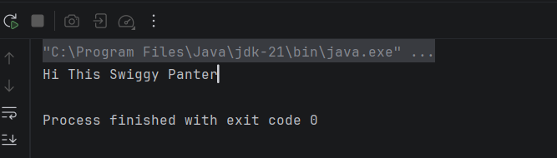
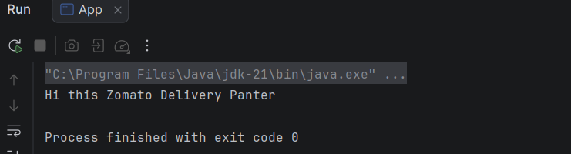
Output:

Assignment 2: E-Commerce Product Service
Scenario
An e-commerce company wants to inject product details using Setter Injection.
Requirements
Create Product class.
Fields:
- productId
- productName
- price
Inject values using Setter Injection in XML.
Display product details.

Sample Output
Product ID : 101​
Product Name : Laptop​
Price : 55000

Solution:

Project Structure

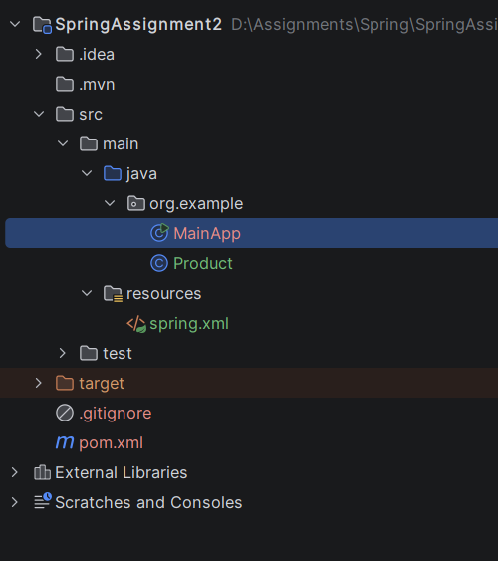

pom.xml
<project xmlns="http://maven.apache.org/POM/4.0.0" xmlns:xsi="http://www.w3.org/2001/XMLSchema-instance"
xsi:schemaLocation="http://maven.apache.org/POM/4.0.0 http://maven.apache.org/xsd/maven-4.0.0.xsd">
<modelVersion>4.0.0</modelVersion>
<groupId>org.example</groupId>
<artifactId>SpringAssignment2</artifactId>
<version>1.0-SNAPSHOT</version>
<packaging>jar</packaging>
<name>SpringAssignment2</name>
<url>http://maven.apache.org</url>
<properties>
<project.build.sourceEncoding>UTF-8</project.build.sourceEncoding>
</properties>
<dependencies>
<dependency>
<groupId>junit</groupId>
<artifactId>junit</artifactId>
<version>3.8.1</version>
<scope>test</scope>
</dependency>
<dependency>
<groupId>org.springframework</groupId>
<artifactId>spring-context</artifactId>
<version>7.0.8</version>
<scope>compile</scope>
</dependency>
</dependencies>
</project>

spring.xml

<?xml version="1.0" encoding="UTF-8"?>
<beans xmlns="http://www.springframework.org/schema/beans"
xmlns:xsi="http://www.w3.org/2001/XMLSchema-instance"
xsi:schemaLocation="
http://www.springframework.org/schema/beans
http://www.springframework.org/schema/beans/spring-beans.xsd">
<bean id="product" class="org.example.Product">
<property name="productId" value="101"/>
<property name="productName" value="Keyboard"/>
<property name="price" value="1500"/>
</bean>
</beans>

Product.java
package org.example;
public class Product {
private int productId;
private String productName;
private long price;
public void setProductId(int productId){this.productId = productId;}
public int getProductId(){return productId;}
public void setProductName(String productName){this.productName = productName;}
public String getProductName(){return productName;}
public void setPrice(long price){this.price = price;}
public long getPrice(){return price;}
@Override
public String toString(){return productId +" " + productName + " " + price;}
}

MainApp.java
package org.example;
import org.springframework.context.ApplicationContext;
import org.springframework.context.support.ClassPathXmlApplicationContext;
public class MainApp {
public static void main(String[] args) {
ApplicationContext context = new ClassPathXmlApplicationContext("spring.xml");
Product prod = context.getBean("product", Product.class);
System.out.println("Product Id: " + prod.getProductId() +
"\nProduct Name: " + prod.getProductName() +
"\nPrice: " + prod.getPrice());
}
}

Output:
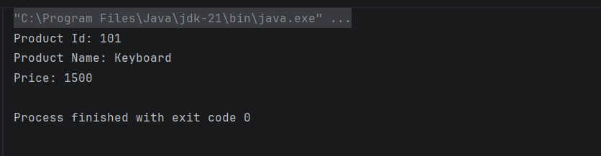
Assignment 3: Banking System Using Constructor Injection

Scenario
A bank wants to create account objects using Constructor Injection.
Requirements
Create Account class.
Fields:
accountNumber
customerName
balance
Inject values using Constructor Injection.
Display account information.

Sample Output
Account Number: 1001​
Customer Name: John​
Balance: 50000

Solution:

Project Structure:

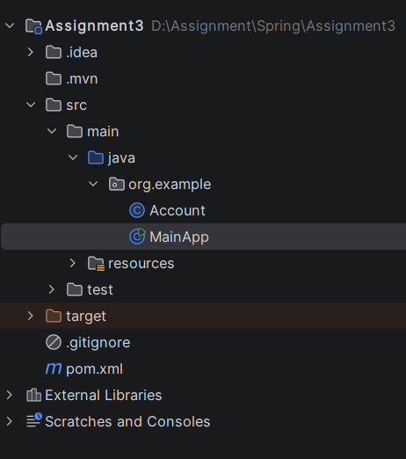

pom.xml

<project xmlns="http://maven.apache.org/POM/4.0.0" xmlns:xsi="http://www.w3.org/2001/XMLSchema-instance"
xsi:schemaLocation="http://maven.apache.org/POM/4.0.0 http://maven.apache.org/xsd/maven-4.0.0.xsd">
<modelVersion>4.0.0</modelVersion>
<groupId>org.example</groupId>
<artifactId>Assignment3</artifactId>
<version>1.0-SNAPSHOT</version>
<packaging>jar</packaging>
<name>Assignment3</name>
<url>http://maven.apache.org</url>
<properties>
<project.build.sourceEncoding>UTF-8</project.build.sourceEncoding>
</properties>
<dependencies>
<dependency>
<groupId>junit</groupId>
<artifactId>junit</artifactId>
<version>3.8.1</version>
<scope>test</scope>
</dependency>
<dependency>
<groupId>org.springframework</groupId>
<artifactId>spring-context</artifactId>
<version>7.0.8</version>
<scope>compile</scope>
</dependency>
</dependencies>
</project>

spring.xml

<?xml version="1.0" encoding="UTF-8"?>
<beans xmlns="http://www.springframework.org/schema/beans"
xmlns:xsi="http://www.w3.org/2001/XMLSchema-instance"
xsi:schemaLocation="
http://www.springframework.org/schema/beans
http://www.springframework.org/schema/beans/spring-beans.xsd">
<bean id="account" class="org.example.Account">
<constructor-arg index="0" value="2345023430"/>
<constructor-arg name="customerName" value="Vishnu"/>
<constructor-arg type="double" value="700023"/>
</bean>
</beans>

Account.java

package org.example;
public class Account {
private long accountNumber;
private String customerName;
private double balance;
public Account(){}
public Account(long accountNumber, String customerName, double balance){
this.accountNumber = accountNumber;
this.customerName = customerName;
this.balance = balance;
}
public long getAccountNumber() {
return accountNumber;
}
public String getCustomerName() {
return customerName;
}
public double getBalance() {
return balance;
}
}

MainApp.java

package org.example;
import org.springframework.context.ApplicationContext;
import org.springframework.context.support.ClassPathXmlApplicationContext;
public class MainApp
{
public static void main( String[] args )
{
ApplicationContext context = new ClassPathXmlApplicationContext("spring.xml");
Account ac = context.getBean("account", Account.class);
System.out.println("Account Number :"+ ac.getAccountNumber()+
"\nCustomer Name :" + ac.getCustomerName()+
"\nBalance: " + ac.getBalance());
}
}

Output:

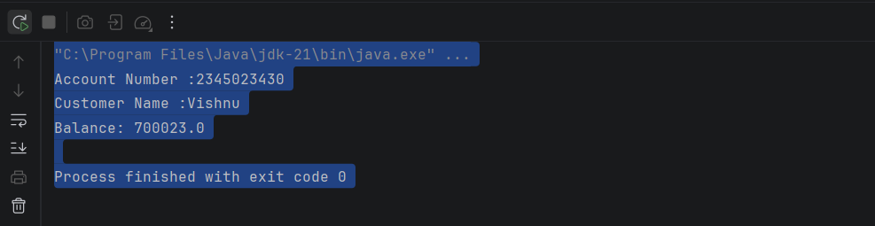

Assignment 4: Vehicle Management Using Java Configuration
Scenario
A transport company wants to configure vehicles using Java-based configuration.
Requirements
Create interface Vehicle.
Create implementations:
Car
Bike
Configure beans using @Configuration and @Bean.
Use @Primary to make Car the default bean.
Display vehicle information.
Sample Output
Vehicle Type : Car​
Engine Started

Solution:

Project Structue

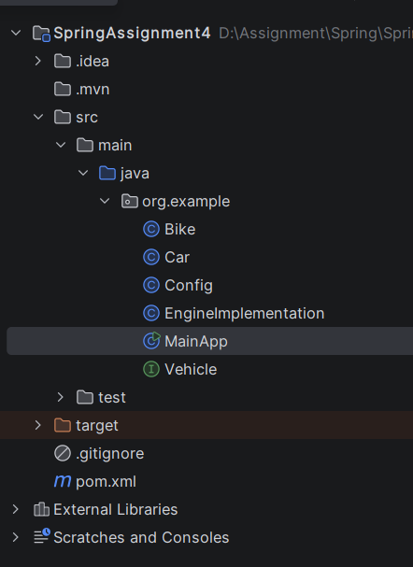

pom.xml

<project xmlns="http://maven.apache.org/POM/4.0.0" xmlns:xsi="http://www.w3.org/2001/XMLSchema-instance"
xsi:schemaLocation="http://maven.apache.org/POM/4.0.0 http://maven.apache.org/xsd/maven-4.0.0.xsd">
<modelVersion>4.0.0</modelVersion>
<groupId>org.example</groupId>
<artifactId>SpringAssignment4</artifactId>
<version>1.0-SNAPSHOT</version>
<packaging>jar</packaging>
<name>SpringAssignment4</name>
<url>http://maven.apache.org</url>
<properties>
<project.build.sourceEncoding>UTF-8</project.build.sourceEncoding>
</properties>
<dependencies>
<dependency>
<groupId>junit</groupId>
<artifactId>junit</artifactId>
<version>3.8.1</version>
<scope>test</scope>
</dependency>
<dependency>
<groupId>org.springframework</groupId>
<artifactId>spring-context</artifactId>
<version>7.0.8</version>
<scope>compile</scope>
</dependency>
</dependencies>
</project>

Config.java

package org.example;
import org.springframework.context.annotation.Bean;
import org.springframework.context.annotation.Configuration;
import org.springframework.context.annotation.Primary;
@Configuration
public class Config {
@Bean
public Bike bike(){
return new Bike();
}
@Bean
@Primary
public Car car(){
return new Car();
}
@Bean(name="engine")
public EngineImplementation engine(){
return new EngineImplementation();
}
}

Vehicle.java (Interface)

package org.example;
public interface Vehicle {
String useVehicle();
}

Bike.java
package org.example;
public class Bike implements Vehicle{
public String useVehicle(){
return "Bike";
}
}

Car.java
package org.example;
public class Car implements Vehicle{
public String useVehicle(){
return "Car";
}
}

EngineImplementation.java

package org.example;
import org.springframework.beans.factory.annotation.Autowired;
public class EngineImplementation {
@Autowired
private Vehicle vehicle;
public void startEngine(){
System.out.println("Vehicle Type: "+vehicle.useVehicle());
System.out.println("Engine Started");
}
}

MainApp.java
package org.example;
import org.springframework.context.ApplicationContext;
import org.springframework.context.annotation.AnnotationConfigApplicationContext;
public class MainApp
{
public static void main( String[] args )
{
ApplicationContext context = new AnnotationConfigApplicationContext(Config.class);
EngineImplementation engine = context.getBean("engine",EngineImplementation.class);
engine.startEngine();
}
}

Output:

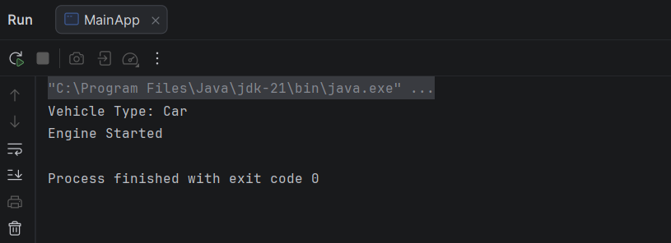

Assignment 5: Employee Management Using Spring Boot

Scenario
An organization wants to manage employee information using Spring Boot and Dependency
Injection.
Requirements
Create:
EmployeeService
EmployeeRepository
Use:
@Component
@Autowired
@Value
Inject employee details from application.properties.
Display employee information on application startup.
Sample Output
Employee ID : 101​
Employee Name : Dharshan​
Department : IT

Additional Challenge
- Use @Qualifier with multiple repository implementations.
- Make one repository @Primary.
- Configure one bean with @Lazy.
- Demonstrate Singleton and Prototype scopes.

Solution:

Project Structue

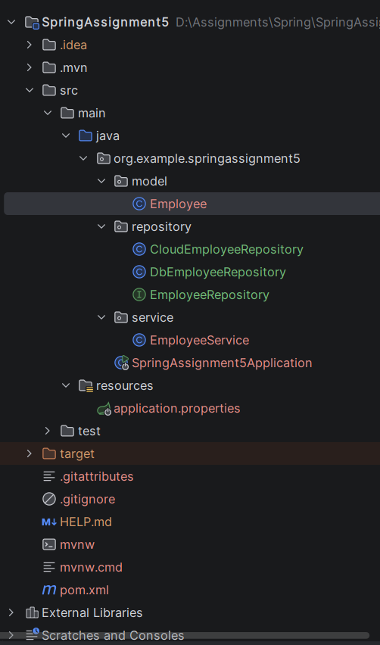
pom.xml
<?xml version="1.0" encoding="UTF-8"?>
<project xmlns="http://maven.apache.org/POM/4.0.0" xmlns:xsi="http://www.w3.org/2001/XMLSchema-instance"
xsi:schemaLocation="http://maven.apache.org/POM/4.0.0 https://maven.apache.org/xsd/maven-4.0.0.xsd">
<modelVersion>4.0.0</modelVersion>
<parent>
<groupId>org.springframework.boot</groupId>
<artifactId>spring-boot-starter-parent</artifactId>
<version>4.1.0</version>
<relativePath/> <!-- lookup parent from repository -->
</parent>
<groupId>org.example</groupId>
<artifactId>SpringAssignment5</artifactId>
<version>0.0.1-SNAPSHOT</version>
<name>SpringAssignment5</name>
<description>SpringAssignment5</description>
<url/>
<licenses>
<license/>
</licenses>
<developers>
<developer/>
</developers>
<scm>
<connection/>
<developerConnection/>
<tag/>
<url/>
</scm>
<properties>
<java.version>21</java.version>
</properties>
<dependencies>
<dependency>
<groupId>org.springframework.boot</groupId>
<artifactId>spring-boot-starter</artifactId>
</dependency>
<dependency>
<groupId>org.springframework.boot</groupId>
<artifactId>spring-boot-starter-test</artifactId>
<scope>test</scope>
</dependency>
</dependencies>
<build>
<plugins>
<plugin>
<groupId>org.springframework.boot</groupId>
<artifactId>spring-boot-maven-plugin</artifactId>
</plugin>
</plugins>
</build>
</project>
application.properties
spring.application.name=SpringAssignment5
employee.id=1
employee.name=Vishnu
employee.dept= Tindivanam

model/Employee.java
package org.example.springassignment5.model;
import org.springframework.stereotype.Component;
import org.springframework.boot.context.properties.ConfigurationProperties;
@Component
@ConfigurationProperties(prefix = "app.employee")
public class Employee {
private int id;
private String name;
private String dept;
public Employee(){}
public Employee(int id, String name, String dept) {
this.id = id;
this.name = name;
this.dept = dept;
}
public int getId() {
return id;
}
public void setId(int id) {
this.id = id;
}
public String getName() {
return name;
}
public void setName(String name) {
this.name = name;
}
public String getDept() {
return dept;
}
public void setDept(String dept) {
this.dept = dept;
}
public String toString(){
return id + " " + name + " " + dept;
}
}

repository/EmployeeRepository.java (Interface)
package org.example.springassignment5.repository;
public interface EmployeeRepository {
String getRepository();
}

repository/DbEmployeeRepository.java
package org.example.springassignment5.repository;
import org.springframework.context.annotation.Lazy;
import org.springframework.context.annotation.Primary;
import org.springframework.stereotype.Component;
@Component
@Primary
@Lazy
public class DbEmployeeRepository implements EmployeeRepository{
@Override
public String getRepository(){
return "Database Storage";
}
}

repository/CloudEmployeeRepository.java
package org.example.springassignment5.repository;
import org.springframework.beans.factory.annotation.Qualifier;
import org.springframework.stereotype.Component;
@Component("cloudRepo")
@Qualifier("cloudRepository")
public class CloudEmployeeRepository implements EmployeeRepository{
@Override
public String getRepository(){
return "Cloud Storage";
}
}

service/EmployeeService.java
package org.example.springassignment5.service;
import org.example.springassignment5.repository.CloudEmployeeRepository;
import org.example.springassignment5.repository.DbEmployeeRepository;
import org.example.springassignment5.model.Employee;
import org.example.springassignment5.repository.EmployeeRepository;
import org.springframework.beans.factory.annotation.Qualifier;
import org.springframework.stereotype.Component;
import org.springframework.beans.factory.annotation.Value;
import org.springframework.context.annotation.Scope;
import org.springframework.beans.factory.annotation.Autowired;
import java.util.List;
@Component
//@Scope("prototype")
@Scope("singleton")
public class EmployeeService {
@Value("${employee.id}")
private int empId;
@Value("${employee.name}")
private String empName;
@Value("${employee.dept}")
private String empDept;
@Autowired
// @Qualifier("cloudRepository")
private EmployeeRepository empRepo;
public void getEmpDetails(){
System.out.println("Employee ID: "+ empId+
"\nEmployee Name: "+ empName+
"\nDepartment: "+ empDept);
System.out.println("Primary Repo:"+empRepo.getRepository());
}
}

SpringAssignment5Application
package org.example.springassignment5;
import org.springframework.boot.SpringApplication;
import org.springframework.boot.autoconfigure.SpringBootApplication;
import org.example.springassignment5.service.EmployeeService;
import org.springframework.context.ApplicationContext;
@SpringBootApplication
public class SpringAssignment5Application {
public static void main(String[] args) {
ApplicationContext context = SpringApplication.run(SpringAssignment5Application.class, args);
EmployeeService empServ= context.getBean("employeeService", EmployeeService.class);
EmployeeService empServ1= context.getBean("employeeService", EmployeeService.class);
empServ.getEmpDetails();
System.out.println("Scope Verification Sigleton :"+ (empServ == empServ1));
System.out.println("Scope Verification Prototype :"+ (empServ != empServ1));
}
}
Output:
