Work Acceptance Letter

From:

To: Altos Technologies,

Thapasya Infopark Phase I, Ground Floor,

Infopark Campus, Kakkanad, Kochi, Kerala 682042

Work List:

Employee Name : Shebin Shaji

Work :DM Core table design

Start Date: 29/09/23 End Date:29/09/23

Sir,

I do accept the above mentioned work and I will submit that on or before

deadline without any corrections and errors. In future if any error occurs in my work, it’s my responsibility to solve that. I do here by solemnly affirm and declare that all information and particulars furnished here by me are true and correct to the best of my knowledge.

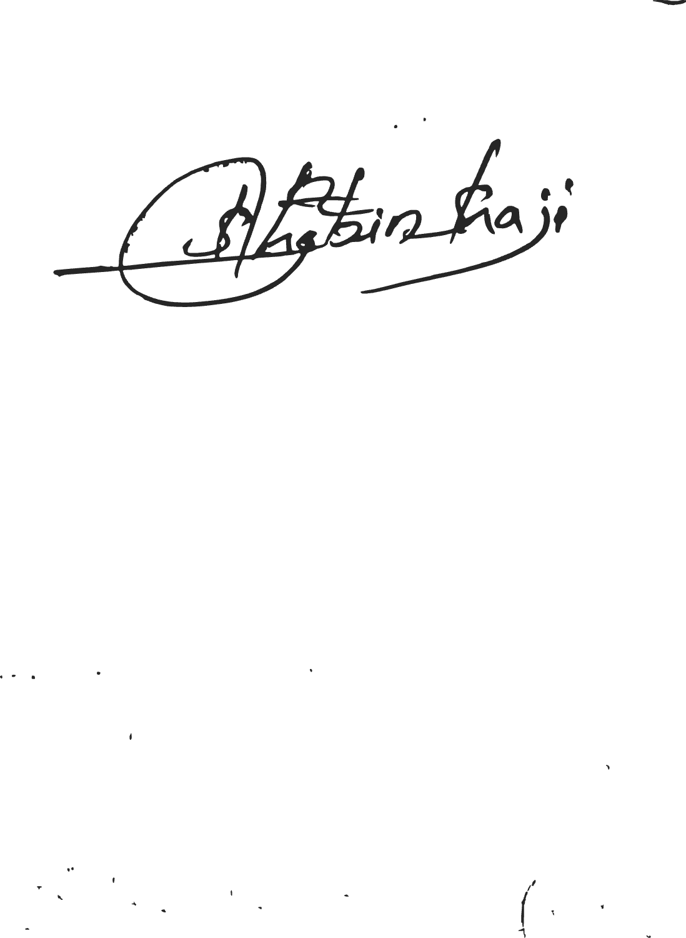Date:29/09/23Place: Pala

Yours Faithfully

Signature