Centene Forecasting Portal
Standard Planning Workflow

End-to-End Process Guide · Delivery Analytics Team · May 2026

1. Process Flowchart
The flowchart below illustrates the complete end-to-end planning cycle in the Centene Forecasting Portal. Follow the steps in sequence, observing the two branch points: an allocation failure (which requires escalation) and the configuration review loop (triggered whenever new lines of business are detected in the report).
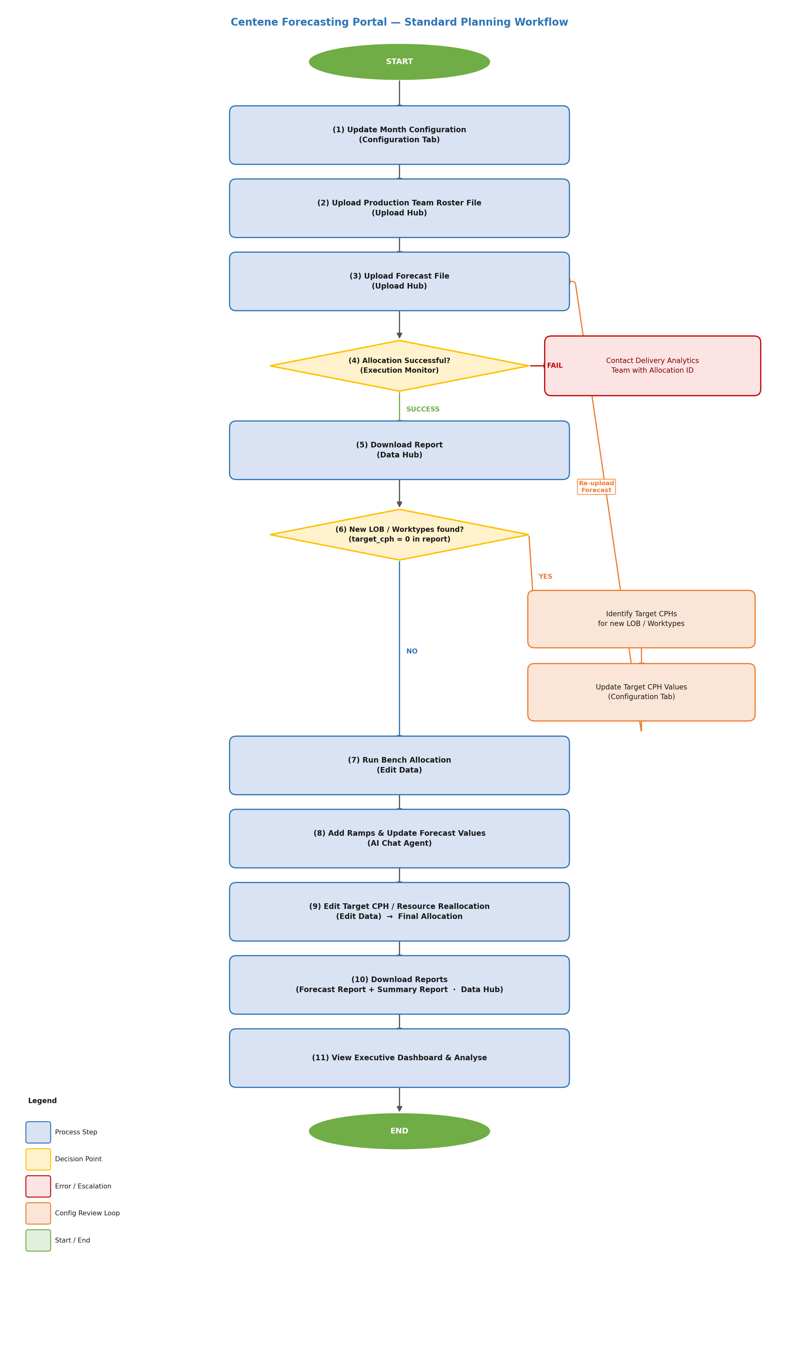

2. Step-by-Step Reference
Use the table below as a quick reference during each planning cycle. The Navigation column shows where in the portal each action is performed.
Step | Action | Navigation
1 | Update Month Configuration  Set working days, occupancy, shrinkage, and work hours for each month. Do this before uploading any files. | Configuration → Month Config
2 | Upload Production Team Roster  Upload the latest production team roster CSV/XLSX. This establishes the available agent headcount for allocation. | Upload Hub → Roster Upload
3 | Upload Forecast File  Upload the client forecast file. This triggers the automatic allocation process in the background. | Upload Hub → Forecast Upload
4 | Check Allocation Status  Monitor the allocation run. Wait for status to reach SUCCESS or FAILED. Each run has a unique Allocation ID. | Execution Monitor → Dashboard
5 | Download & Review Report  Download the allocation output report. Review capacity figures and check for new LOBs or work types. | Data Hub → Download Report
6 | Identify New LOB / Work Types  In the report, locate rows where target_cph = 0. These represent new lines of business requiring CPH values. | Data Hub → Report review
7 | Update Target CPH Values  Add or update CPH targets for newly identified LOBs and work types, then re-upload the forecast file (repeat Steps 3–6). | Configuration → Target CPH
8 | Run Bench Allocation  Allocate unassigned (bench) agents proportionally across forecast rows using the Largest Remainder Method. | Edit Data → Bench Allocation
9 | Add Ramps & Update Forecasts  Use the AI Chat Agent to configure weekly ramp-up profiles for new cohorts and adjust forecast values as needed. | AI Chat Agent
10 | Finalize via Edit Data  Refine target CPH values or perform manual resource reallocation to generate the final, reviewed allocation. | Edit Data → Target CPH / Reallocation
11 | Download Final Reports  Export the Forecast Report and Summary Report once the data is validated and approved. | Data Hub → Reports
12 | View Executive Dashboard  Review the Executive View dashboard for high-level KPIs, trends, and capacity summaries for stakeholder reporting. | Dashboard → Executive View

3. Key Decision Points

Allocation Failure
After uploading a forecast file, the system automatically runs the allocation algorithm. Monitor the result in the Execution Monitor dashboard.
- If the status shows FAILED or PARTIAL SUCCESS, do not proceed further.
- Note the Allocation ID displayed in the Execution Monitor.
- Share the Allocation ID with the Delivery Analytics team for root-cause investigation.
- Once the issue is resolved and the file is corrected, re-upload the forecast file to restart the allocation.

Configuration Review Loop (New LOBs or Work Types)
After downloading the allocation report, review it for rows where target_cph equals zero. A zero CPH indicates a line of business or work type that has not yet been configured in the system.
- Filter the downloaded report for target_cph = 0 to identify all missing configurations.
- Obtain the correct CPH values from the Delivery Analytics team or the client SLA documentation.
- Enter the CPH values in Configuration → Target CPH.
- Re-upload the same forecast file. The allocation will re-run automatically using the updated CPH values.
- Repeat this loop until the report contains no target_cph = 0 rows before proceeding to bench allocation.

4. Important Notes
Allocation Failure
If the allocation run fails, note the Allocation ID shown in Execution Monitor and share it with the Delivery Analytics team for investigation.
Config Review Loop
Steps 6–7 form a review loop. Repeat the forecast upload (Step 3) after updating CPH values until the report shows no target_cph = 0 rows.
Idempotent Uploads
Re-uploading the same forecast file with updated configurations is safe. Each upload creates a new allocation execution record.
Ramp Naming
Give each ramp a descriptive name (e.g. 'Q2 Onboarding') so it can be identified and updated without confusion later.

