**Element:** Welcome Message



**Web Service:**

Welcome Message Service (/ws/member/welcomeMessage.json)

**Element:**

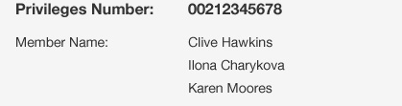

**WebService:**

**MyAccount**

Privileges Number – memberNumber

Member Name - Owner_names – firstName lastName

**Element**: News

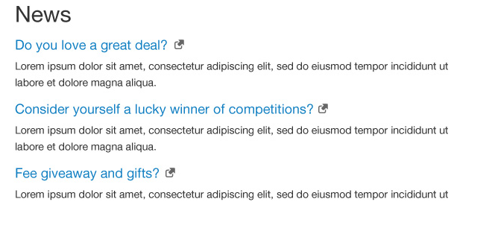

**WebService:**

MyAccount

push_notifications

**Element:** Membership Numbers

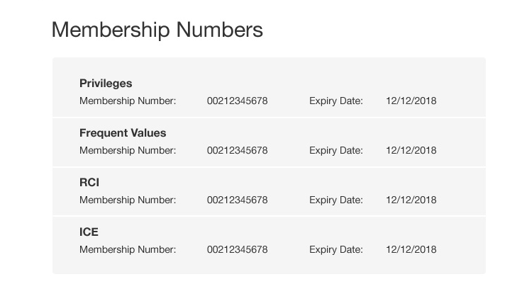

**Webservice:**

MyAccount

Membership –name (Eg. Privileges)

Membership – number (Eg. 00202345678)

**Note:** It looks like some membership numbers have an expiry (E.g. Privileges) while others do not (Eg. RCI, ICE).

Are you able to have the screen show the ‘Expiry Date:’ field if a value is passed and hide this if is missing.

This should cater for if they decide to put expiry dates on numbers in the future.

**Element:** Contact Details

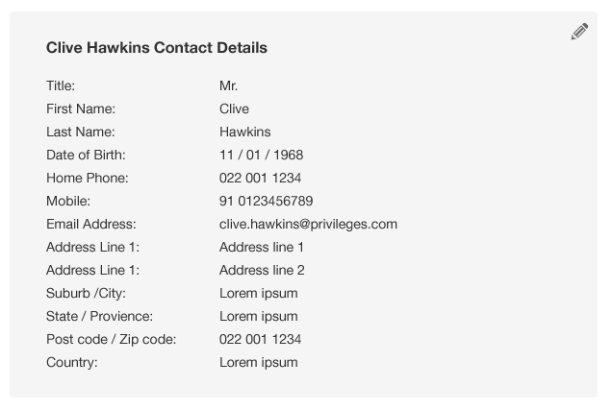

MyAccount

All details should be easily mapped to this.

**Note:** It’s not on the current Prototype, but the business area asked if they could include Privilege Number at the top.

This also needed to be updated to cater / show that there are multiple member names.

**Element:** My Orders

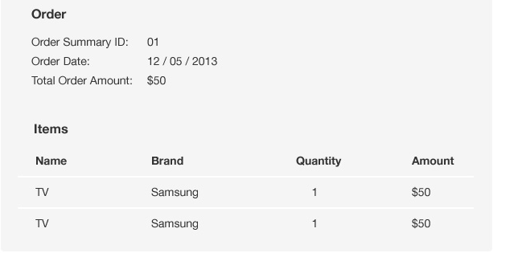

**Webservice:**

Order History Service (/ws/order/getOrderHistory.json)

**Note:**

Order Summary ID – summaryID

Order Date – date

Total Order Amount – total

For the items themselves

Name – name

Brand – brand

Quantity – quantity

Amount – amount