**TN MARGINAL WORKERS**

**Development part 1:**

**Introduction:**

**we will focus on improving project outcomes by emphasizing the best approaches for loading and processing datasets related to marginal workers in Tamil Nadu. Our aim is to understand the specific challenges involved in working with this type of data and to develop effective solutions to address them. By delving into the intricacies of handling marginal worker datasets, we can ensure the reliability and quality of the data. This, in turn, will enable us to make more informed decisions and ultimately enhance the overall success of the projects we undertake in Tamil Nadu.**

**Defining of Marginal Worker Datasets:**

**Marginal worker datasets encompass information about individuals engaged in employment for less than six months annually. These datasets often lack comprehensive information and demand meticulous preprocessing to guarantee data accuracy. This data type presents unique challenges due to its incompleteness and requires careful handling to derive meaningful insights.**

**In this section, we delve into the intricacies of working with marginal worker data, addressing the challenges and proposing effective solutions. We focus on the preprocessing phase, a critical step in transforming raw data into a usable and informative format. Specifically, we explore essential practices for preprocessing marginal worker data, including techniques such as data normalization to bring data to a common scale, outlier detection to identify and handle anomalous data points, and feature selection to determine the most relevant and impactful variables for analysis. By employing these best practices, we aim to ensure the reliability and accuracy of the insights derived from marginal worker datasets, facilitating informed decision-making and comprehensive analysis within this specific context..**

**Best Practices for Loading Marginal Worker:**

**Datasets Best Practices for Loading Marginal Worker Datasets Loading marginal worker datasets Requires careful attention to detail. In This section, we’ll explore best Practices for loading and cleaning Marginal worker data, including Verifying data sources, identifying Missing data, and performing quality Checks.**

**Analyzing marginal worker datasets:**

**Analyzing marginal worker datasets requires Specialized techniques to account for missing And incomplete data. In this section, we’ll explore Best practices for analyzing marginal worker Data, including imputation, regression analysis,And machine learning techniques.**

**import pandas as pd**

**import matplotlib.pyplot as plt**

**import seaborn as sns**

**data = pd.read_csv("C:/Users/STUDENT/Downloads/DDW_B06SC_3300_State_TAMIL_NADU-2011 (1).csv")**

**data.dropna(inplace=True)**

**plt.figure(figsize=(20, 10))**

**sns.histplot(data['Age group'], bins=20, kde=True)**

**plt.title("Age Distribution of Marginal Workers in Tamil Nadu")**

**plt.xlabel("Age Group")**

**plt.ylabel("Count")**

**plt.xticks(rotation=45)**

**plt.show()**

**# Gender Distribution**

**gender_counts = data[['Worked for 3 months or more but less than 6 months - Persons',**

**'Worked for 3 months or more but less than 6 months - Males',**

**'Worked for 3 months or more but less than 6 months - Females']].sum()**

**plt.figure(figsize=(6, 6))**

**plt.pie(gender_counts, labels=gender_counts.index, autopct='%1.1f%%', startangle=90)**

**plt.title("Gender Distribution of Marginal Workers in Tamil Nadu")**

**plt.show()**

**output :**

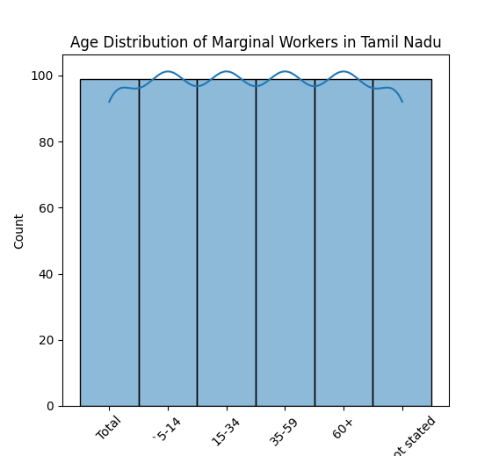

Tools used in this program:

* **NumPy:**

**A fundamental package for scientific computing with Python, which provides support for arrays, matrices, and mathematical functions.**

* **Pandas:**

**A fast, powerful, and flexible open-source data analysis and manipulation tool, built on top of NumPy.**

* **Matplotlib:**

**A widely-used plotting library that provides publication-quality 2D plotting as well as simple 3D plotting.**

* **Seaborn:**

**A statistical data visualization library that provides a high-level interface for drawing attractive and informative statistical graphics.**

* **SciPy:**

**A Python-based ecosystem of open-source software for mathematics, science, and engineering. It includes modules for optimization, linear algebra, integration, interpolation, special functions, and more.**

* **Scikit-learn:**

**A simple and efficient tool for data mining and data analysis, built on NumPy, SciPy, and Matplotlib. It is used for tasks such as classification, regression, and clustering.**

**Conclusion:**

**In conclusion, optimizing project success through best Practices for loading and preprocessing marginal worker Datasets in Tamil Nadu requires careful attention to detail and Specialized techniques. By following the best practices Outlined in this presentation, you can ensure the accuracy and Reliability of your data and improve project outcomes.**