**Scheme of Course Project**

**Name of the course :** Operating Systems And Computer Networks

**Year / Semester :** III- B.Tech I-semester

**Project Title :** Multi-Threading Application in C.

**Aim :** To create a chat Monitor with multiple connected clients in a network using using threads.(A Chat Room)

**Stages involved:**

**1.** Creating Sockets for Transmission of Messages.

**2.** Detailed Study About IPV4 and IPV6 Addresses.

**3.** Understanding the 7 Layers of TCP/ IP Protocol.

**4**. Involving Socket Programming Concepts like Bind(), Mutex,Connect(),Socket() etc...

**5.** Referring PO SIX-threads in C **.**

**Features:**

**1.** A Chat Server Monitoring Activities of Multiple Connected Clients.

**2.** Clients connected to the server can send messages to any of the Connected Users in the Specified Format.

**3.** A file To Store the Information of All the registered Users for every new Session.

**4.** A Console I/O Bases Application Which Creates a Chat Room for the devices connected through a Common Network.

Typical Time line of course project (after completion of theory portion of proposed project in the course):

For the above said project, this time line starts from 3rd week from start of the course.

|  |  |
| --- | --- |
| **Duration** | **Task to be given** |
| 3rd-4th weeks | Creating Sockets For Transmission of Messages : Here we create Sockets using IP- Address and Port-No for Transmission of Messages. |
| 5th -6th week | Detailed Study About IP Address: Here we understood Types of IP - Address Both IPv4 and IPV6. |
| 7th week | Seven Layer of TCP/IP Protocol: In this week we Understood the Role of 7 Layers of TCP/IP Model.  Reference:  **[http://beej.us/guide/bgnet/output/html/singlepage/bgnet.html#select](http://beej.us/guide/bgnet/output/html/singlepage/bgnet.html" \l "select)** |
| 8th week | Socket Programming: In this week we learned the concepts and libraries of Socket Programming like Pthread,bind(),send(),socket(),Mutex...etc  **[http://beej.us/guide/bgnet/output/html/singlepage/bgnet.html#select](http://beej.us/guide/bgnet/output/html/singlepage/bgnet.html" \l "select)** |
| 9th week | In this week we implemented the ChatServer by running both the Server.c and Client.c Programs. |

Overview

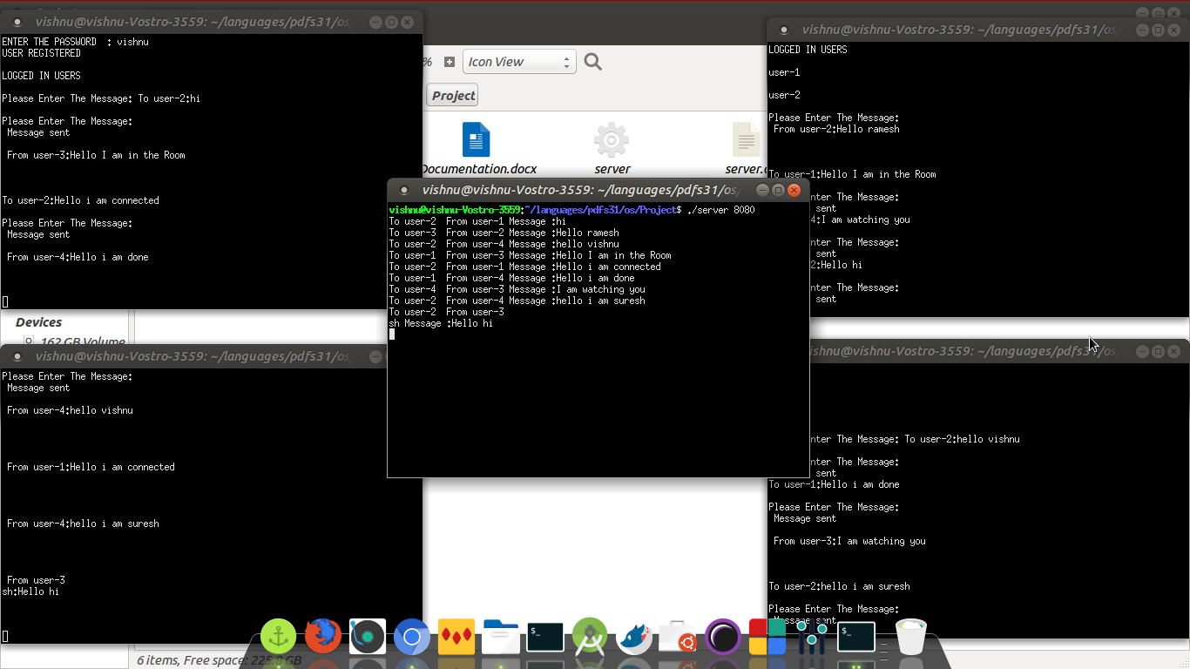

Team Members:

1.Challa Vishnu Vardhan Reddy - 15071A05J0

2.Varun Patlola - 15071A05L5

3.Swaroop Manchala - 15071A05K6

4.Rohit Gannu - 15071A05J7

5.Amgoth Rama Krishna - 15071A05I4.