Building a Content Strategy Agent That Learns From Its Content History
Author: JOGIPARTHI VISHNUCHETHANA
Every time we build an AI content system, we face the same basic limitation: the model can generate an answer, but it does not automatically understand everything that happened before that request. Previous content, editorial decisions, audience preferences, and changes in brand direction can disappear between interactions.
That led us to build ChronicleAI, a content strategy agent designed around persistent memory. Instead of treating every content request as an isolated prompt, ChronicleAI is designed to use information from previous interactions when planning future content.
The central idea is straightforward: if content strategy develops over time, the AI system helping with that strategy should also have a way to retain useful experience over time.
What ChronicleAI Does
ChronicleAI is designed as a content strategy agent rather than simply a text-generation interface.
A conventional workflow looks like this:
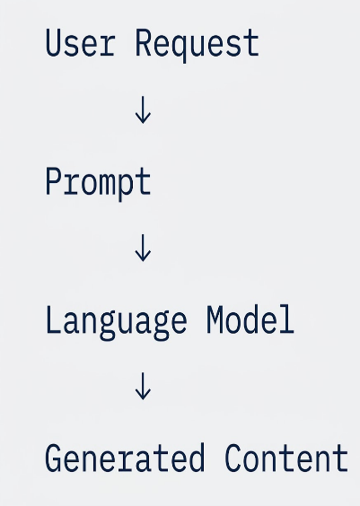
The model receives the current request and generates a response.
Our architecture adds persistent memory:
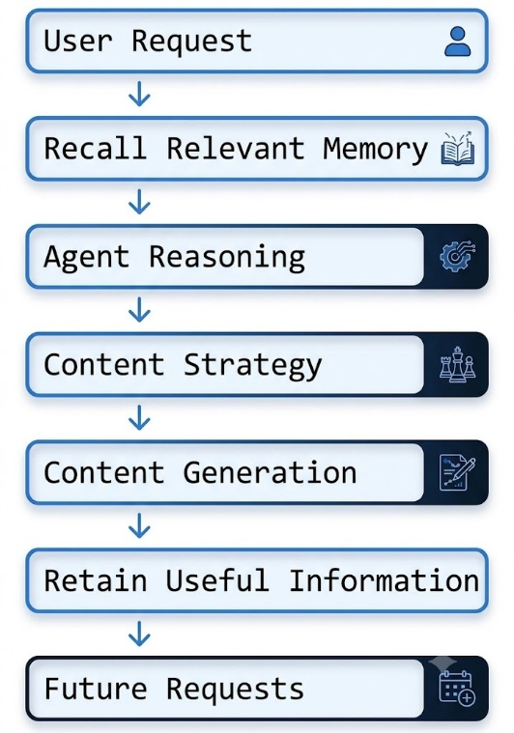
This creates a continuous memory loop.
Previous content and decisions can become useful context for later requests, while new interactions can contribute additional information to the memory system.
The technology we use for this persistent memory layer is Hindsight. Its role is not simply to store conversation transcripts. It provides the memory layer through which the agent can retain information and later recall relevant experiences and knowledge.
Why Ordinary RAG Was Not Enough
Our first architectural question was whether a conventional Retrieval-Augmented Generation approach would be sufficient.
RAG is useful when an application needs to retrieve relevant information from a collection of documents.
However, content strategy introduces another problem.
Information can change over time.
Consider two observations:
January:
"Our technical audience prefers concise code examples."

May:
"Our audience is responding better to detailed
architecture-focused content."
A basic semantic search system can retrieve both statements because they are related to technical content.
The language model then has to determine which information is more recent, which information represents a change in strategy, and whether the two statements actually conflict.
This is where persistent memory becomes more interesting than simple retrieval.
Instead of thinking only about:
"Which text looks similar to this query?"
we need to think about:
"What do we know, what happened before, and how has that knowledge changed?"
Hindsight provides the memory infrastructure for this type of workflow.
How the Memory Layer Fits Into the System
The architecture separates the content agent from the persistent memory layer.
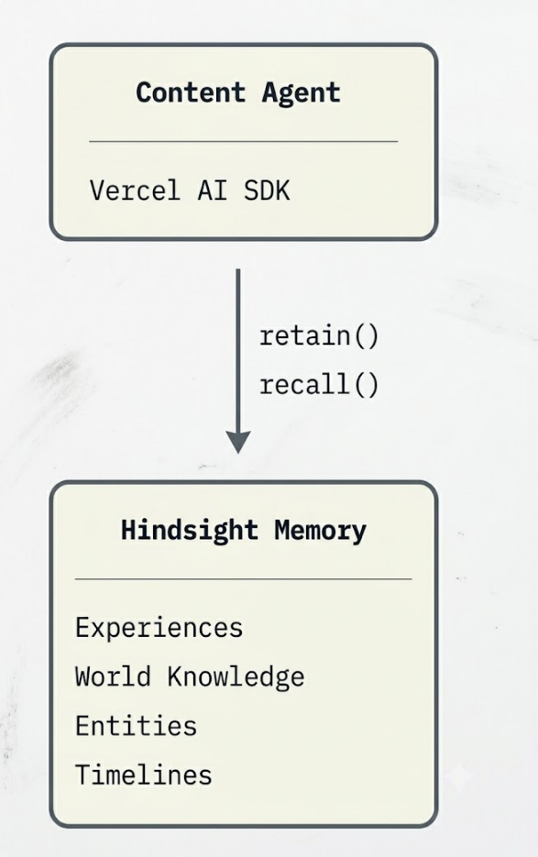
The agent interacts with Hindsight through its client and SDK.
The application uses a workspace-specific memory bank so that information belonging to one workspace can remain separated from another.
The relevant workspace is represented by:
workspaceId
and is used as the Hindsight:
bankId
This is important because memory becomes part of the application's state.
If different users or teams are using the same application, their memories should not accidentally become mixed together.
Initializing Hindsight in the Agent
The implementation supplied by our development team uses TypeScript together with the Vercel AI SDK and Hindsight SDK.
The Hindsight client is initialized using the configured API endpoint:
import { HindsightClient } from '@vectorize-io/hindsight-client';

const hindsightClient = new HindsightClient({
baseUrl: process.env.HINDSIGHT_API_URL!
});
The environment variable keeps the service configuration outside the application source code.
The application can then create Hindsight tools for the current workspace.
import { createHindsightTools } from '@vectorize-io/hindsight-ai-sdk';

const tools = createHindsightTools({
client: hindsightClient,
bankId: workspaceId,
recall: {
budget: 'high',
types: ['experience', 'world'],
includeEntities: true,
}
});
The important detail here is bankId.
Rather than using one global memory store, the application associates memory with the active workspace.
This gives the memory layer an explicit boundary.
Connecting Memory to the Language Model
The memory tools are then made available to the agent through the Vercel AI SDK.
The implementation currently uses the following pattern:
import { streamText } from 'ai';
import { openai } from '@ai-sdk/openai';

const result = await streamText({
model: openai('gpt-4o'),
tools,
messages,
});

return result.toDataStreamResponse();
This keeps the memory operations close to the agent workflow.
The language model can use the available tools rather than requiring the application to manually inject every previous conversation into the prompt.
Retaining New Knowledge
Recall is only one side of persistent memory.
The system also needs to retain useful information.
For example, after reviewing content performance, the application can store an observation:
await hindsightClient.retain({
bankId: workspaceId,
content:
"Technical deep-dives with architecture diagrams drove 3x higher engagement than listicles.",
context:
"Q2 Content Performance Retrospective",
timestamp:
new Date().toISOString(),
});
The specific performance statement above is an example supplied by the development team. Before publication, we will replace it with the actual measured result from our completed implementation:
The important architectural idea is the separation between an event and the memory that can be useful later.
For example, a performance review can become a memory that influences a future content decision.
From Content History to Content Gaps
Persistent memory becomes particularly useful when the system needs to understand what has already been covered.
Suppose a brand has published several articles about the same product feature.
A new request asks:
"Suggest our next technical topic."
Without historical context, the model can generate another generic idea.
With relevant memory, the agent can consider:
Previous Topics
↓
Repeated Themes
↓
Underrepresented Areas
↓
Potential Content Gap
↓
New Content Recommendation
This changes the agent's role.
It is no longer only producing text.
It is using historical information to help determine what should be produced next.
Brand Voice as Memory
Brand voice is another area where persistence matters.
A system prompt can define an initial style, but real editorial preferences often emerge through repeated decisions.
For example:
Brand Voice Rule
Once the final application has established these rules, they can become persistent memories.
A future content request can retrieve the relevant rules instead of relying entirely on the user to repeat them.
This is particularly useful when multiple content requests are handled over a longer period.
A Simple Before-and-After Example
The clearest way to demonstrate the difference is through two interactions.
Before Memory
The user asks:
"Create five technical content ideas for our engineering audience."
The agent generates suggestions based on the current request.
There is no historical context beyond what the user provides.
After Memory
The user asks the same type of question after ChronicleAI has accumulated relevant memories.
This before-and-after comparison is more meaningful than simply showing the number of memories stored.
The real question is whether memory changes the agent's behavior.
What We Learned
1. Memory is not the same as storage
A database containing old conversations does not automatically create a memory-enabled agent.
The useful part is the connection between stored information and future decisions.
2. Retrieval without context can be misleading
Finding text that is semantically similar is not always enough.
Content strategy involves changes over time, conflicting observations, and evolving preferences.
The memory layer therefore needs to support more than simple similarity matching.
3. Workspace isolation matters
We use the workspace identifier to associate memory with the correct Hindsight bank.
This provides a clear boundary between users or teams.
4. Memory should affect behavior
A memory system should be evaluated by what the agent does differently after remembering something.
If deleting the memory produces exactly the same result, that memory may not be contributing enough to the workflow.
5. Content strategy naturally benefits from historical context
A content plan is not created in isolation.
It is influenced by previous topics, previous decisions, audience reactions, and the evolving identity of the brand.
That makes persistent memory a natural architectural component.
The Memory Loop
The final ChronicleAI workflow can be summarized as:
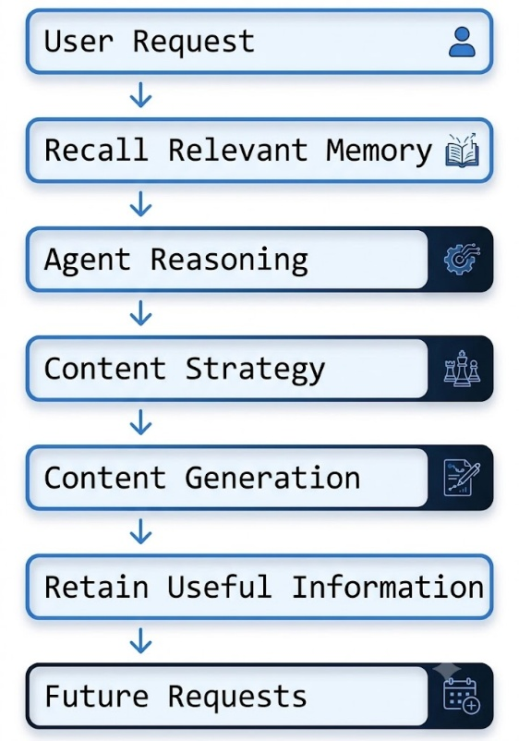
The loop is intentionally simple.
The agent looks at what it already knows, makes a new decision, receives new information, and retains useful knowledge for future interactions.
Conclusion
The most important lesson from building ChronicleAI is that persistent memory is not valuable simply because an AI system can store information.
It becomes valuable when the past changes what the system does next.
A content agent that forgets every previous decision can generate individual pieces of content.
A content agent with persistent memory can begin to understand the history behind those pieces.
With Hindsight, ChronicleAI is designed around that second approach.
The system can retain experiences, recall relevant information, consider previous content and brand decisions, and use that context when planning future work.
For developers interested in exploring the memory layer, the [Hindsight GitHub repository] and [Hindsight documentation] provide the technical starting points. Vectorize's explanation of [agent memory] is also useful for understanding the broader architecture.
The idea behind ChronicleAI is ultimately simple:
Don't just generate the next piece of content. Remember enough of the previous work to make the next decision more informed.

