Designing Persistent Memory for a Content Strategy Agent
Author: V CHERISHMA PRIYA
The most interesting engineering problem in a content AI system is not generating text. Modern language models already make that part relatively easy.
The harder problem is maintaining useful knowledge between requests.
If an agent recommends a content topic today, reviews its performance later, and receives new editorial feedback after that, all three events should be connected. Otherwise, every request starts from almost the same blank state.
While working on ChronicleAI, I focused on this problem from the architecture side: how should persistent memory fit into an AI agent, how should memories be isolated, how should information be retained and recalled, and how can the system use that memory without turning the application into a large collection of custom retrieval code?
Our approach uses Hindsight as the persistent memory layer and integrates it with a TypeScript-based agent workflow using the Vercel AI SDK.
The Architecture
At a high level, the system has three important layers:
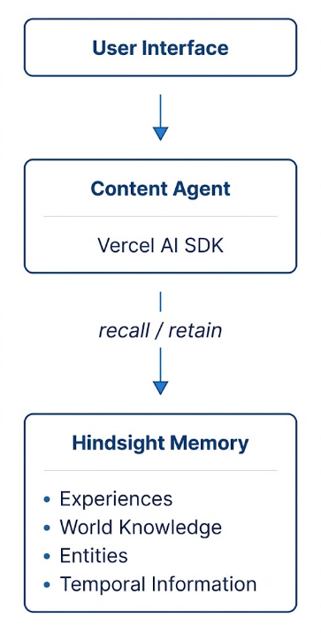
The separation is deliberate.
The content agent handles the interaction and reasoning flow.
Hindsight handles persistent memory.
This means the application does not have to treat every previous interaction as part of one enormous prompt.
Instead, relevant information can be recalled when it is needed.
Why We Chose a Dedicated Memory Layer
One tempting approach would have been to store every conversation in a conventional database and retrieve the most recent records.
That would solve storage.
It would not necessarily solve memory.
Content strategy contains several types of information:
Events
Preferences
Previous decisions
Performance observations
Relationships between entities
Changes over time
These pieces of information do not all behave like ordinary documents.
For example, a brand preference may remain valid for months.
A performance observation may apply only to a specific period.
A previous content topic may be relevant because it overlaps with a new request.
A strategic decision may replace an older assumption.
The memory layer therefore needs to support the relationship between information, not just the storage of information.
This is the reason Hindsight is central to our architecture.
The Memory Lifecycle
I think about the memory system as a lifecycle:
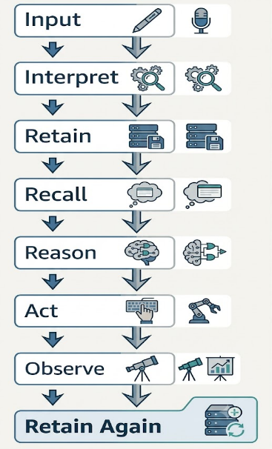
This creates a feedback loop.
For example, a user may provide a brand preference.
That information is retained.
Later, a content request arrives.
The agent recalls the preference.
The preference influences the generated content.
The user reviews the result and provides feedback.
That feedback can become another memory.
The next request can therefore use both the original preference and the newer feedback.
Workspace-Specific Memory
One of the architectural decisions I consider important is memory isolation.
ChronicleAI is intended to work with workspaces.
If Workspace A and Workspace B use the same content agent, their memories should not accidentally overlap.
The implementation associates the active workspace with a Hindsight memory bank:
const tools = createHindsightTools({
client: hindsightClient,
bankId: workspaceId,
recall: {
budget: 'high',
types: ['experience', 'world'],
includeEntities: true,
}
});
The critical value here is:
bankId: workspaceId
The memory store is therefore connected to the current workspace rather than treated as one global collection.
The final authentication and workspace-resolution implementation
This separation becomes particularly important as an application grows.
A memory system that mixes users can create incorrect recommendations even if the underlying language model is working perfectly.
Initializing the Hindsight Client
The application initializes the Hindsight client through its API endpoint:
import { HindsightClient } from '@vectorize-io/hindsight-client';

const hindsightClient = new HindsightClient({
baseUrl: process.env.HINDSIGHT_API_URL!
});
The API URL is supplied through an environment variable rather than being embedded directly in the source code.
That keeps environment-specific configuration outside the application logic.
Giving the Agent Memory Tools
The next step is connecting Hindsight to the agent.
The supplied implementation uses createHindsightTools():
import { createHindsightTools } from '@vectorize-io/hindsight-ai-sdk';

const tools = createHindsightTools({
client: hindsightClient,
bankId: workspaceId,
recall: {
budget: 'high',
types: ['experience', 'world'],
includeEntities: true,
}
});
There are several details worth noticing.
First, memory is connected to a specific workspace.
Second, recall has an explicit budget.
Third, the system requests specific memory types.
Fourth, entity information can be included in the recalled context.
This makes the memory operation part of the agent configuration instead of an unrelated backend service.
Token Budgets and Retrieval
One of the practical problems with memory retrieval is context size.
If the system returns everything that might be relevant, the language model receives too much information.
That can increase cost and make the context harder to reason about.
The implementation therefore uses a recall budget:
recall: {
budget: 'high',
types: ['experience', 'world'],
includeEntities: true,
}
The important architectural principle is that retrieval should be controlled.
A memory system should not simply maximize the number of retrieved records.
It should provide enough relevant context for the current decision.
Connecting Hindsight to the Agent
The recalled memory becomes available to the language model through the agent's tool workflow.
The implementation uses the Vercel AI SDK:
import { streamText } from 'ai';
import { openai } from '@ai-sdk/openai';

const result = await streamText({
model: openai('gpt-4o'),
tools,
messages,
});

return result.toDataStreamResponse();
This provides a clean separation.
The model handles the reasoning and generation.
The memory tools provide access to persistent knowledge.
If the completed implementation changes from the model shown in the current code, the final article should reflect the actual deployed configuration.
Retaining Information
Recall is only useful if the system has something meaningful to recall.
ChronicleAI therefore needs a retention step.
The current implementation demonstrates this with:
await hindsightClient.retain({
bankId: workspaceId,
content:
"Technical deep-dives with architecture diagrams drove 3x higher engagement than listicles.",
context:
"Q2 Content Performance Retrospective",
timestamp:
new Date().toISOString(),
});
The structure is more important than the example itself.
The retained memory contains:
Memory content
Context
Timestamp
Workspace
This gives future retrieval more information than a raw chat transcript.
Why Temporal Information Matters
Content strategy changes.
A preference that was correct several months ago may not remain correct forever.
Consider:
January:
Concise technical explanations performed well.

May:
Long-form architecture content became more effective.
A system that only searches for semantically similar information can retrieve both statements.
The agent then needs to understand that they occurred at different times and may represent an evolution in strategy.
This is one reason the memory architecture is more interesting than simply storing embeddings.
The system needs to reason about information as part of a timeline.
Memory and Content Gaps
Persistent memory also allows the agent to reason about missing areas.
Suppose the memory contains many previous topics:
Product announcements
Product announcements
Engineering updates
Product announcements
Customer stories
Engineering updates
A future request for content ideas can be evaluated against this history.
That information can then influence the content strategy.
The Difference Between a Memory Feature and a Memory Architecture
There is an important distinction between adding a memory button to an AI application and actually designing the application around memory.
A memory feature might allow a user to save information manually.
A memory architecture changes the application's workflow.
ChronicleAI is designed around the second idea.
The memory layer participates in:
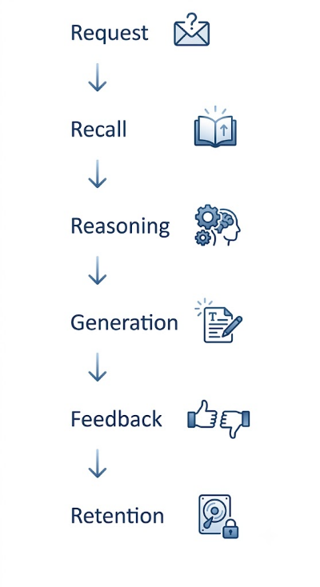
That makes memory part of the application's lifecycle.
Testing Memory Through Multiple Interactions
A single prompt is not enough to demonstrate a persistent memory system.
The useful test is a sequence.
This is the strongest type of test because it demonstrates behavior rather than simply showing that records exist in a database.
Engineering Lessons
1. Persistent memory needs clear boundaries
The bankId approach gives the application an explicit workspace boundary.
Memory should not be treated as a global bucket.
2. Retrieval needs constraints
Returning unlimited historical context is not a solution.
A recall budget gives the application a mechanism for controlling how much information is introduced into the agent workflow.
3. Memory and reasoning should remain separate
The memory system should provide useful context.
The agent should decide how that context affects the current task.
Keeping those responsibilities separate makes the architecture easier to understand and maintain.
4. Memory needs a lifecycle
The useful cycle is:
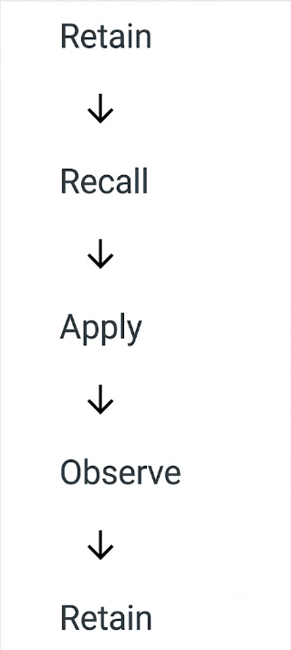
Without the final retention step, the agent never accumulates new knowledge.
5. Memory quality matters more than memory quantity
A large number of stored records does not automatically make an agent better.
The important question is whether the system can retrieve information that is relevant to the current decision.
The Final Architecture
The architecture can ultimately be represented as:
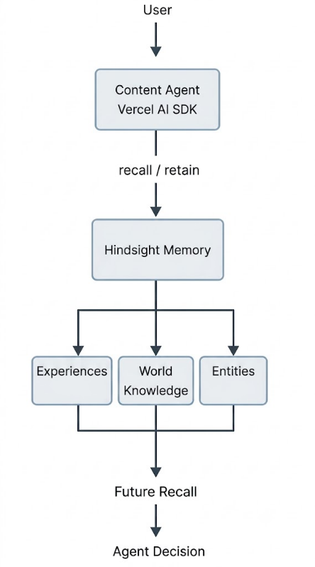
The completed system will additionally include:
Conclusion
The main architectural lesson from ChronicleAI is that persistent memory should not be treated as an add-on.
If an AI system is expected to participate in a workflow that develops over time, memory needs to be part of that workflow.
For our content strategy agent, the lifecycle is straightforward:
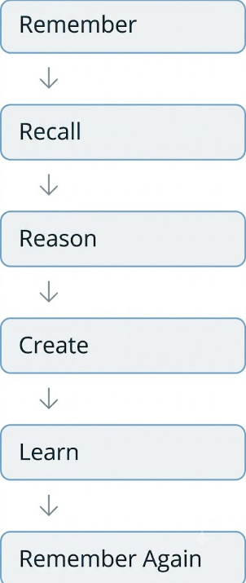
Hindsight provides the persistent memory layer that makes this possible.
The Vercel AI SDK connects the memory tools to the agent execution flow, while workspace-specific memory banks provide a boundary around each application's knowledge.
The most important thing I learned is that persistent memory is not about making an AI system remember everything.
It is about making the right information available when a future decision depends on it.
For developers interested in the implementation, the [Hindsight GitHub repository] and [Hindsight documentation] provide the technical reference, while Vectorize's explanation of [agent memory] gives useful context for understanding why persistent memory is becoming an important part of agent architecture.
ChronicleAI is ultimately built around one principle:
The quality of an agent's next decision can depend on what it remembers from its previous ones.

