**COVID_19 DATA ANALYSIS AND VISUALISATION**

# Importing Library Files

# import pandas as pd

# import numpy as np

# import matplotlib.pyplot as plt

# import seaborn as sns

# import plotly.express as px

# from plotly.subplots import make_subplots

# from datetime import datetime

# Reading Dataset

# covid_df=pd.read_csv("C:/Users/naren/Desktop/covid data/covid_19_india.csv")

# Dataset

covid_df.head(100).style.background_gradient(cmap = "cubehelix")

# Statistical data from Dataset

covid_df.describe().style.background_gradient(cmap = "cubehelix")

# Cleaning Dataset

covid_df.drop(["Sno","Time","ConfirmedIndianNational","ConfirmedForeignNational"], inplace = True,axis = 1)

covid_df.head(100).style.background_gradient(cmap = "cubehelix")

# Active Cases

covid_df['Active_cases'] = covid_df['Confirmed'] - (covid_df['Cured'] + covid_df['Deaths'])

covid_df.head(100).style.background_gradient(cmap = "cubehelix")

# Recovery and Mortality Rate

statewise = pd.pivot_table(covid_df, values= ["Confirmed","Deaths","Cured"],index = "State/UnionTerritory",aggfunc = max)

statewise["Recovery Rate"] = statewise["Cured"]*100/statewise["Confirmed"]

statewise = statewise.sort_values(by = "Confirmed", ascending = False)

statewise = statewise.sort_values(by = "Confirmed", ascending = False)

statewise.style.background_gradient(cmap = "cubehelix")

# Top 10 states with Active Cases

top_10_active_states=covid_df.groupby(by = 'State/UnionTerritory').max()[['Active_cases','Date']].sort_values(by=['Active_cases'], ascending = False).reset_index()

top_10_active_states.head(10).style.background_gradient(cmap = "cubehelix")

# Barplot for Top 10 states with Active Cases

fig = plt.figure(figsize=(16,9))

plt.title("Top 10 states with most active cases in India",size = 25)

ax = sns.barplot(data =top_10_active_states.iloc[:10], y= "Active_cases",x = "State/UnionTerritory")

plt.xlabel("States")

plt.ylabel("Total Active Cases")

plt. show()

# Piechart for Top 5 States of Active Cases

import matplotlib.pyplot as plt

%matplotlib inline

states=['Maharashtra','Karnataka','Kerala','Tamil Nadu','Uttar Pradesh']

active_cases=['701614','605515','445692','313048','310783']

colors=['c','b','r','y','g']

explode=[.08,.08,.08,.08,.08]

plt.pie(active_cases,labels=states,colors=colors,explode=explode,autopct='%2.1f%%')

plt.show()

# Boxplot for Top 10 States of Active Cases

sns.boxplot(top_10_active_states.head(10)['Active_cases'],top_10_active_states.head(10)['State/UnionTerritory']);

# Top 10 States With Highest Deaths

top_10_deaths=covid_df.groupby(by = 'State/UnionTerritory').max()[['Deaths','Date']].sort_values(by=['Deaths'],ascending = False).reset_index()

top_10_deaths.head(10).style.background_gradient(cmap = "cubehelix")

# Barplot for Top 10 States With Highest Deaths

fig = plt.figure(figsize=(18,5))

plt.title("Top 10 states with most Deaths",size=25)

ax = sns. barplot(data = top_10_deaths.iloc[:10],y="Deaths",x="State/UnionTerritory",linewidth=2)

plt.xlabel("States")

plt.ylabel("Total Death Cases")

plt.show()

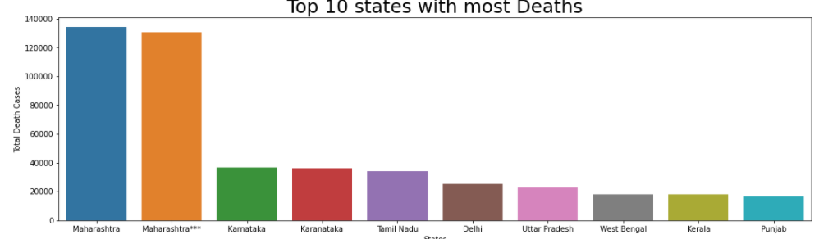

# Piechart for Top 5 States With Highest Deaths

import matplotlib.pyplot as plt

%matplotlib inline

states=['Karnataka','Tamil Nadu','Delhi','Uttar Pradesh','Maharashtra']

active_cases=['36848','34367','25068','22775','134201']

colors=['c','b','r','y','g']

explode=[.08,.08,.08,.08,.08]

plt.pie(active_cases,labels=states,colors=colors,explode=explode,autopct='%2.1f%%')

plt.show()

# Boxplot for Top 10 States with most Deaths[¶](http://localhost:8888/notebooks/Desktop/python%20project/Covid_19_India_Data%20Analysis.ipynb#Boxplot-for-Top-10-States-with-most-Deaths)

sns.boxplot(top_10_deaths.head(10)['Deaths'],top_10_deaths.head(10)['State/UnionTerritory']);

