Error Detection and Correction
Data Link Layer
The data link layer is responsible for node-to-node communication. Specific responsibilities of data link layer includes framing, addressing, flow control, error control, and media access control.
Error Detection and Correction
While transmitting data from source to destination, they can become corrupted. Many factors can alter one or more bits of a message. Some applications require a mechanism for detecting and correcting errors. There are different types of errors can occur
Types of Errors
Whenever bits flow from one point to another, they are subject to some changes. There are two types of errors, Single Bit Error and Burst Error.
Single Bit Error
The term single bit error means that only 1 bit of a given data unit is changed from 1 to 0 or from 0 to 1.
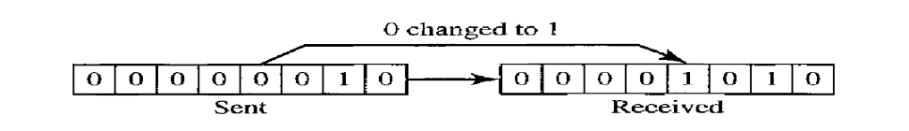
Single bit errors are the least likely type of error in serial data transmission.

Burst Error
The term burst error means that 2 or more bits in the data unit have changed from 1 to 0 or from 0 to 1.
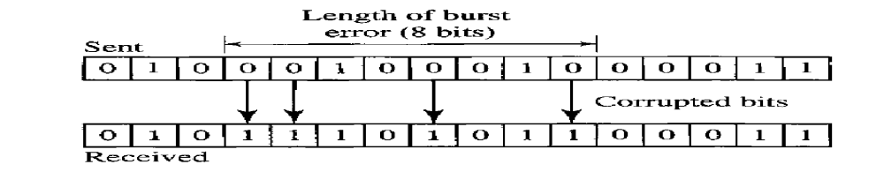
A burst error is more likely to occur than a single bit error.

Redundancy
The central concept of detection or correction of errors is redundancy. To be able to detect or correct errors we need to send extra bit with data. These redundant bits are added by the sender and removed by the receiver. Their presence allows the receiver to detect or correct corrupted bits.
Detection versus Correction
The correction of errors is more difficult than detection. In error detection, we are looking only to see if any error has occurred. We are not even interested in the number of errors. In error correction, we need to know the exact numbers of bits are corrupted and their location in the message. The number of errors and the size of the message are important factors.

Forward Error Correction versus Retransmission
There are two main methods for error correction, Forward Error Correction and Retransmission. Forward Error Correction is the process in which the receiver tries to guess the message by using redundant bits. Correction by retransmission is a technique in which the receiver detects the occurrence of an error and asks the sender to resend the message. Resending is repeated until a message arrives that the receiver believes is error-free.
Coding
Redundancy is achieved through various coding schemes. The sender adds redundant bits through a process that creates a relationship between the redundant bits and the actual data bits. We can divide the coding scheme into two categories; block coding and convolution coding.
Block Coding
In block coding, we divide our message into blocks, each of k bits, called datawords.
We add r redundant bits to each block to make the length n = k + r. The resulting n-bit blocks are called codewords. That means we have a set of datawords each of size k, and a set of codewords, each of size ‘n’. With k bits , we can create a combination of 2^{k} datawords. With n bits we can create a combination of 2^{n} codewords. Since n>k, the number of possible codewords is larger than the number of possible datawords. The block coding process is one-to-one the same dataword is always encoded as the same codewords. This means that we have 2^{n}- 2^{k} codewords that are not used, these are called invalid or illegal codewords.

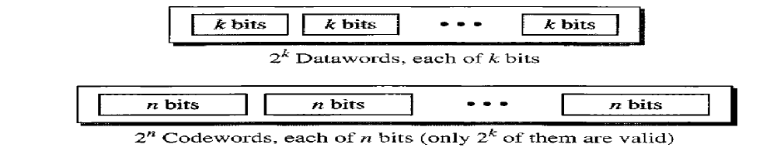

Error Detection
If the following conditions are met, the receiver can detect the error
- The receiver has a list of valid codewords
- The original codeword has changed to an invalid one

Process of error detection in block coding
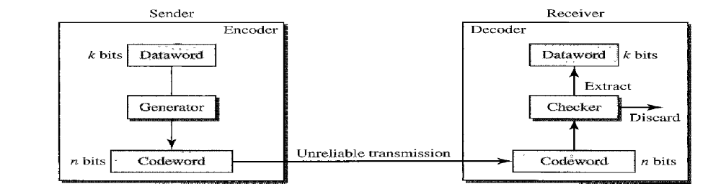

The sender creates codewords out of datawords by using a generator. Each codeword sent to the receiver may change during transmission. If the received codeword is the same as one of the valid codewords, the word is accepted. If the received codeword is not valid, it is discarded. If any mismatch occurs, an error happened during transmission.
Error Correction
Error correction is much more difficult than error detection. In error detection , the receiver needs to know only that the received codeword is invalid; in error correction the receiver needs to find or guess the original codeword sent. There are different methods used to correct the errors. Some of they are
Hamming Distance
It is the concept for error control. The hamming distance between two words of same size is the number of difference between the corresponding bits. We show the distance between two words x and y as d(x,y). The hamming distance can be found by applying XOR operation.
Example:
- The Hamming distance d(000, 011) is 2
- The Hamming distance d(10101, 11110) is 3

Minimum Hamming Distance
It is the smallest hamming distance between all possible pairs in the set of words. We use dmin to define minimum hamming distance.
Three Parameters
To mention the coding scheme we need to have at least three parameters the codeword size n, the dataword size k, and the minimum hamming distance dmin. The coding scheme C is written as C(n,k) with a separate expression for minimum hamming distance dmin.
Hamming Distance and Error
The hamming distance between the send and the received codeword is the number of bits that are corrupted during transmission. When a codeword is corrupted during transmission, the Hamming distance between the sent and received codewords is the number of bits affected by the error.
Error Correction
If the data is corrupted the receiver need to find the original signal by some appropriate method. An example is territory method , an exclusive area surrounding the codeword.

Linear Block Codes
Almost all block codes used today belong to a subset called linear block codes. A linear block code is a code in which the exclusive OR (addition modulo-2) of two valid codewords creates another valid codeword.
Minimum Distance for Linear Block Codes
It is simple to find the minimum Hamming Distance for a linear block code. The minimum Hamming Distance is the number of 1s in the nonzero valid codeword with the smallest number of 1s.

Some Linear Block Codes
1: Simple Parity –check code
The most familiar error detecting code is Simple Parity –check code. There are even parity check code and odd parity check code. In this code, a k-bit dataword is changed to an n-bit codeword where n=k+1. The extra bit called parity bit. In the case of even parity the total number of 1’s in the codeword will be even and in the case of odd parity the total number of 1’s will be an odd number. In both case the value of dmin will be 2.

For example assume that we use even parity mechanism, the encoder uses a generator that takes a copy of a 4-bit dataword(a0, a1, a2, a3) and generate a parity bit r0. The dataword and the parity bit crate the 5-bit codeword. The parity bit that is added makes the number of 1’s in the codeword is even.

Encoder and decoder for simple parity check code
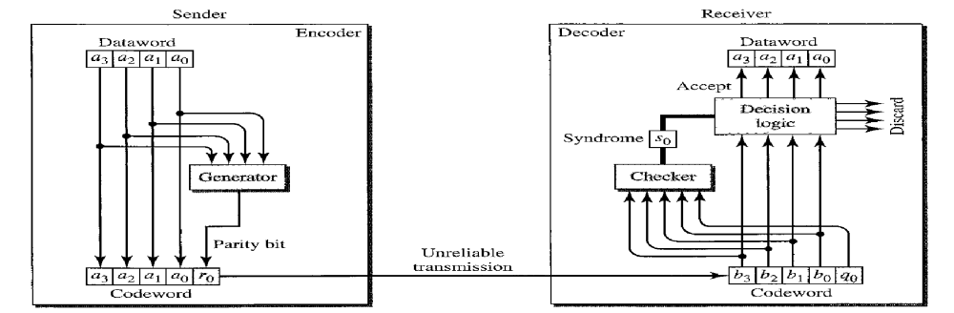

The sender sends the codeword during transmission. The receiver receives a 5-bit word. The checker at the receiver side does the reverse of what did by the generator. The addition is done over all 5 bits. The result which is called the syndrome, is just 1 bit. The syndrome is 0 when the number of 1s in the received codeword is even; otherwise it is 1. The syndrome is passed to the decision logic analyzer. If the syndrome is 0, there is no error in the received codeword; the data is accepted, otherwise it is discarded.

A simple parity check code can detect an odd number of errors. A better approach is the two-dimensional parity check. In this method dataword is organizes in the form of a table, raws and columns. This method can detect up to three errors. However , errors affecting 4 bits may not be detected.
2: Hamming Codes
These codes are originally designed with dmin=3. First find a relationship between dmin, n and k. We need to choose an integer m >= 3. The value of n and k can be calculated, n= 2^{n} -1 and k= n-m, r=m.
The structure of the encoder and decoder for Hamming code
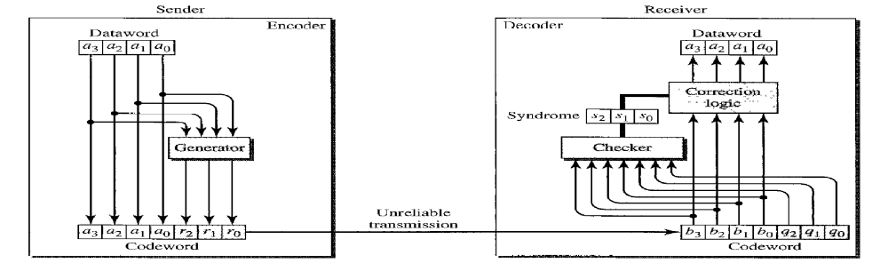

A copy of a 4-bit dataword is fed into the generator that creates there parity checks r0, r1, r2 based on modulo-2 arithmetic. At the receiver side based on the syndrome the data bay accepted or rejected.

Cyclic Codes
These are special linear codes with one extra property. Here codeword is cyclically shifted (rotated) , the result is another codeword. For example, 100101 cyclically shifted to 001011

3: Cyclic Redundancy Check(CRC)
We can create cyclic codes to correct errors. The CRC is used in networks such as LANs and WANs.

In the encoder , the dataword has k bits (4 here); the codeword has n bits(7 here). The size of the datawors is augmented by adding n-k (3 here) 0s with the dataword. The n-bit result is fed into the generator. The generator use a divisor of n-k+1 (4 here), predefined and agreed upon.
The generator divides the augmented dataword by the divisor (modulo-2 division). The quotient of the division is discarded; the remainder ( r2,r1, r0) is appended to the dataword to create the codeword.

CRC encoder and decoder
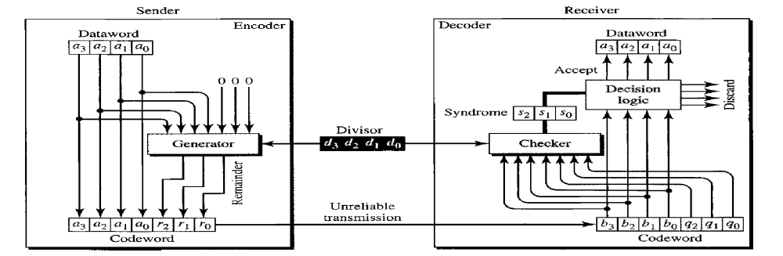

The decoder receives the codeword. A copy of all n bits is fed to the checker which is a replica of the generator. The remainder produced by the checker is a syndrome of n-k (3 here) bits , which is fed into the decision logic analyzer. The analyzer has a simple function. If the syndrome bits are all 0s, the codeword is accepted otherwise it is discarded.

4: Polynomials
Another way for error detection is Polynomials. A pattern of 0s and 1s can be represented as polynomials with coefficients 0 and 1.

A polynomial to represent a binary word
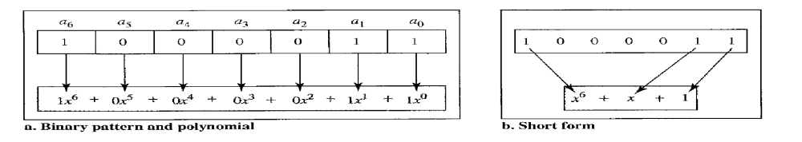

5: CHECKSUM
The concept of the checksum is simple. In addition to sending the numbers , we send the sum of the numbers as the additional bit. The receiver checks the sum and compare with the sum, if the two are same ,then no error. There is positive sum method and negative sum method.

Suppose our data is a list of five 4-bit numbers that we want to send to a destination. In addition to sending theses numbers , we send the sum of the numbers. For example , if the set ,of numbers is (7,11,12,0,6) we send (7,11,12,0,6, 36), where 36 is the sum of original numbers. The receiver adds five numbers and compares the result with the sum. If the two are same, the word is accepted otherwise the word is rejected.

If we are using negative check sum method, we will send (7,11,12,0,6, -36). The receiver can add all the numbers received including the checksum number. If the result is 0, it assumes no error, and the codeword is accepted, otherwise rejected.

FRAMING
The two main functions of data link layer functions include framing, flow and error control. Data transmission in the physical layer means moving bits in the form of signals from the source to destination. Data link layer on the other hand, needs to pack bits into frames and each frame is distinguishable from another. The data link layer splits the message in to different number of frames. It is possible to consider the whole message as a single frame, but it is not normally done. When a message is carried in very large frame, even a single-bit error would require the retransmission of the whole message. When message is divided into frames, a single bit error affects only that small frame.
There are two type framing, Fixed-Size Framing and Variable-Size Framing
Fixed-Size Framing
Frames can be of fixed or variable size. In Fixed-Size Framing, there is no need for defining the boundaries of the frame; the size itself can be used as a delimiter.
Variable-Size Framing
In Variable-Size Framing, we need a way to define the end of the frame and the beginning of the next. There are two approaches used for this purpose, Character-Oriented approach and Bit-Oriented approach
Character-Oriented approach
In a Character-Oriented protocol, data to be carried are 8-bit characters from a coding system. The header normally carries the source and destination address and other control information. The trailer carries error detection and correction information. To separate one frame from the next, an 8-bit flag is added at the beginning and the end of a frame. The flag contain a special type characters.

A frame in a Character-Oriented approach
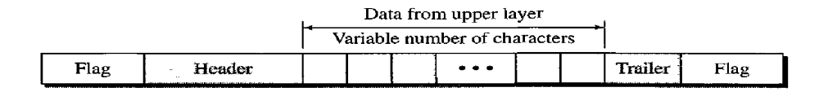

While selecting the flag, the flag could also be a part of the information. If this happens, the receiver , when it encounters this pattern in the middle of the data, thinks it has reached the end of the frame. To fix this problem a byte-stuffing strategy added to character-oriented framing. In byte stuffing a special byte is added to the data section of the frame when there is a character with the same pattern as the flag. That is the data section is stuffed with an extra byte, it is usually called escape character (ESC), which has a predefined bit pattern. Whenever the receiver encounters the ESC character , it removes it from the data section and treat the next character as the data, not a delimiting flag.

What happens if the text contains one or more escape character followed by a flag? The receiver removes the escape character, but keeps the flag, which is incorrectly interpreted as the end of the frame. To solve this problem, the escape character that are part of the text must also be marked by another escape character.
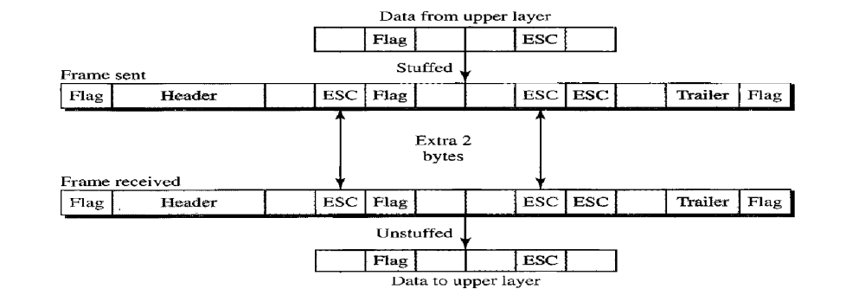

Bit-Oriented Protocol
Here the protocol use a special 8-bit pattern flag 01111110 as the delimiter to define the beginning and end of the frame.

A frame in a Bit-Oriented Protocol
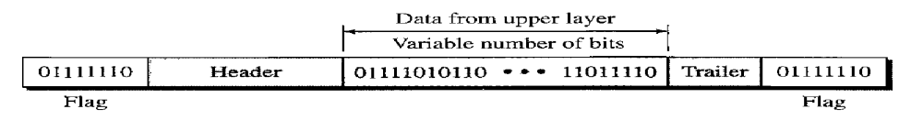

This flag can create the same type of problem we saw in the byte-oriented protocol. That is what happens if the flag pattern appears in the data. We can solve this by stuffing 1 single bit to prevent the pattern from looking like a flag. This strategy is called bit stuffing. In bit stuffing , if a 0 and five consecutive 1 bits are encountered , an extra 0 is added. This extra stuffed bit is removed from the data by the receiver. This guarantees that the flag field sequence does not appear in the frame.
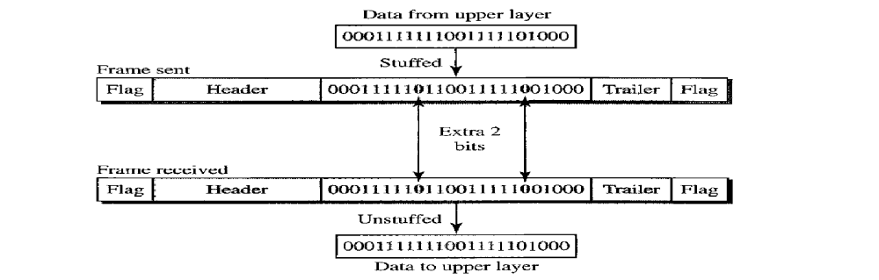

This means that if the flaglike pattern 01111110 appears in the data, it will change to 011111010 and is not mistaken as a flag by the receiver.

Flow and Error Control
Flow control refers to set of procedures used to restrict the amount of data that the sender can send before waiting for acknowledgement. The flow of data must not be allowed to overwhelm the receiver. The receiving device has a block of memory called a buffer, reserved for storing incoming data until they are processed. If the buffer begins to fill up, the receiver must be able to tell the sender to halt transmission until it is once again able to receive.
Error control is both error detection and error correction. It allows the receiver to inform the sender of any frames lost or damaged in the transmission. In the data link layer the term error control refers the methods of error detection and retransmission. There are different number of protocols used for flow control and error control.

