***Design database for Zen class programme***

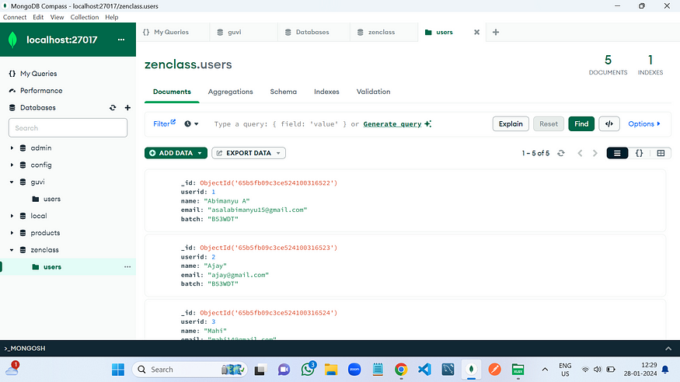

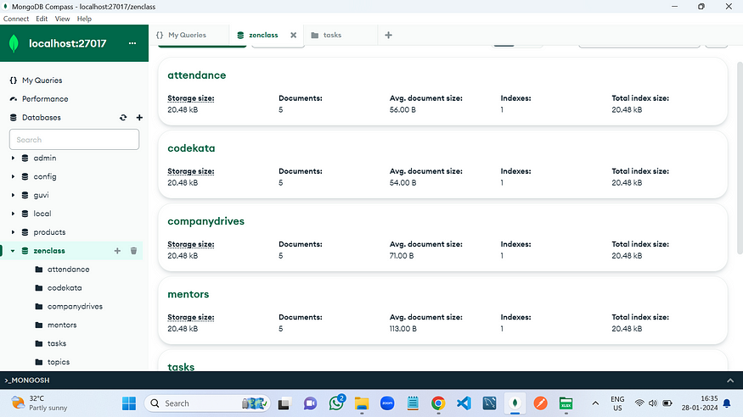

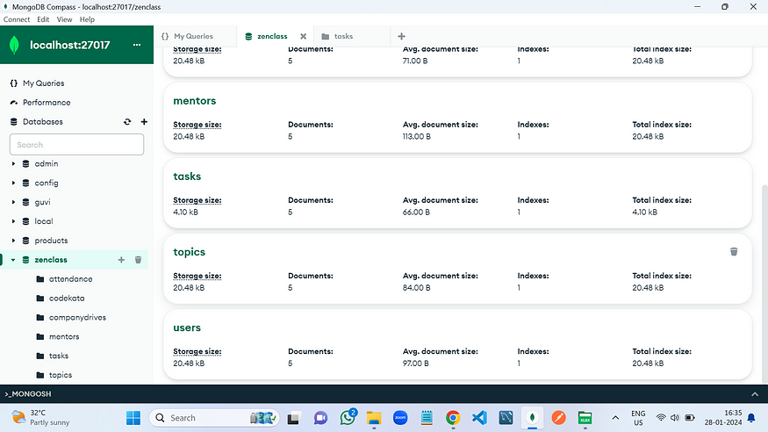

**Design database for Zen class programme**

**users**

**codekata**

**attendance**

**topics**

**tasks**

**company_drives**

**mentors**

**Questions:**

1.**Find all the topics and tasks which are thought in the month of October ?**

db.topics.aggregate([  
{  
$lookup: {  
from: “tasks”,  
localField: “topicid”,  
foreignField: “topicid”,  
as: “taskinfo”  
}  
},  
{  
$match: {  
$and: [  
{ topicDate: { $gte: new Date(“2020–10–01”), $lt: new Date(“2020–11–01”) } },  
{  
$or: [  
{ “taskinfo.task_date”: { $gte: new Date(“2020–10–01”), $lt: new Date(“2020–11–01”) } },  
{ “taskinfo.task_date”: { $exists: false } }  
]  
}  
]  
}  
},  
{  
$project: {  
_id: 0,  
topicid: 1,  
topic: 1,  
topicDate: 1,  
task_date: “$taskinfo.task_date”  
}  
}  
])

— — — — — — — — — — — — — — — — — — — — — — — — — — — — — — — — — — — — —

2.**Find all the company drives which appeared between 15 oct-2020 and** **31-oct-2020?**

**Answer:**

db.companydrives.find({  
$or: [  
{ drive_date: { $gte: new Date(“2020-oct-15”) ,$lte: new Date(“2022-oct-31”)} }  
  
]  
})

— — — — — — — — — — — — — — — — — — — — — — — — — — — — — — — — — -

**3.Find all the company drives and students who are appeared for the placement.?**

**Answer:**

db.companydrives.aggregate([  
{  
$lookup: {  
from: “users”,  
localField: “userid”,  
foreignField: “userid”,  
as: “info”,  
},  
},  
{  
$project: {  
_id: 0,  
company: 1,  
drive_date: 1,  
“info.name”: 1,  
“info.email”: 1,  
“info.userid”: 1,  
},  
},  
])

— — — — — — — — — — — — — — — — — — — — — — — — — — — — — — — — -

**4.Find the number of problems solved by the user in codekata.?**

**Answer:**

db.codekata.aggregate([  
{  
$lookup: {  
from: “users”,  
localField: “userid”,  
foreignField: “userid”,  
as: “info”,  
},  
},  
{  
$project: {  
_id: 0,  
userid: 1,  
solved_problems: 1,  
“info.name”: 1,  
},  
},  
])

— — — — — — — — — — — — — — — — — — — — — — — — — — — — — — — — —

**5**. **Find all the mentors with who has the mentee’s count more than 15.?**

**Answer:**

db.mentors.find({mentee_count:{$gte:15}})

— — — — — — — — — — — — — — — — — — — — — — — — — — — — — — —

**6.Find the number of users who are absent and task is not submitted between 15 oct-2020 and 31-oct-2020.?**

**Answer:**

db.attendence.aggregate([  
{  
$lookup: {  
from: “topics”,  
localField: “topicid”,  
foreignField: “topicid”,  
as: “topics”,  
},  
},  
{  
$lookup: {  
from: “tasks”,  
localField: “topicid”,  
foreignField: “topicid”,  
as: “tasks”,  
},  
},  
{ $match: { $and: [{ staus: false }, { “tasks.submitted”: false }] } },  
{  
$match: {  
$and: [  
{  
$or: [  
{ “topics.topicDate”: { $gte: new Date(“2020–10–15”) , $lte: new Date(“2020–10–31”) } }  
],  
},  
{  
$or: [  
{ “tasks.task_date”: { $gte: new Date(“2020–10–15”) , $lte: new Date(“2020–10–31”) } },  
],  
},  
],  
},  
},  
{  
$count:”Absentees”,  
},  
])

— — — — — — — — — — — — — — — — — — — — — — — — — — —