API

Application programming interface is a Java class available in the form of JRA’s.

A set of functions and procedures that allow the creation of applications which access the features or data of an operating system, application, or other service.

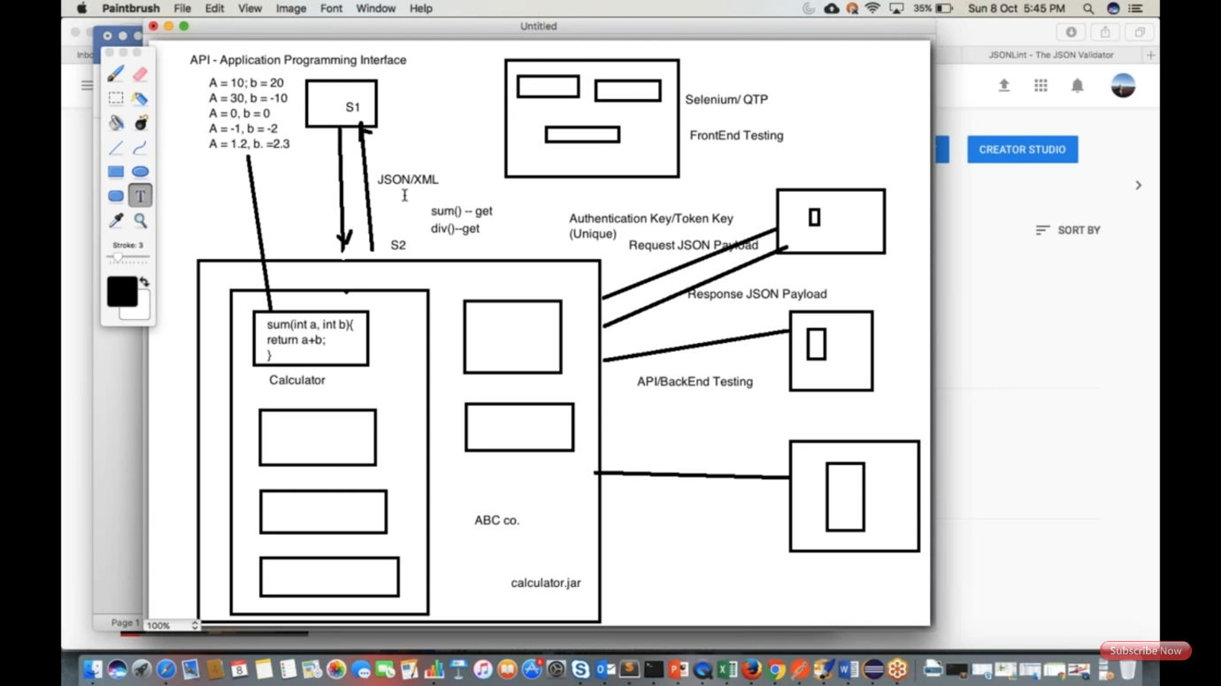

1. Web Service is an API wrapped in HTTP.  
2. All Web Services are API but APIs are not Web Services.  
3. Web Service might not perform all the operations that an API would perform.  
4. A Web Service needs a network while an API doesn't need a network for its operation.

### Three basic types of APIs

APIs take three basic forms: local, web-like and program-like.

Local APIs are the original form, from which the name came. They offer OS or [middleware](https://searchmicroservices.techtarget.com/definition/middleware)services to application programs. Microsoft's [.NET](https://searchwindevelopment.techtarget.com/definition/NET) APIs, the [TAPI (Telephony API)](https://searchexchange.techtarget.com/definition/TAPI) for voice applications, and database access APIs are examples of the local API form.

Web APIs are designed to represent widely used resources like [HTML](https://searchmicroservices.techtarget.com/definition/HTML-Hypertext-Markup-Language) pages and are accessed using a simple [HTTP](https://searchwindevelopment.techtarget.com/definition/HTTP) protocol.  Any web [URL](https://searchnetworking.techtarget.com/definition/URL) activates a web API.  Web APIs are often called [REST (representational state transfer)](https://searchmicroservices.techtarget.com/definition/REST-representational-state-transfer) or [RESTful](https://searchmicroservices.techtarget.com/definition/RESTful-API) because the publisher of REST interfaces doesn**'**t save any data internally between requests. As such, requests from many users can be intermingled as they would be on the internet.

Program APIs are based on [remote procedure call (RPC)](https://searchmicroservices.techtarget.com/definition/Remote-Procedure-Call-RPC) technology that makes a remote program component appear to be local to the rest of the software. [Service oriented architecture (SOA)](https://searchmicroservices.techtarget.com/definition/service-oriented-architecture-SOA) APIs, such as Microsoft**'**s WS-series of APIs, are program APIs.

https://searchmicroservices.techtarget.com/definition/application-program-interface-API