**Map**

Session1: (1 to 1)

Map is used to handle key and values.

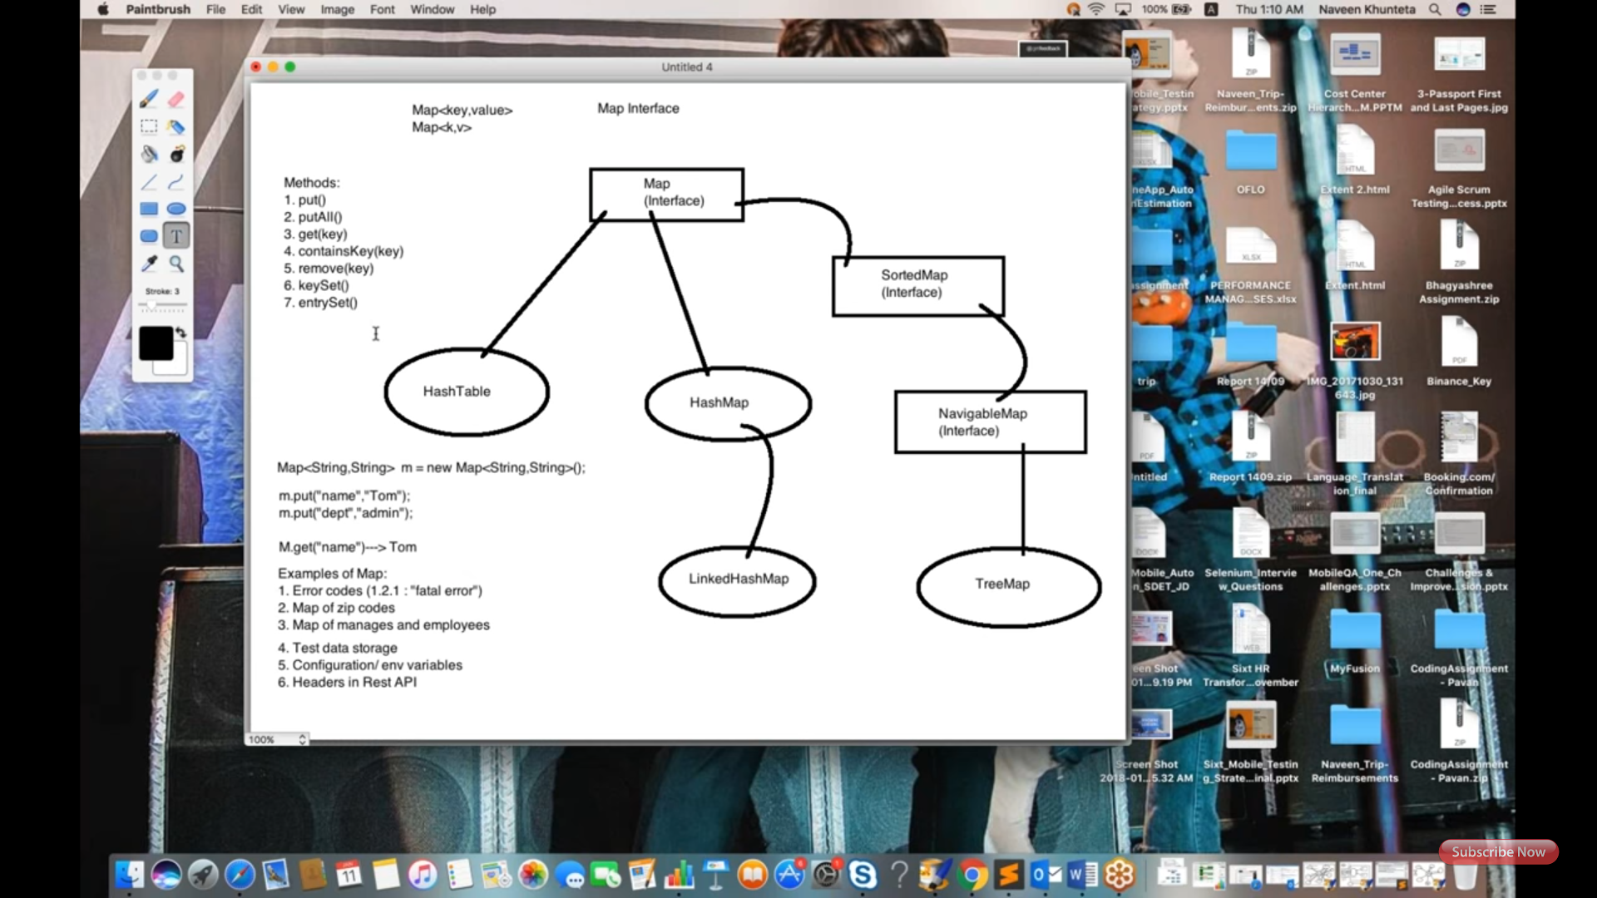

Session1: (2 to 1)

HashMap declaration and storing, removing and printing, attached 1st screenshot.

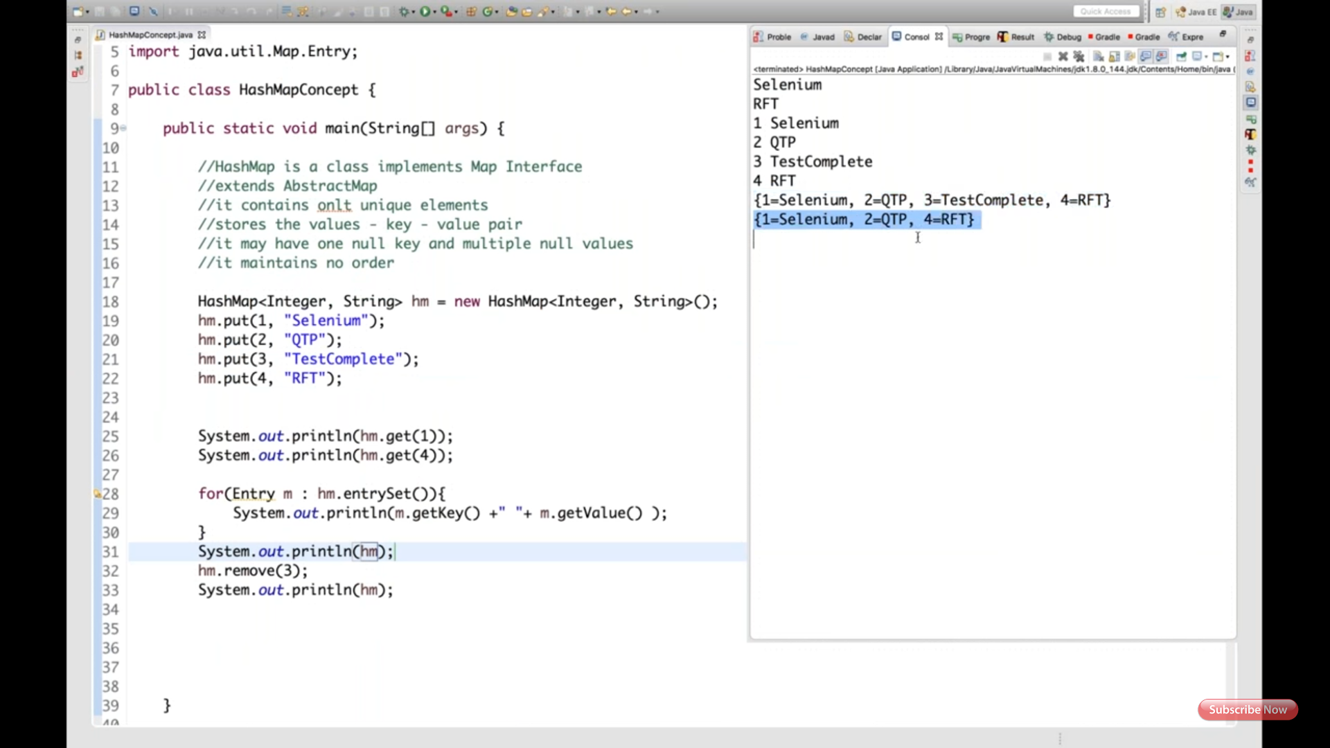

HashMap accessing object reference, explained screenshot 2nd show employee class and 3rd screenshot showing how it's used.

Hashtable is synchronized, one thread at a time (thread safe), HashMap is non-synchronized, more than one thread can access at a time(not thread safe), HashMap increases its performance automatically.

Problem with HashMap is: if t1, t2, t3 treads accessing same object, if t1 updates key : value as 1:Arun as 1:Tarun the remaining t2, t3 will get latest value. That is called fail-fast condition, concurrent modification exception you will get.

