[https://youtu.be/0XowYwfvbo8](https://youtu.be/0XowYwfvbo8" \t "_blank)

First screenshot explains reading properties file.

Second screenshot explains config.properties file definition.

Third screenshot explains, log4j.properties file, this need to be credited under Java/Maven project.

Forth screenshot explains, creating one Logger class object and use ref obj to write info message.

Fifth screenshot explains, setting log4j append=true

If true it appends to the same file, if false it creates new log file

<https://mvnrepository.com/artifact/log4j/log4j/1.2.17> (Log4J dependency for Maven)

Below are the Images: (Note: Plz refer hints and info for **log4j**)

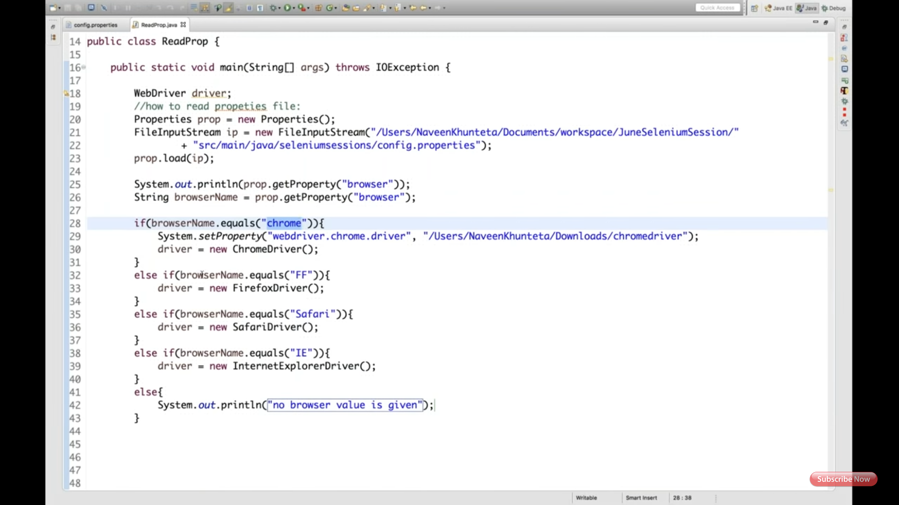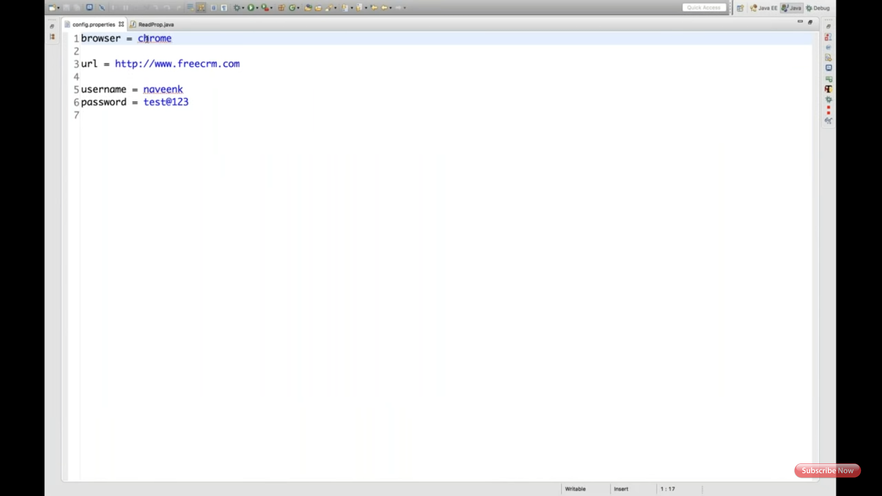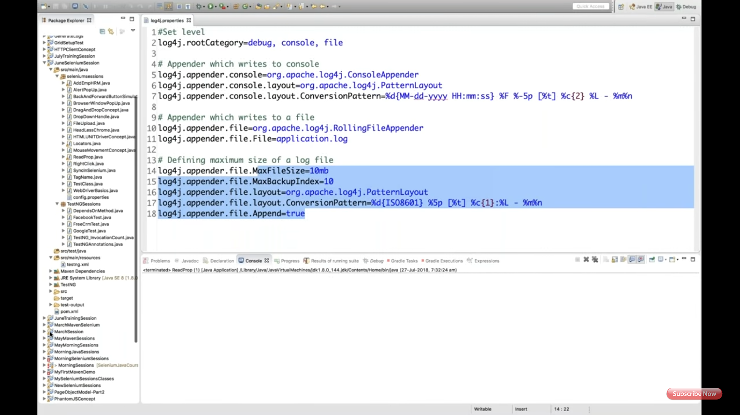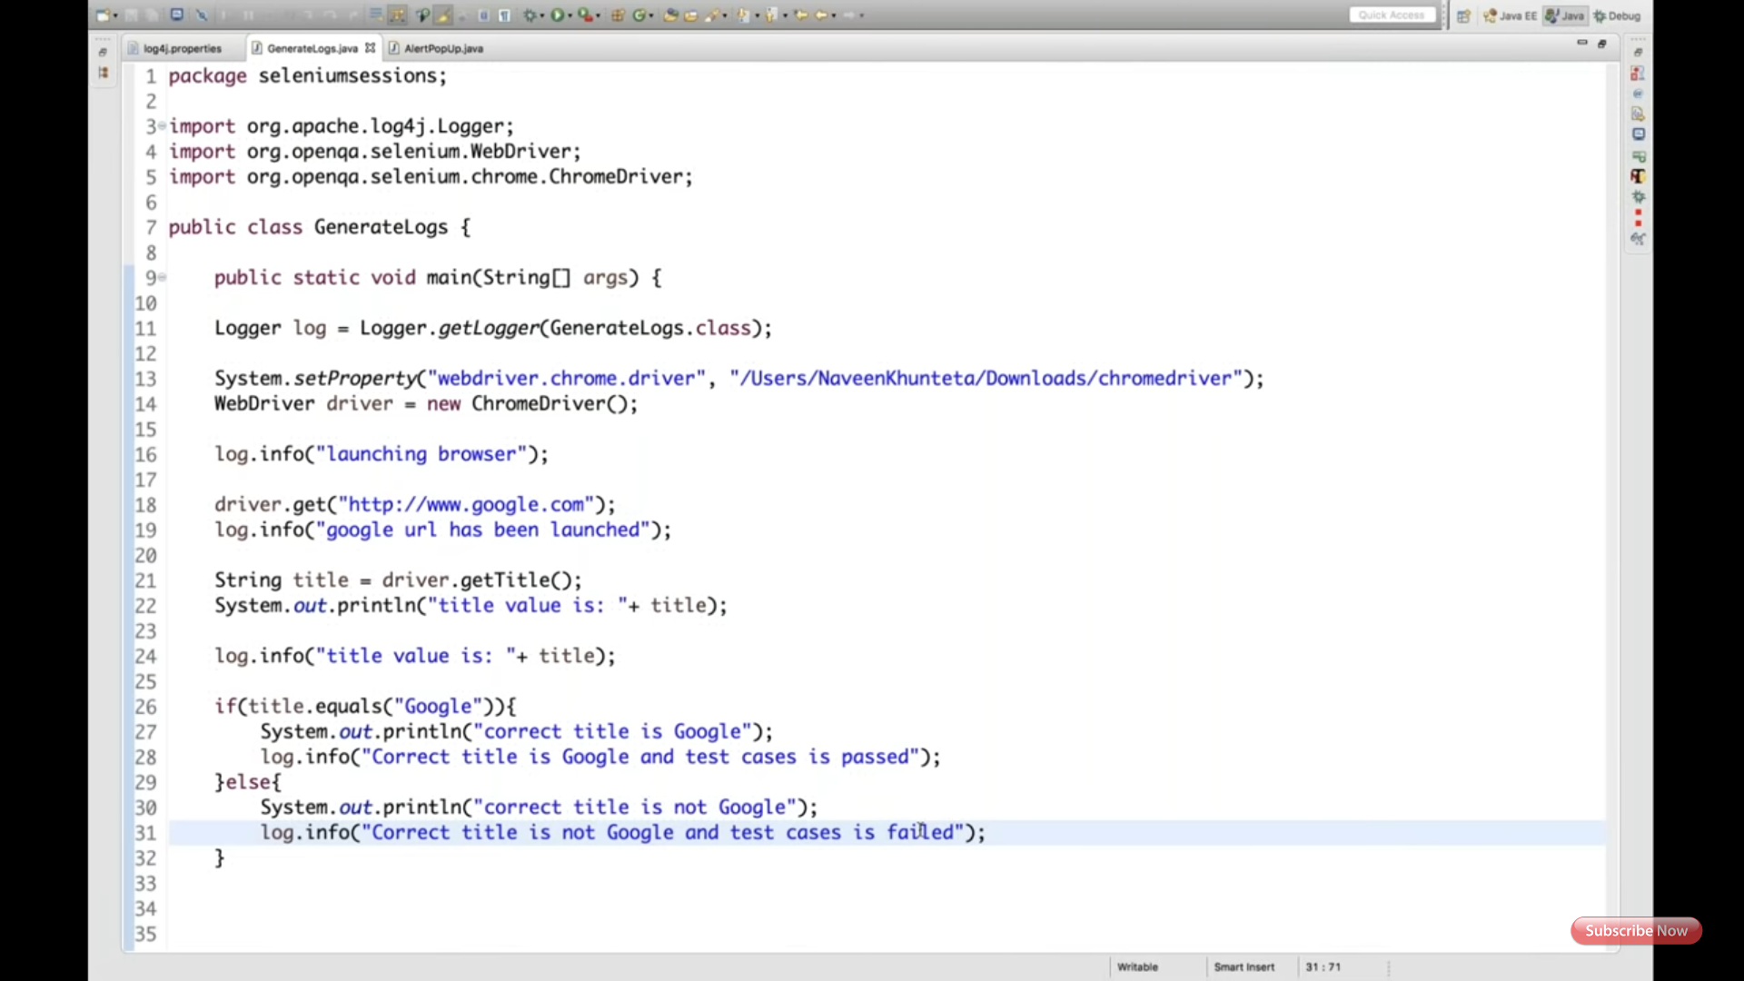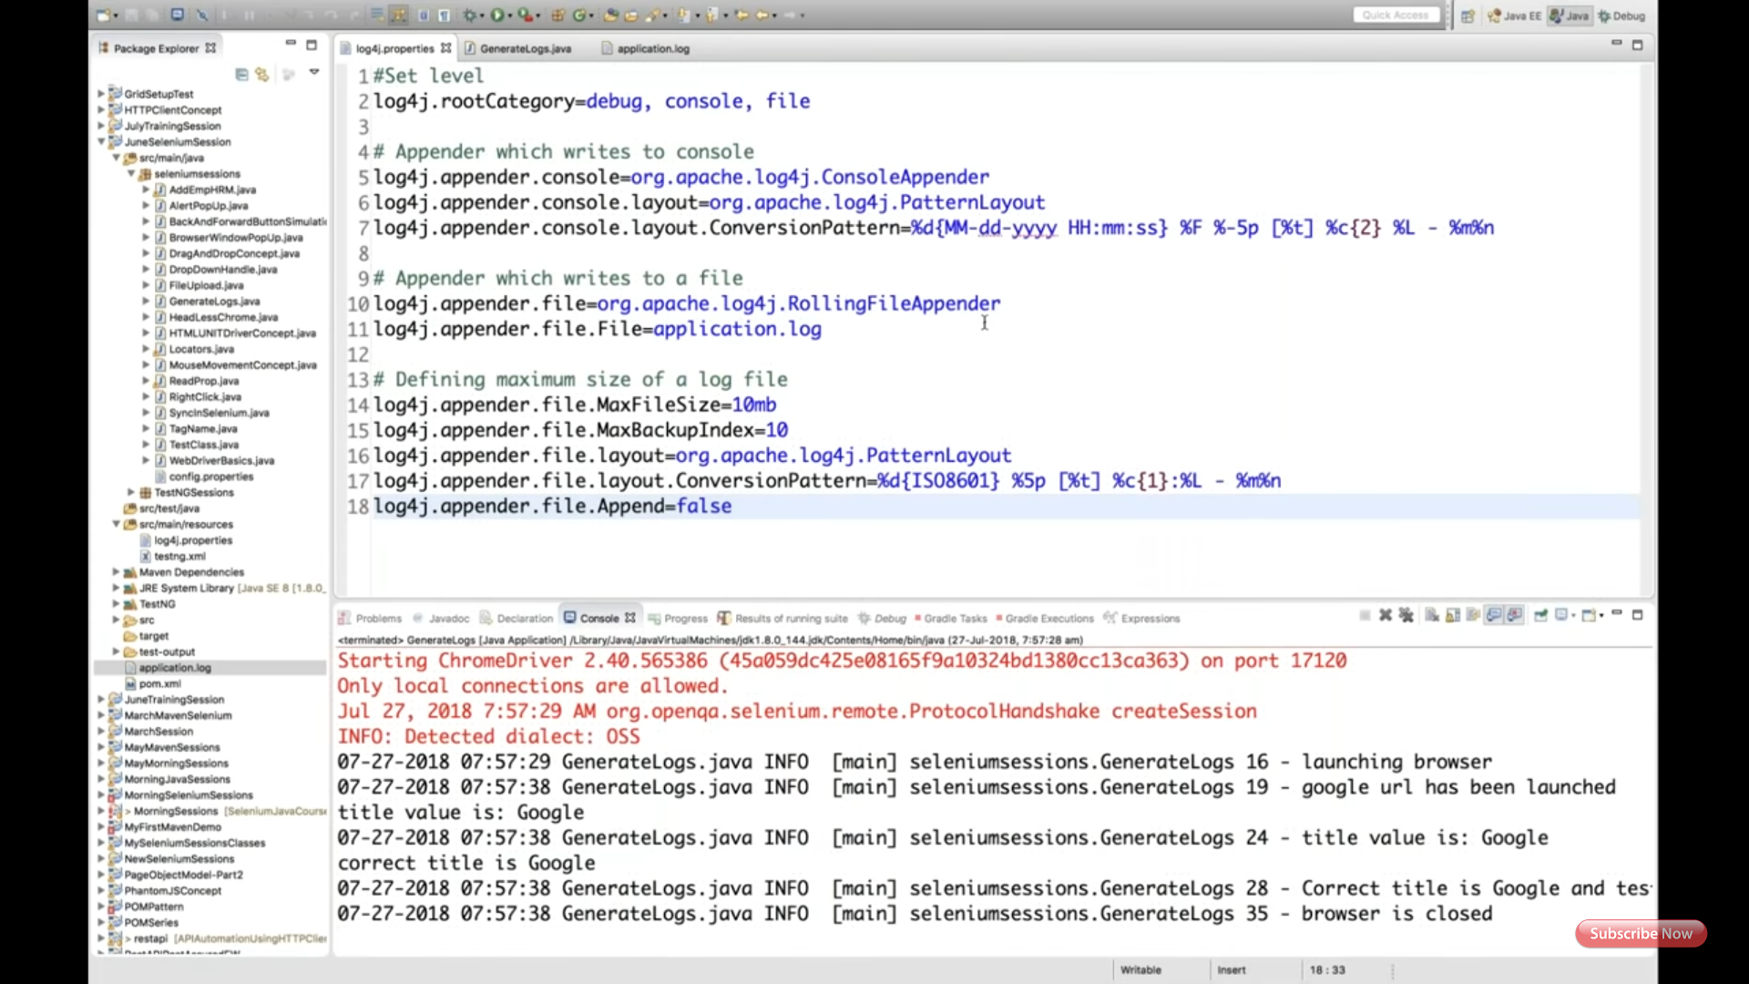

Log4J give maven dependency to get log4j.jar or download and add jar as external jar file.

Create log4j.properties file under src/main/resources or under main Java project.

**File: Log4j.properties**

# Set root logger level to DEBUG and its only appender to A1.

log4j.rootLogger=DEBUG, A1

# A1 is set to be a ConsoleAppender.

log4j.appender.A1=org.apache.log4j.ConsoleAppender

# A1 uses PatternLayout.

log4j.appender.A1.layout=org.apache.log4j.PatternLayout

log4j.appender.A1.layout.ConversionPattern=%-4r [%t] %-5p %c %x - %m%n

**Java file to test:**

**package** com.att.qa.testcases;

**import** org.apache.log4j.Logger;

**public** **class** TestLog4J {

**public** **static** **void** main(String[] args) {

Logger log = Logger.*getLogger*(TestLog4J.**class**);

log.info("Lovely");

}

}

**Another example:**

**File: Log4j.properties**

log4j.rootLogger=DEBUG, consoleAppender, fileAppender

log4j.appender.consoleAppender=org.apache.log4j.ConsoleAppender

log4j.appender.consoleAppender.layout=org.apache.log4j.PatternLayout

log4j.appender.consoleAppender.layout.ConversionPattern=[%t] %-5p %c %x - %m%n

log4j.appender.fileAppender=org.apache.log4j.RollingFileAppender

log4j.appender.fileAppender.layout=org.apache.log4j.PatternLayout

log4j.appender.fileAppender.layout.ConversionPattern=[%t] %-5p %c %x - %m%n

log4j.appender.fileAppender.File=demoApplication.log

**Java file to test:**

package AwesomeJava;

import org.apache.log4j.Logger;

import org.apache.log4j.PropertyConfigurator;

public class Log4jPropertiesConfigurationExample

{

static Logger logger = Logger.getLogger(Log4jPropertiesConfigurationExample.class);

public static void main(String[] args)

{

//PropertiesConfigurator is used to configure logger from properties file

PropertyConfigurator.configure("log4j.properties");

//Log in console in and log file

logger.debug("Log4j appender configuration is successful !!");

}

}

Below is the screenshot of Prop path:

