**TestNG-Maven-Junkins-GIT**

JUnit, TestNG, cucumber BDD, jbehave all these help in order of execution, reports, logs, screenshots, configuration, Auto email and so on. These are acts as centralized controller to facilitate and coordination.

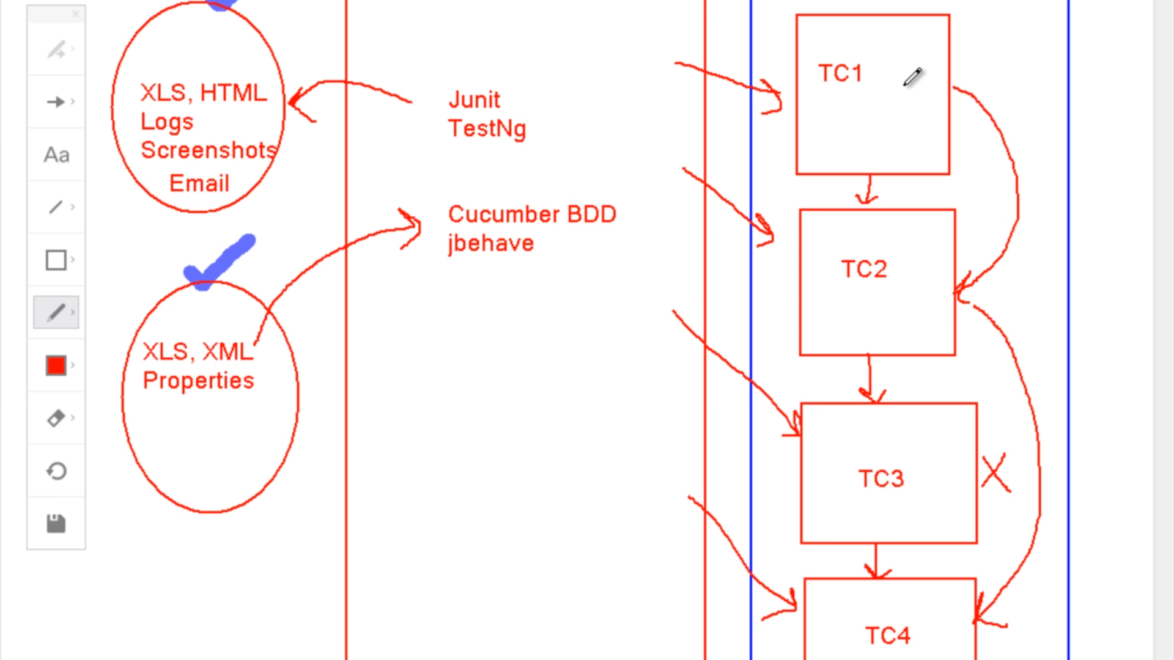

Maven helps to maintain the right version jars and execute framework from the command prompt.

ANT helps to run framework from the command prompt.

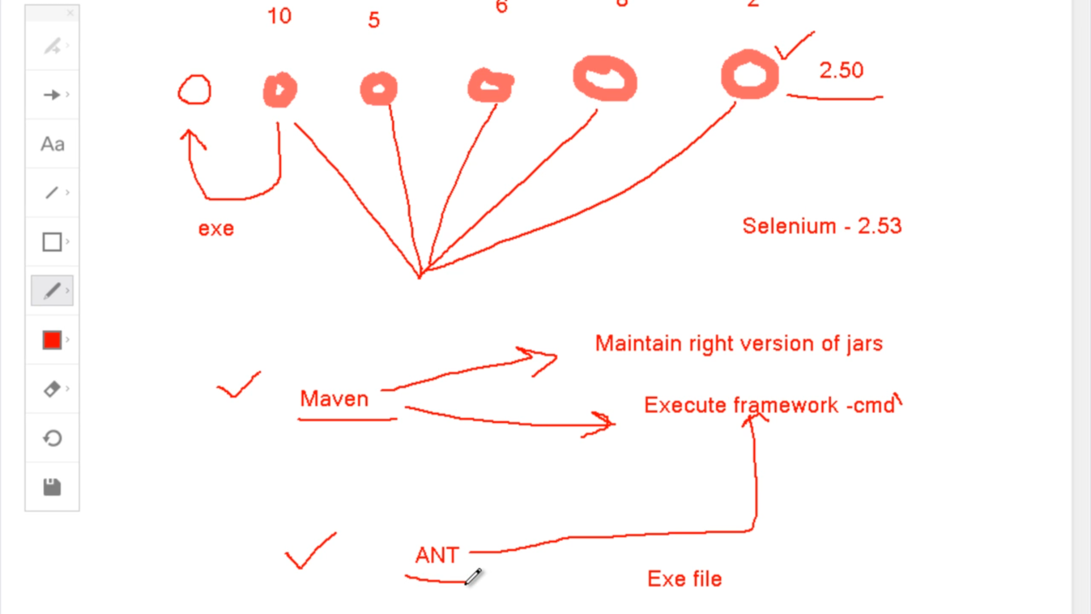

Jenkins and Git - used to check compilation issues, different people helps in random check-in errors. And Jenkins also help to schedule the build.

