CS 5710
Machine Learning (Assignment # 2)
E-mail: vxg49800@ucmo.edu
Name: Vishnu Vardhan Reddy Gooli
Student ID : 700734980
Course: CS 5710
Assignment: In- class Programming Assignment-2
Github: vishnugooli/In-class-assignment-2 (github.com)
Video Link: ML programming assignment-2 - Google Drive
Question 1
Description: Reading the provided CSV file ‘data.csv’. we also printed basic statistical description about the data
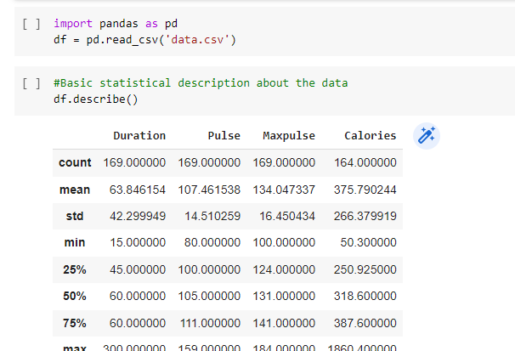

Description: . 3. Check if the data has null values. Replace the null values with the mean

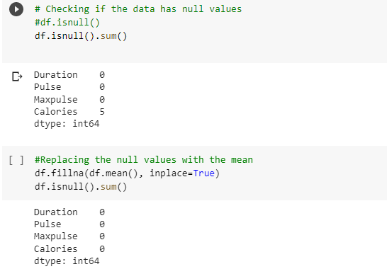
Description: . Select at least two columns and aggregate the data using: min, max, count, mean
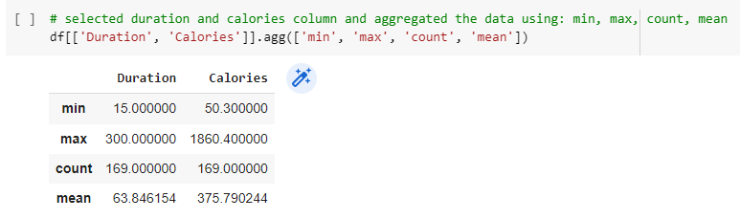

Description: . Filter the dataframe to select the rows with calories values between 500 and 1000.

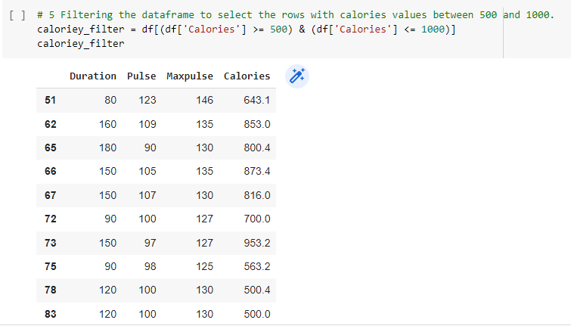

Filter the dataframe to select the rows with calories values > 500 and pulse < 100

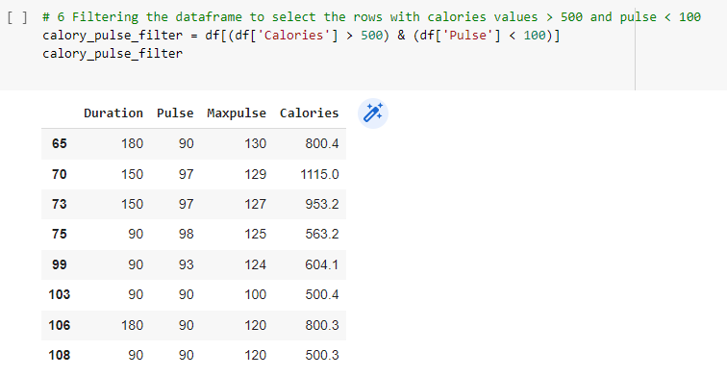

Description:Creating a new “df_modified” dataframe that contains all the columns from df except for “Maxpulse” .we set the axix 1 to represent the column
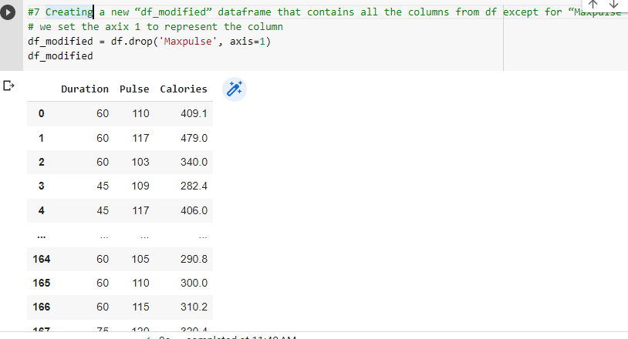

Description: Deleting the “Maxpulse” column from the main df dataframe

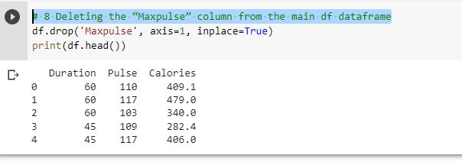

Description:Converting the datatype of Calories column to int datatype
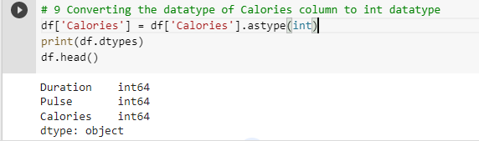

Description:Using pandas creating a scatter plot for the two columns (Duration and Calories)
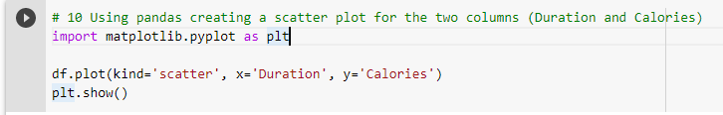
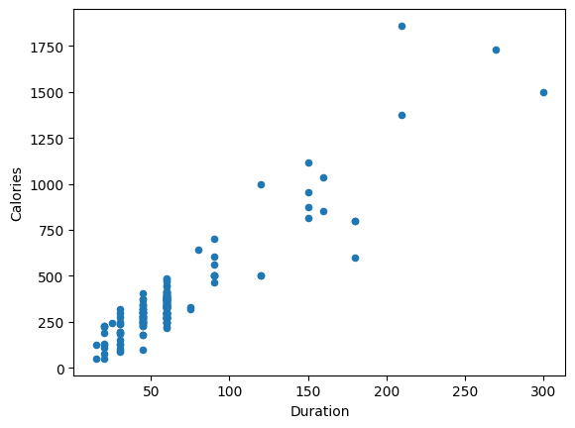

Description : Implemented Naïve Bayes method using scikit-learn library and reported the accuracy.
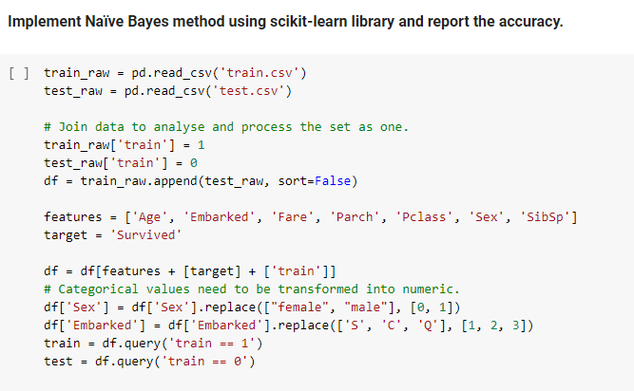

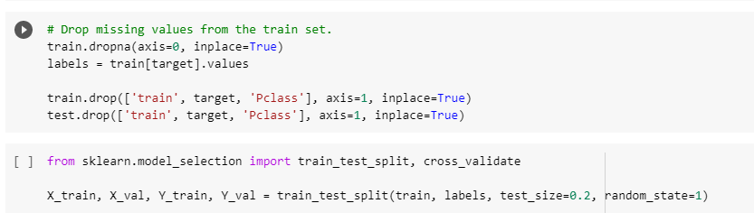

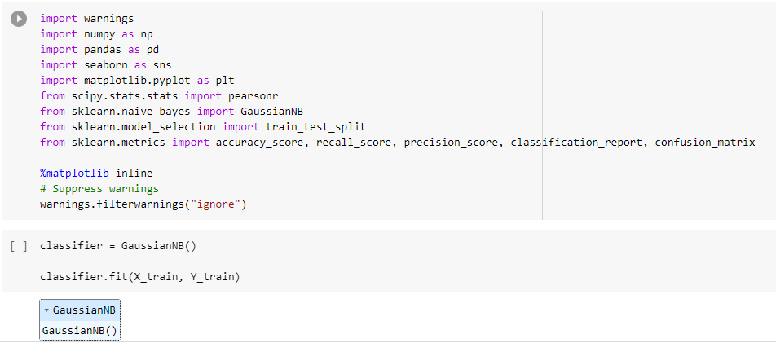

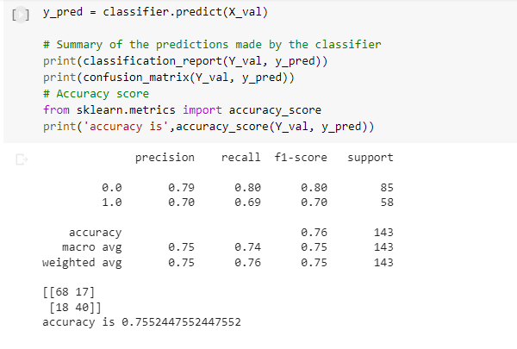

3) Glass Dataset
- Used the glass dataset available in Link also provided in your assignment:
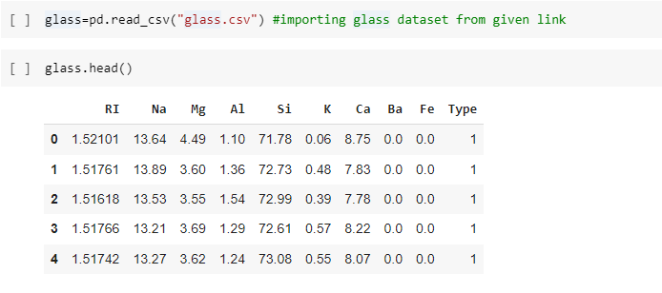

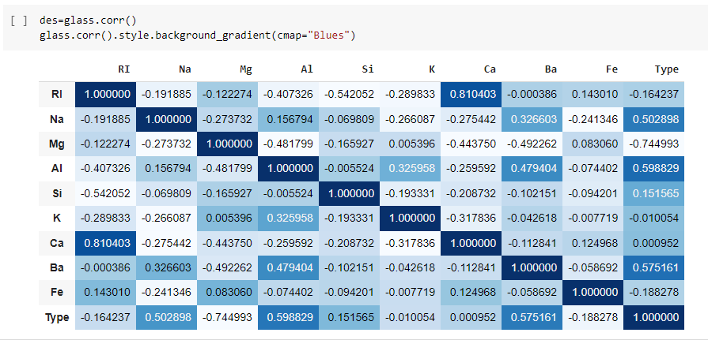
B:Use train_test_split to create training and testing part:

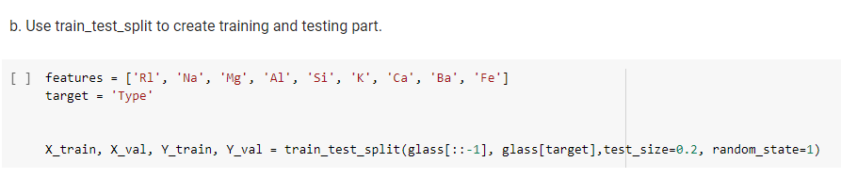

2. Evaluate the model on testing part using score and classification_report(y_true, y_pred)
Output :

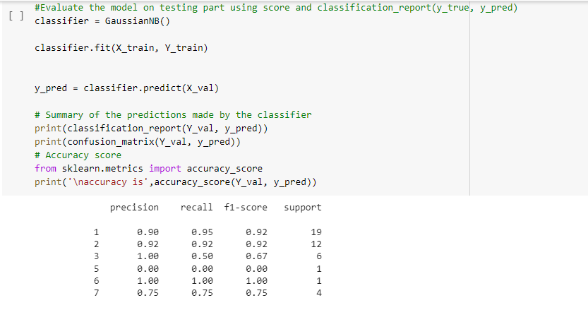

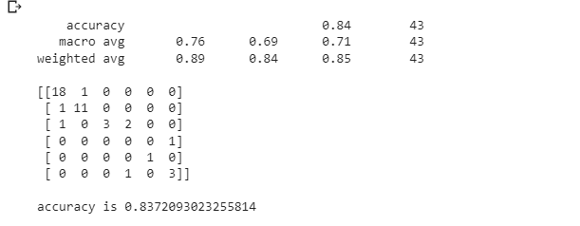

Implement linear SVM method using scikit library

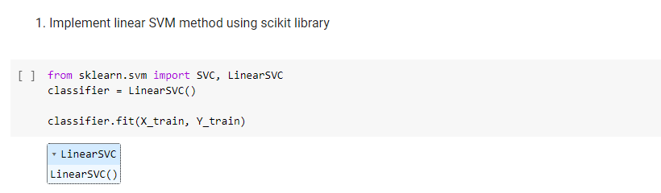

- Evaluate the model on testing part using score and classification_report(y_true, y_pred) :

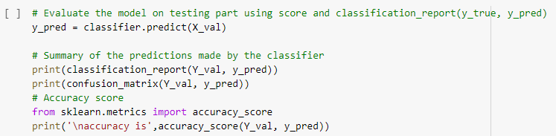

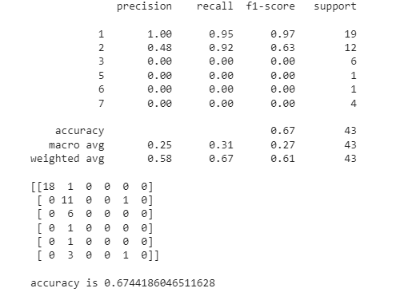
Do at least two visualizations to describe or show correlations in the Glass Dataset:

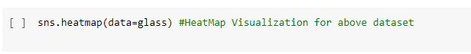
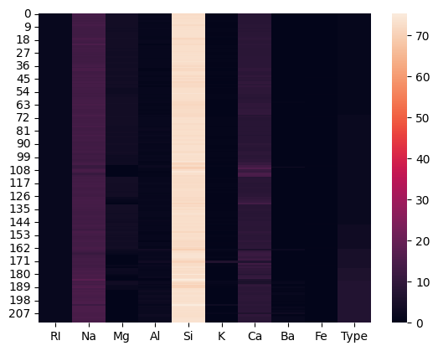

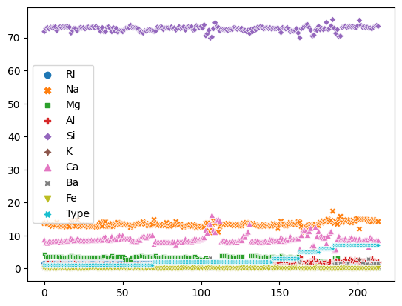

Which algorithm you got better accuracy? Can you justify why?
Naïve Bayes accuracy is 83.7% which got more than SVM algorithm which has only 60.46%. While naive Bayes can handle both categorical predictor variables and continuous hence, therefore SVM algorithm can handle only continuous predictors.

