MONOGB QUERIES

FIND ALL INFO ABOUT PRODUCTS

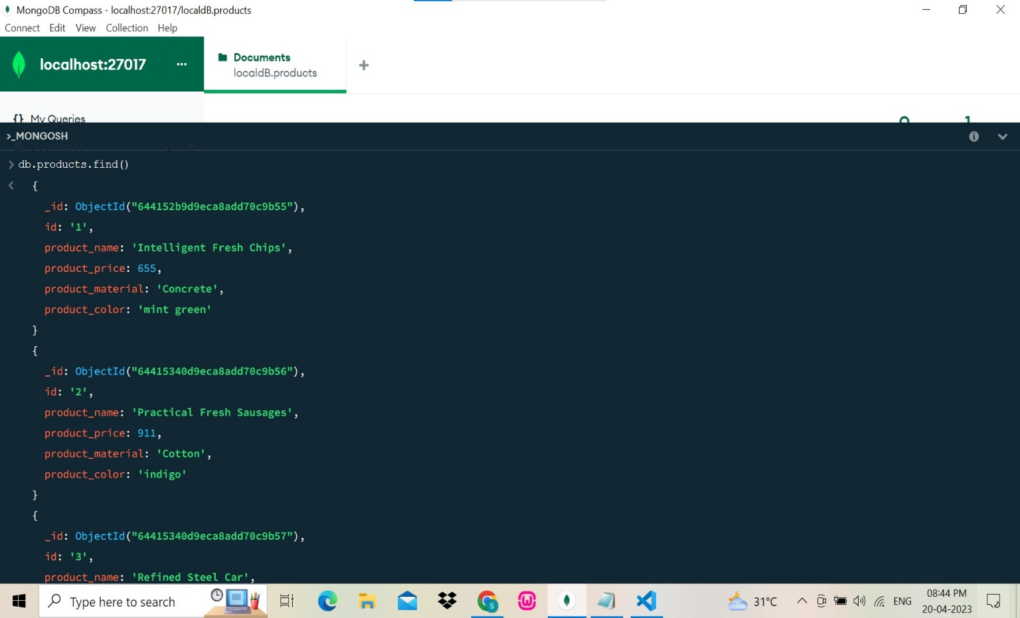

FIND PRODUCT PRICE BETWEEN 400-800

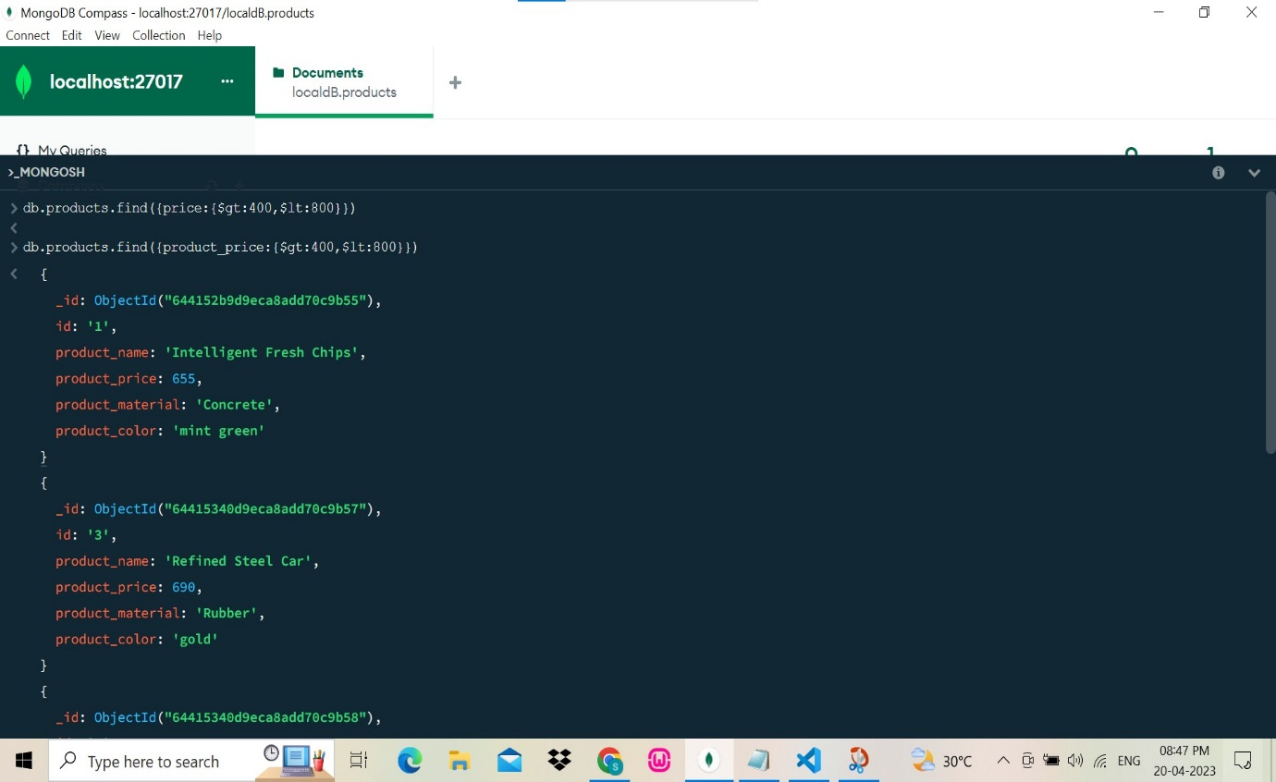

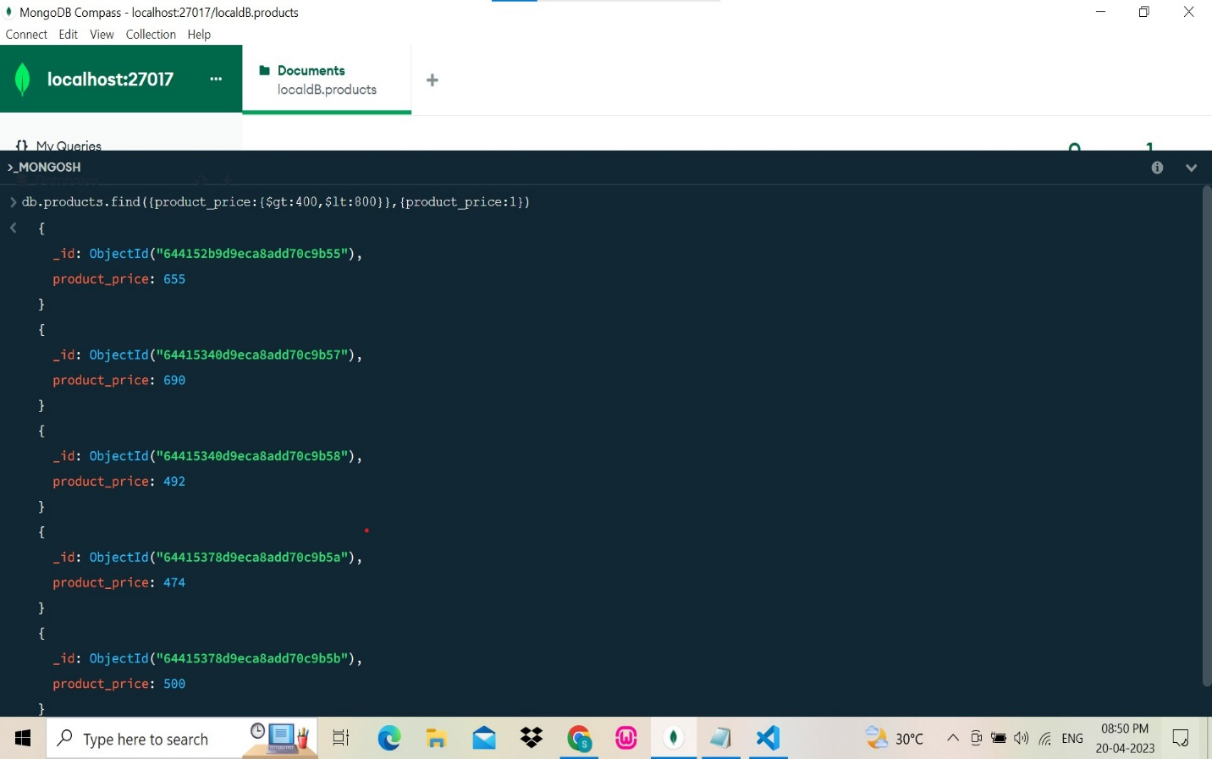

FIND PRODUCT PRICE NOT BETWEEN 400-600

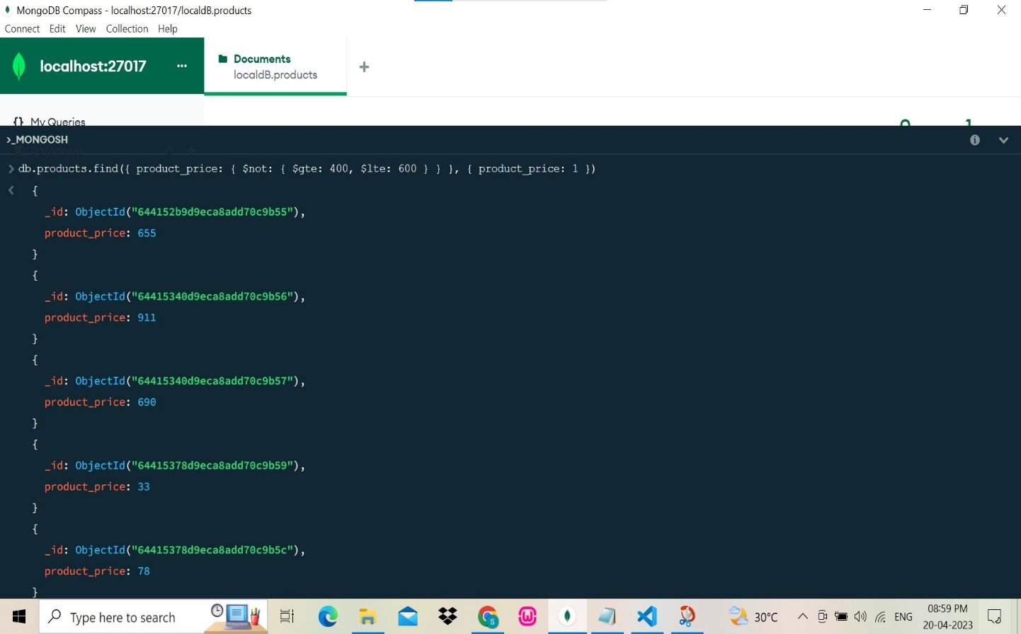

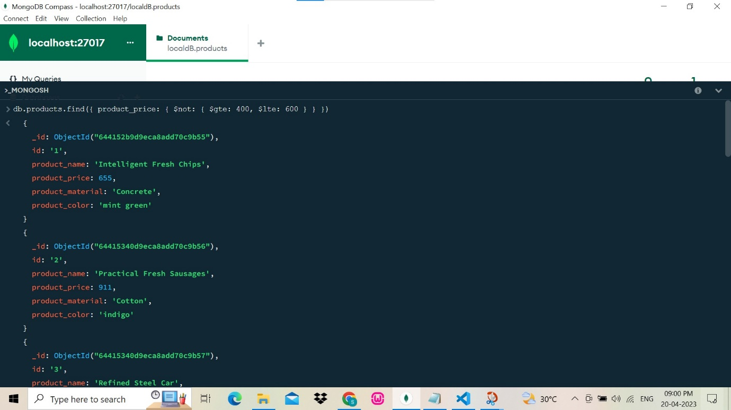

LIST 4 PRODUCT PRICE > 500

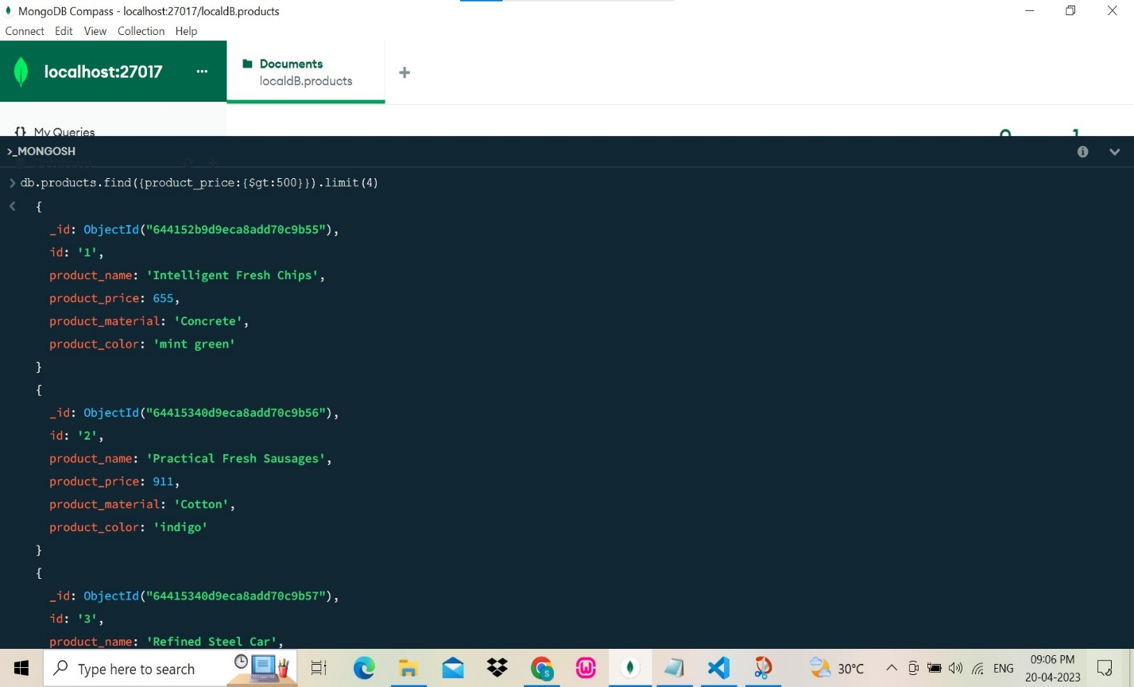

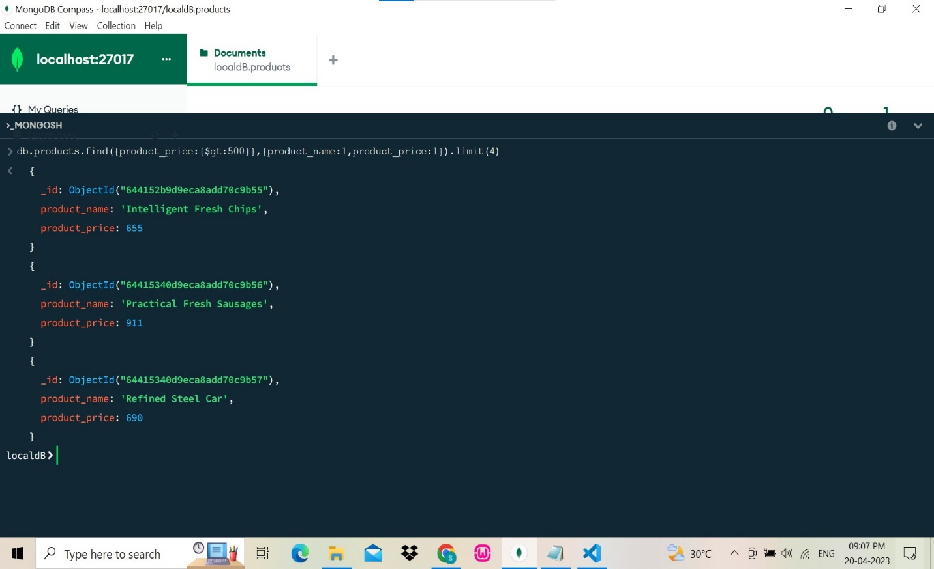

FIND PRODUCT NAME AND MATERIAL

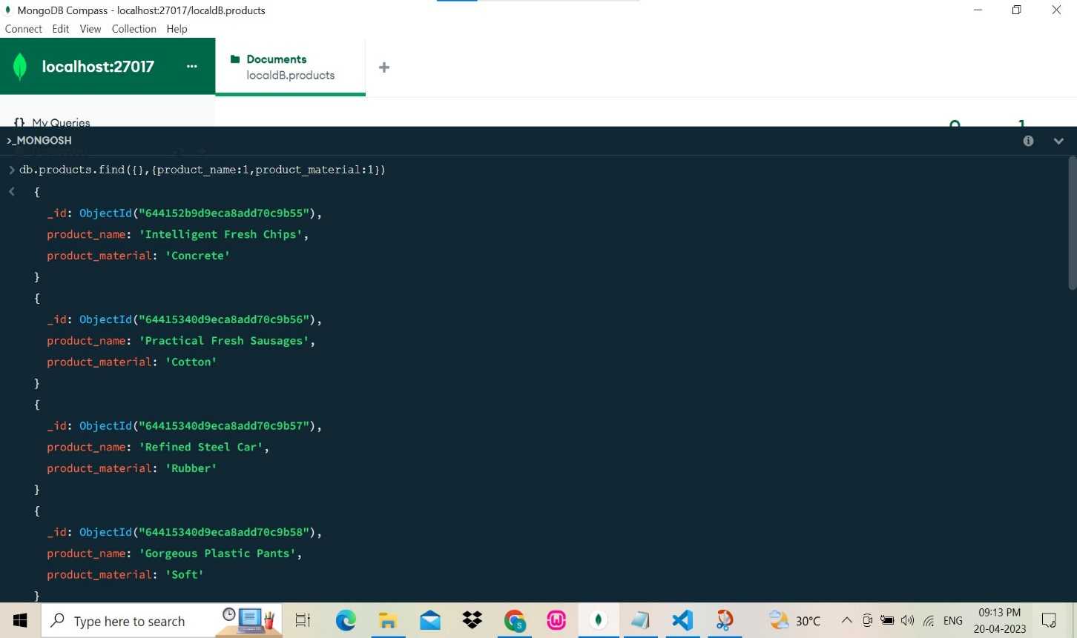

FIND PRODUCT WITH ID 10

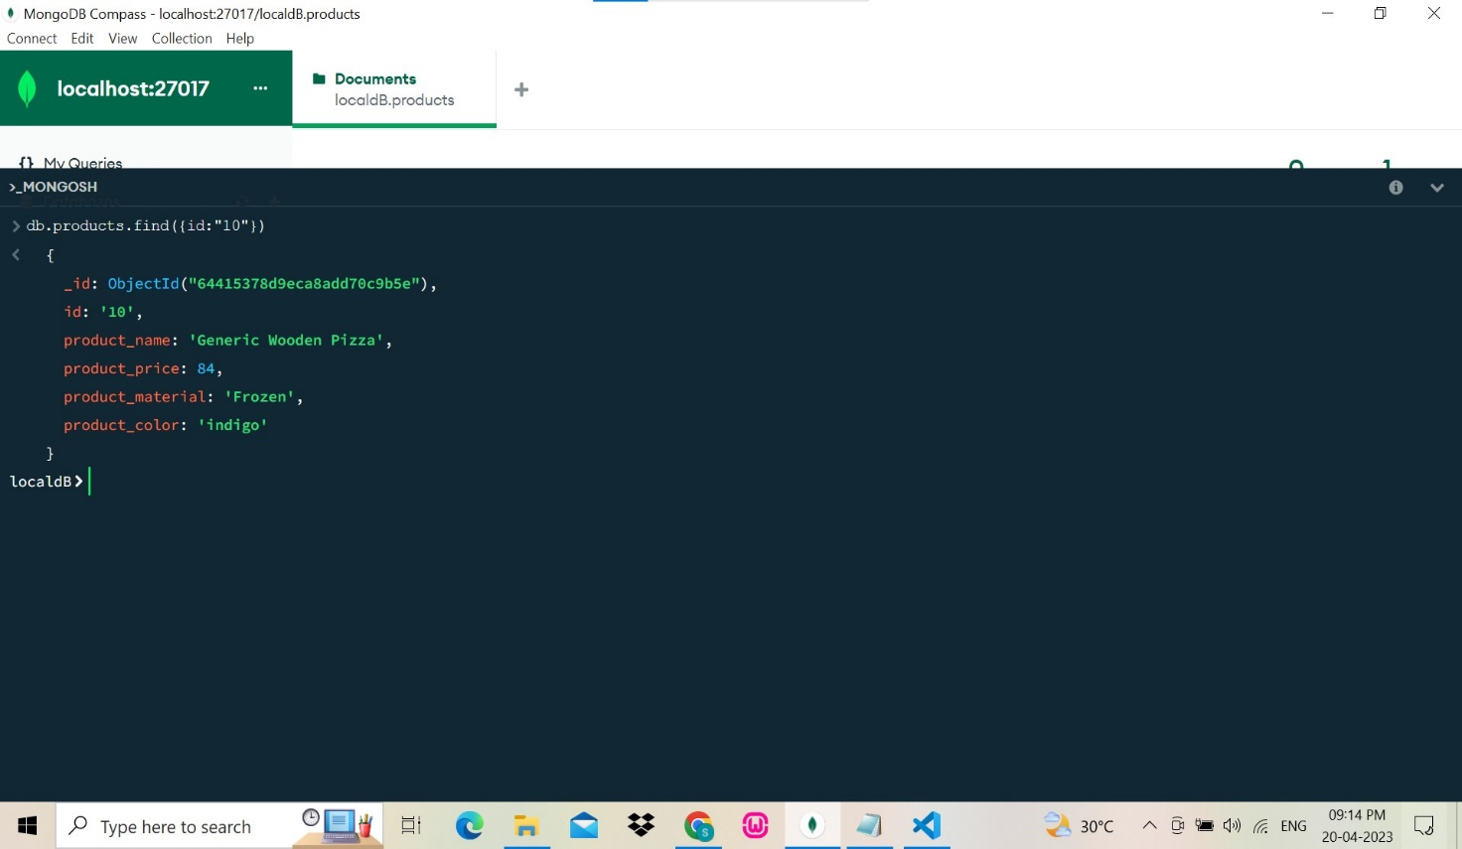

FIND PRODUCTS WITH MATERIAL SOFT

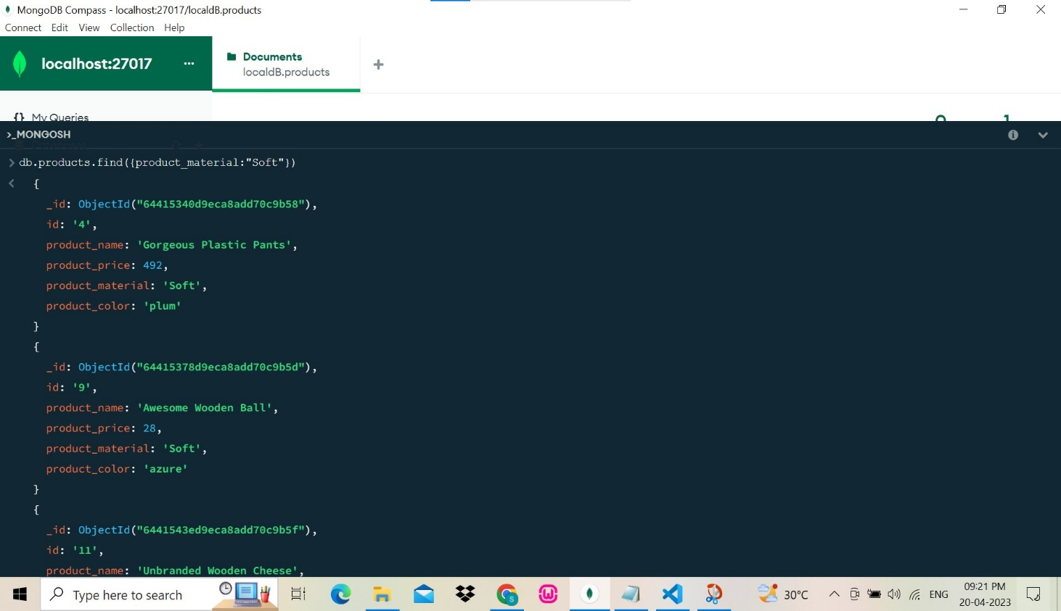

FIND PRODUCTS WITH COLOR INDIGO AND PRICE 492

