Task -2

Name: Vishnu Praveen Gude

NO: 16103389

1.UMKC VPN

a.I downloaded umkc vpn for windows 7 64 bit and installed it in my system

b.After that I logged in to vpn using my credentials

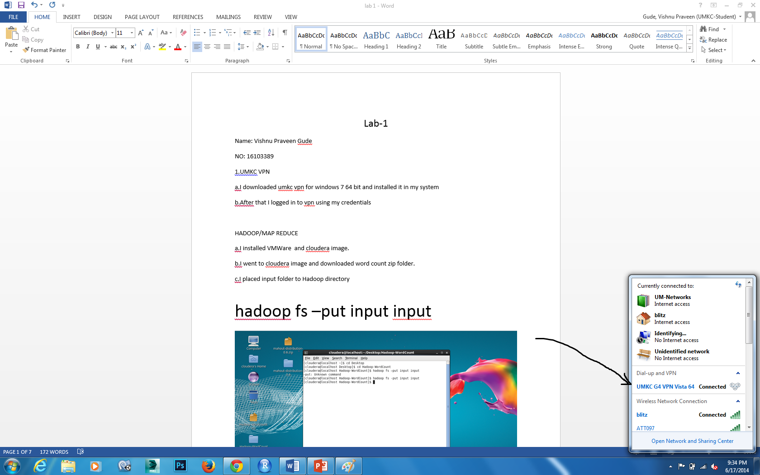

4.Now I Opened url http://134.193.136.127:7180

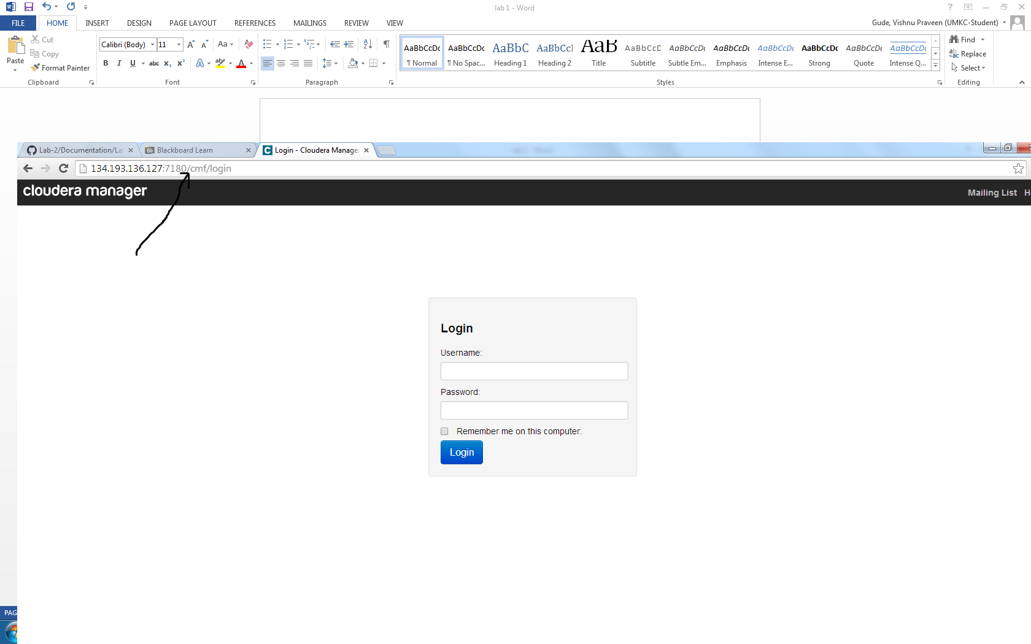

After logging in

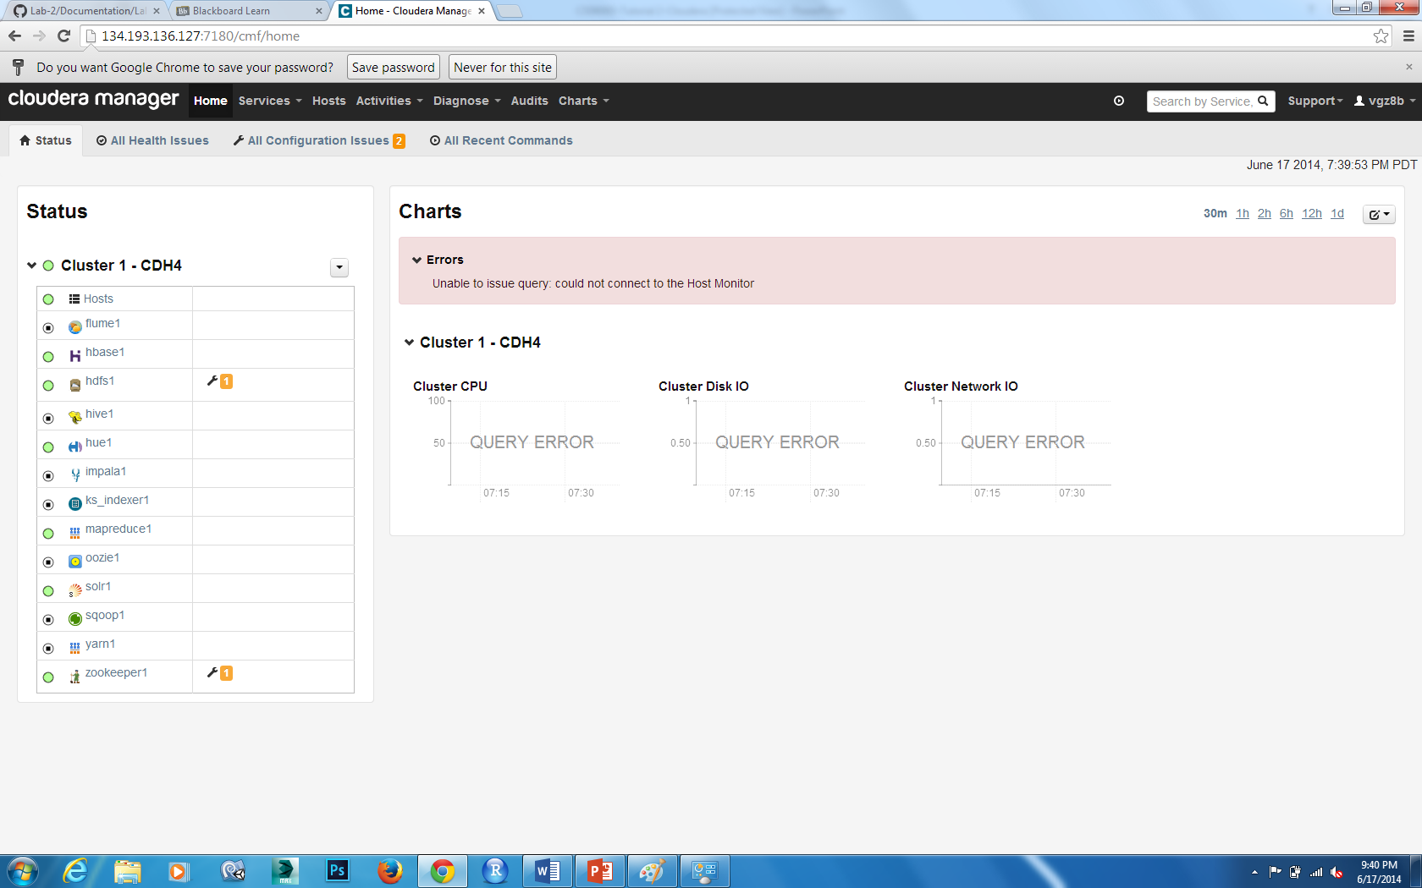

2.Installing my own cloudera

I downloaded VMWare workstation and cloudera quickstart 4.4.0.1 image and installed it



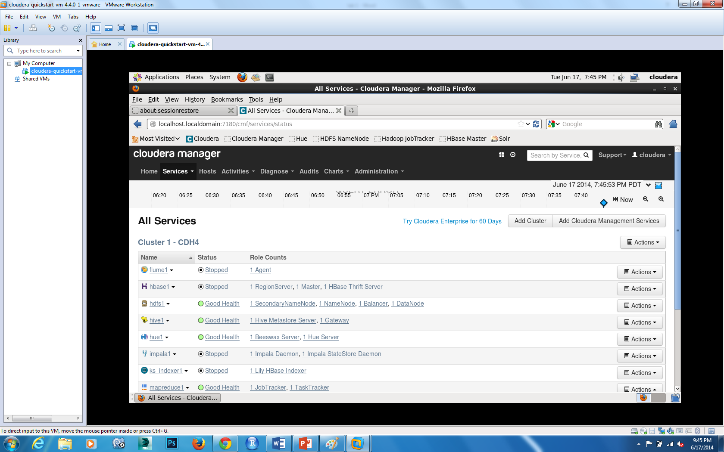

Transferring files to cloudera :

1.I downloaded and installed winscp.

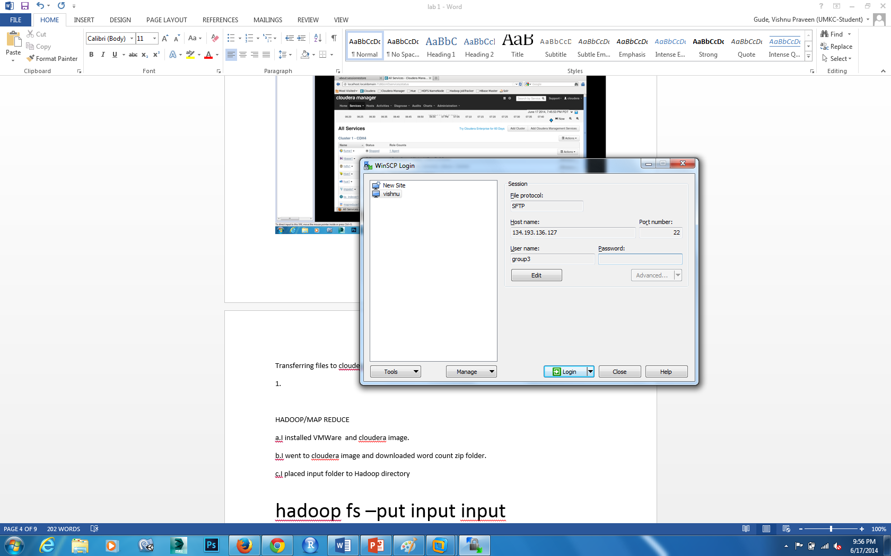

I logged in and connected to vpn

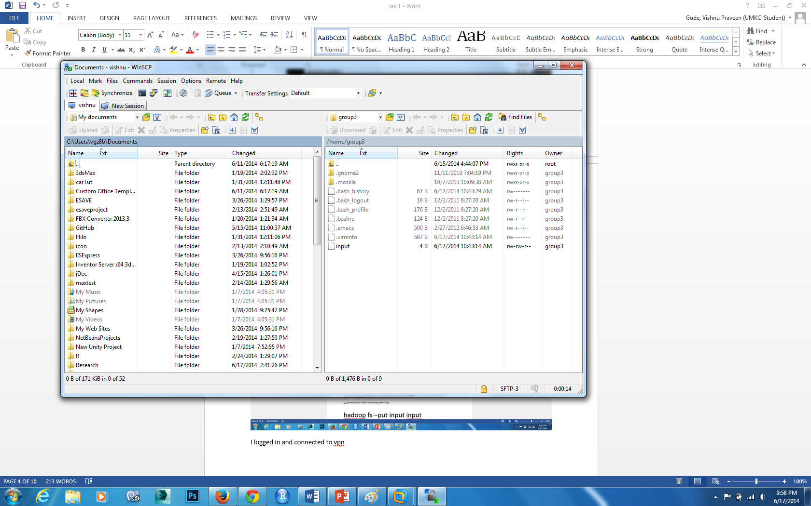

Now we can transfer files from local machine to cloudera server.

HADOOP/MAP REDUCE

a.I installed VMWare and cloudera image.

b.I went to cloudera image and downloaded word count zip folder.

c.I placed input folder to Hadoop directory

hadoop fs –put input input

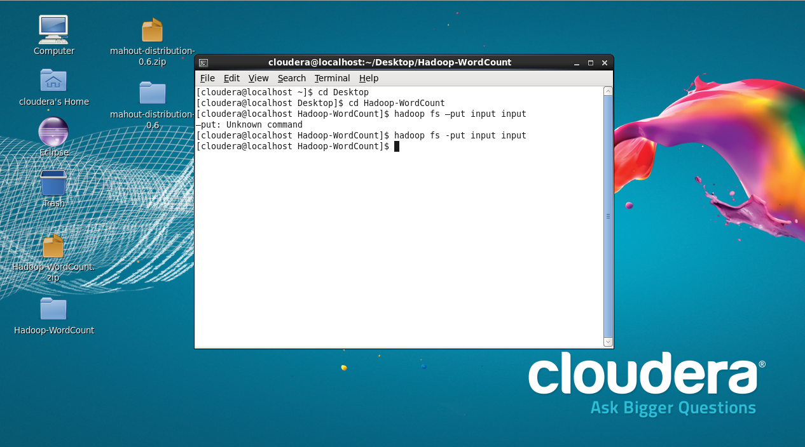

d.Then run Hadoop using

hadoop jar wordcount.jar WordCount input output1

e.view the result

hadoop fs -cat output1/\*

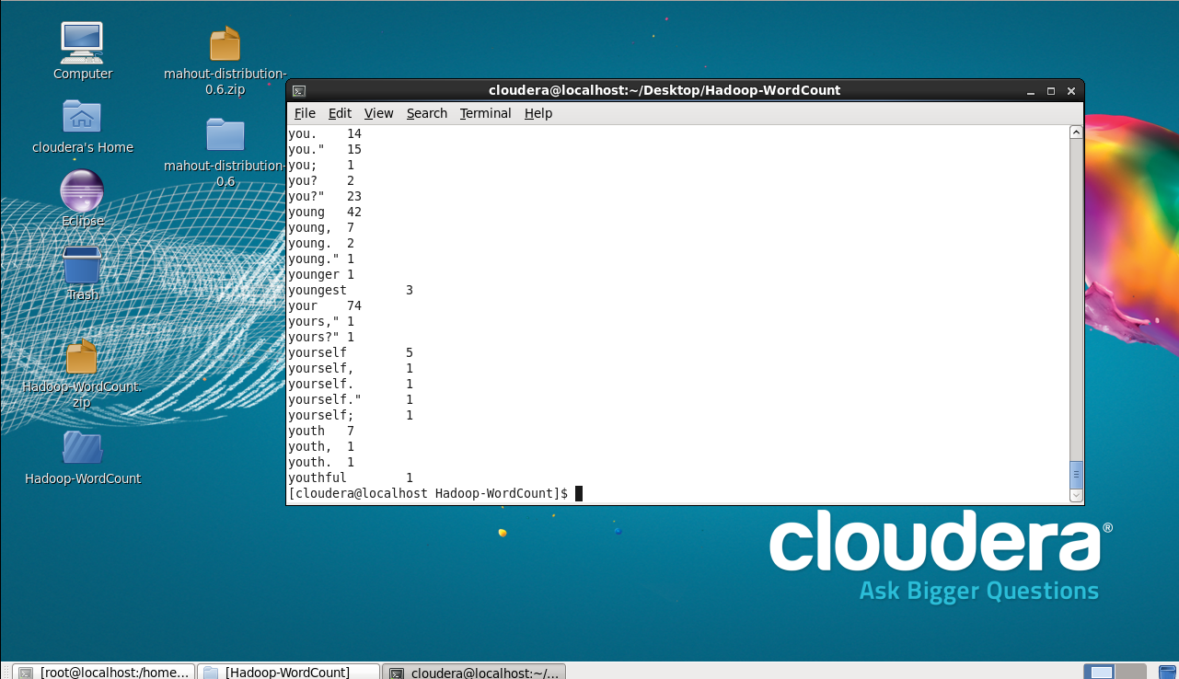

TASK -3

1.GITHUB ACCOUNT