Lab -2

Name:Vishnu Praveen Gude

Number : 16103389

**SensorTagData/Hbase Application:**

1. I downloaded SensorTag Application in the blackboard and imported to eclipse.
2. I modified the code to get humidity and temperature data along with GPS and accelerometer Data.
3. I will get a humtemp.txt file which contains humidity and temperature along with sensor.txt file.
4. Before running the program my Data folder is empty.

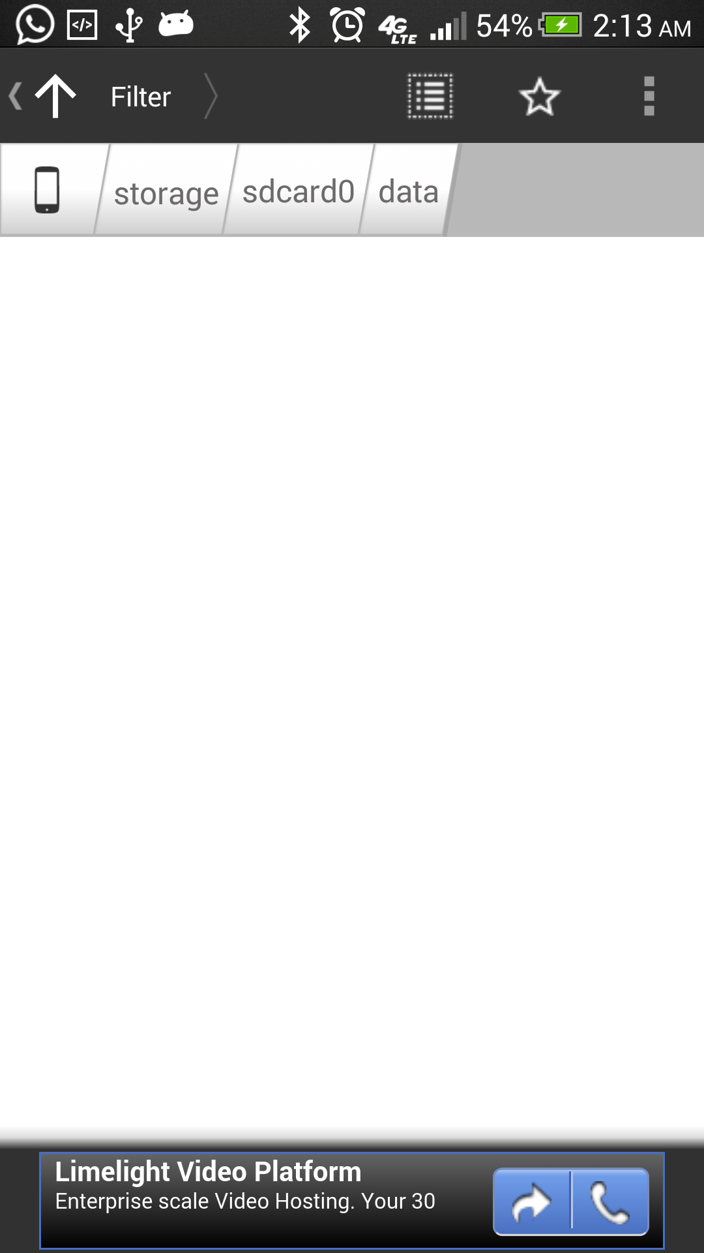

After Executing the program

After Exiting the application my data folder is

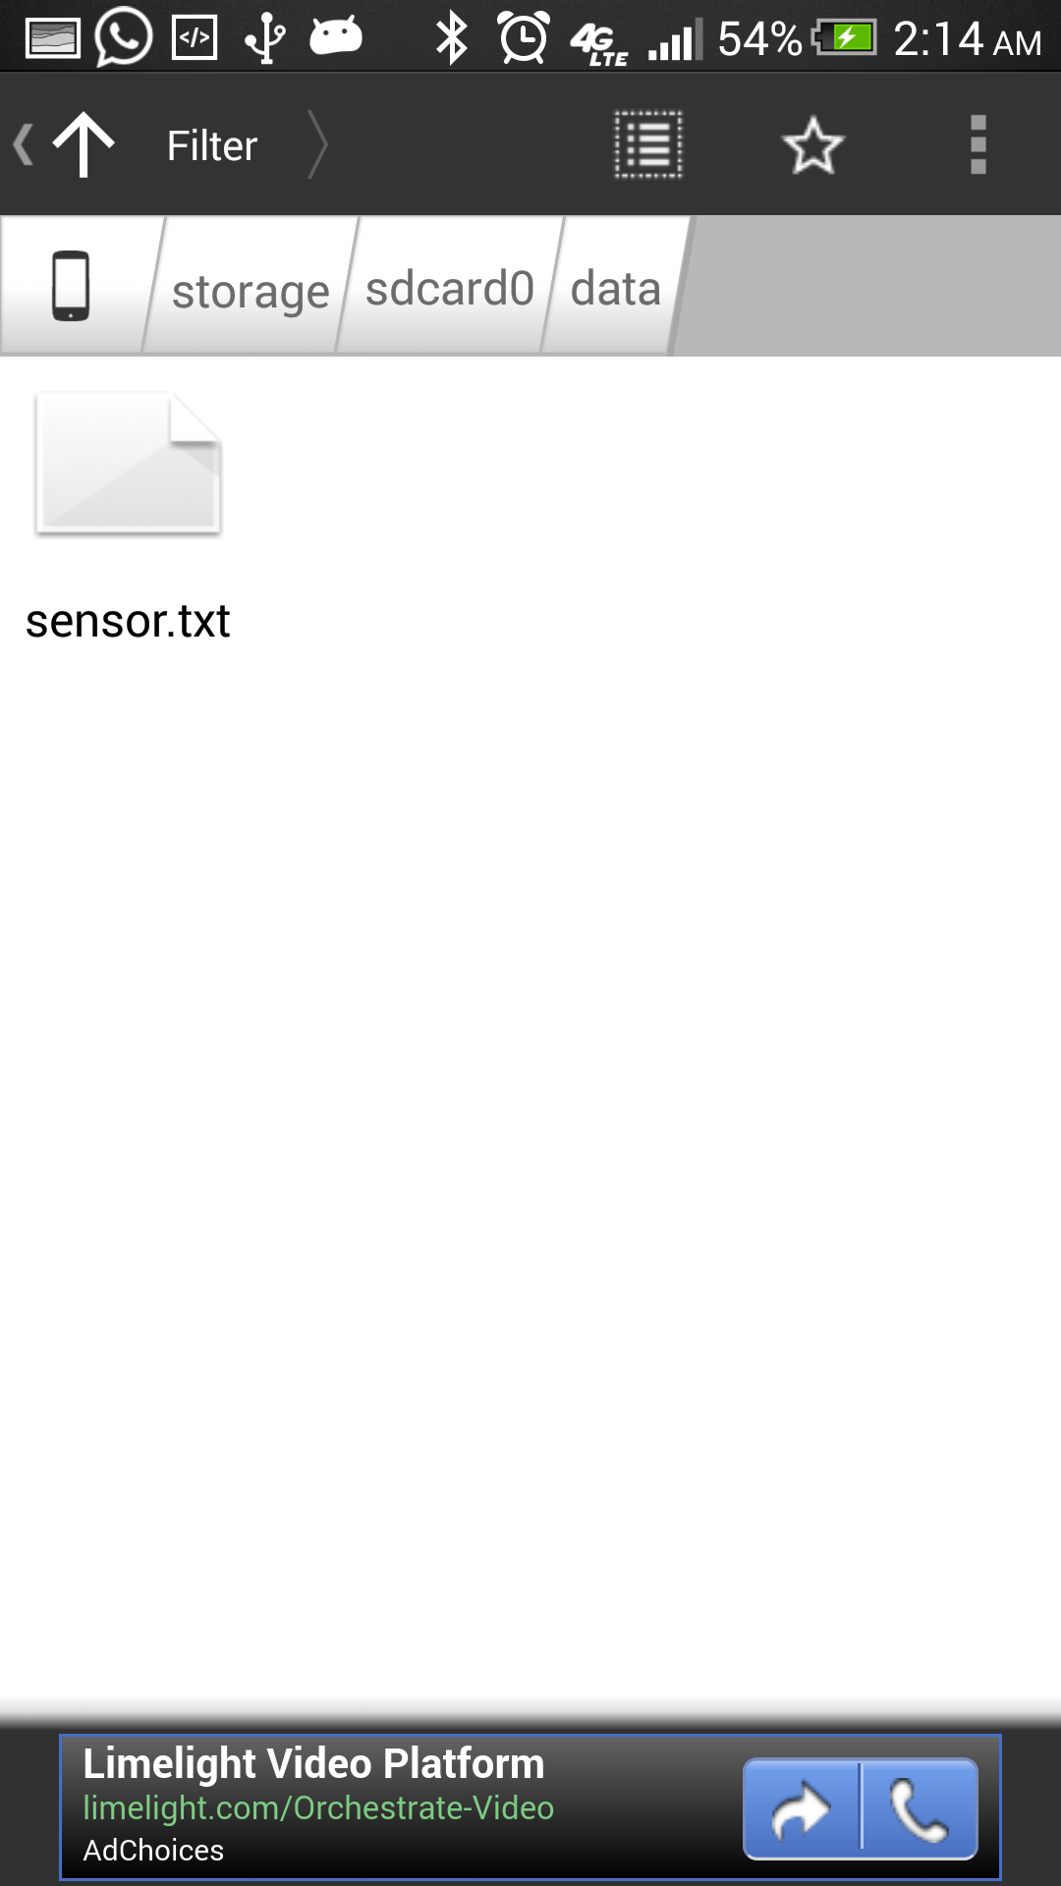

I opened that files in file editor

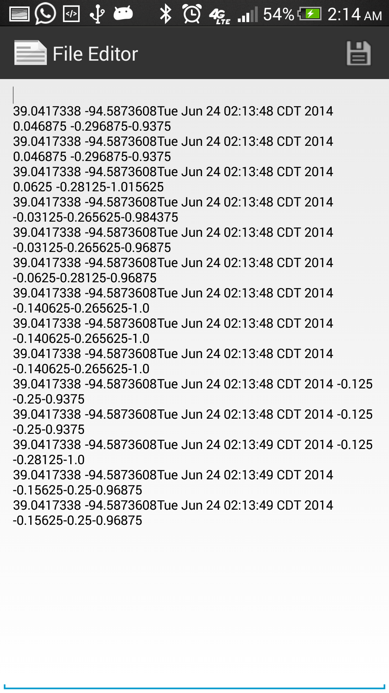

Now I saved that files into my system and separated the data with \t(Tab separator)

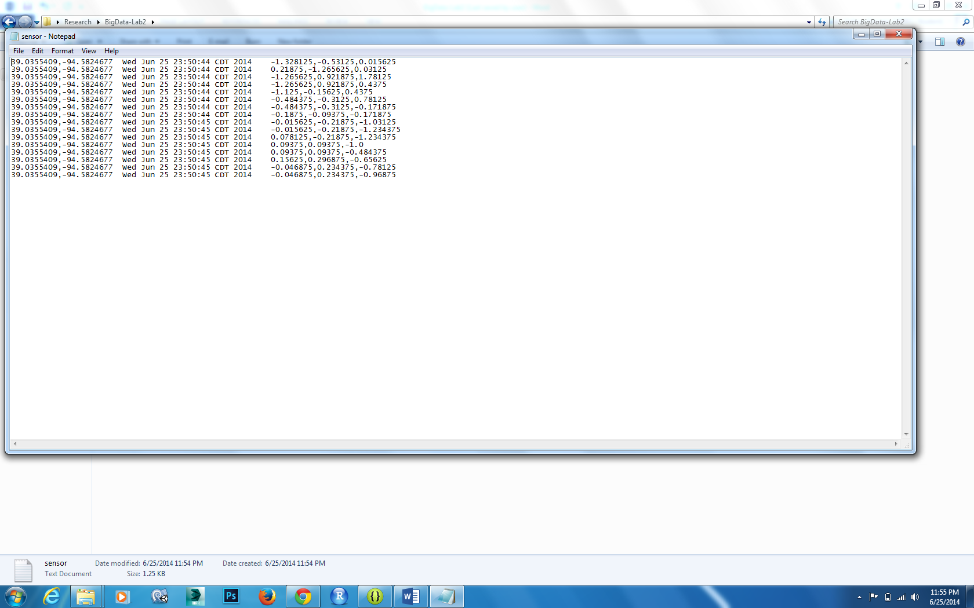

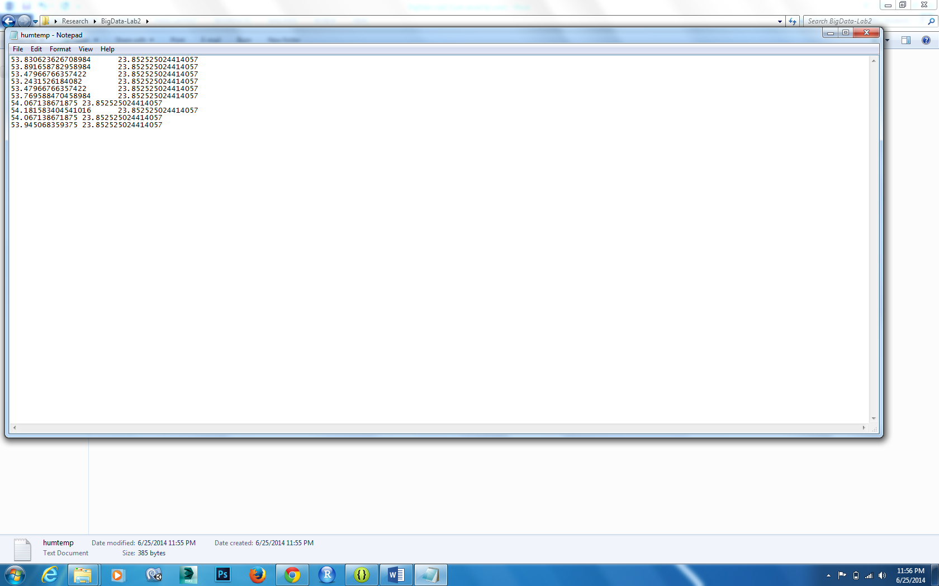

Now I downloaded the Hbase client application from blackboard and I imported into eclipse

I edited hosts file as administrator and added IP in last line

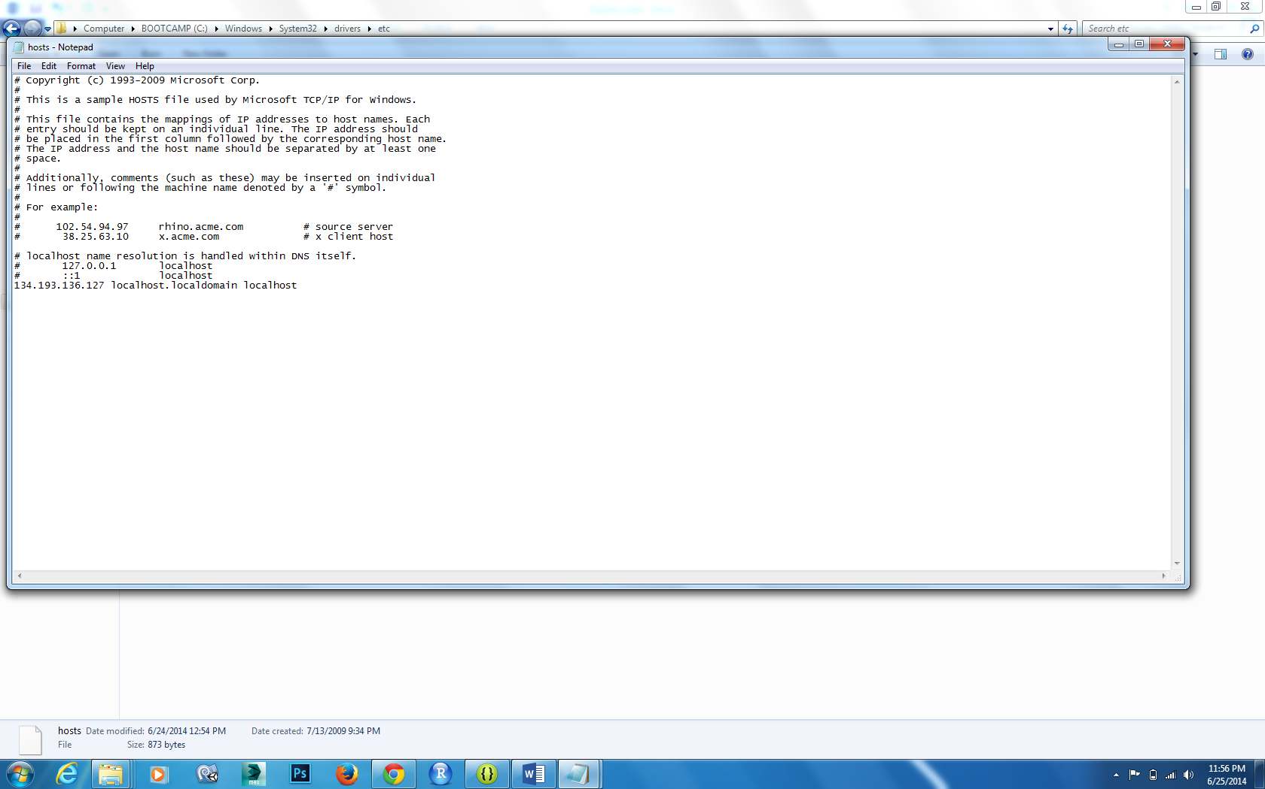

Now I made lot of changes to code to add my data structure in Hbase

Table Creation:

My table name is Vishnu_Lab2 and I created three column families inside the table Location,Date,AxisData,Humidity,Temperature

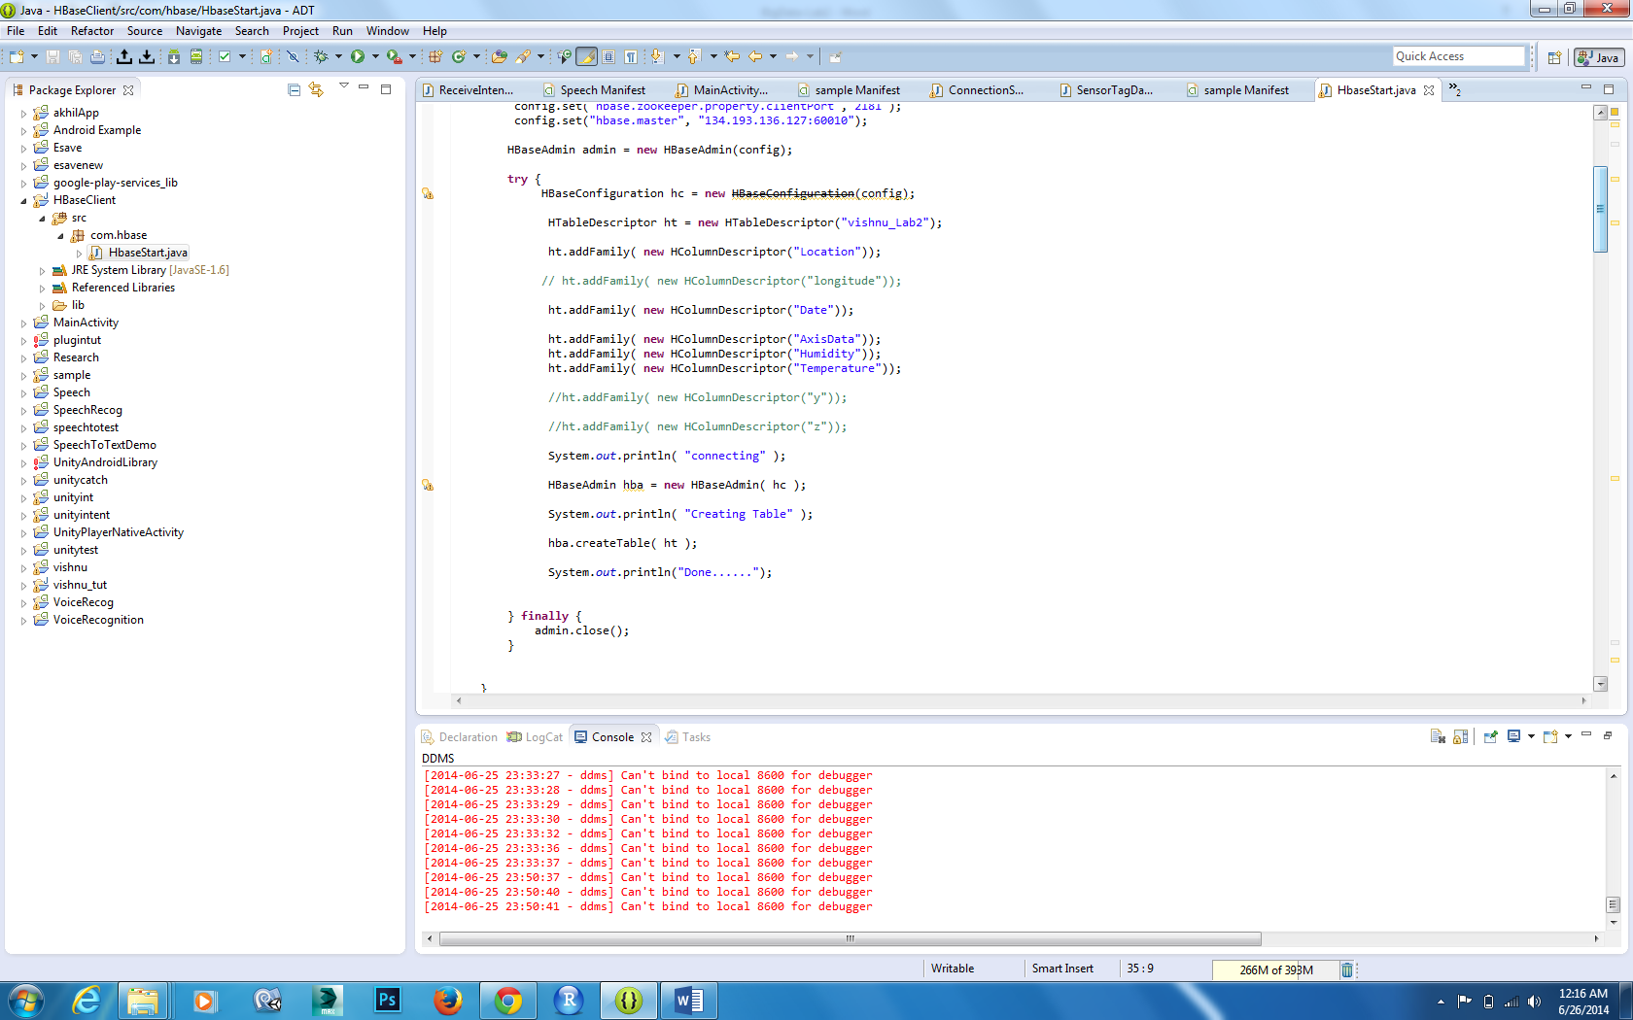

I added One row key “sensor” for all sensor related data

Now in column families I inserted family keys to each column family

Location : Longitude,Location:Latitude

Date : Timestamp

AxisData:X,AxisData,Y,AxisData:Z

Humidity:humidity

Temperature:temperature

Now inside the code sensor.txt and humtemp.txt data is taken into arrays by separator \t(Tab)

Now I inserted to colum families with Row key and Family Keys

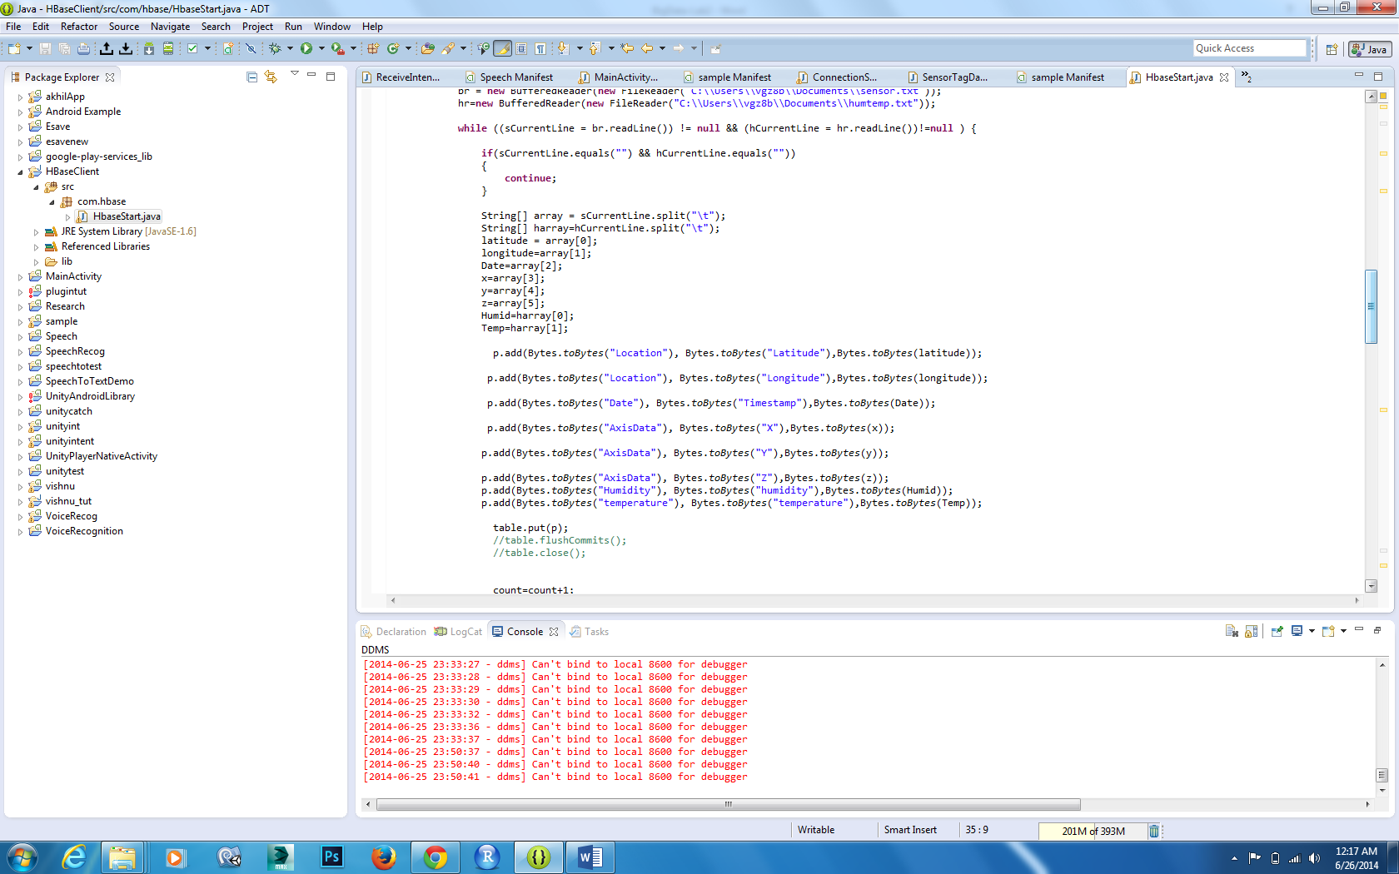

Retrieve Data:

Now Based on My Row key and Column Keys I retrieved Data and displayed to console .

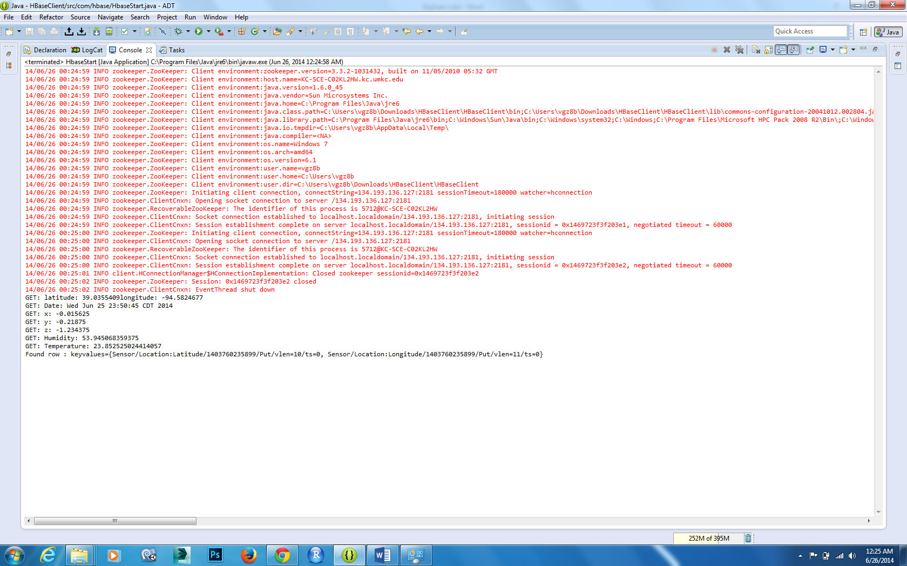

Now I used Scan class to scan the rows

I had only one row so the row sensor is displayed to console



In this way we can push sensortag data to Hbase tables and we can retrieve data and use that data in various applications easily.