ASSIGNMENT-3

Name:Vishnu Praveen Gude

No:16103389

1.From Lab -2 we will get a text file with Gps, Timestamp, Accelerometer, humidity, temperature Data with tab separated.

2. Now I saved the text file and I built a webservice with four functions hbasecreate, hbaseinsert, hbaseretrieveall, hbasedelete1 by referring HbaseWS project in Blackboard.

3.I changed the Code to make it create 5 column families and insert data into 5 column families.

4..I deployed it in glassfish server and run on server

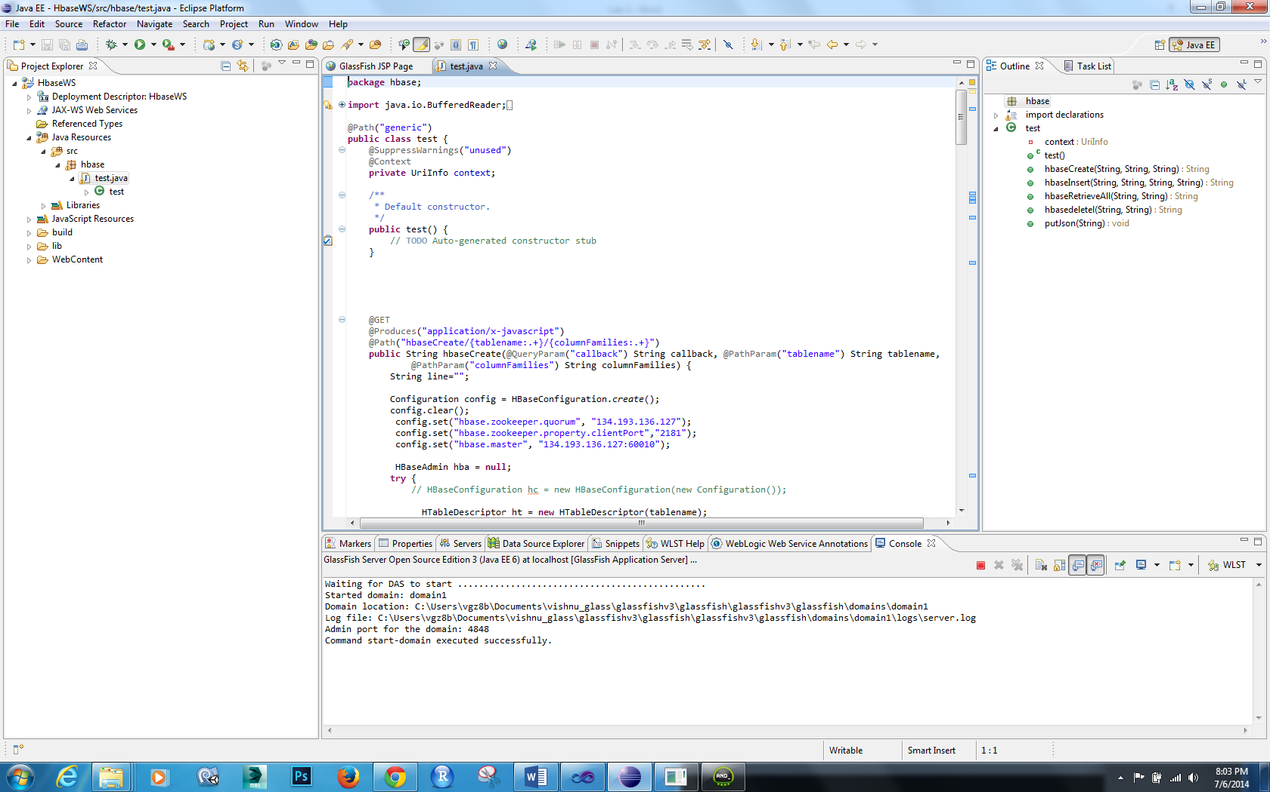

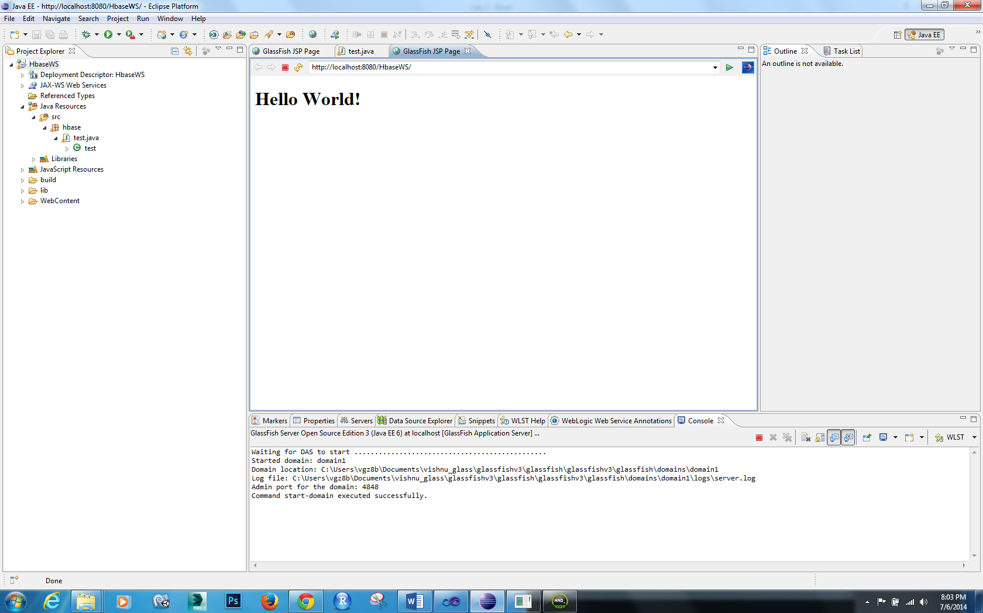

Lets try in browser

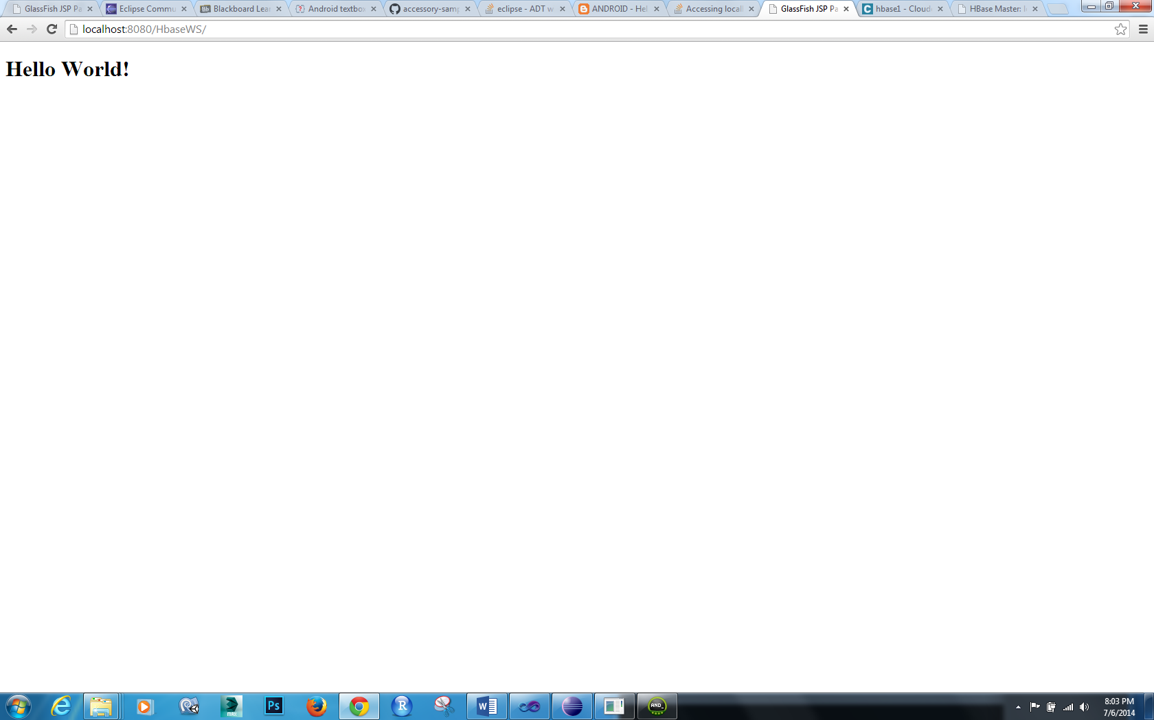

OK,now webservices are ready

Now I created an android application project and started an activity

I created 4 button and one textfiled and one textview

I have written four functions for create,insert,retrieve and delete operations on Hbase with our webservice.

I changed localhost url to 10.0.2.2. because I want to test in emulator.

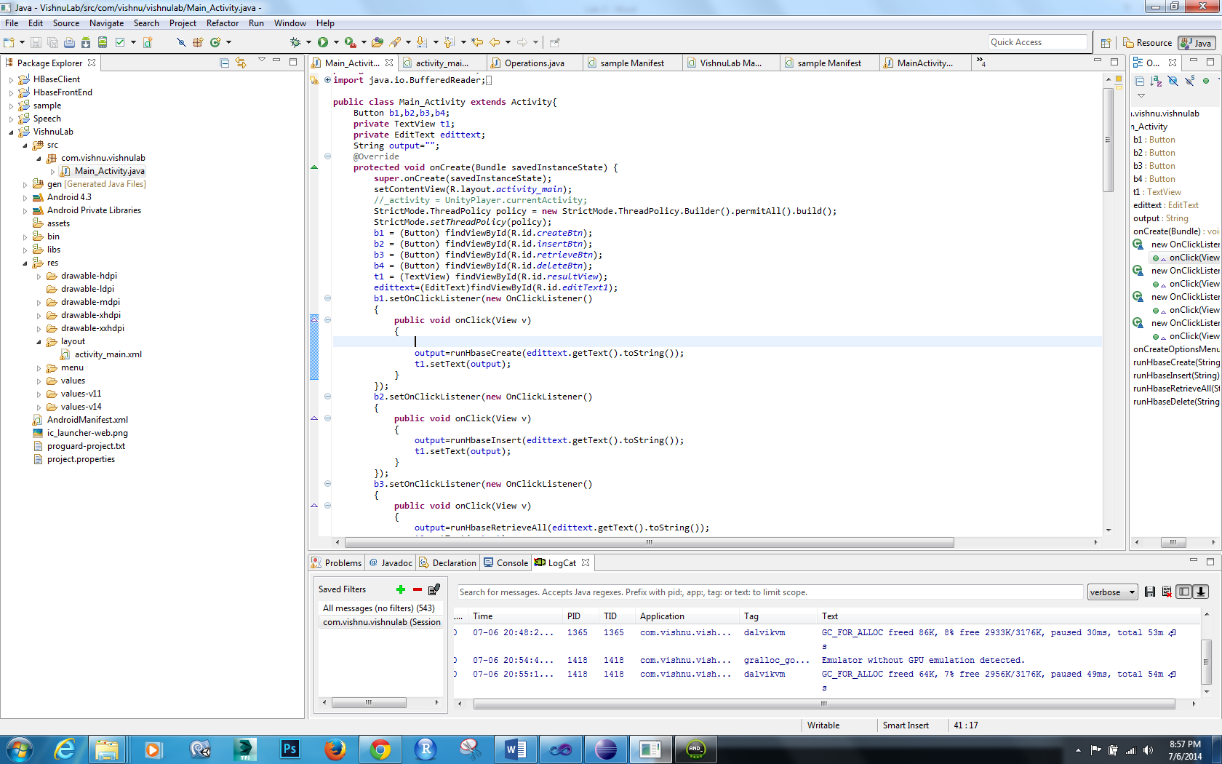

Output looks like

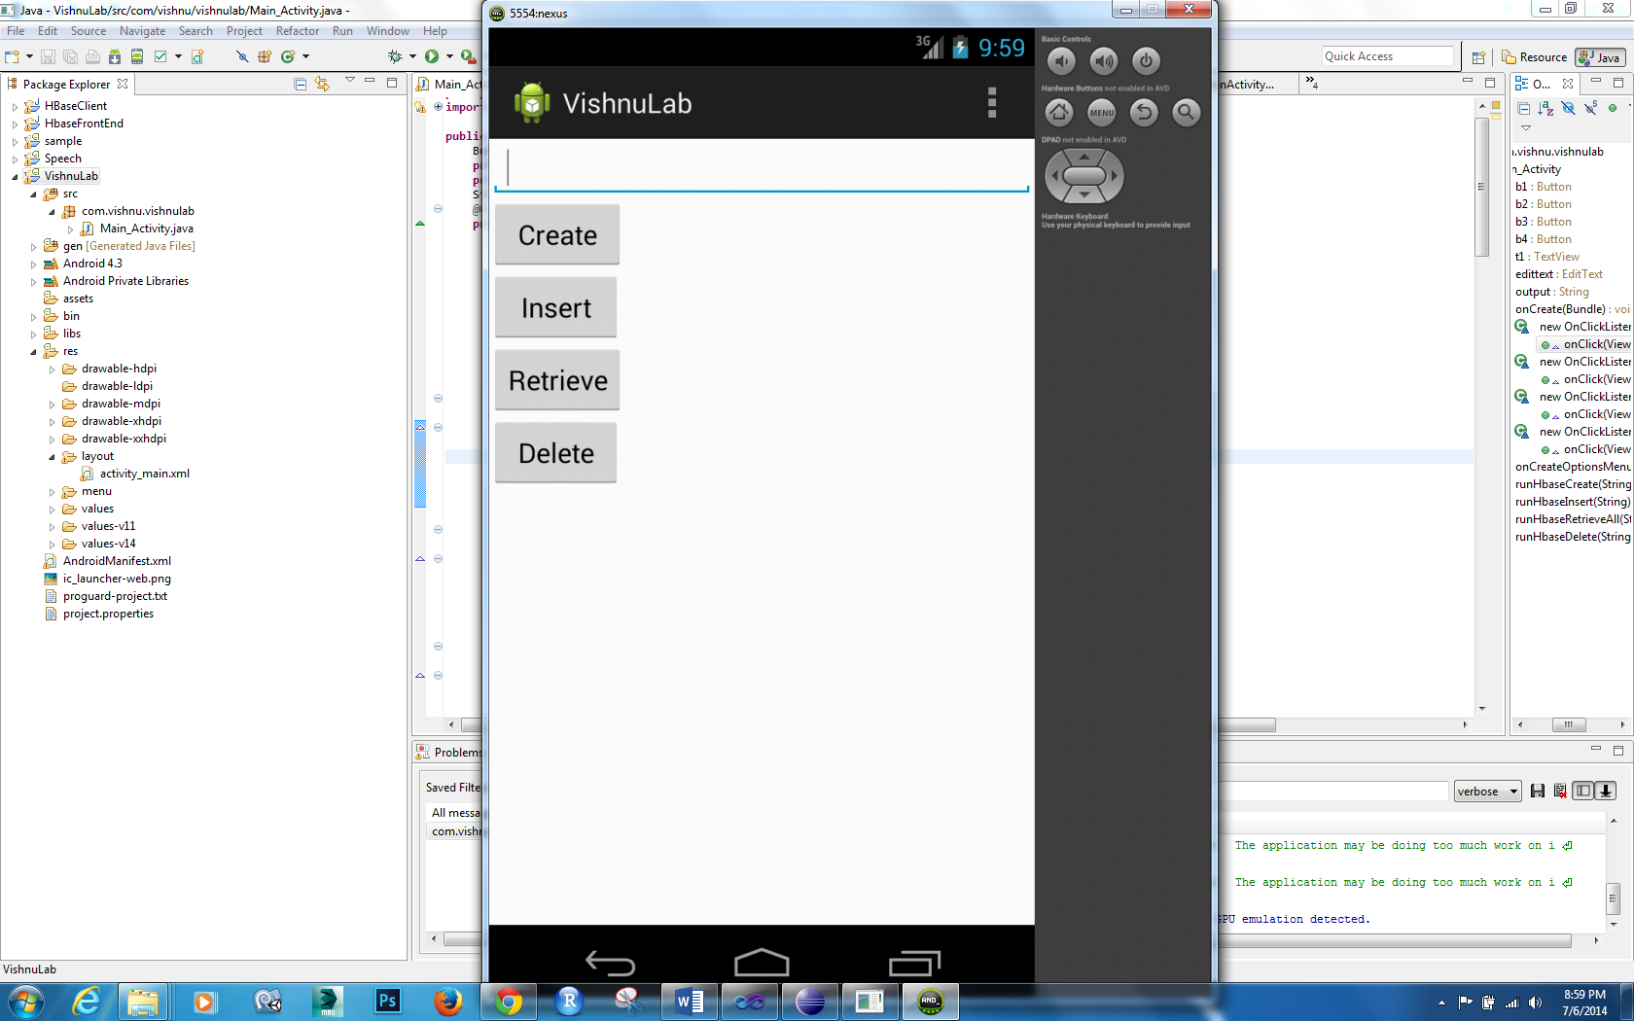

We have to write the name of the table we want to create and then hit create

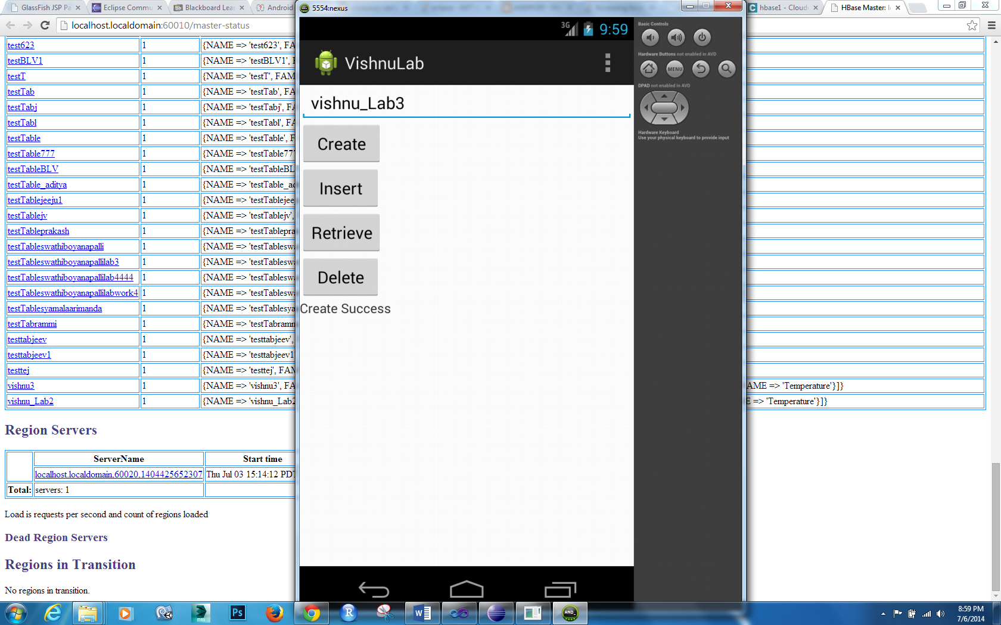

Create success indicates it is created the table lets check in cloudera

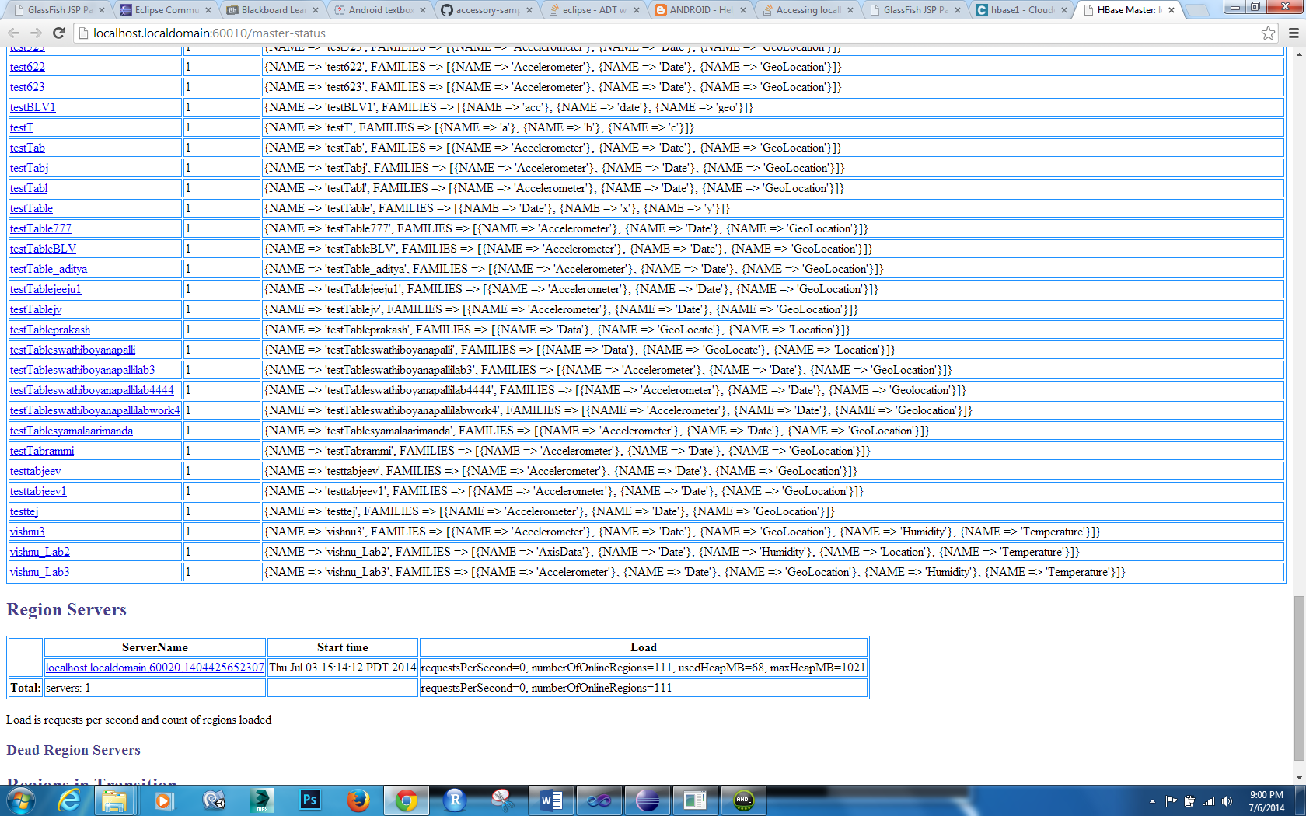

Yes its there

Then if I hit insert

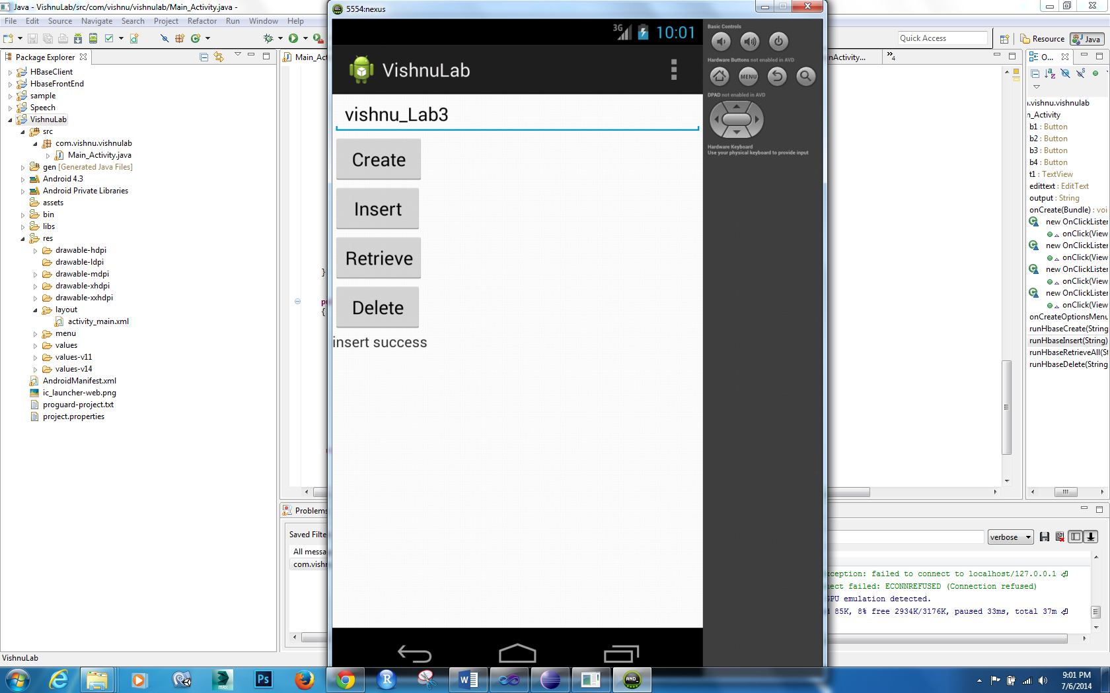

If I hit retrieve then it should display inserted data into textview

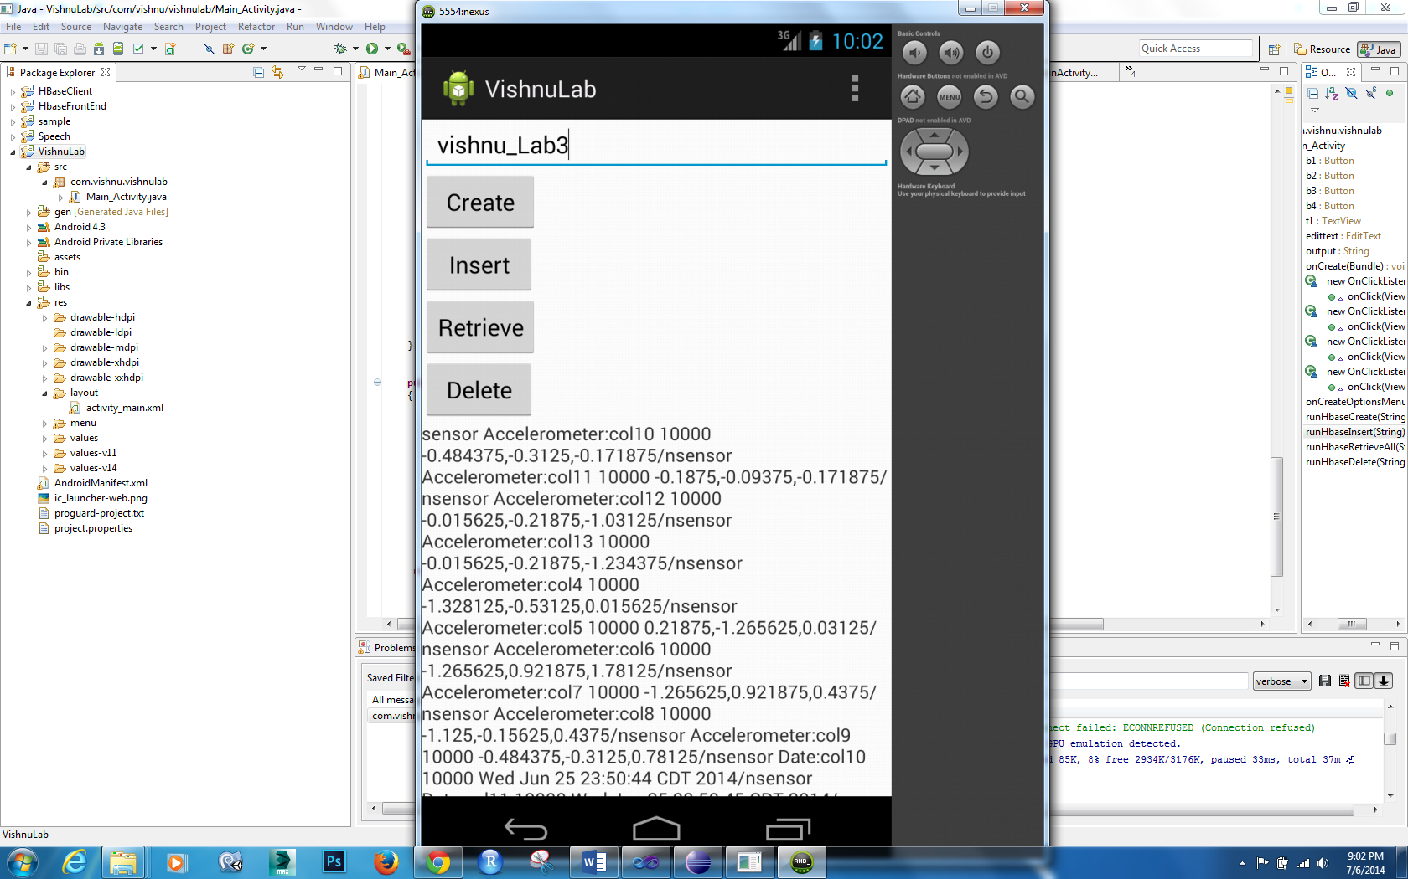

Similarly delete operation also gets done.