LAB – 4

Vishnu Praveen Gude

16103389

1.I downloaded HMMWS Dynamic web project and imported into Eclipse and Run on GlassFish server to start webserver.

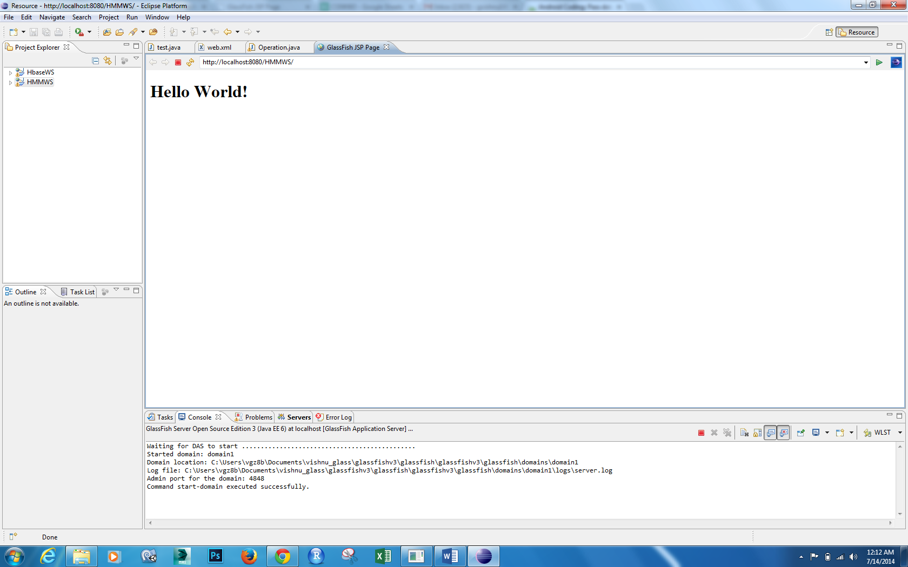

Now We have to train Gestures by collecting and saving data into txt files

Now I collected three types of Gesture data in txt files using my App i.e Punch,Left to Right,Right to left gesturs

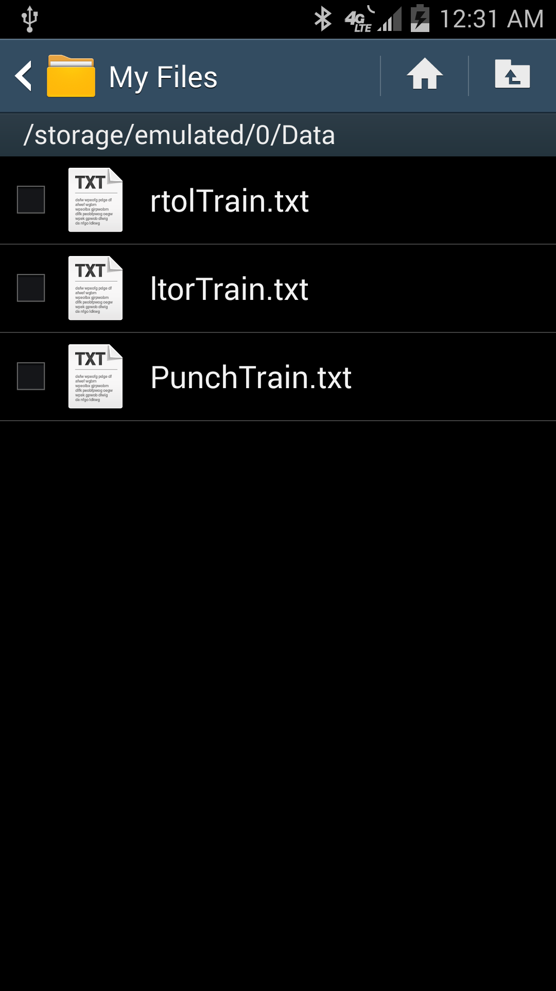

Now generate te Test Gesture files too for testing

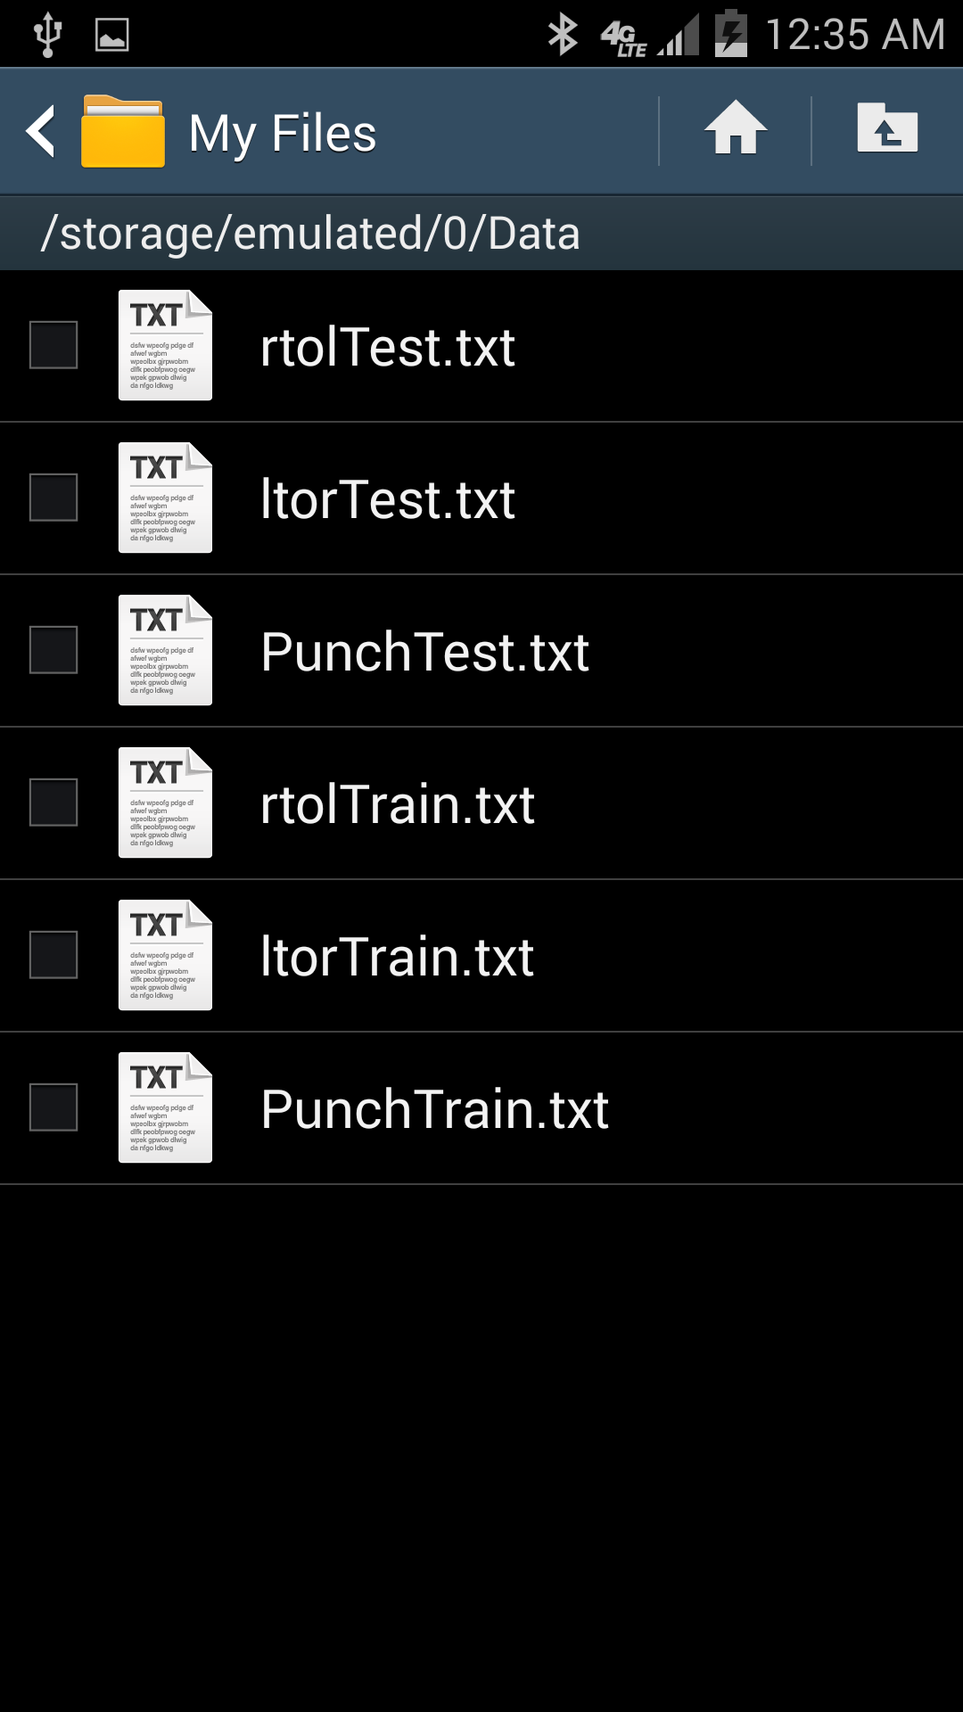

Now copied files into localhost and started HMMWS webservice in GlassFish

First generate seq files for training data

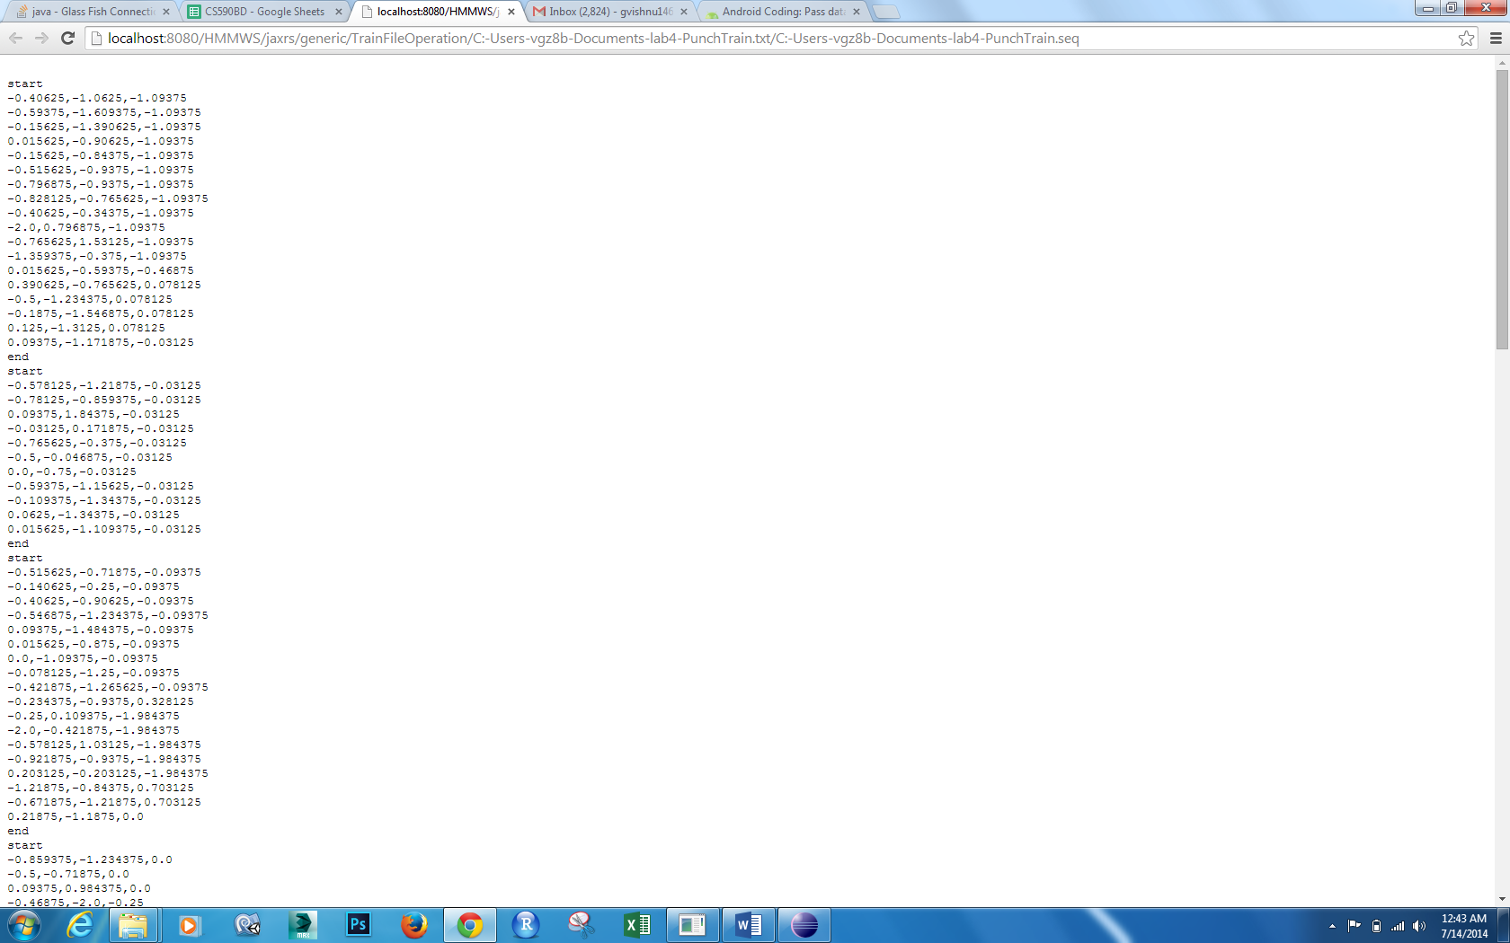

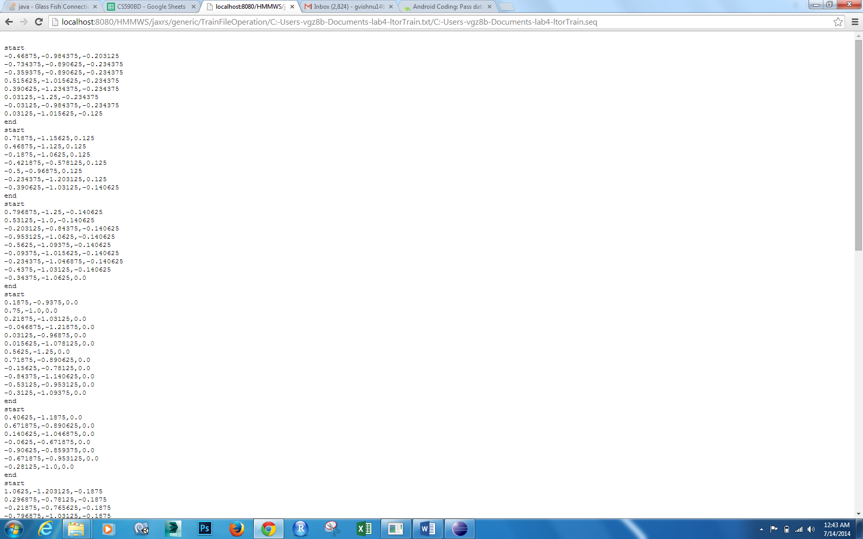

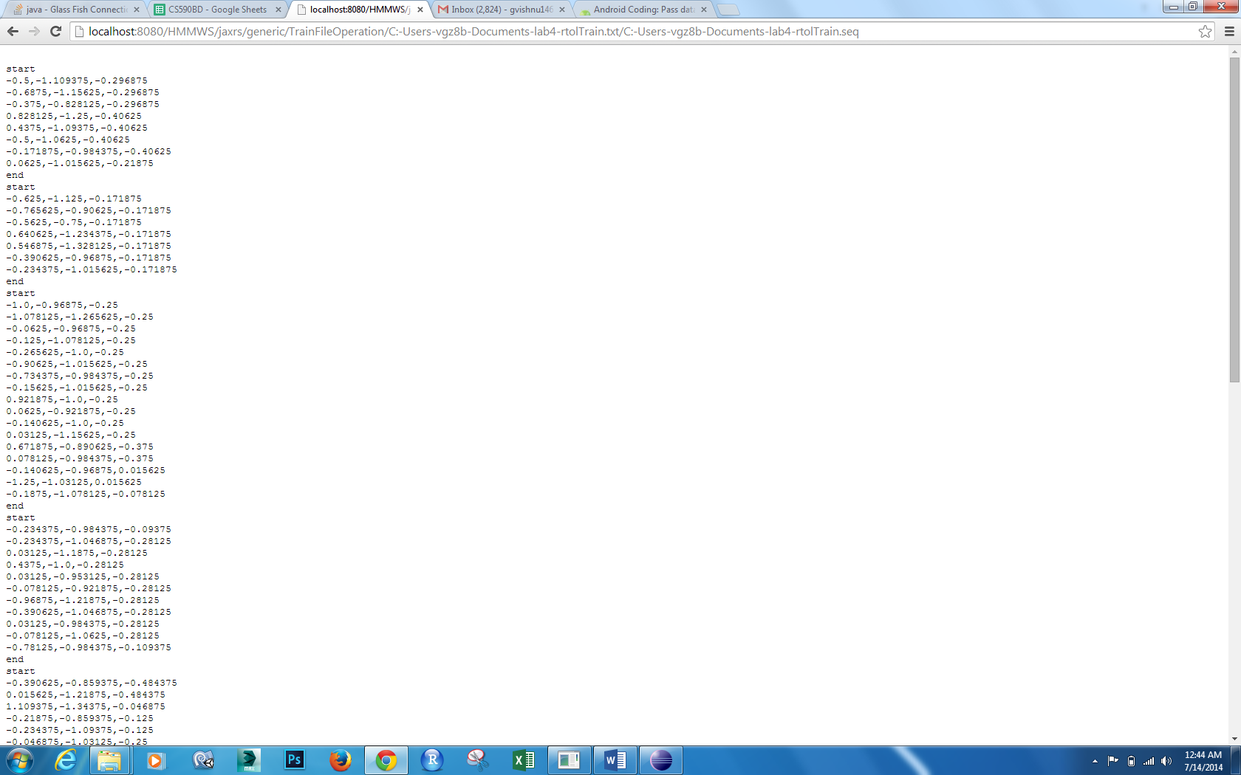

Now Generate Seq files for Testing Data

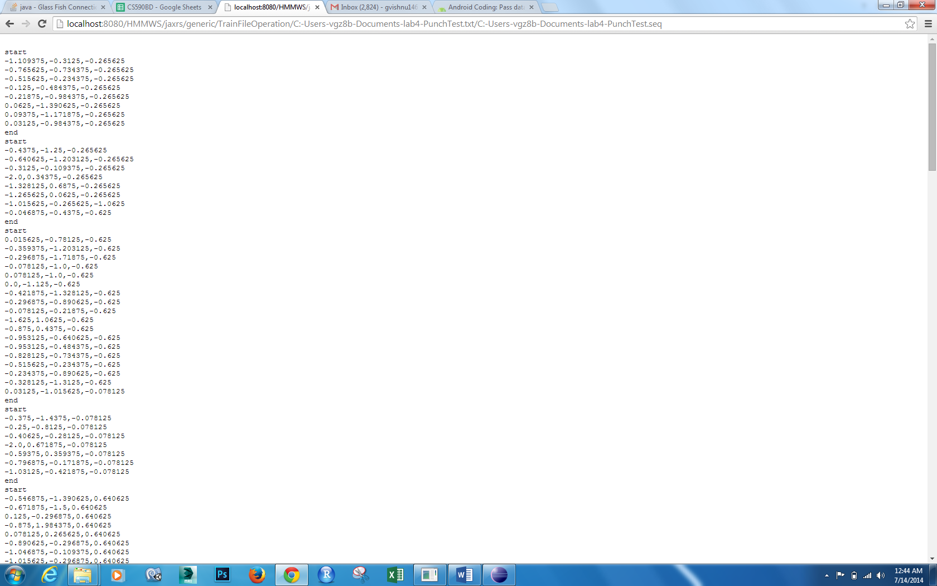

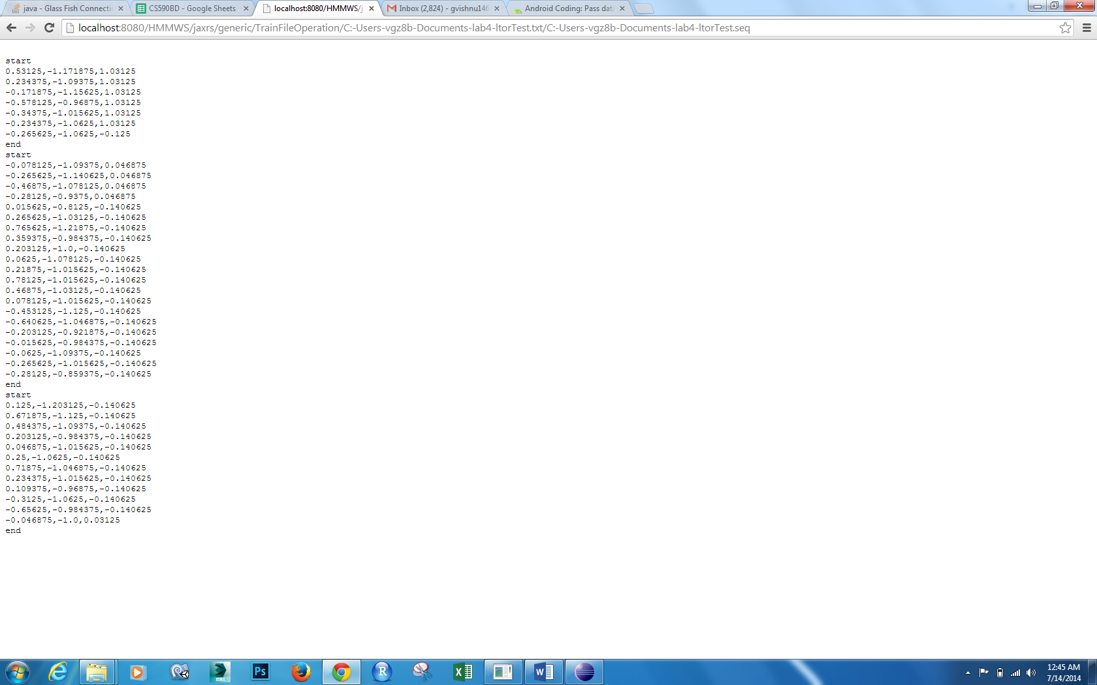

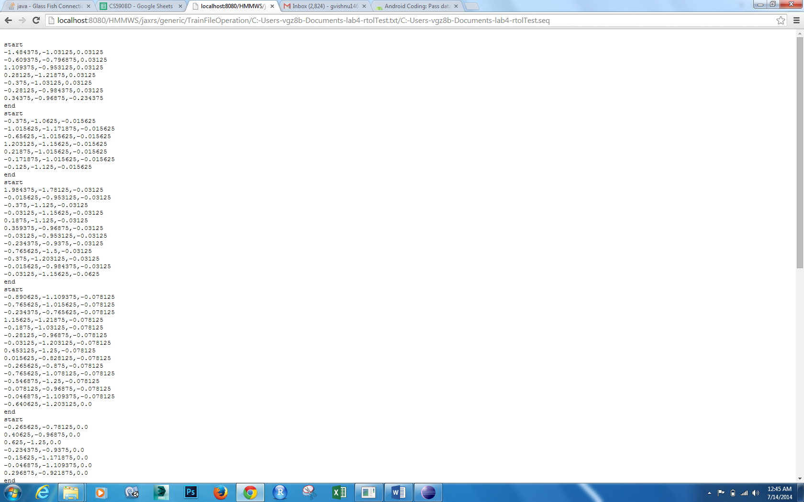

Now Generated a Combination.txt by doing three gestures one after other

Now generated seq file for Combination.txt

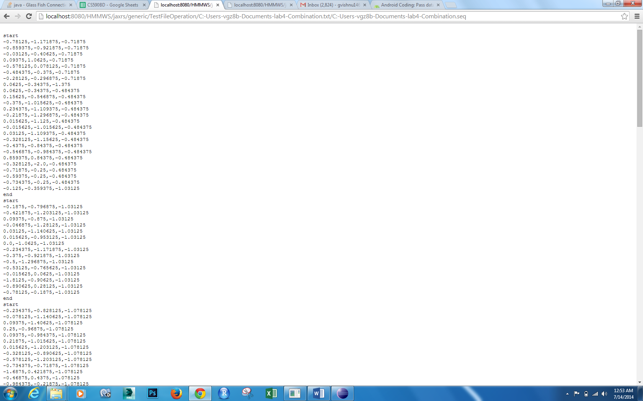

Now test with Webservice HMMTrainingTestThree

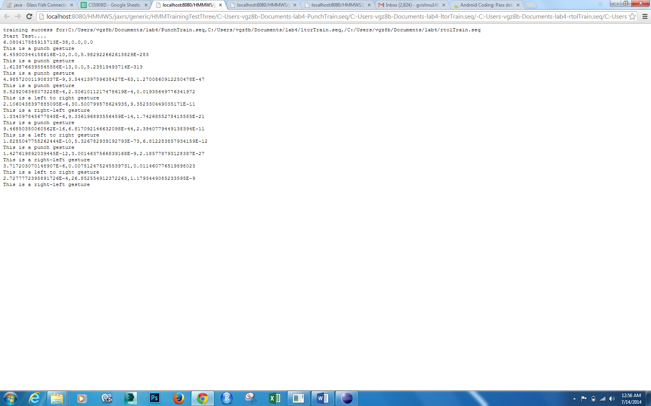

From the output we can see It is detected as punch,left to right and right to left along with probabilities.

Now for the fourth webservice HMMTrainingTest Inside the code changed split deliminator from ‘:’ to ‘::’ because our localhostlink already contains ‘:’

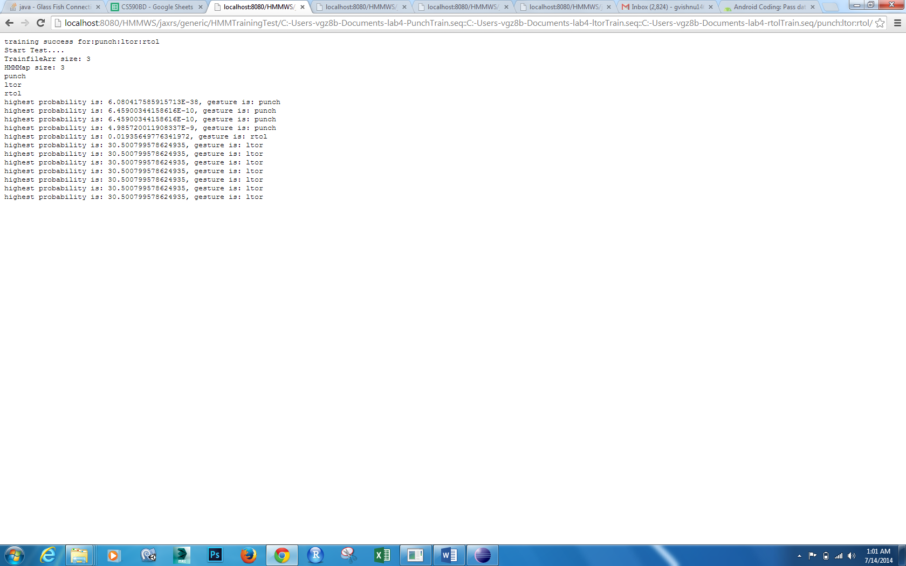

In this way we can detect train gestures and then test them .