**LAB -5**

Name : Vishnu Praveen Gude

Number : 16103389

1.Using SensorTest App I collected data for two gestures punch and circle.

2.In HMMWS webservice App I made some changes and started glassfish server

3.Now,If I run the TrainingFIleOperation from webservice

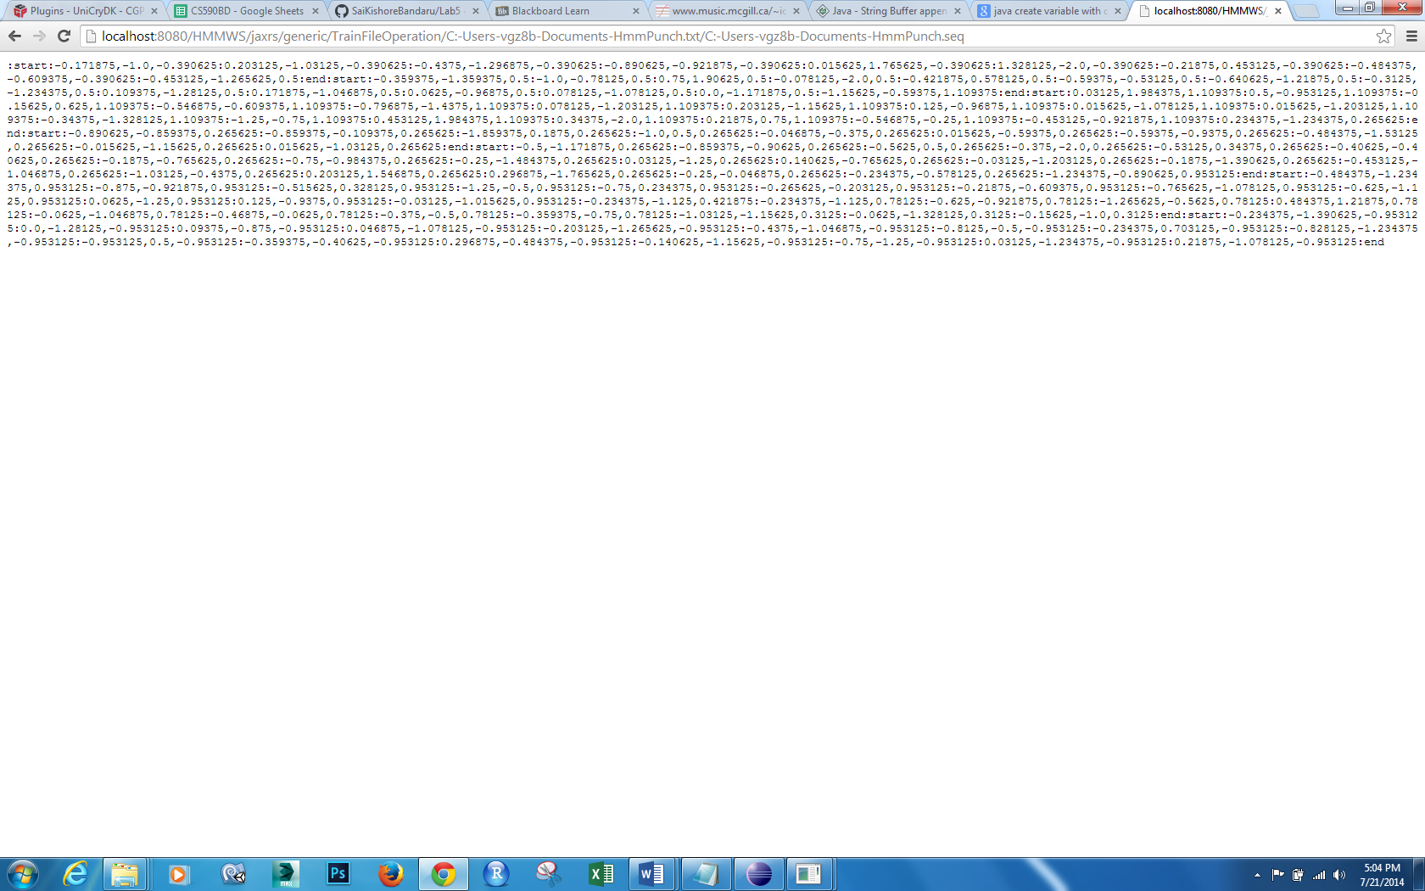

I displayed the sequence file data with ‘:’ separator for data because I am gonna use this data in my service in android app.

Similarly I generated for circle data too

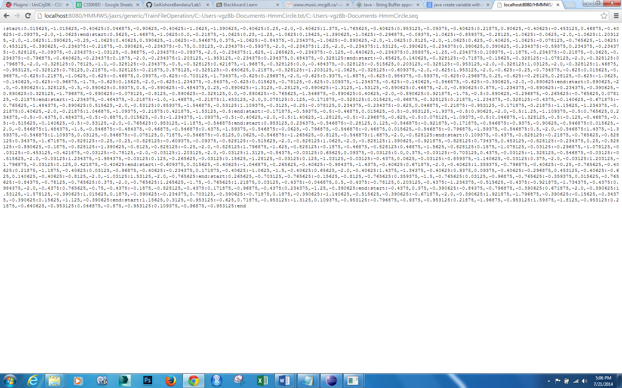

4.Now I downloaded Voice Fighter Android open source game from GutHub

<https://github.com/czyang/Voice-Fighter-Android>

The Game is based on android 2.3 version and some functions are deprecated so I made lot of changes

Working of game is If we say pah airplane should release a bullet and if we say Ahh then it should get down.

Now I Added a DataService which I made for data collection to the android app to broadcast Accelerometer data to MainGame activity.

Now Inside the dataservice I added HMMtrain and testing methods which will take the train data which I got from webservice and HMMtest will take the data from accelerometer and get the result out of punch and circle continuously.

Inside HMMtest method I send a broadcast intent to maingame activity which will say punch or circle.

Then inside the maingame activity I added a receiver intent such that it will take data from Sender Intent which is punch or circle.

Then from that data I Updated game such that Airplane will get down if it is punch and it releases bullet if it is circle.

Screenshots:

When we start the app, see the console it starts training data with HMM and in parallel it will scan for BLE devices.



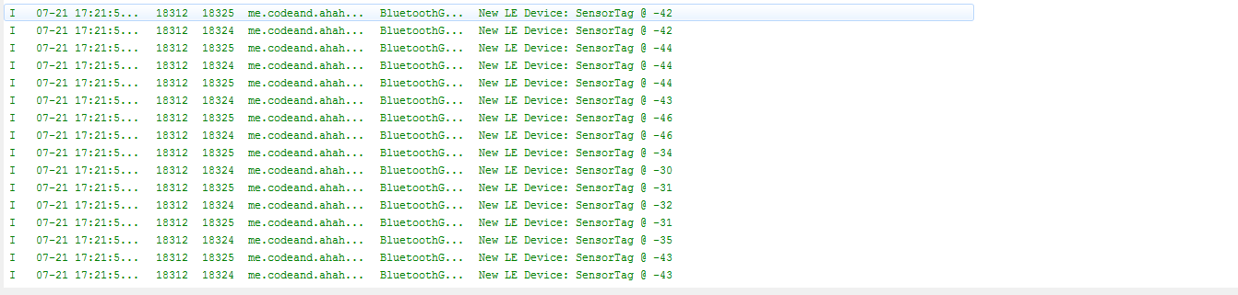

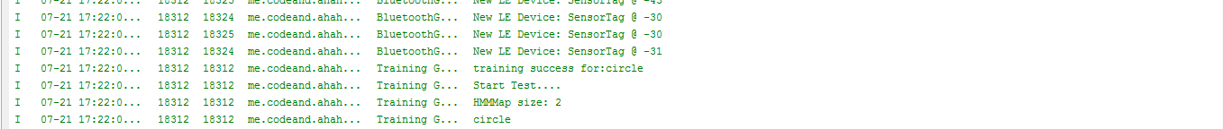

Receiver in MainGame Activity

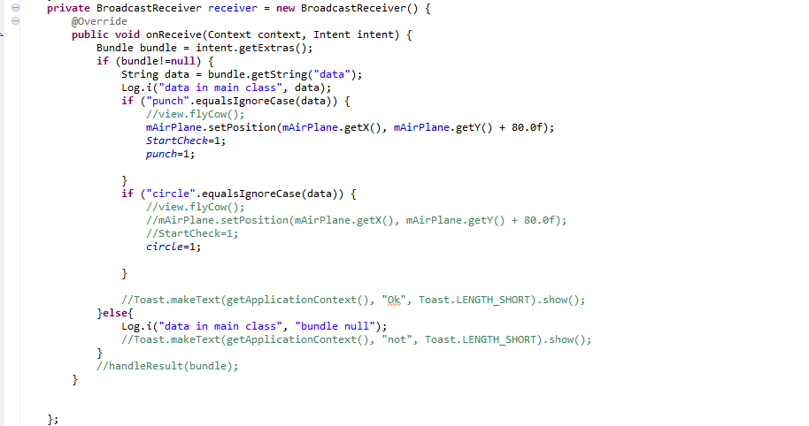

After Starting App

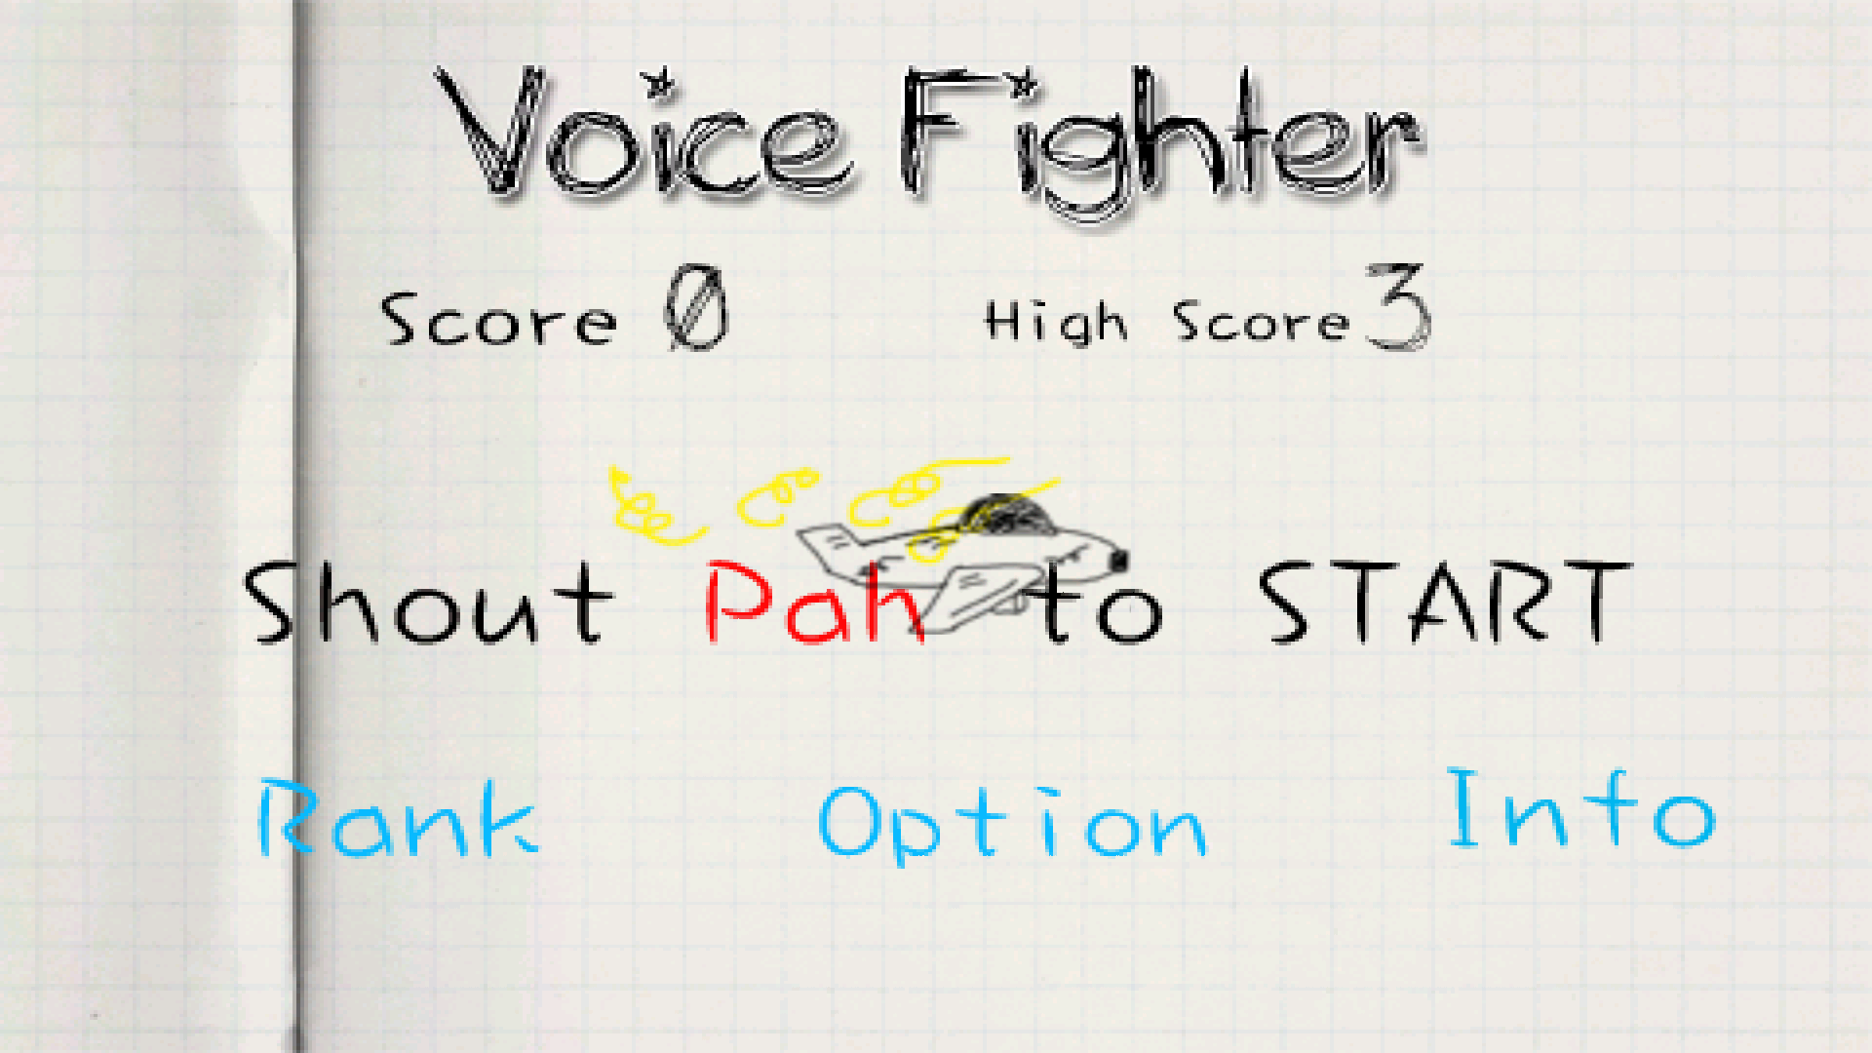

After Doing punch gesture it will start automatically

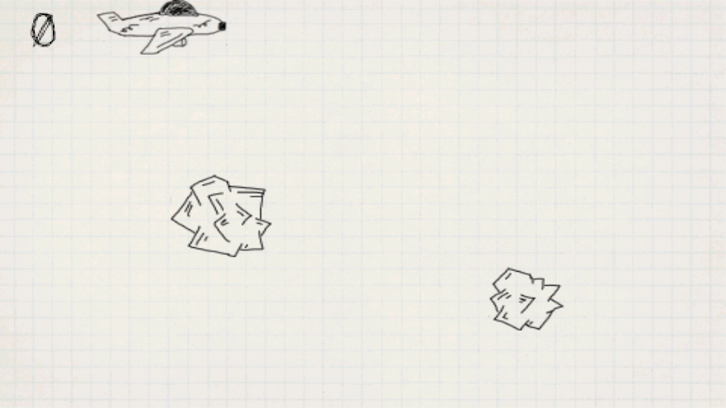

Now in game if we punch then airplane get down and if we do circle then it release bullet to break rocks.

That’s it.