**Lab -6**

Name : Vishnu Praveen Gude

Number : 16103389

1. In lab I have taken open source Game and based on Gestures Game will work on….

2. Then In this Lab, I have taken Achart Library to show the graphs for Gestures.

3. I added achartengine library to Lab 5 Voice Fighter Game to show pie chart of how many times the Gestures punch and circle are done.

4. From the data I sent to Hbase using Row Key counter and column families Date and Gesture.

5. Inside Gesture family two variable named Punch and Circle to note down count.

6.After Game Over the data is sent to Hbase table and retrived to display in chart.

Code:

I have taken new activity Chart, whenever the game over event occurred automatically chart activity will be loaded. In that activity user need to select Date.

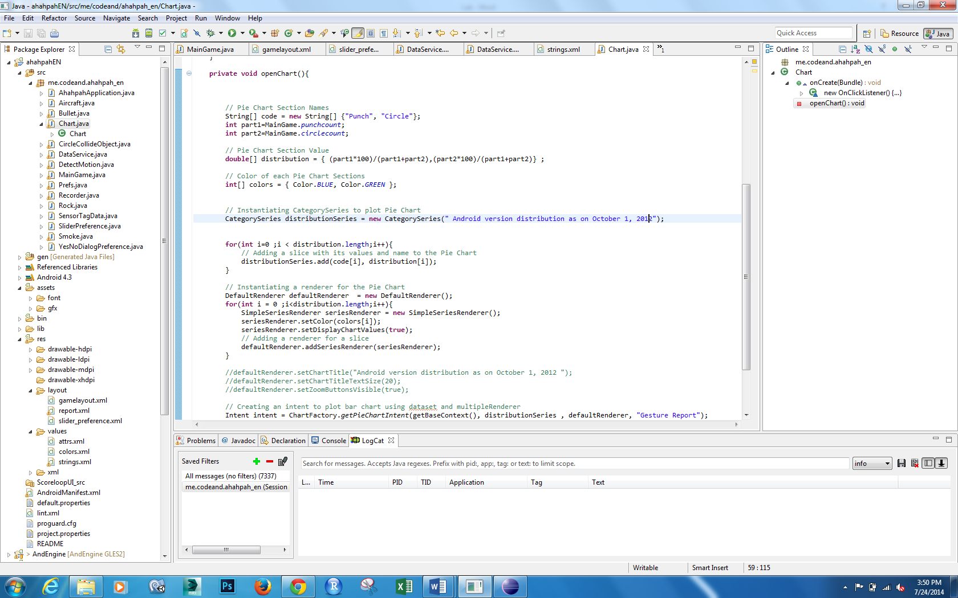

So,When the game starts HMM data is trained and BLE device is connected to our device

The we play game with circle and punch after game ends Report is generated for number of gestures.

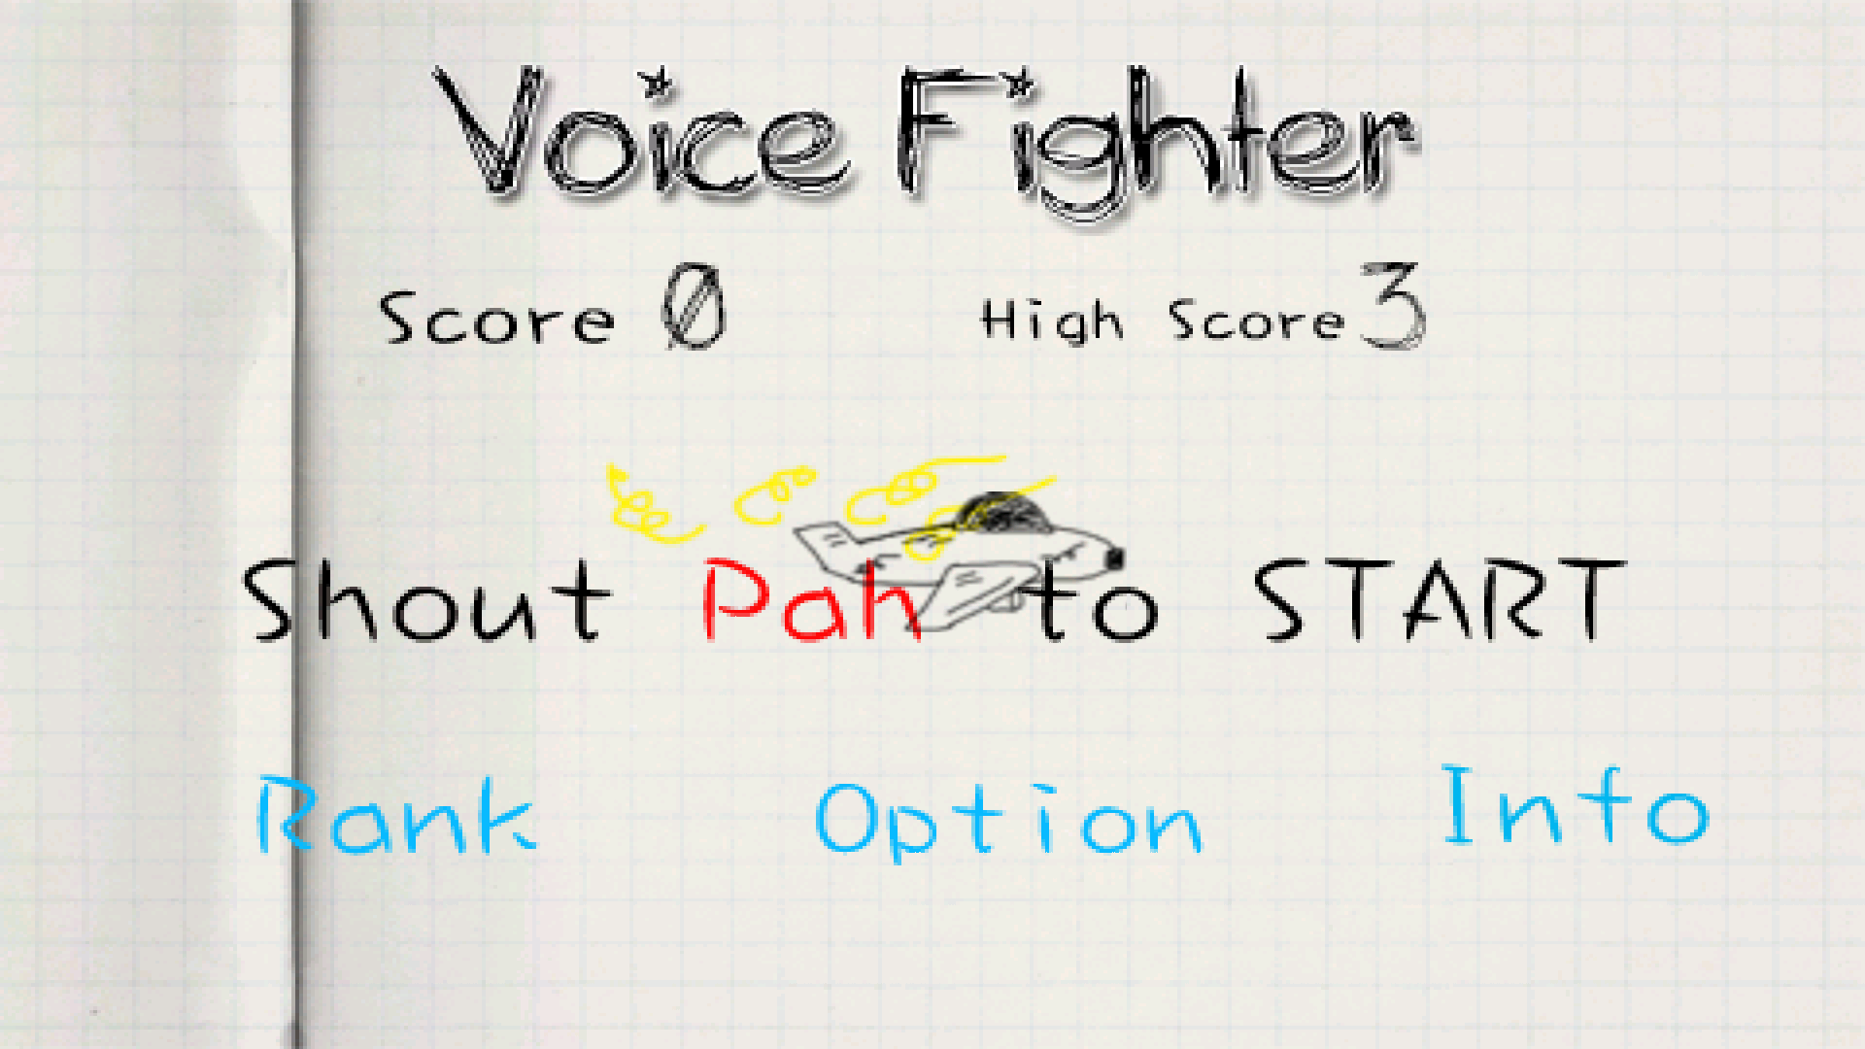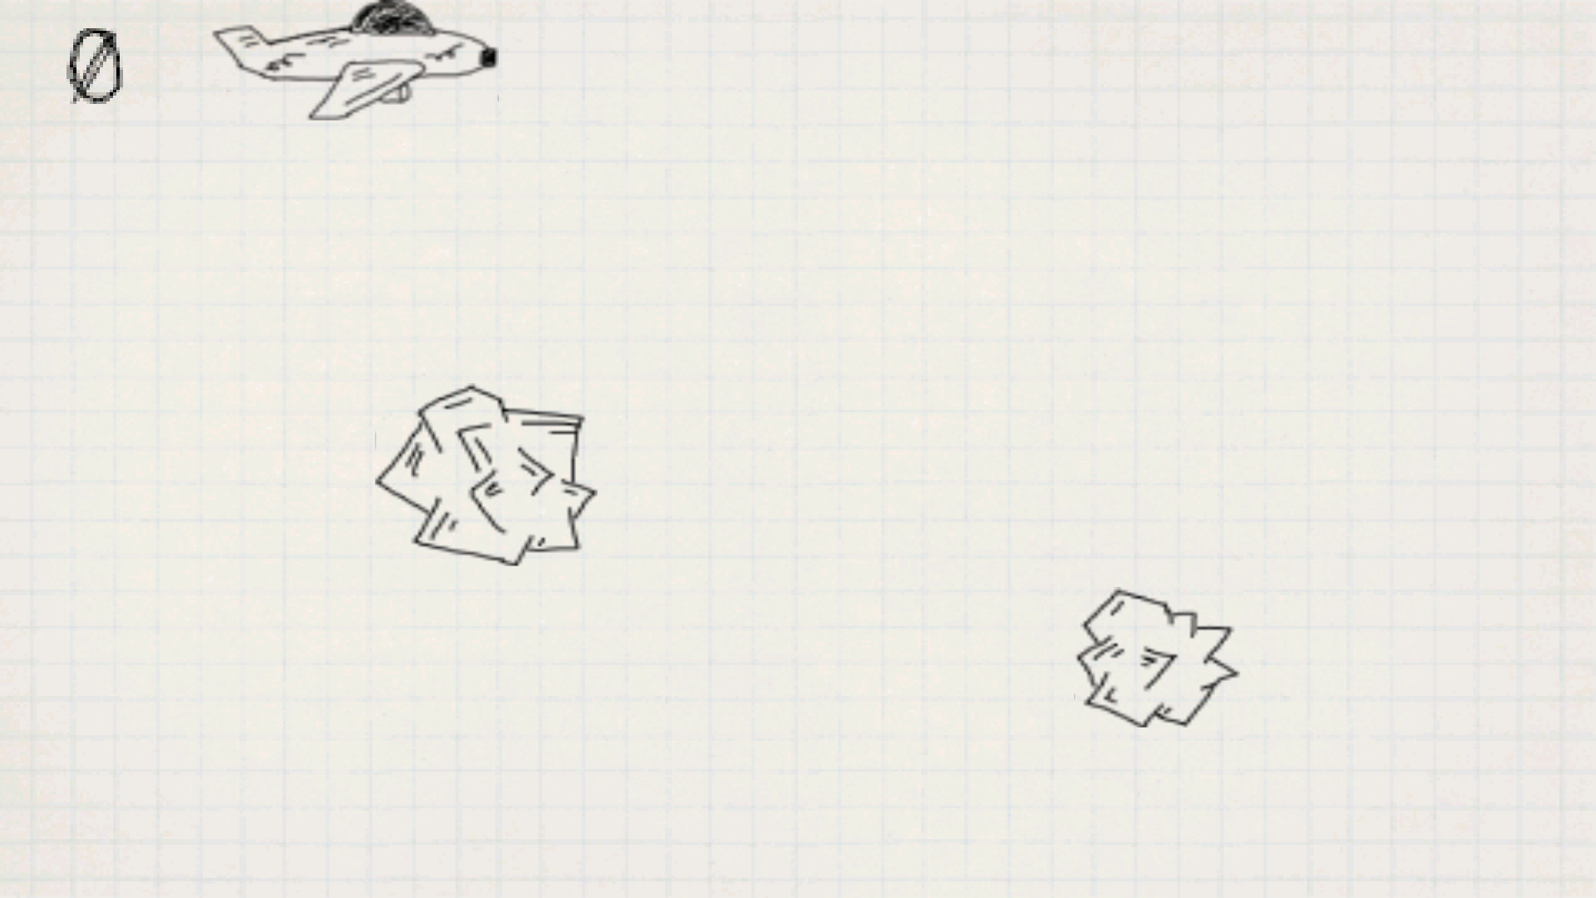

After Game over

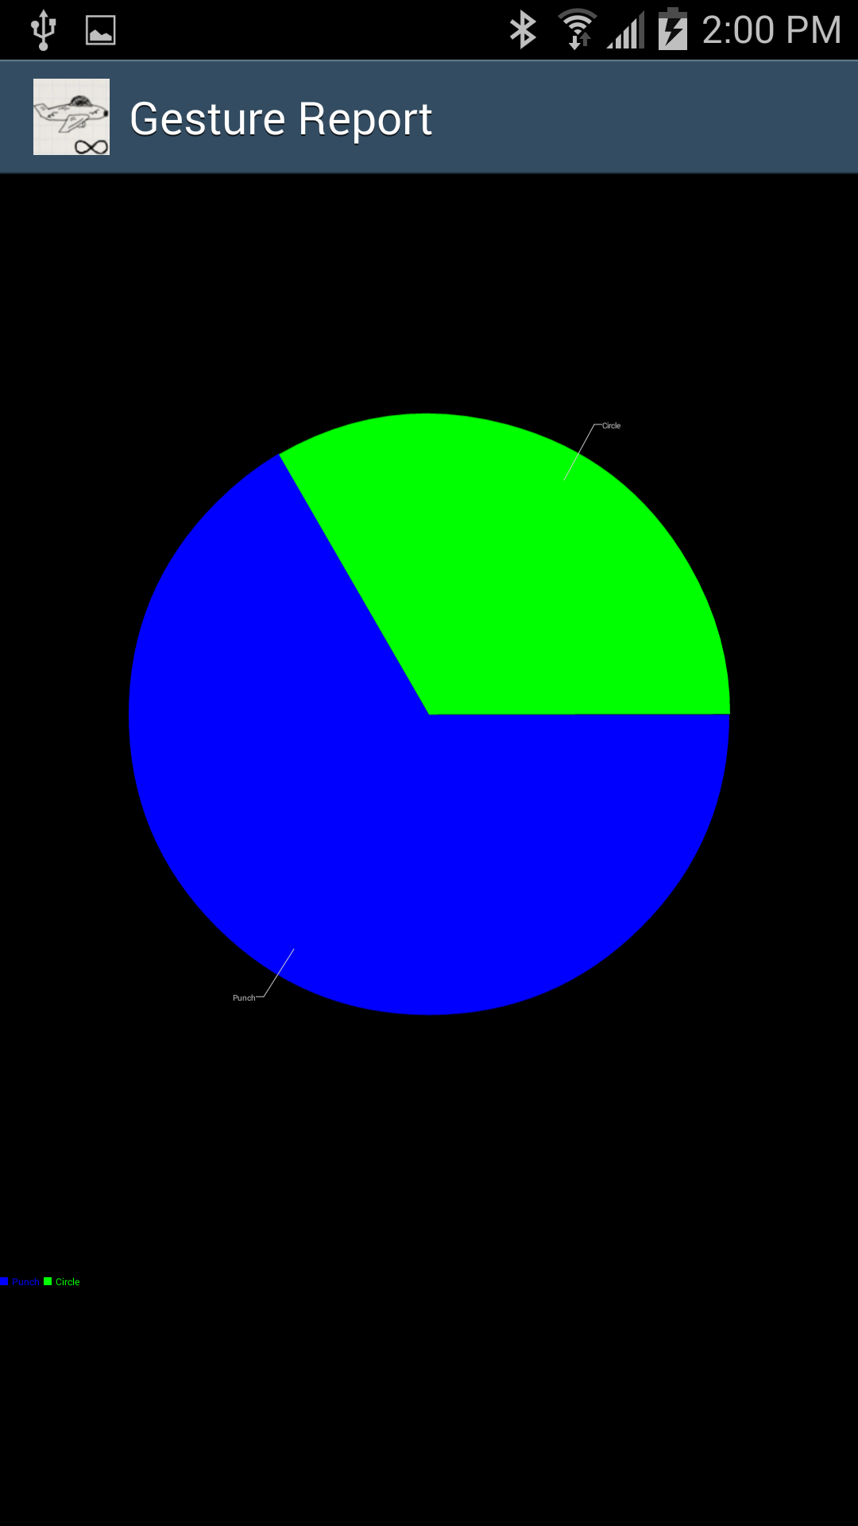

That’s it