LAB-1

Vishnu Praveen Gude

16103389

1.GITHUB ACCOUNT Screenshots

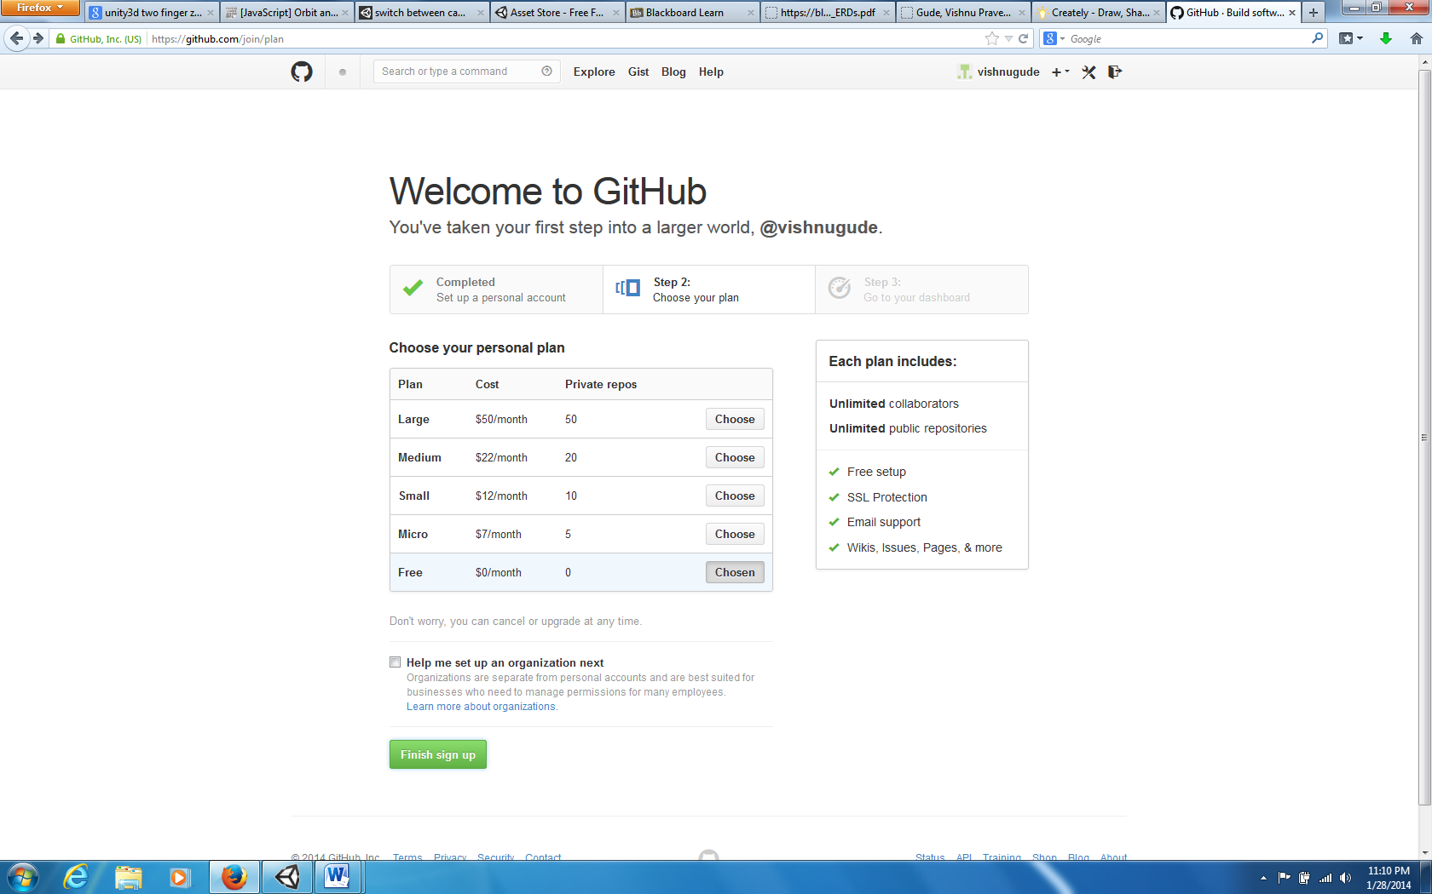

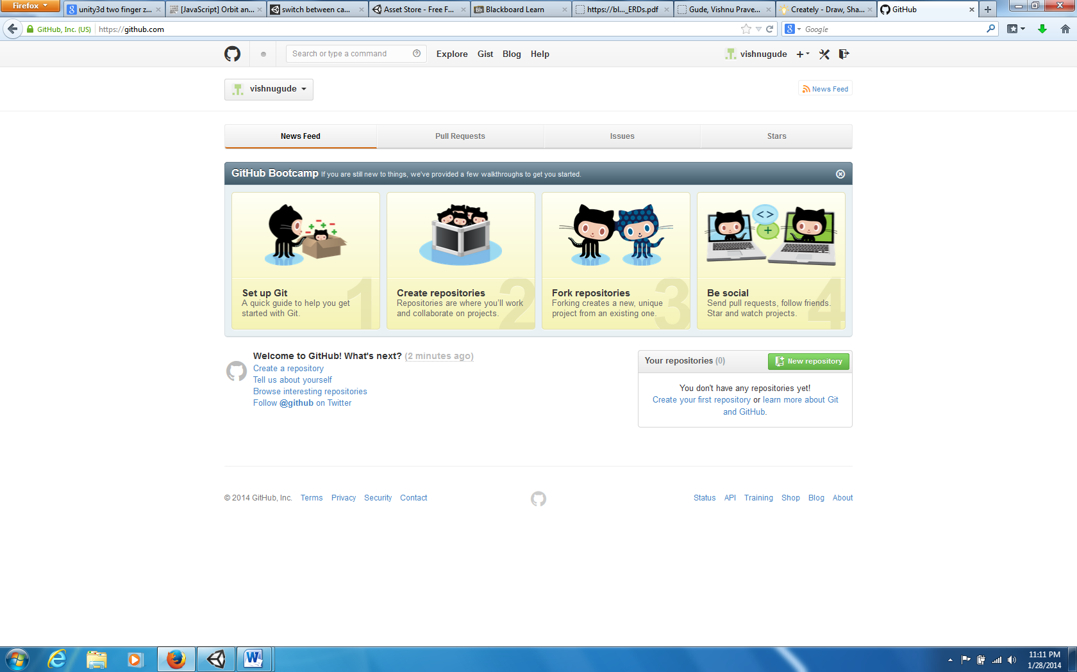

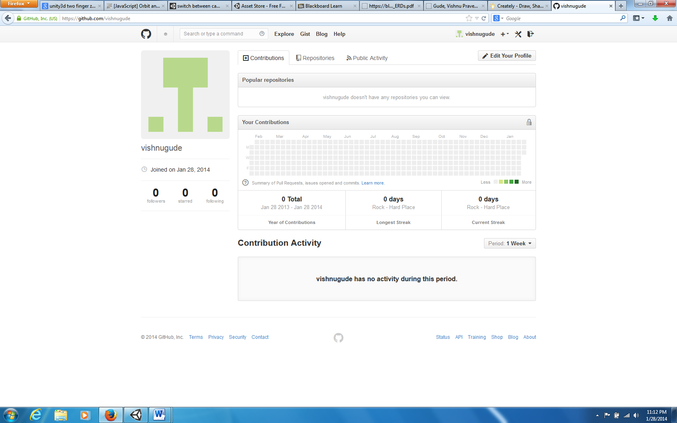

2.SCRUMDO ACCOUNT

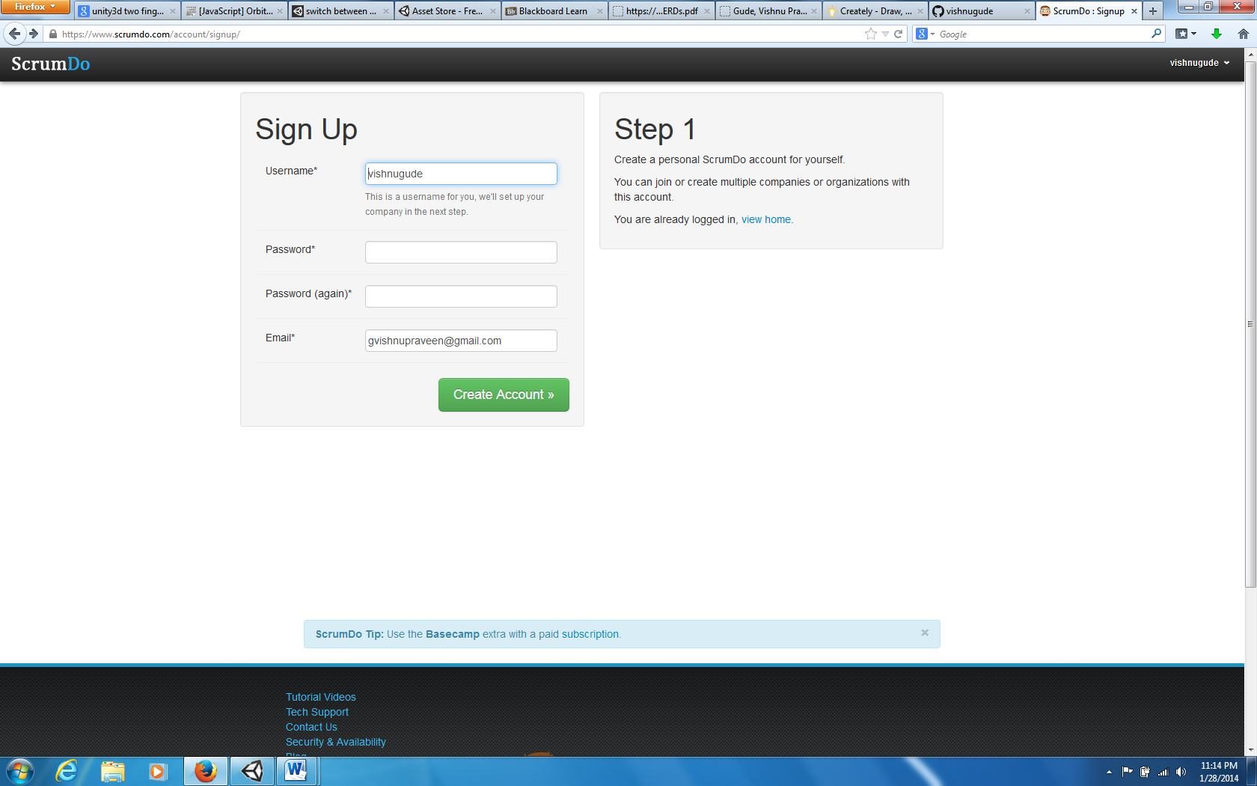

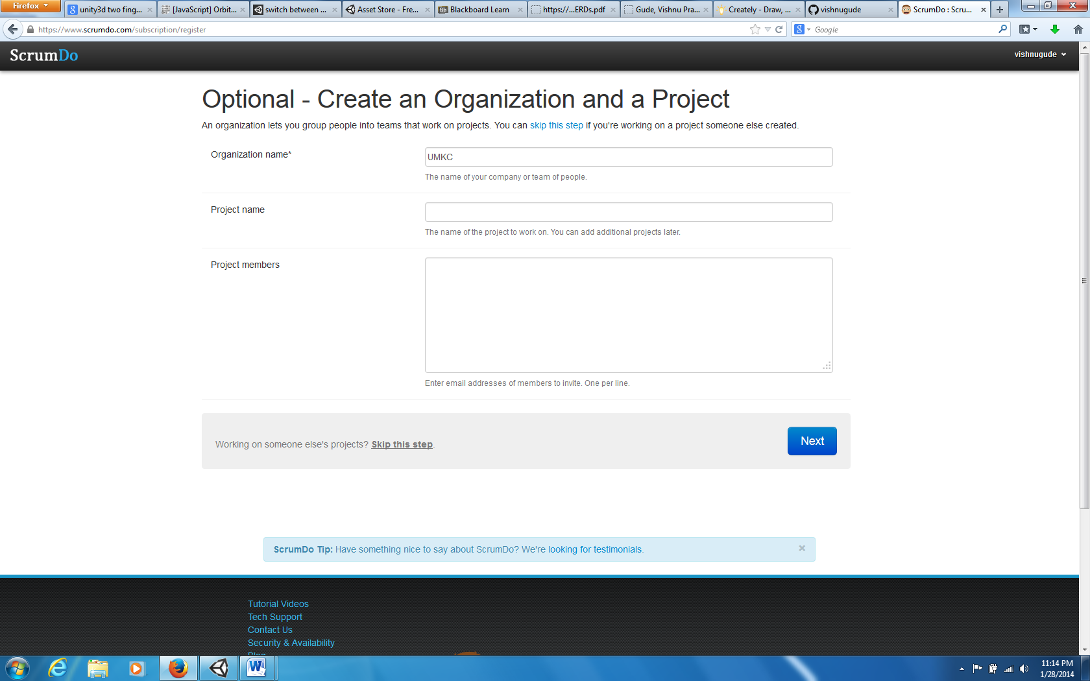

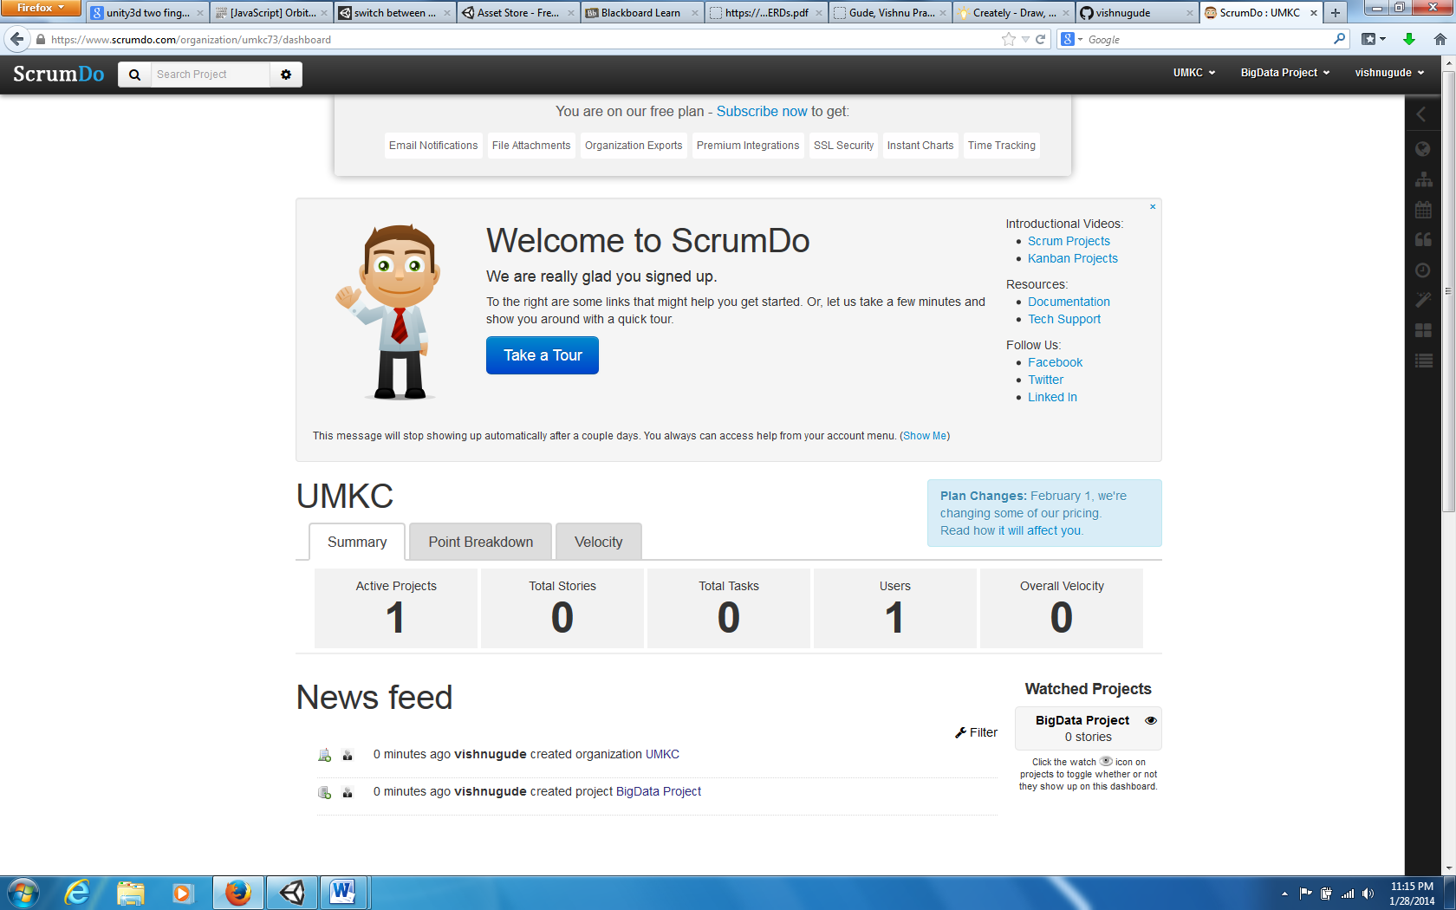

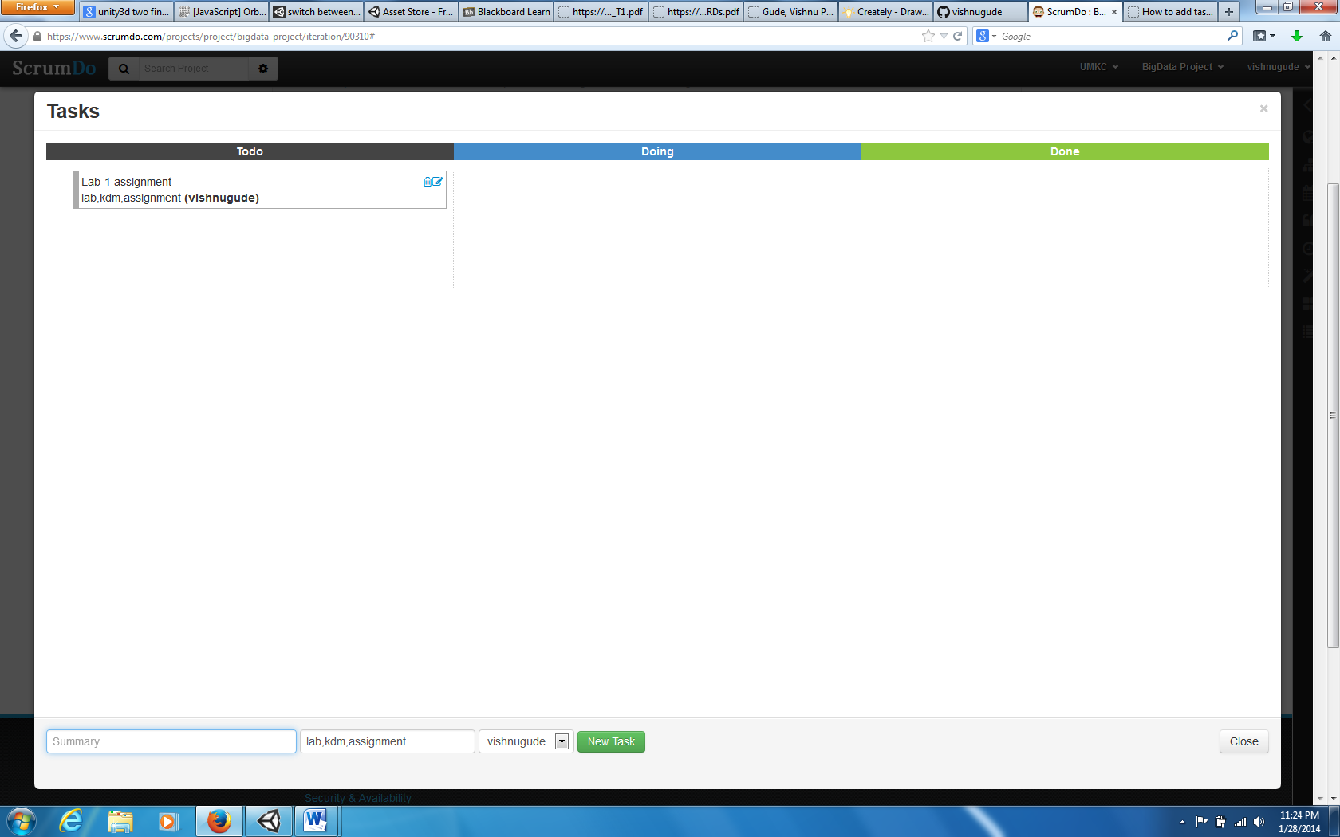

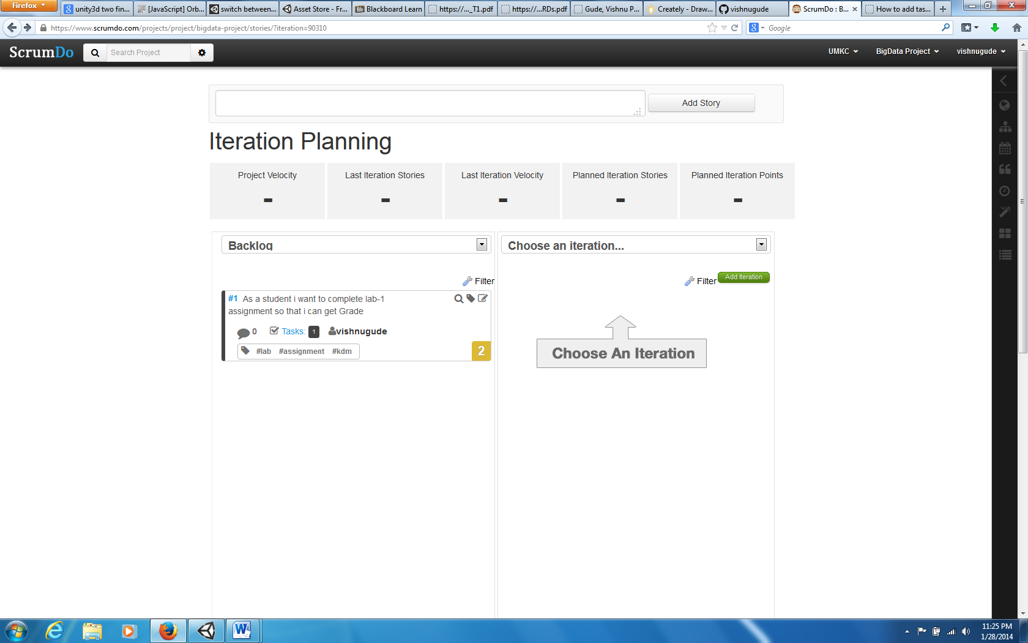

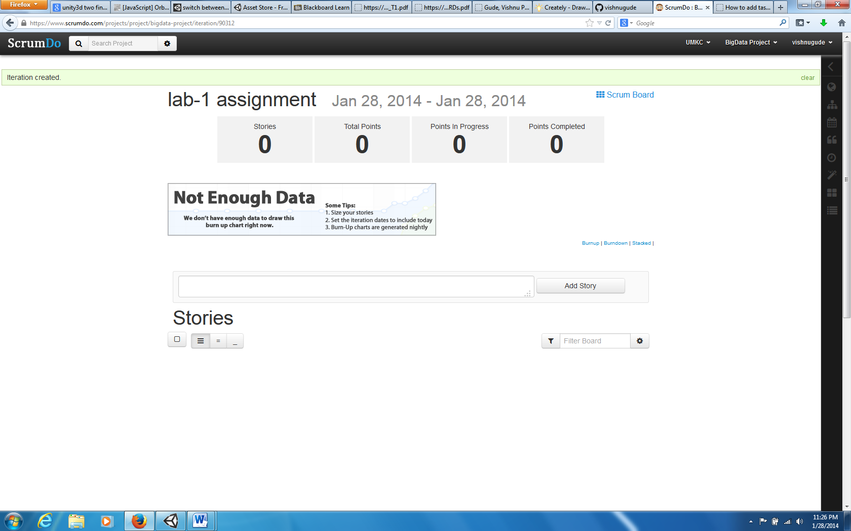

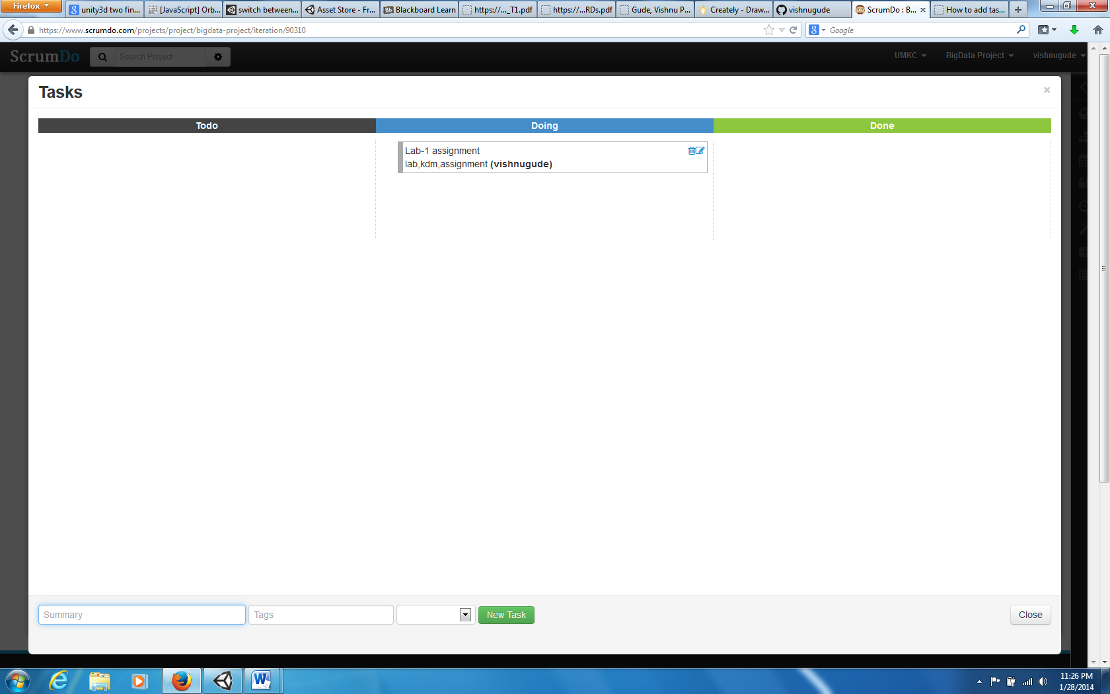

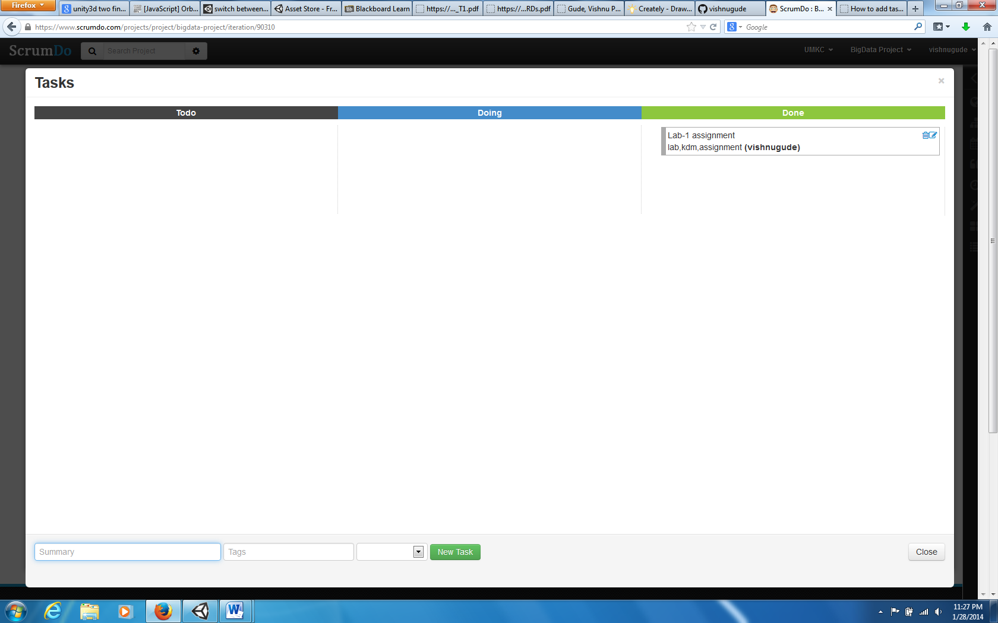

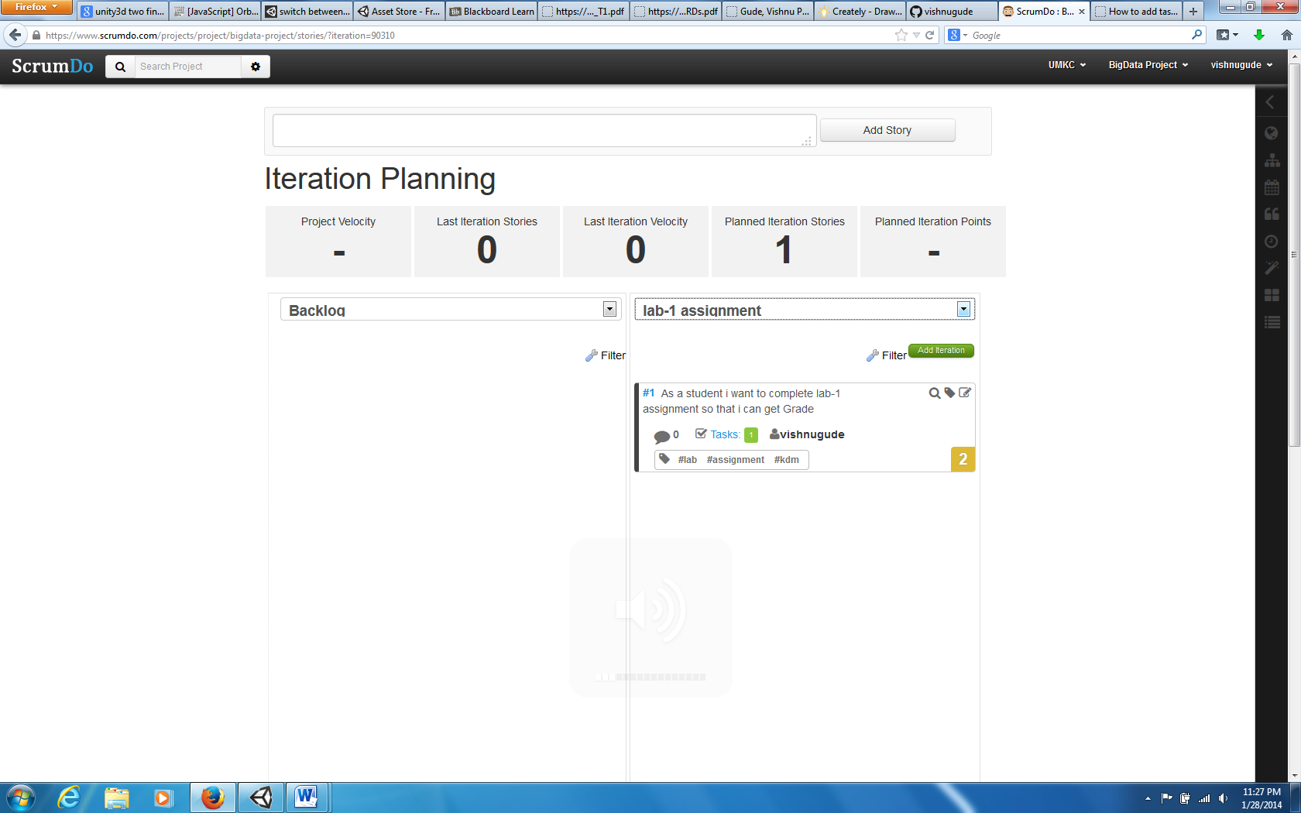

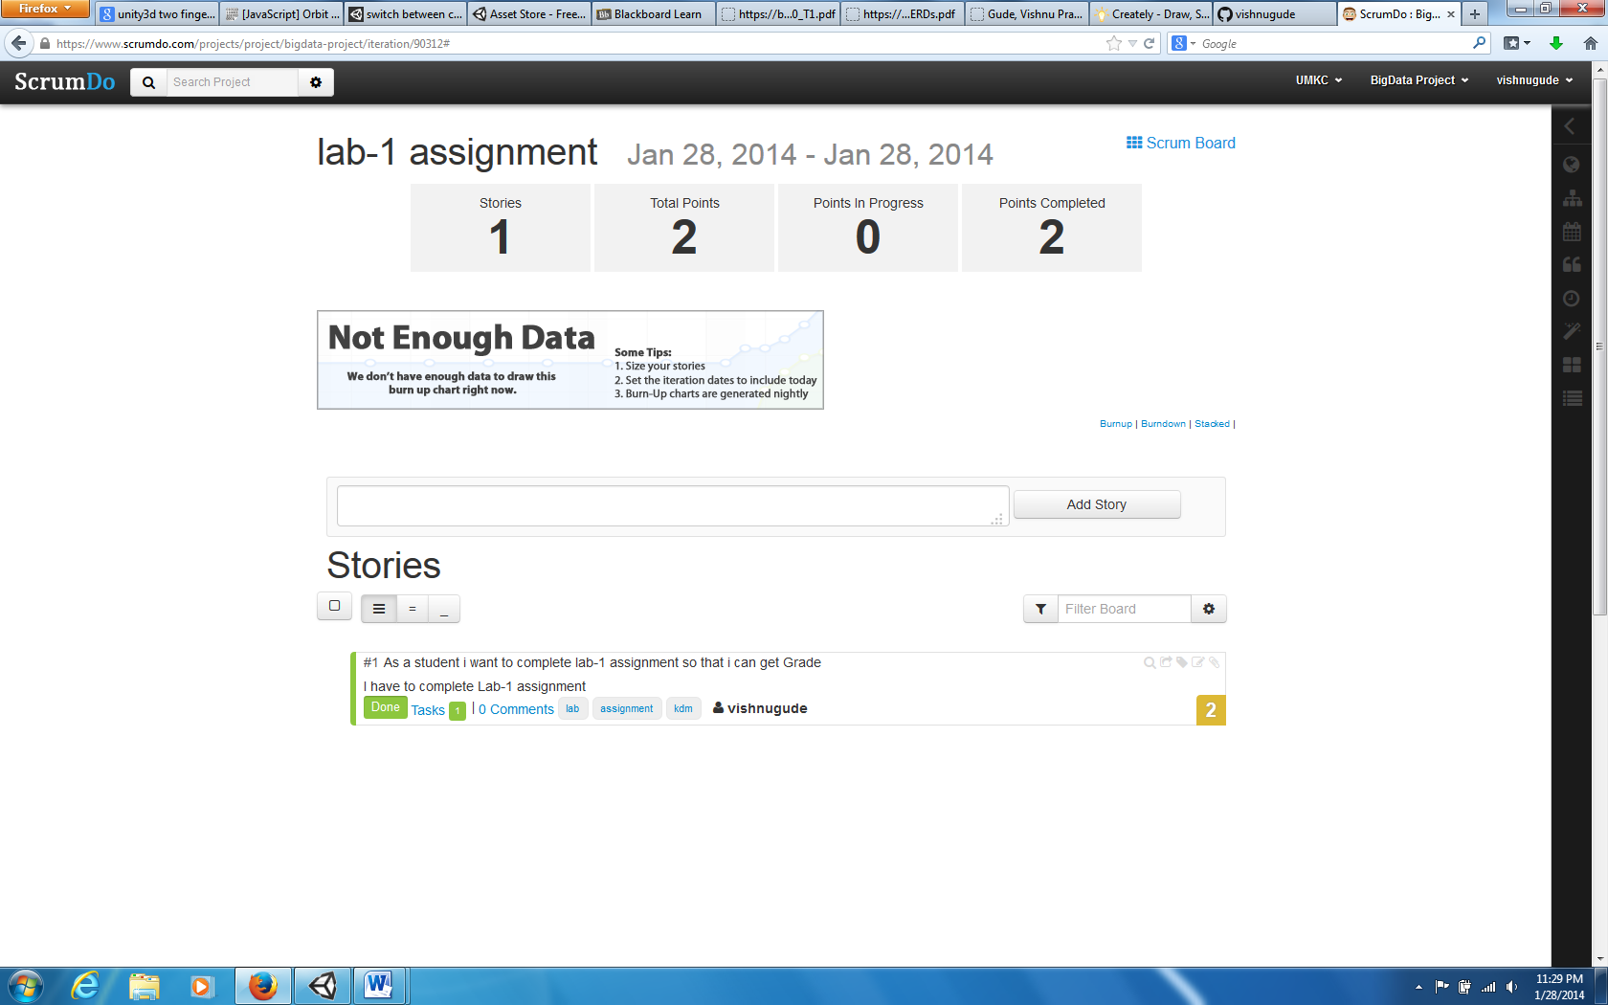

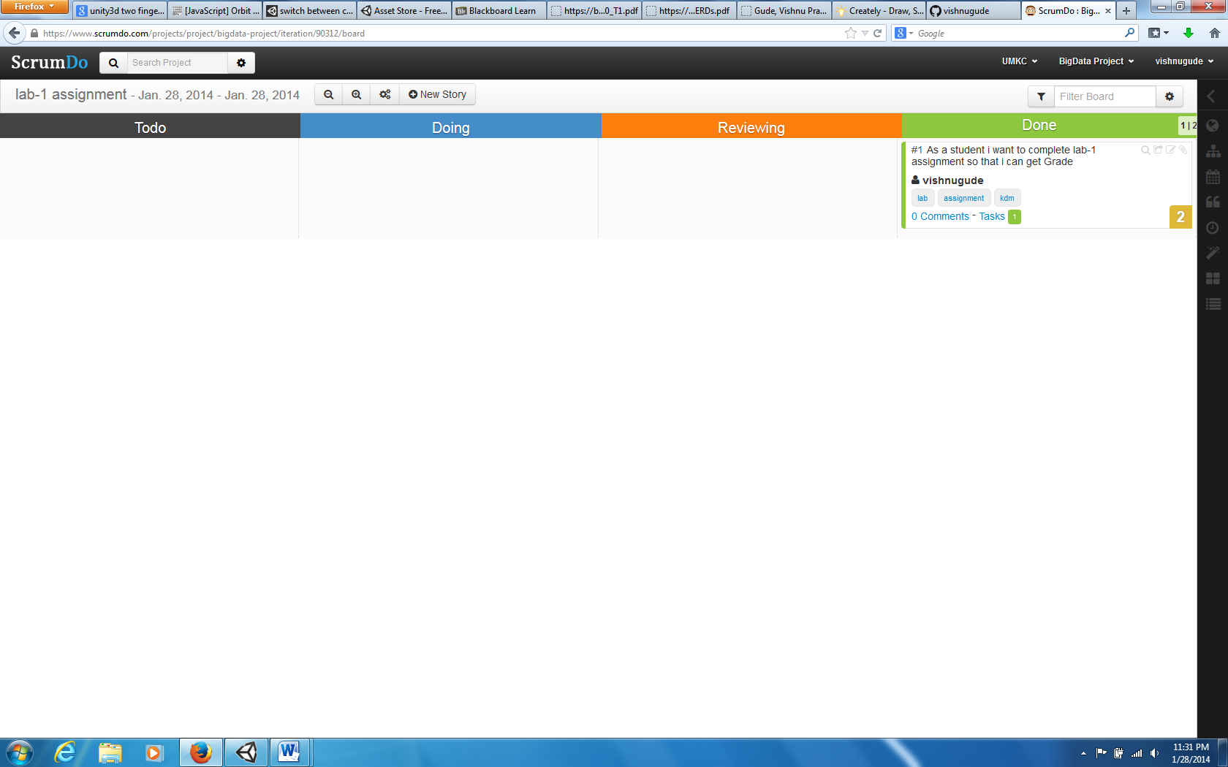

3.Entity Diagram

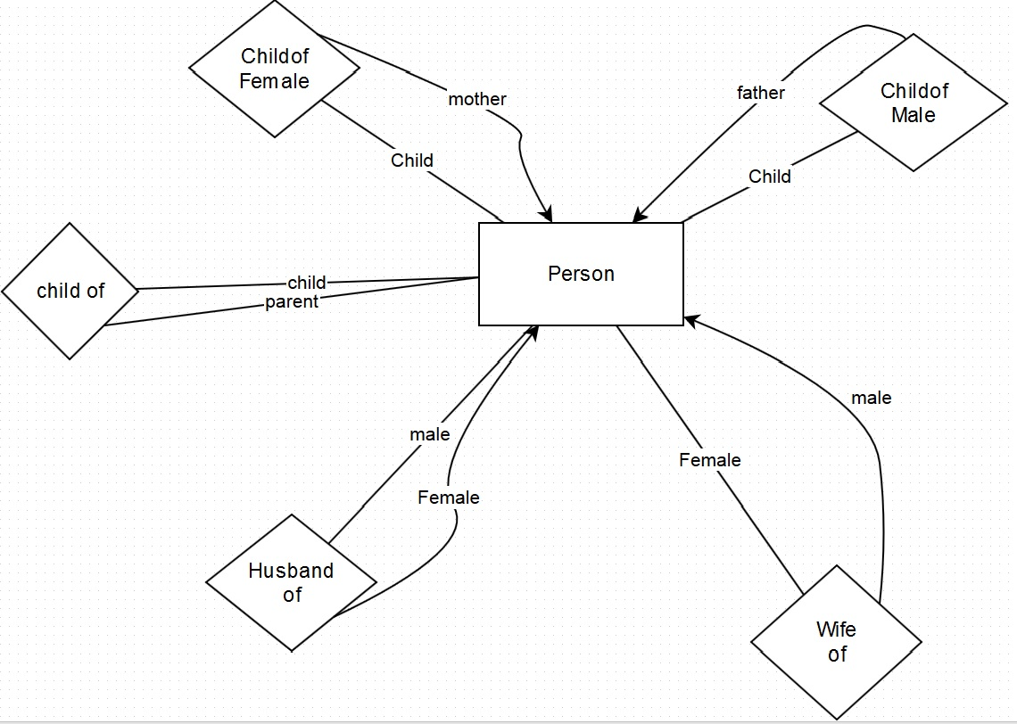

Explaination:

1.Person is the main entity set with name attribute.

2.A person can be a child of another person(father).

3.A person can be a child of another person(Mother).

4.A person can be a husband of another person(Female).

5.A person can be a wife of another person(Male).

6.A person can be a parent of another child person(either male or female).

4.CLASS DIAGRAM

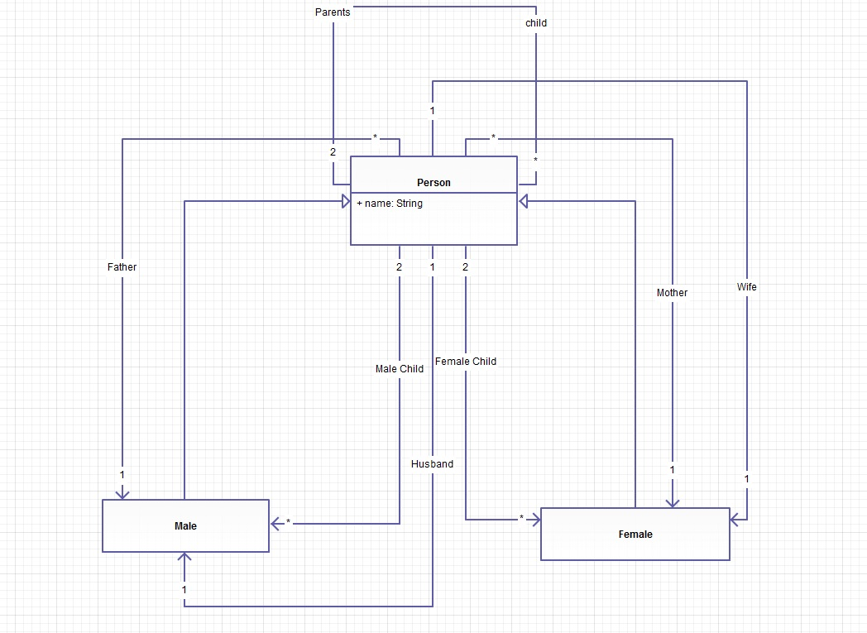

Explaination:

1.Person is a main class with name(string) attribute.

2.Male is a person and aslo Female is also a person

3.One male person can be a Father of Multiple persons(childs).

4.One Female person can be a Mother of Multiple persons(Childs).

5.Two persons(Female and Male) can have multiple persons(Childs).

6.Multiple Male childs can be a children of 2 persons(female and male i.e parents).

7.Multiple Female Childs can be a children of 2 persons(female and male i.e parents)

8.One male is a husband of one person(female) and similarly one female is wife of one person(Male).