LAB-4(Mobile App)

First check the solr output with rest services

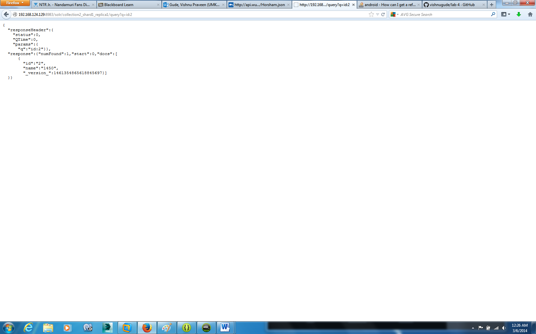

Now start a android project in eclipse

I create a button and two text fileds

One for entering user id and other to show recommended item

Now I added some code in mainactivity.java file to parse json outout and set the output to display

Now compile project

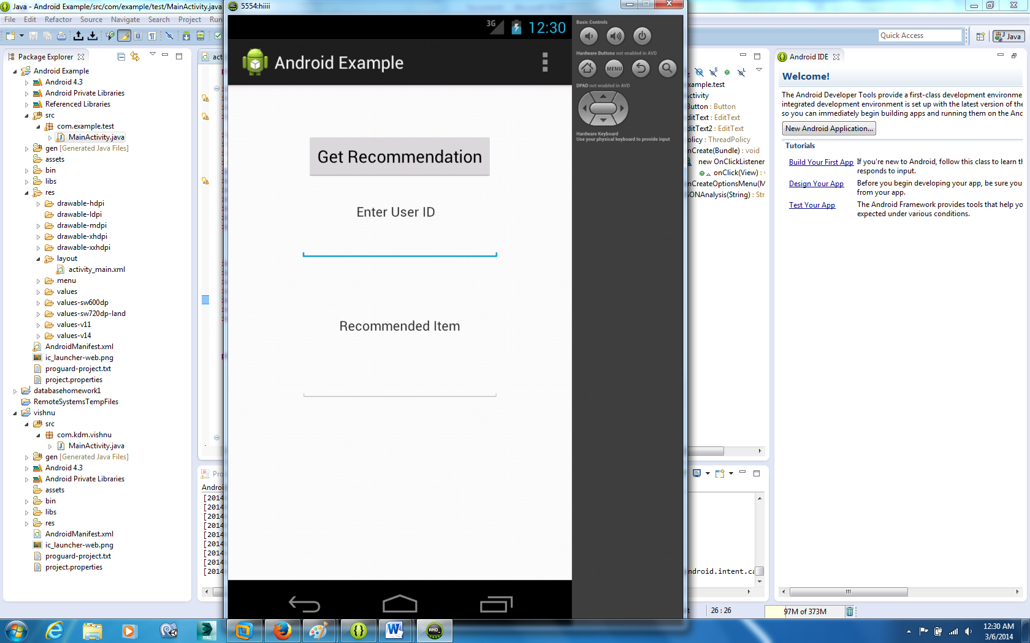

Now if I enter id 2 and click get Recommendation

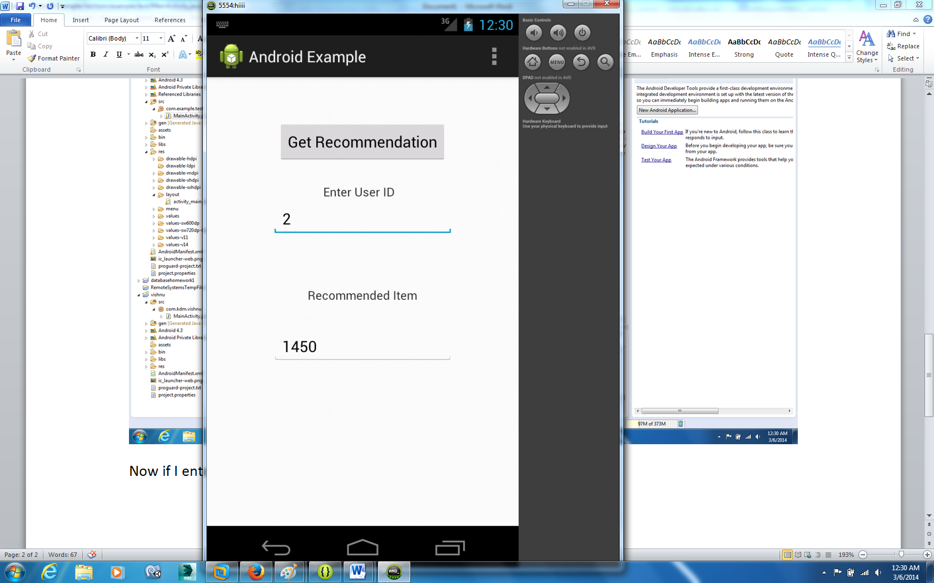

Now check for id 25

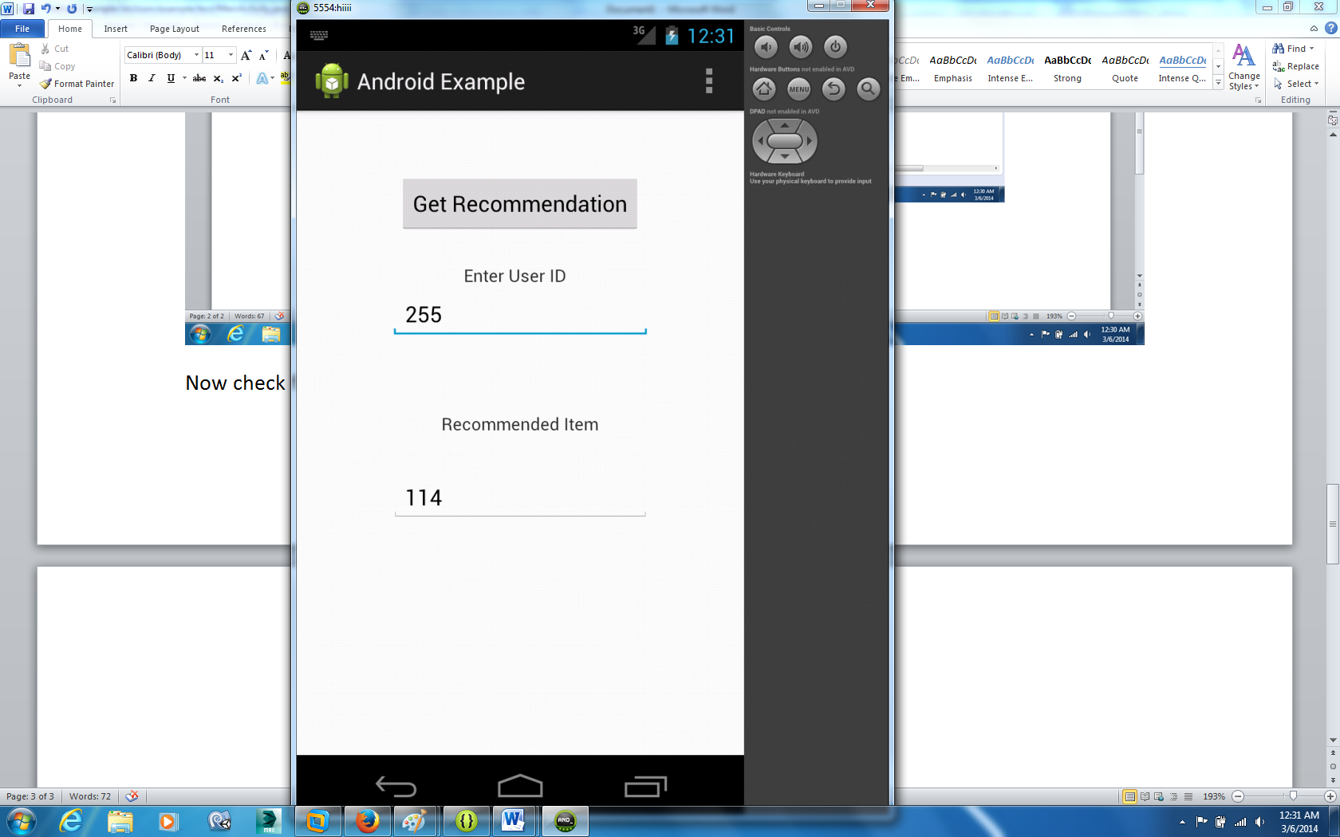

In this way we can get any person recommended item…..

ManiActivity.java

**package** com.example.test;

**import** java.io.ByteArrayOutputStream;

**import** java.io.FileNotFoundException;

**import** java.io.IOException;

**import** java.util.Map;

**import** org.apache.http.HttpResponse;

**import** org.apache.http.HttpStatus;

**import** org.apache.http.StatusLine;

**import** org.apache.http.client.ClientProtocolException;

**import** org.apache.http.client.HttpClient;

**import** org.apache.http.client.methods.HttpGet;

**import** org.apache.http.client.methods.HttpPost;

**import** org.apache.http.impl.client.DefaultHttpClient;

**import** org.json.JSONArray;

**import** org.json.JSONException;

**import** org.json.JSONObject;

**import** android.os.Bundle;

**import** android.os.StrictMode;

**import** android.app.Activity;

**import** android.view.Menu;

**import** android.view.View;

**import** android.widget.Button;

**import** android.widget.EditText;

**public** **class** MainActivity **extends** Activity {

**private** Button sButton;

**private** EditText editText,editText2;

StrictMode.ThreadPolicy policy = **new** StrictMode.ThreadPolicy.Builder().permitAll().build();

@Override

**protected** **void** onCreate(Bundle savedInstanceState) {

**super**.onCreate(savedInstanceState);

setContentView(R.layout.*activity_main*);

StrictMode.*setThreadPolicy*(policy);

sButton = (Button) findViewById(R.id.*button1*);

editText = (EditText)findViewById(R.id.*editText1*);

editText2=(EditText)findViewById(R.id.*editText2*);

sButton.setOnClickListener(**new** View.OnClickListener(){

//private Button.OnClickListener ButtonCapture = new Button.OnClickListener(){

**public** **void** onClick(View v){

HttpClient httpclient = **new** DefaultHttpClient();

HttpResponse response;

String responseString = **null**;

**try** {

HttpPost httpPost = **new** HttpPost("http://192.168.124.129:8983/solr/collection2_shard1_replica1/query?q=id:"+editText.getText());

response = httpclient.execute(httpPost);

StatusLine statusLine = response.getStatusLine();

**if**(statusLine.getStatusCode() == HttpStatus.*SC_OK*){

ByteArrayOutputStream out = **new** ByteArrayOutputStream();

response.getEntity().writeTo(out);

out.close();

responseString = out.toString();

String combine = JSONAnalysis(responseString);

editText2.setText(combine);

} **else**{

//Closes the connection.

response.getEntity().getContent().close();

**throw** **new** IOException(statusLine.getReasonPhrase());

}

} **catch** (ClientProtocolException e) {

e.printStackTrace();

} **catch** (IOException e) {

e.printStackTrace();

}

}

});

}

@Override

**public** **boolean** onCreateOptionsMenu(Menu menu) {

// Inflate the menu; this adds items to the action bar if it is present.

getMenuInflater().inflate(R.menu.*main*, menu);

**return** **true**;

}

**public** String JSONAnalysis(String jsonString)

{

String combine="1";

JSONArray userid;

String item="";

JSONObject jsonObj;

**try** {

jsonObj = **new** JSONObject(jsonString);

JSONObject obser=jsonObj.getJSONObject("response");

userid=obser.getJSONArray("docs");

String str=userid.get(0).toString();

JSONObject jsobj=**new** JSONObject(str);

combine = jsobj.getString("name");

} **catch** (JSONException e) {

// **TODO** Auto-generated catch block

e.printStackTrace();

}

**return** combine;

}

}