Prog1:

Prog2:

Prog3:

Prog4:

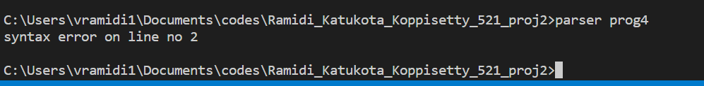

Prog5:

Extra Credits:

Prog6 and prog7:

