**A Mini Project On**

**ONLINE SHOPPING**

Department of Information Technology

**Submitted By**

Batch:11,18,19

|  |  |
| --- | --- |
| BHARATH | 17121A1233 |
| KARTHIK | 17121A1232 |
| RAJSHEKER | 17121A1224 |
| GOPI | 17121A1253 |
| MYTHILI | 17121A1254 |
| SAI NITHYA | 17121A1256 |
| SAI GRISHYANTH  VISHNU HARSHITH | 17121A1257  17121A1258 |
| RANGA SWAMY | 17121A1259 |
| HEPSIBAH | 17121A1260 |



## SREE VIDYANIKETHAN ENGINEERING COLLEGE

**(AUTONOMOUS)**

(Affiliated to JNTUA, Ananthapuramu, Approved by AICTE, Accredited by NBA & NAAC)

Sree Sainath Nagar, Tirupati – 517 102, A.P., INDIA

## (2019 -2020)

**TABLE OF CONTENT**

* 1. **O TITLE PAGE NO**
     1. INTRODUCTION



LITERATURE SURVEY

METHODOLOGY

IMPLEMENTATION

ADVANTAGES

ANALYSIS

2.

3.

4.

5.

6. DRAWBACKS

7.

1. FUTURE SCOPE OF THE PROJECT
2. CONCLUSION 19

REFERENCES

**ABSTRACT**

## Main Objective

This is a small-scale project for Online shopping system. The basic idea is that customers can buy products using online. The administrator can enter the name and password and can create an account and then generate the receipt of the products purchased.

An online shopping system that permits a customer to submit online orders for items and/or services from a store that serves both walk-in customers and online customers. The online shopping system presents an online display of an order cut off time and an associated delivery window for items selected by the customer. The system accepts the customer's submission of a purchase order for the item in response to a time of submission being before the order cut off time.

The online shopping system does not settle with a credit supplier of the customer until the item selected by the customer is picked from inventory but before it is delivered. Therefore, the customer can go online and make changes to the order. In addition, available service windows are presented to the customer as a function of customer selected order and service types and further, the order picking is assigned in accordance with a picker's preference. When ordering goods, many shopping systems provide a virtual shopping cart for holding items selected for purchase. Successive items selected for purchase are placed into the virtual shopping cart until a customer completes their shopping trip. Virtual shopping carts may be examined at any time, and their contents can be edited or deleted at the option of the customer. Once the customer decides to submit a purchase order, the customer may print the contents of the virtual shopping basket in order to obtain a hard copy record of the transaction.

E-commerce is fast gaining ground as an accepted and used business paradigm. More and more business houses are implementing web site providing functionality for performing commercial transactions over the web. It is reasonable to say that the process of shopping on the web is becoming commonplace.

# INTRODUCTION

Online shopping is a form of [electronic commerce w](https://en.wikipedia.org/wiki/Electronic_commerce)hich allows consumers to directly buy [goods o](https://en.wikipedia.org/wiki/Good_(economics))r [services f](https://en.wikipedia.org/wiki/Service_(economics))rom a seller over the [Internet u](https://en.wikipedia.org/wiki/Internet)sing a [web browser. C](https://en.wikipedia.org/wiki/Web_browser)onsumers find a product of interest by visiting the [website o](https://en.wikipedia.org/wiki/Website)f the retailer directly or by searching among alternative vendors using a [shopping search engine, w](https://en.wikipedia.org/wiki/Shopping_search_engine)hich displays the same product's availability and pricing at different e-retailers. As of 2016, customers can shop online using a range of different computers and devices, including [desktop computers,](https://en.wikipedia.org/wiki/Desktop_computer) [laptops,](https://en.wikipedia.org/wiki/Desktop_computer) [tablet](https://en.wikipedia.org/wiki/Desktop_computer) [computers a](https://en.wikipedia.org/wiki/Desktop_computer)nd [smart phones.](https://en.wikipedia.org/wiki/Smartphone)

The aim of this project is on the online shopping it is developed usingHTML5, JAVA script, CSS, PHP. The application is very useful where the buyer can directly buy the products from home via internet on mobile or system. The application reduces lot of work load for customer as well as owner. The transaction of money is completed in real time

system.

Some of the online shops are EBAY Amazon. By this online shopping the product is directly delivered to customer home. Online shopping is the process consumers go through to purchase products or Services over the Internet. An online shop, e-shopping, e-store, internet shop, web shop, web store, online store, or virtual store evokes the physical analogy of buying products or services at a bricks-and-mortar retailer or in a mall.

‘Customer is our god’ mainly this website is based on this formula. After chosen items he bought into Pay pal process like VISA or MASTER credit cards or any Debit cards are accepted in this website. Customer is happily shopping at his rest place.

Once customer entered with his own username and password, at that time automatically one shopping cart will be created, once user select an item it will add to cart. In case user thinks the selected item is not useful for me, then deleted that item from shopping cart.

Customer selected some items, but in his credit or debit cart haven’t that much balance, then he was logout from the website, the selected items are stored at cart with specific users wit

his allotted carts, after some days he bought those items then automatically deleted from the cart.

1

### LITERATURE SURVEY

***Security implications of Electronic Commerce: A Survey of Consumers and Businesses S. M. Furnell and T .Karweni Network Research Group, School of Electronic, Communication and Electrical Engineering, University of Plymouth, Plymouth , United Kingdom.***

Electronic commerce is poised to become one of the major applications areas in the Internet World Wide Web environment, with significant growth forecast to occur within the next two to three years. However, one of the significant requirements for the success of e-commerce is trust, on the part of both the consumers and businesses offering services. It can be observed that while e-commerce services are now being offered on the Internet, a number of examples can be cited that suggest sufficient protection has not been fully achieved. The paper examines the general requirement for security technologies in order to provide a basis for trust in the ecommerce environment. The discussion is supported by the findings from two surveys, conducted by the authors, among general Internet users (i.e. potential target consumers) and commercial businesses.

These surveys considered both the attitudes to ecommerce in general and opinions relating to the associated security requirements. Attempts were also made to assess the respondent’s knowledge of the existing security safeguards that may be applied. The survey results suggest that, while there is significant concern amongst Internet-based consumers regarding the security of their purchasing activities, these are outweighed by the merits offered by the medium. The results also suggested a lack of awareness or understanding of the security technologies that are available and it is concluded that overcoming this problem would help to establish a wider foundation of trust in the new technology.

Recent years have seen an explosion of activity in the domain of electronic commerce (ecommerce). Interest in the concept, and its predicted impact, is such that it has become more than just a current buzzword within the IT industry. Indeed, the issue has become the focus of significant mass media interest.

2

The concept of electronic commerce can be defined as (DTI, 1999): “using an electronic network to simplify and speed up all stages of the business process, from design and making to buying, selling and delivering” It may be argued that e-commerce is not a new phenomenon, With related activities such as Electronic Data Interchange (EDI) having occurred since the 1970s (Chelmsford, 1999). However, this referred to essentially

business-to-business

transactions, operating within a closed environment. The difference now is the use of the Internet as an enabling technology, making ecommerce services directly accessible to the average person. Such business-to-consumer ecommerce, and the associated security issues, represents the particular focus of this paper. Businesses communicate with customers and partners through many channels, but the Internet is one of the newest and, for many purposes, best business communications channel. It is fast, reasonably reliable, inexpensive, and universally accessible. It reaches virtually every major business and more than 100 million consumers from all over the world. There are around three million traders on the Internet today. According to predictions such as those by Ameritrade Holding Corporation, this figure will to rise to 14.4 million by 2002. Until recently, the traditional presence of businesses on the WWW could be analogized to a "shop window" approach - where you can see what products or services are available, but you cannot actually purchase them directly. This is now changing and the web is being put to more varied uses with sites such as Amazon.com (online bookstore) and eBay.com (online auctions). Such populist uses may well be the catalyst for getting more people to buy online. In 1996, Internet purchases totaled $500 million. This is forecast to increase to $1 trillion by the millennium (Howell,1998).

3

# 3. METHODOLOGY

**EXISTING SYSTEM**

* + It is limited to a single system.
  + It is less user-friendly.
  + It is having lots of manual work
  + The present system is very less secure.
  + It is unable to generate different kinds of report.
  + User must go to shop and order products.

**PROPOSE**



* It is difficult to identify the required product.
* Description of the product obtained only on manually.
* Accuracy not guaranteed.
* Not in reach of distant users.

**D SYSTEM**

* The development of the new system contains the following activities,

which try to automate the entire process keeping in view of the database integration approach.

* + To debug the existing system, remove procedures those cause data redundancy, make navigational sequence proper. To provide information about audits on different level and also to reflect the current work status depending on organization/auditor or date. Required to build strong password mechanism.
  + User friendliness is provided in the application with various control.
  + It can be accessed over the Internet.
  + The system makes the overall project management much easier and flexible.
  + Various classes have been used to provide file upload and mail features.
  + There is no risk of data mismanagement at any level while the project development is under process.



# ADVANTAGES

## Convenience

Online stores are usually available 24 hours a day, and many consumers in Western countries have Internet access both at work and at home. Other establishments such as Internet cafes, community centre and schools provide internet access as well. In contrast, visiting a conventional retail store requires travel or commuting and costs such as gas, parking, or bus tickets, and must typically take place during business hours. Delivery was always a problem which affected the convenience of online shopping.

**Better prices**

Cheap deals and better prices are available online, because products come to you direct from the manufacturer or seller without involving middlemen. Plus, it's easier to compare prices and find a better deal. Many online sites offer discount coupons and rebates, as well. Not only are prices better, but you can save on tax as well, since online shops are only required to collect a sales tax if they have a physical location in your state. Factor in the saved expense of gas and parking and you have saved yourself a lot of money!

## More variety

The choices online are amazing. You can find almost any brand or item you're looking for. You can get in on the latest international trends without spending money on airfare. You can shop from retailers in other parts of the state, country, or even world instead of being limited to your own geography. A far greater selection of colors and sizes than you will find locally are at your disposal. Plus, the stock is much more plentiful, so you'll always be able to find your size and colors. Some online shops even accept orders for out-of-stock items and ship when they come in.

**.**

1. **DRAWBACKS**

**Fraud and security concerns**

Given the lack of ability to inspect merchandise before purchase, consumers are at higher risk of fraud than face-to-face transactions. When ordering merchandise online, the item may not work properly, it may have defects, or it might not be the same item pictured in the online photo. Merchants also risk fraudulent purchases if customers are using stolen credit cards or fraudulent repudiation of the online purchase.

Phishing is another danger, where consumers are fooled into thinking they are dealing with a reputable retailer, when they have actually been manipulated into feeding private information to a system operated by a malicious party. Denial of service attacks are a minor risk for merchants, as are server and network outages.

## Lack of full cost disclosure

The lack of full cost disclosure may also be problematic. While it may be easy to compare the base price of an item online, it may not be easy to see the total cost up front. Additional fees such as shipping are often not visible until the final step in the checkout process. The problem is especially evident with cross-border purchases, where the cost indicated at the final checkout screen may not include additional fees that must be paid upon delivery such as duties and brokerage.

## Privacy

Privacy of personal information is a significant issue for some consumers. Many consumers wish to avoid spam and telemarketing which could result from supplying contact information to an online merchant. In response, many merchants promise to not use consumer information for these purposes, Many websites keep track of consumer shopping habits in order to suggest items and other websites to view. Brick-and-mortar stores also collect consumer information.

## ANALYSIS

The Current shopping System is critical to set up online shops, customers to browse through the shops, and a system administrator to approve and reject requests for new shops and maintain lists of shop categories. This is a small scale project for Online shopping System.

The basic idea is that the candidates can buy product from anywhere during any time by using their card number and password provided to them. The database will maintain the product details information. Customer can view their product details using the card details.

This Online shopping system involves with two types of users.

* CUSTOMER
* ADMINISTRATOR

**CUSTOMER ROLE:**

The customer’s can login to the System. He or She can view his/her product details and buy their product. The customer can just view the information whereas he/she could not make changes in the database.

**ADMINISTRATOR ROLE**:

The administrator plays a vital role in the Online shopping system. The administrator controls the entire database. The report of the product is generated by the administrator itself.

The main role of the administrator is to safeguard the database and can add/delete the products from the database.

**FUTURE SCOPE OF THE PROJECT**

Well I and my team members have worked hard in order to present an improved website better than the existing one’s regarding the information about the various activities. Still, we found out that the project can be done in a better way. Primarily, when we request information about a product it just shows the company, product id, product name and number of quantities available. So, after getting the information we can get access to the product company website just by a click on the product name.

The next enhancement that we can add the searching option. We can directly search to the product company from this site. These are the two enhancements that we could think of at present.

Most generic consumer to consumer e-commerce website, which covers almost all possible categories, with 2 level listing.

* + Maximize benefits and minimize the disadvantages of a common e-commerce website.
  + User friendly, Vendor friendly environment.
  + Since it stand alone application, one or more user may use it at a time.

**OUTPUT SCREENSHOTS:**

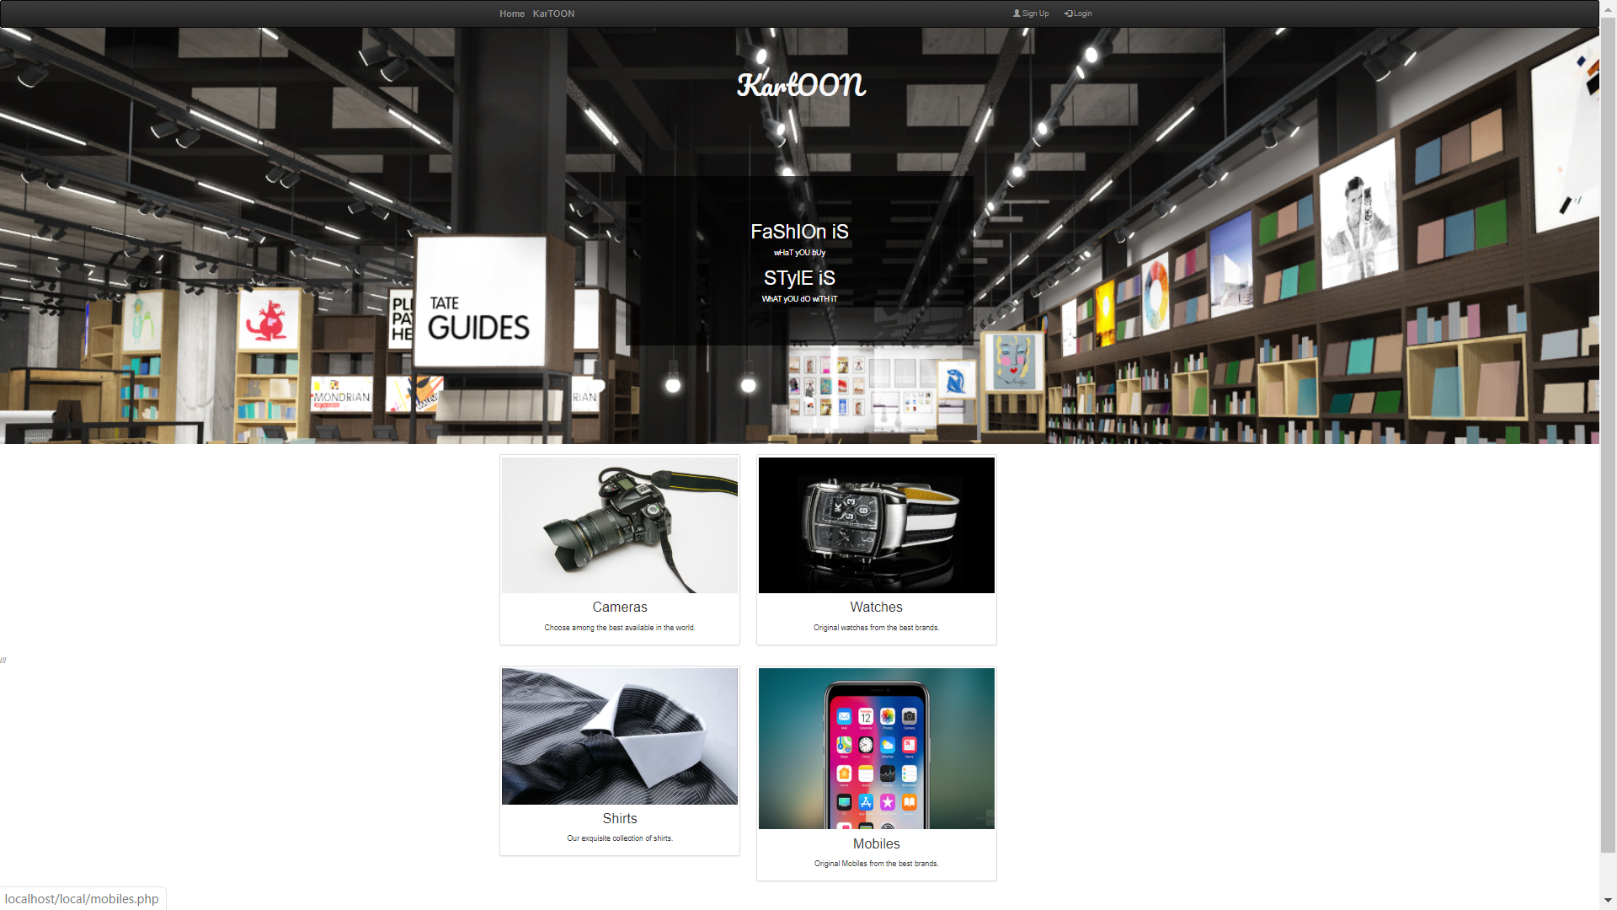

**Fig1 : Homepage**

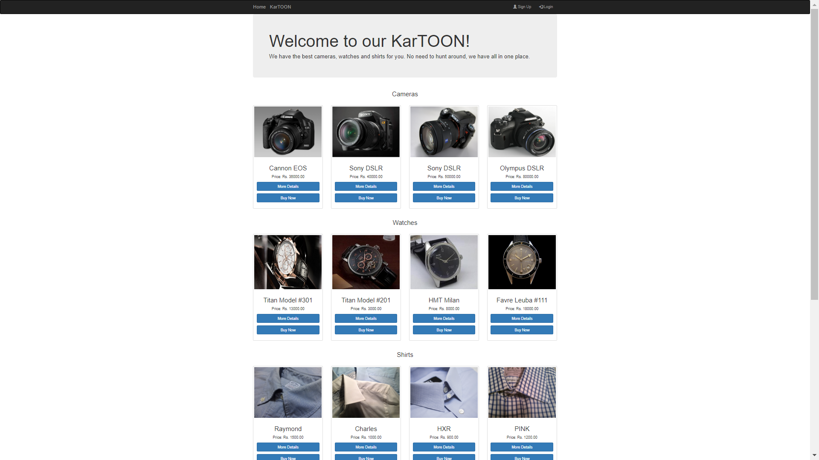**Fig2 : On Clicking kartoon button**

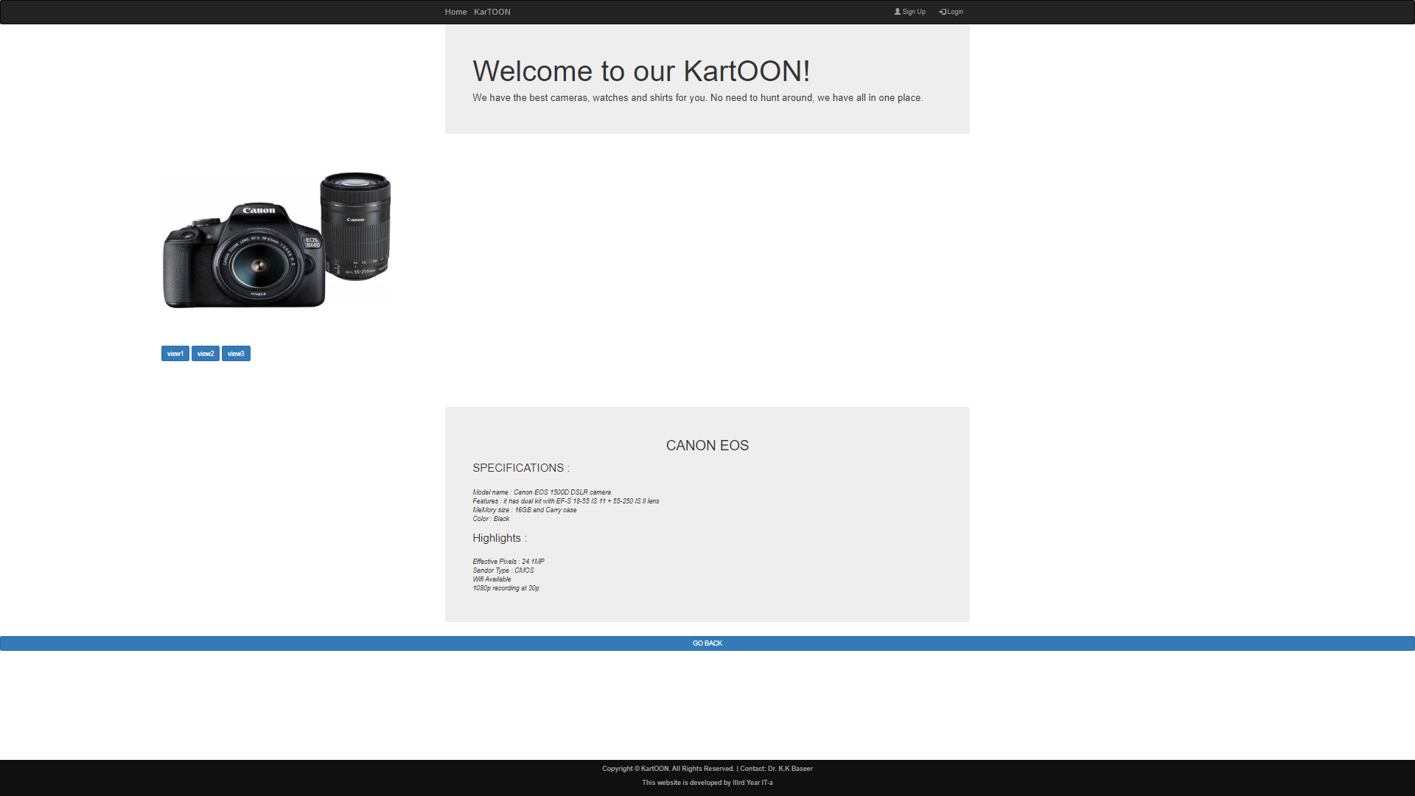

**Fig3 : On clicking more details button**

**Fig4 : Sign Up pag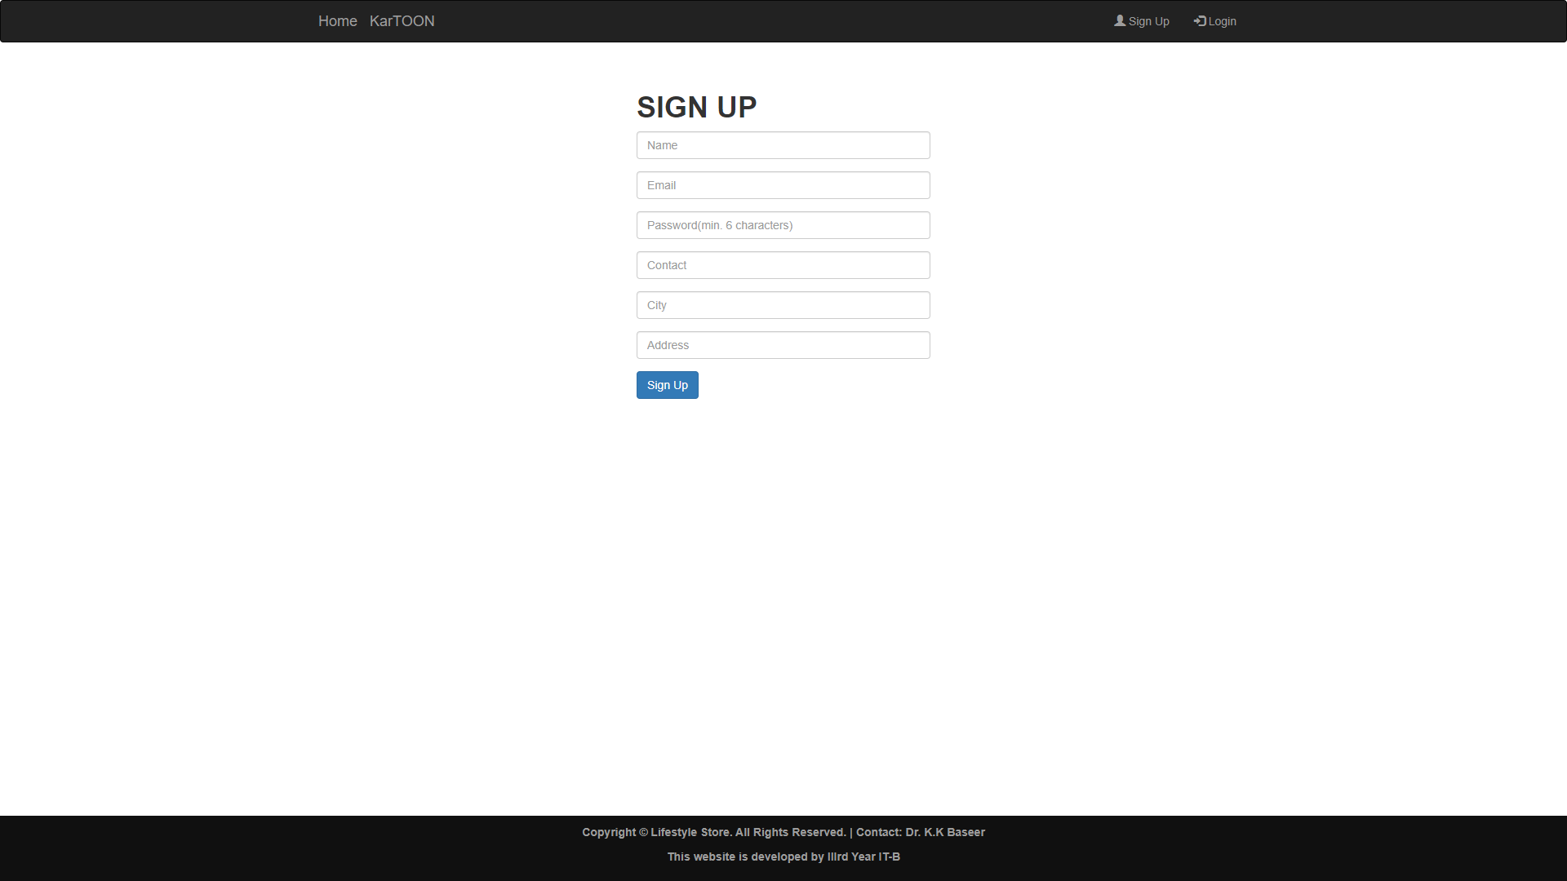e**

**Fig5 : login page**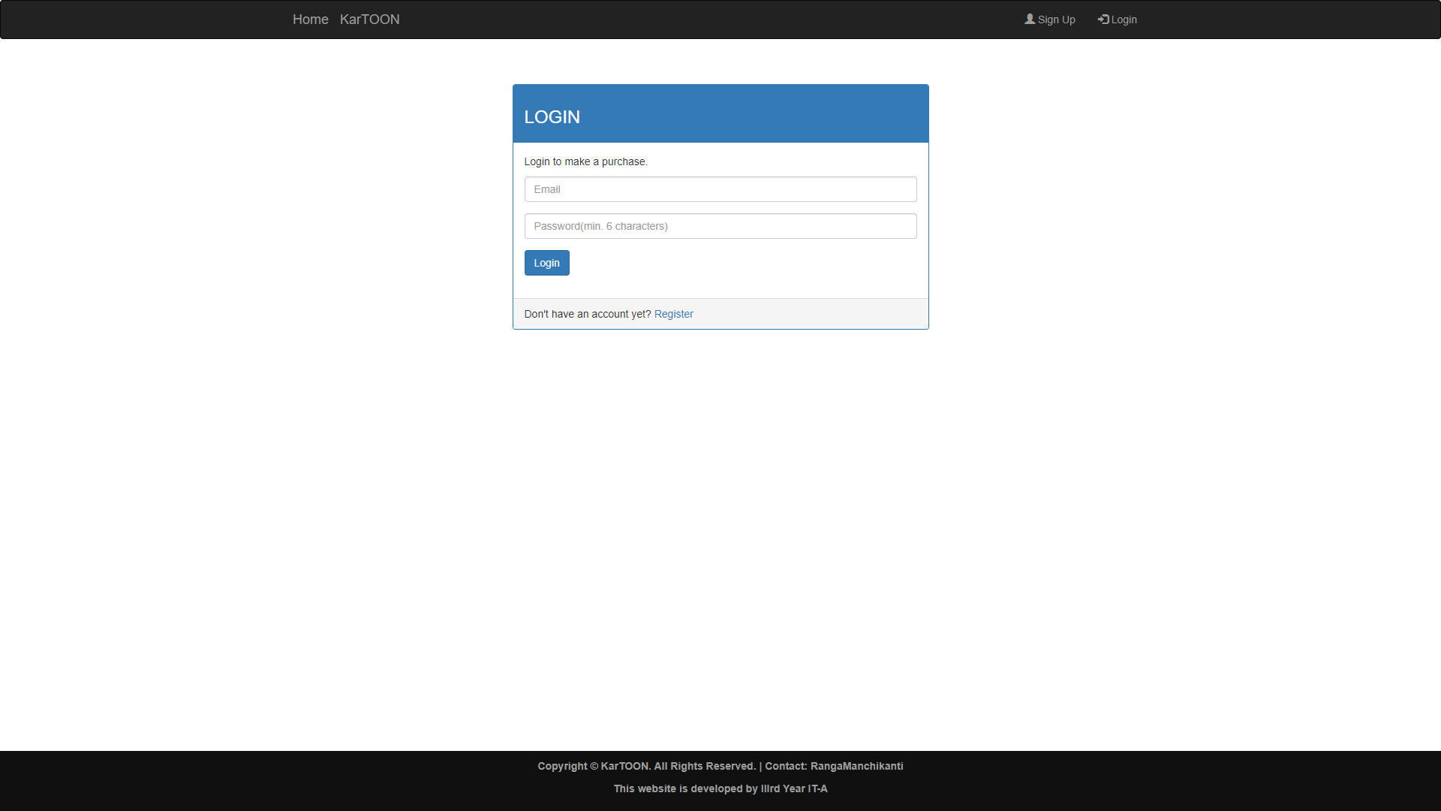

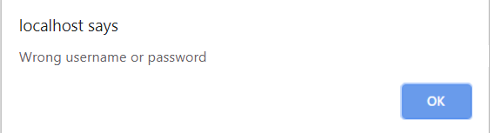

**Fig6:On entering wrong login credentials**

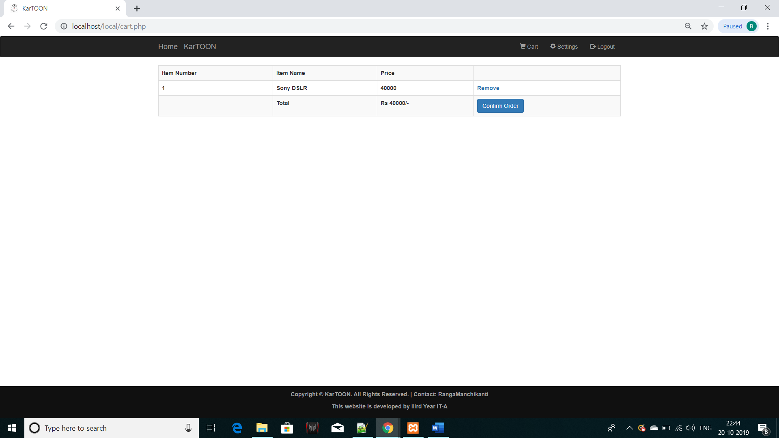

**Fig7 : On Clicking on Cart**

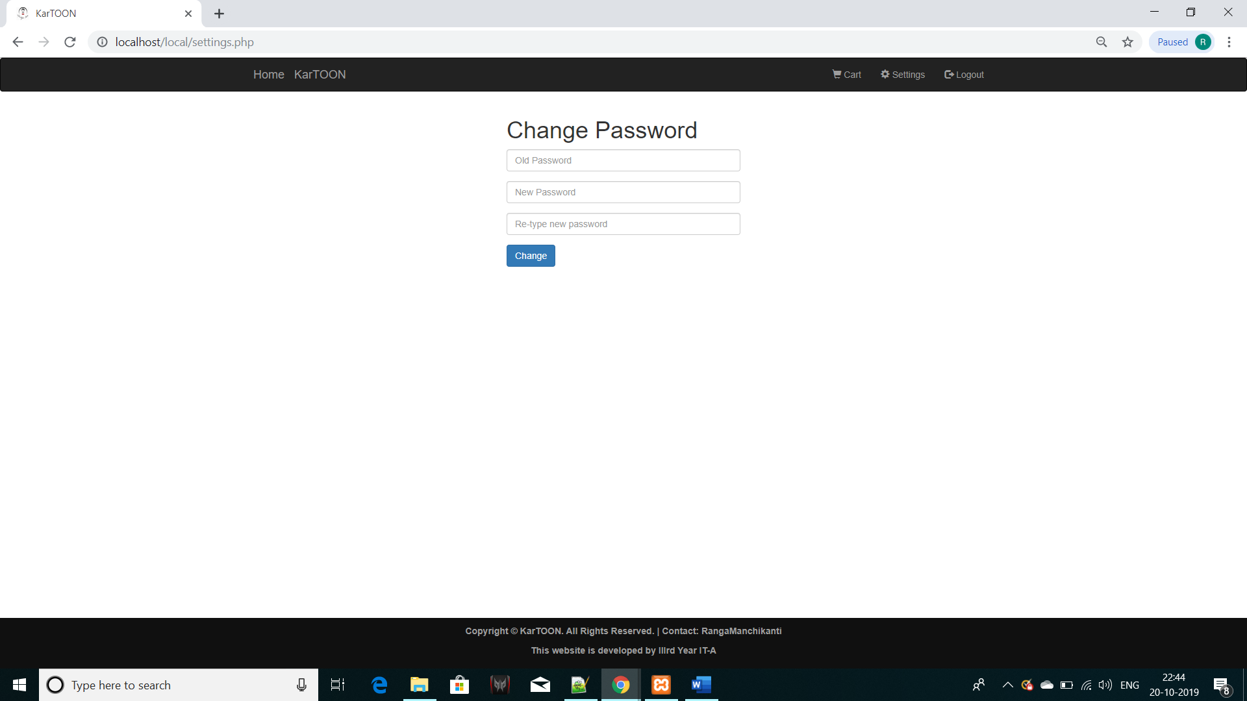

**Fig8:On Clicking Settings**

**CONCLUSION**

After having detail study on Online Shopping one can see a great change in the behavior of people in many manners like their attitude Buying pattern. In earlier times people use to do manual shopping but now as time changed people are becoming busy and due to which technology has brought a new revolution i.e. Online Shopping.

As we started doing survey it came to in notice that young age group people i.e. 15-30 uses or prefer online shopping because it is time and energy saving. But middle-age group does not prefer much because they have wrong perception that by seeing the product one can get the goods of proper quality. And even some people do not prefer using plastic money i.e. credit cards.

But online shopping has a great future but to be successful it is Necessary to spread awareness about its benefit. The package was designed in such a way that future modifications can be done easily.

The following conclusions can be deduced from the development of the project.

* It provides a friendly graphical user interface which proves to be better when compared to the existing system.
* It gives appropriate access to the authorized users depending on their permissions.
* It effectively overcomes the delay in communications.
* Updating of information becomes so easier.
* System security, data security and reliability are the striking features.
* The System has adequate scope for modification in future if it is necessary.
* Automation of the entire system improves the efficiency.