1. lsusb



pip3 install pyserial

sudo python3 -m pip install pandas

sudo python3 -m pip3 install wheel

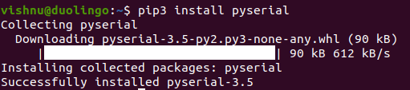

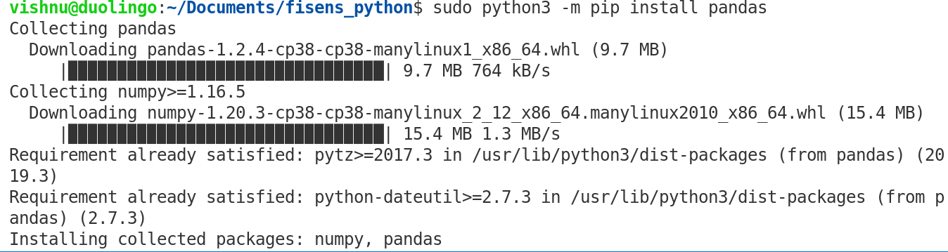

1. dmesg | grep tty // list port on which fisens is attached - Here it is ttyUSB0

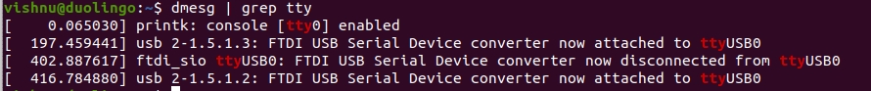

1. usb-devices

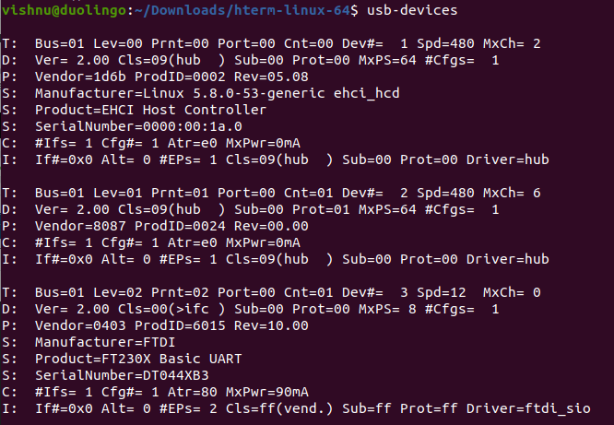

1. ls /dev/tty*

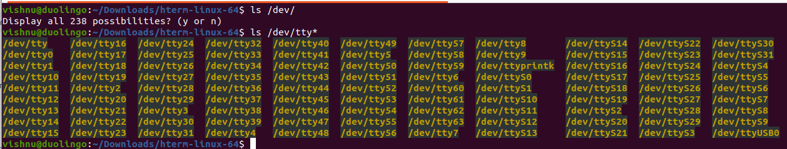

1. sudo adduser vishnu dialout // else it will not work

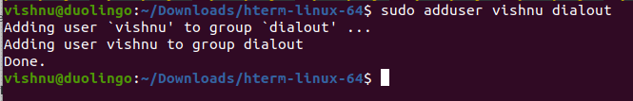

1. **REBOOT**
2. **pip3 install pandas**
3. **pip install matplotlib**
   1. 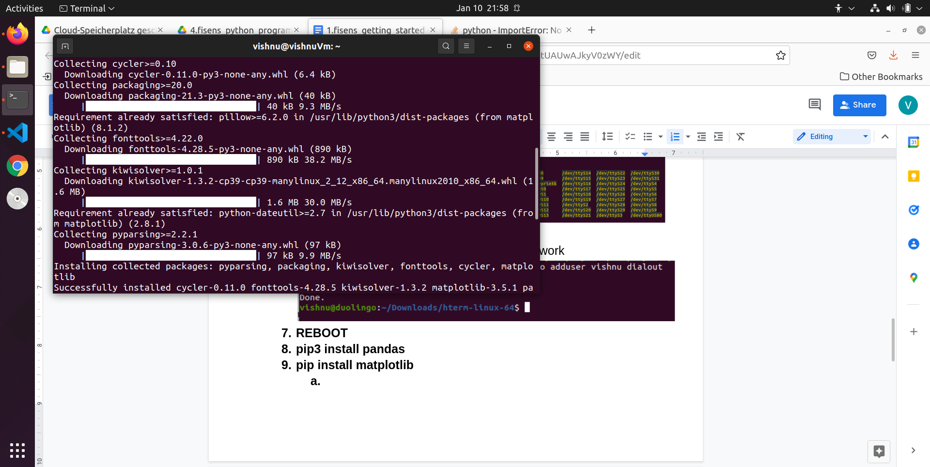
4. **Test**