HABIT HERO
AI-Powered Habit Tracking and Personal Growth Platform

Complete Software Project Documentation

Document Type: Technical Project Documentation
Audience: Academic submission, technical reviews, interviews
Documentation Date: 2026-11-11
Repository: https://github.com/vishnuk29072004-prog/Habit-Hero-
Primary Branch: main
Stack: React + Vite frontend · FastAPI + SQLite backend · Google Gemini · Google Calendar · ReportLab
This document describes the actual implemented system. Secrets, API keys and .env values are intentionally excluded.

Table of Contents
The table of contents below is a Word TOC field. In Microsoft Word, right-click and choose Update Field → Update entire table to refresh page numbers.

(Update TOC field in Microsoft Word to populate entries.)

1. Project Introduction

1.1 Introduction
Habit Hero is a full-stack web application for building consistent habits, tracking daily and weekly completions, managing personal goals, journaling reflections, and generating AI-assisted insights. The product pairs a React single-page application with a FastAPI backend, SQLite persistence, JWT authentication, Google Gemini AI features, ReportLab PDF export, and optional Google Calendar synchronization.

1.2 Background
Personal productivity tools often separate habit tracking, journaling, analytics and calendar planning into disconnected apps. Habit Hero consolidates these concerns into one authenticated workspace where the application remains the source of truth for habits, while external services (Gemini, Google Calendar, PDF generation) are invoked on demand.

1.3 Problem Statement
- Users struggle to maintain consistent habit schedules across daily and weekly cadences.
- Progress is hard to visualize without streak, category and calendar analytics.
- Generic habit suggestions rarely account for a user’s existing habits and goals.
- Journal writing lacks structured reflection on mood and motivation patterns.
- Exportable progress reports and calendar visibility are frequently missing or insecurely integrated.

1.4 Project Objectives
- Provide secure multi-user habit tracking with JWT access and refresh tokens.
- Support Daily and Weekly habit scheduling, check-ins, calendar status and streak math.
- Deliver goals, achievements, journal entries and in-app notification reminders.
- Integrate Google Gemini for personalized habit suggestions and journal mood analysis.
- Generate on-demand PDF progress reports without permanently storing report files.
- Offer optional Google Calendar OAuth sync with encrypted token storage.
- Expose a documented REST API and maintain automated pytest + frontend smoke coverage.

1.5 Scope
In scope (implemented):
- Web SPA (React/Vite) and REST API (FastAPI) with SQLite via SQLAlchemy + Alembic.
- Auth, profile/settings, habits, check-ins, calendar, analytics, goals, achievements, journal, notifications.
- AI Insights (habit suggestions + mood analysis), PDF export, Google Calendar connect/sync.
- Automated backend tests and Node smoke scripts under frontend/scripts.
Out of scope / not claimed as implemented:
- Native mobile apps, email/push notification delivery channels.
- Medical diagnosis from mood analysis.
- Automatic live Google OAuth consent without operator-configured Cloud credentials.
- Permanent server-side storage of AI outputs or PDF binaries.

1.6 Target Users
- Individuals seeking structured habit and goal tracking.
- Students and professionals documenting personal growth workflows.
- Reviewers evaluating full-stack engineering (API design, security, AI integration).

1.7 Proposed Solution
Habit Hero uses a layered architecture: React pages consume Axios API modules; FastAPI routers delegate to service modules; SQLAlchemy models persist per-user data; Gemini and Google Calendar are isolated behind backend services so secrets never reach the browser.

1.8 Key Differentiators
- Unified habit + journal + goals + analytics workspace with JWT isolation.
- Structured Gemini JSON outputs validated by Pydantic schemas.
- Fernet-encrypted Google OAuth tokens and HMAC-signed OAuth state.
- Deterministic scheduling/streak utilities shared by calendar and analytics.
- On-demand PDF composed from live analytics aggregates.

1.9 Expected Outcomes
Users can register, build habit routines, inspect calendar and analytics, reflect in a journal, request AI coaching insights, export PDF reports and optionally mirror habits to Google Calendar—demonstrating production-oriented full-stack skills.

2. Complete Technology Stack

2.1 Frontend Technologies
Technology | What it is | Why / Where in Habit Hero
React 19 | UI component library | All pages under src/pages; contexts for auth/habits
Vite 8 | Frontend build tooling | dev/build/preview scripts in package.json
JavaScript (ES modules) | Application language | src/**/*.jsx and services
HTML5 / CSS3 | Markup and styling | index.html, page CSS, Tailwind utilities
React Router DOM 7 | Client routing | App.jsx route table + ProtectedRoute
Context API | Global client state | AuthContext, HabitContext
Axios | HTTP client | apiClient.js + domain API modules
Lucide React | Icon set | Sidebar and page UI icons
Recharts | Charts | Analytics/dashboard visualizations
date-fns | Date helpers | Calendar/journal date handling
Tailwind CSS 4 | Utility CSS | @tailwindcss/vite integration

2.2 Backend Technologies
Technology | Responsibility in Habit Hero
Python 3 | Backend runtime
FastAPI | REST API, OpenAPI/Swagger, dependency injection
Uvicorn | ASGI server
SQLAlchemy 2 | ORM models and sessions
Alembic | Schema migrations (4 revisions)
Pydantic v2 / pydantic-settings | Request/response validation and Settings
SQLite | Local relational store (habit_hero.db)
python-jose | JWT encode/decode (HS256)
passlib + bcrypt | Password hashing
google-genai | Gemini generate_content / structured JSON
httpx | Google OAuth/Calendar HTTP calls
cryptography Fernet | Encrypt Google tokens at rest (token_crypto.py)
ReportLab | In-memory PDF composition
Pillow | Avatar image processing
Pytest + httpx TestClient | API/unit tests
pypdf | PDF test assertions (tests only)

2.3 Development Tools (verified usage)
Tool | Usage
Git / GitHub | Version control; remote Habit-Hero- on main
PowerShell | Windows setup commands in README
Swagger UI / OpenAPI | FastAPI /docs when server running
Google Cloud Console | Required for live Calendar OAuth credentials
Cursor / VS Code class editors | Development environment for this codebase
Node.js + npm | Frontend install, Vite build, smoke scripts

Versions referenced from frontend/package.json and backend/requirements.txt at documentation time. No unused speculative frameworks are listed.

3. System Architecture

3.1 Overview
Habit Hero follows a classic SPA ↔ REST API ↔ ORM ↔ database pattern with optional external integrations invoked only from the backend service layer.
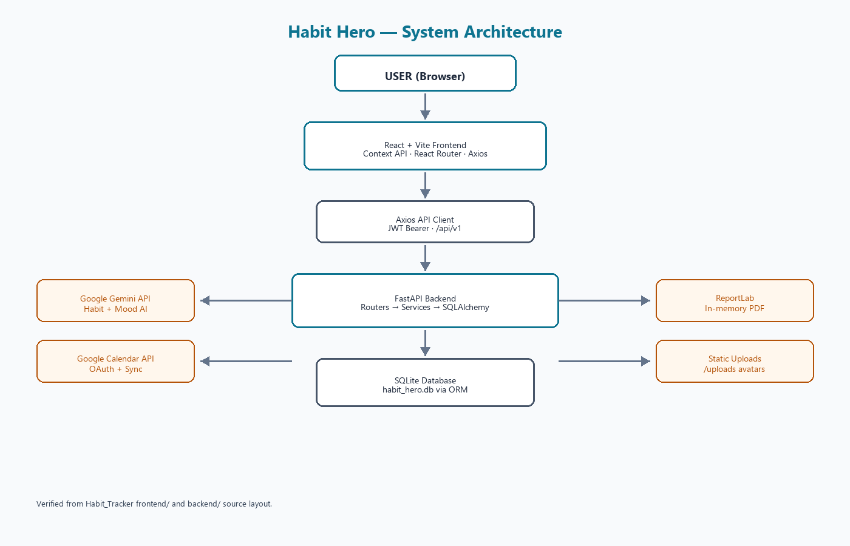
Figure 3.1 — System architecture

3.2 Frontend Architecture
- Entry: src/main.jsx mounts App.jsx.
- Routing: public /login and /signup; authenticated MainLayout routes for product pages.
- State: AuthProvider wraps session/profile/settings; HabitProvider loads domain data when authenticated.
- API boundary: src/services/api/* centralizes Axios calls and token refresh.

3.3 Backend Architecture
- app/main.py creates FastAPI app, CORS, uploads mount, lifespan scheduler hook.
- app/api/v1/router.py aggregates endpoint routers under settings.api_v1_prefix (default /api/v1).
- Endpoint modules call service modules; there is no separate repository package—services use SQLAlchemy Session directly.
- app/core holds config, security, scheduler; app/models and app/schemas define persistence and contracts.
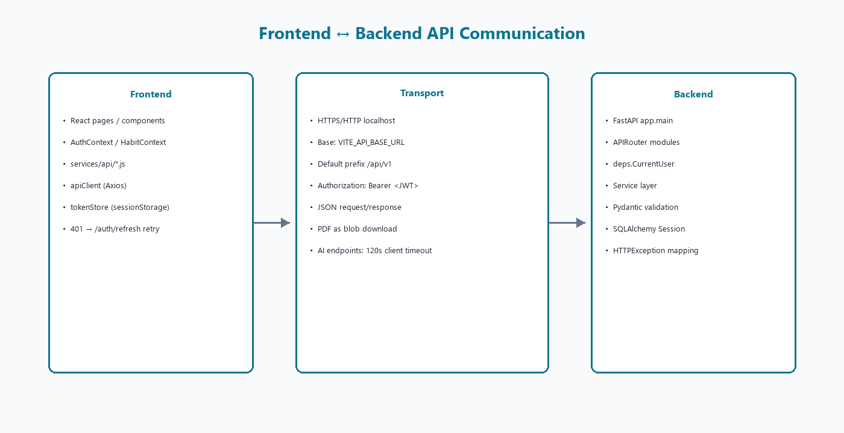
Figure 3.2 — API communication

3.4 Folder Structure (project root)
Habit_Tracker/
frontend/ React + Vite SPA
backend/ FastAPI + SQLAlchemy + Alembic + tests
docs/ Plans and validation reports
README.md Root setup overview
.gitignore Excludes .env, *.db, node_modules, .venv, dist

3.5 External Integrations
- Google Gemini via gemini_service (backend-only GEMINI_* settings).
- Google Calendar via google_calendar_service + Fernet token_crypto.
- ReportLab PDF via pdf_report_service streamed to the client.

4. Complete Frontend Pages
Routes are defined in frontend/src/App.jsx. Screenshots of a running UI were not stored in the repository; therefore this chapter documents pages from source rather than fabricated images. Asset hero.png exists under src/assets but is not referenced by routed pages.

4.1 Dashboard (`/`) — Dashboard.jsx
Purpose: Authenticated home overview of habit productivity.

Features
- Welcome header and summary statistics
- Today’s habits, weekly progress, category breakdown
- Streak and monthly overview widgets; progress trend; next goal
- Data primarily via analytics hooks (useDashboardAnalytics) and HabitContext

Backend APIs used
GET /analytics/* aggregates and habit/goal context data

Benefits
Provides a focused UX surface for the corresponding domain module while keeping secrets and business rules on the server.

4.2 Habit Management (`/habits`) — Habits.jsx
Purpose: Create, edit, archive/restore and check in habits.

Features
- Tabs: all/active/completed/archived; search and filters
- List/grid presentations; add/edit modal; delete confirmation
- Categories: Health, Work, Learning, Productivity, Mental Health
- Frequencies: Daily and Weekly (with week_day)

Backend APIs used
CRUD /habits and nested /habits/{id}/checkins

Benefits
Provides a focused UX surface for the corresponding domain module while keeping secrets and business rules on the server.

4.3 Calendar (`/calendar`) — Calendar.jsx
Purpose: Monthly and daily habit status with day notes. `/progress` redirects here.

Features
- Monthly grid from GET /calendar/monthly
- Daily summary with completed/pending/missed statuses
- Day notes CRUD via /calendar/notes
- Monthly statistics and legend

Backend APIs used
/calendar/monthly, /daily, /notes

Benefits
Provides a focused UX surface for the corresponding domain module while keeping secrets and business rules on the server.

4.4 Analytics (`/analytics`) — Analytics.jsx
Purpose: Performance analytics with date-range filtering and PDF export.

Features
- Tabs: overview, habits, categories, trends, insights
- DateRangeFilter drives analytics API queries
- PDFExportButton opens modal for progress PDF download
- Charts via Recharts components under components/analytics

Backend APIs used
/analytics/* and GET /reports/progress/pdf

Benefits
Provides a focused UX surface for the corresponding domain module while keeping secrets and business rules on the server.

4.5 Goals (`/goals`) — Goals.jsx
Purpose: Goal lifecycle plus achievements panel.

Features
- Create/edit/delete goals; progress visualization
- Linked habits and target types supported by backend schemas
- Achievements list/summary from achievement APIs

Backend APIs used
/goals*, /achievements*

Benefits
Provides a focused UX surface for the corresponding domain module while keeping secrets and business rules on the server.

4.6 Journal (`/journal`) — Journal.jsx
Purpose: Mood-tagged journal entries and history.

Features
- Create/edit/delete entries with tags and optional habit link
- Stats, calendar cues, recent entries, history modal
- Supports later AI mood analysis which requires ≥3 entries in range

Backend APIs used
/journal*

Benefits
Provides a focused UX surface for the corresponding domain module while keeping secrets and business rules on the server.

4.7 AI Insights (`/ai-insights`) — AIInsights.jsx
Purpose: Landing page for Gemini-powered coaching features.

Features
- HabitSuggestions component → POST /ai/habit-suggestions
- JournalMoodAnalysis component → POST /ai/mood-analysis
- Add Habit action persists a suggestion through normal habit create
- Extended Axios timeout (120s) for AI calls in aiApi.js

Backend APIs used
/ai/habit-suggestions, /ai/mood-analysis

Benefits
Provides a focused UX surface for the corresponding domain module while keeping secrets and business rules on the server.

4.8 Settings (`/settings`) — Settings.jsx
Purpose: Preferences, reminders, Google Calendar, local data clear.

Features
- Account card links to /profile
- Streak goal target and eight reminder preference toggles
- GoogleCalendarSettings: connect/sync/disconnect/status
- Clear local STORAGE_KEY habit cache

Backend APIs used
/users/me/settings, /calendar/google/*

Benefits
Provides a focused UX surface for the corresponding domain module while keeping secrets and business rules on the server.

4.9 Profile (`/profile`) — Profile.jsx
Purpose: Profile editing, avatar upload/remove, password change, logout.

Features
- PATCH /users/me, avatar POST/DELETE, password PATCH
- Logout clears tokens and returns to /login

Backend APIs used
/users/me*

Benefits
Provides a focused UX surface for the corresponding domain module while keeping secrets and business rules on the server.

4.10 Authentication — Login.jsx / Signup.jsx
Purpose: Public auth pages with redirect-to-origin after login.

Features
- Signup enforces password complexity rules in UI
- ProtectedRoute gates MainLayout children
- JWT stored via tokenStore (memory + sessionStorage)

Backend APIs used
/auth/register, /auth/login, /auth/refresh, /auth/logout, /auth/me

Benefits
Provides a focused UX surface for the corresponding domain module while keeping secrets and business rules on the server.

4.11 Unrouted page note
frontend/src/pages/Progress/Progress.jsx exists but is not imported in App.jsx; navigation to /progress redirects to /calendar. It is therefore not part of the live route map.

5. Backend Modules
Backend responsibilities are organized as FastAPI endpoint modules plus service modules. There is no separate repository layer package in this codebase.
Module | Primary code | Responsibilities
Authentication | auth endpoints + auth_service + security.py | Register/login, JWT pair, refresh rotation, logout, /auth/me
User Profile | users endpoints + user_service | Profile, password, avatar (Pillow), settings flags
Habit Management | habits + habit_service | CRUD, archive/restore, safe delete-vs-archive
Habit Check-ins | checkins + checkin_service | Per-day completion with unique (habit_id, date)
Calendar | calendar + calendar_service + day_note_service | Monthly/daily/summary statuses and day notes
Analytics | analytics + analytics_service + streak utils | Overview, weekly/monthly, categories, best days, streaks
Goals | goals + goal_service + goal_progress | CRUD, summary, computed progress by target_type
Achievements | achievements + achievement_service | Catalogue evaluation and earned records
Journal | journal + journal_service | Entries, tags, moods, summaries
Notifications | notifications + notification_service + notification_generator | In-app inbox generation and read state
AI Habit Suggestions | ai + ai_habit_service + gemini_service | Structured Gemini suggestions with validation
AI Mood Analysis | ai + ai_journal_service + gemini_service | Journal range analysis with minimum entry gate
PDF Reports | reports + pdf_report_service | Streaming ReportLab PDF
Google Calendar | google_calendar + google_calendar_service + token_crypto | OAuth, encrypted tokens, habit event sync

5.1 Cross-cutting concerns
- Validation: Pydantic request models (extra=forbid on many writes).
- AuthZ: CurrentUser dependency isolates rows by user_id.
- Errors: HTTPException mapping in services/endpoints; Gemini errors classified in gemini_service.
- Security: bcrypt passwords, hashed refresh tokens, Fernet Google tokens, CORS from settings.

6. Complete REST API Documentation
Default API prefix is /api/v1 (Settings.api_v1_prefix). Interactive Swagger UI is available at http://127.0.0.1:<port>/docs when Uvicorn is running. Local development has successfully used port 8010 when port 8000 hit Windows socket permission issues; README examples often show 8000. Frontend .env.example documents VITE_API_BASE_URL pointing at 8010.

6.1 Endpoint catalogue
Method | Path | Purpose | Auth
GET | /api/v1/health | Health check | No
POST | /api/v1/auth/register | Create account | No
POST | /api/v1/auth/login | Login token pair | No
POST | /api/v1/auth/refresh | Rotate refresh + access | No
POST | /api/v1/auth/logout | Revoke refresh | No
GET | /api/v1/auth/me | Auth profile | Yes
GET/PATCH | /api/v1/users/me | Profile | Yes
POST/DELETE | /api/v1/users/me/avatar | Avatar | Yes
PATCH | /api/v1/users/me/password | Change password | Yes
GET/PATCH | /api/v1/users/me/settings | Settings | Yes
POST/GET | /api/v1/habits | Create/list habits | Yes
GET/PATCH/DELETE | /api/v1/habits/{id} | Habit detail/update/delete | Yes
PATCH | /api/v1/habits/{id}/archive|restore | Archive lifecycle | Yes
POST/GET | /api/v1/habits/{id}/checkins | Check-ins | Yes
GET/PATCH/DELETE | /api/v1/habits/{id}/checkins/... | Check-in by date/id | Yes
GET | /api/v1/calendar/monthly|daily|summary | Calendar views | Yes
CRUD | /api/v1/calendar/notes | Day notes | Yes
GET | /api/v1/calendar/google/status|connect|events | Google status/connect/list | Yes*
GET | /api/v1/calendar/google/callback | OAuth callback | No (signed state)
POST | /api/v1/calendar/google/disconnect|sync | Disconnect/sync | Yes
DELETE | /api/v1/calendar/google/events/{id} | Delete mapped event | Yes
GET | /api/v1/analytics/* | Overview/habit/weekly/monthly/categories/best-days/streaks | Yes
CRUD | /api/v1/goals | Goals + /summary | Yes
GET | /api/v1/achievements* | Earned + summary | Yes
CRUD | /api/v1/journal | Journal + /summary | Yes
GET/POST/PATCH/DELETE | /api/v1/notifications* | Inbox + generate + read | Yes
POST | /api/v1/ai/habit-suggestions | AI suggestions | Yes
POST | /api/v1/ai/mood-analysis | AI mood analysis | Yes
GET | /api/v1/reports/progress/pdf | PDF stream | Yes

* Google connect/status/events require JWT except the OAuth callback, which validates HMAC state.

6.2 Representative AI schemas (Pydantic)
HabitSuggestionsRequest: count integer default 5, ge=1, le=5.
HabitSuggestionItem fields: name, description, category (HABIT_CATEGORIES), frequency (Daily|Weekly), reason, recommended_start_date (YYYY-MM-DD).
MoodAnalysisRequest: start_date, end_date (end ≥ start). MoodAnalysisData includes overall_mood, mood_summary, mood_patterns.positive/challenging, motivation_patterns, positive_observations, areas_to_improve, recommendations, summary, entries_analyzed, analysis_period.

6.3 Error handling patterns
- 401/403 for missing/invalid Bearer tokens on protected routes.
- 422 for Pydantic validation failures.
- AI: 503 not configured / overloaded; 429 rate limit; 504 upstream timeout; 502 invalid upstream response.
- Google Calendar: refuses operation when GOOGLE_* / TOKEN_ENCRYPTION_KEY incomplete.

7. Google Gemini AI Integration
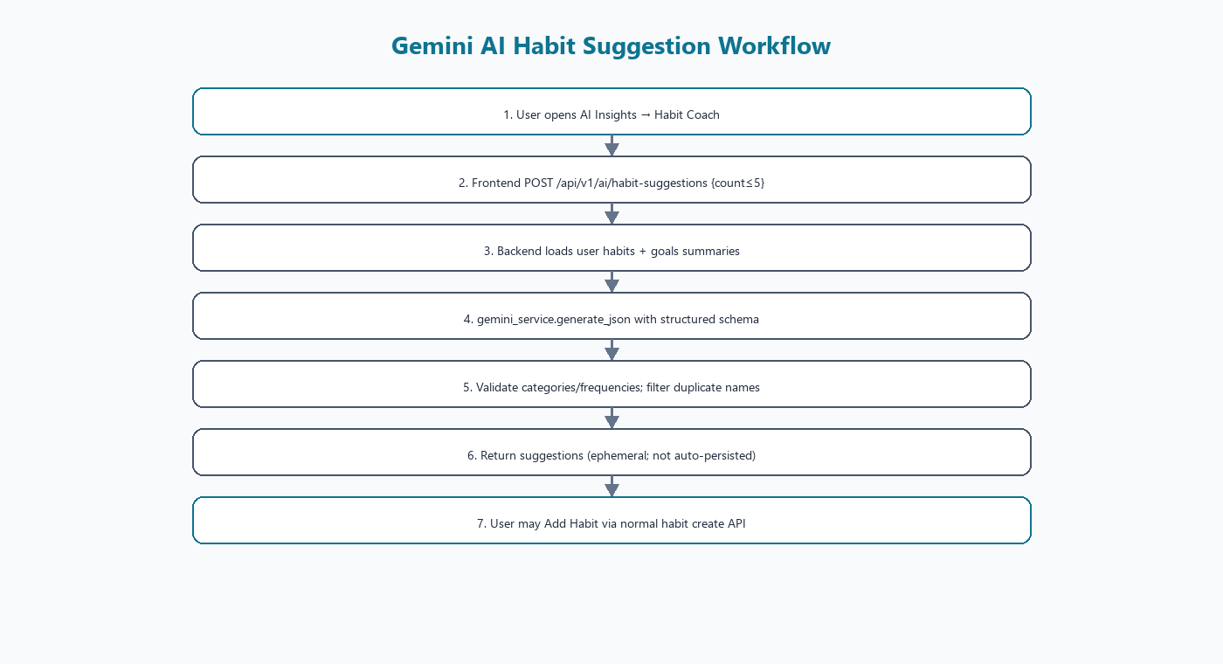
Figure 7.1 — Habit suggestion workflow

7.1 AI Habit Suggestions
- User requests suggestions from AI Insights Habit Coach.
- Frontend calls POST /api/v1/ai/habit-suggestions with count ≤ 5.
- ai_habit_service loads habit and goal summaries for the authenticated user.
- A prompt is composed and passed to gemini_service.generate_json with HabitSuggestionsLLMResponse schema.
- Gemini returns structured JSON; backend validates categories/frequencies/dates.
- Suggestions whose names collide with existing habits are filtered.
- Response is ephemeral (not written as habits automatically).
- User may add a suggestion through the standard habit create path.

7.2 AI Journal Mood Analysis
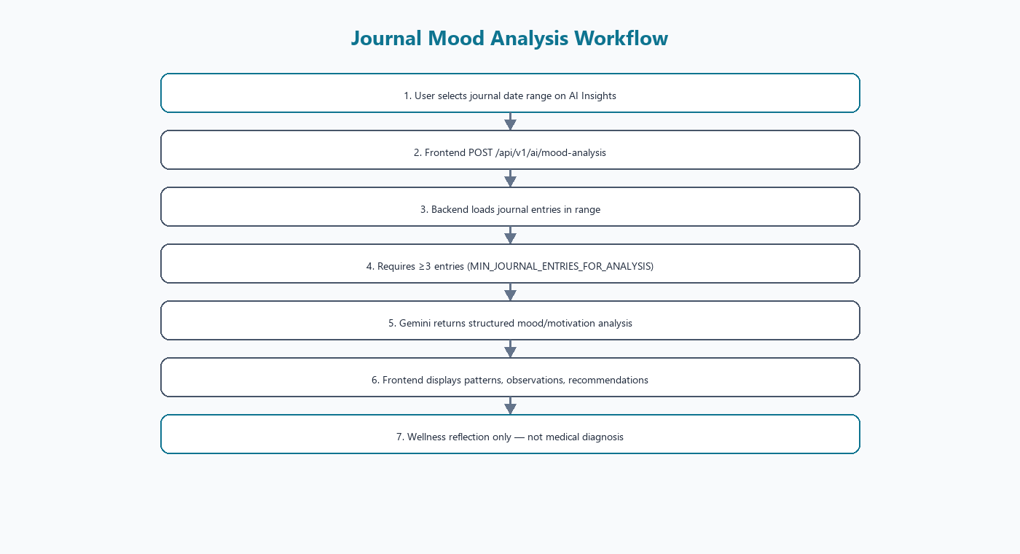
Figure 7.2 — Mood analysis workflow
- User selects a date range.
- Backend loads journal entries in range.
- Requires at least MIN_JOURNAL_ENTRIES_FOR_ANALYSIS = 3 entries.
- Gemini produces structured mood, motivation, observations and recommendations.
- Frontend renders the analysis sections.
- Content is wellness reflection, not medical diagnosis (product intent / UI copy).

7.3 Configuration (names only)
Variable | Purpose | Code default
GEMINI_API_KEY | Backend-only Google AI credential | empty → features disabled
GEMINI_MODEL | Model id for generate_content | gemini-3.8-flash
GEMINI_TIMEOUT_SECONDS | Client HttpOptions timeout (seconds→ms) | 90 (allowed 5–180)

Credentials live in backend/.env and must never be exposed to Vite. google-genai Client is created with HttpOptions.timeout in milliseconds. Upstream 503 high-demand and 504 DEADLINE_EXCEEDED are classified into user-safe HTTP errors. Live Gemini latency/timeouts have been observed even with valid keys and listed models; mocked pytest does not prove live upstream availability.

8. Google Calendar Integration
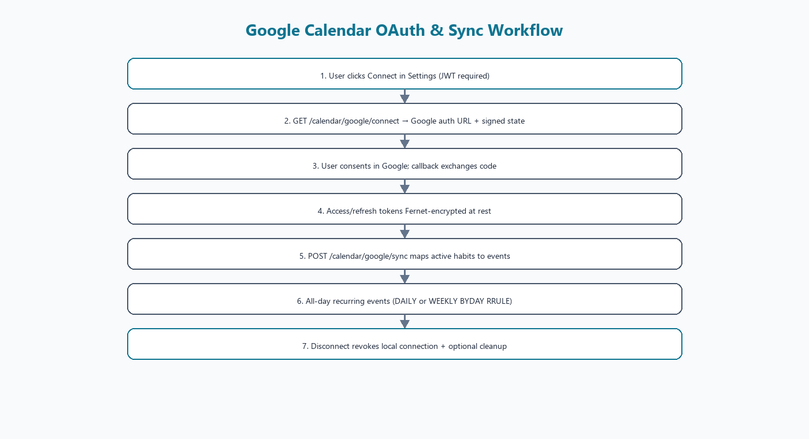
Figure 8.1 — OAuth and sync

8.1 Setup requirements
- Create a Google Cloud project.
- Enable Google Calendar API.
- Configure OAuth 2.0 Client ID/Secret.
- Set redirect URI to match GOOGLE_REDIRECT_URI.
- Generate a stable Fernet TOKEN_ENCRYPTION_KEY.
- Set FRONTEND_APP_URL for post-connect redirect to Settings.

8.2 Environment variable names
Variable | Purpose
GOOGLE_CLIENT_ID | OAuth client id
GOOGLE_CLIENT_SECRET | OAuth client secret
GOOGLE_REDIRECT_URI | Backend callback URL
TOKEN_ENCRYPTION_KEY | Fernet key for access/refresh token ciphertext
FRONTEND_APP_URL | Where callback redirects after success

TOKEN_ENCRYPTION_KEY must remain stable while encrypted rows exist; rotating it without re-auth renders stored tokens unreadable.

8.3 Runtime behavior
- Connect builds Google auth URL with HMAC-SHA256 signed state (≈10 minute expiry) bound to user id.
- Callback exchanges code, fetches userinfo, stores encrypted tokens in google_calendar_connections.
- Sync creates/updates/deletes mappings in habit_google_events for non-archived habits.
- Events are all-day because the habit model has no wall-clock time field.
- RRULE: FREQ=DAILY for daily habits; FREQ=WEEKLY;BYDAY=.. for weekly habits (Sun=0..Sat=6).
- API responses intentionally omit raw OAuth tokens.
- Live consent still requires operator-supplied Cloud credentials (documented limitation).

9. PDF Report Generation
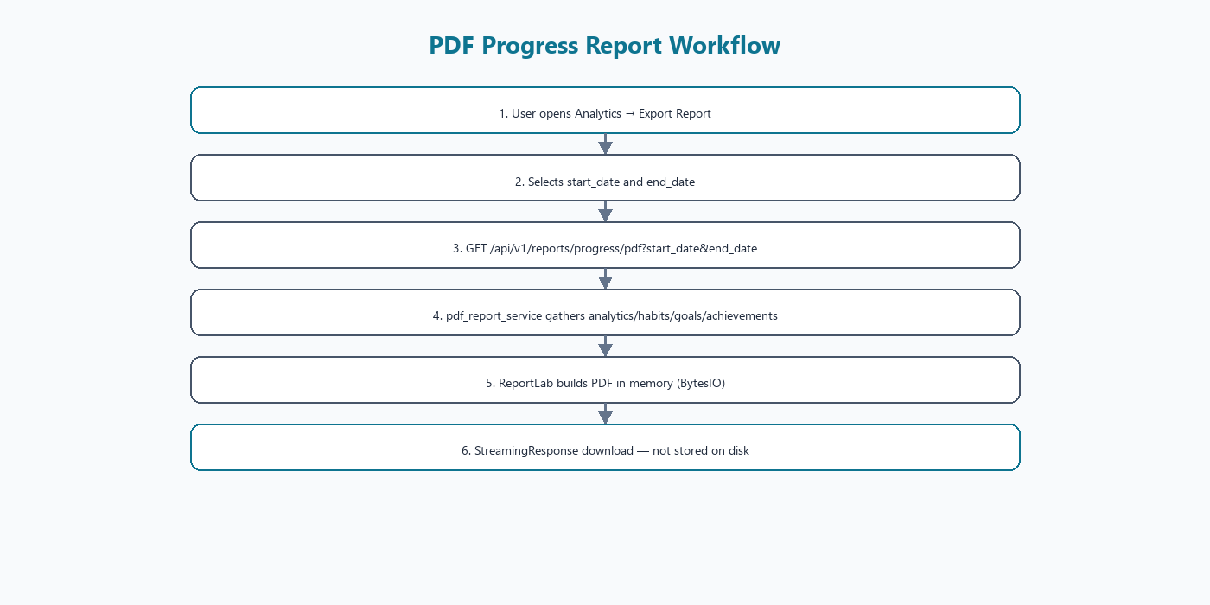
Figure 9.1 — PDF workflow
Endpoint GET /api/v1/reports/progress/pdf accepts authenticated start_date and end_date query params. pdf_report_service.build_progress_pdf composes a ReportLab document in memory and returns bytes. FastAPI streams them via StreamingResponse with Cache-Control: no-store. Reports are not persisted on disk. The PDF builder does not call Gemini.

9.1 Report sections (from code)
- User Information
- Overall Habit Summary
- Individual Habit Performance
- Streak Analysis
- Calendar Progress
- Category-wise Performance
- Goal Progress
- Achievements
- Final Summary
Frontend PDFExport modal (components/reports/PDFExport.jsx) downloads a blob named like HabitHero_Progress_Report_*.pdf.

10. Database Design
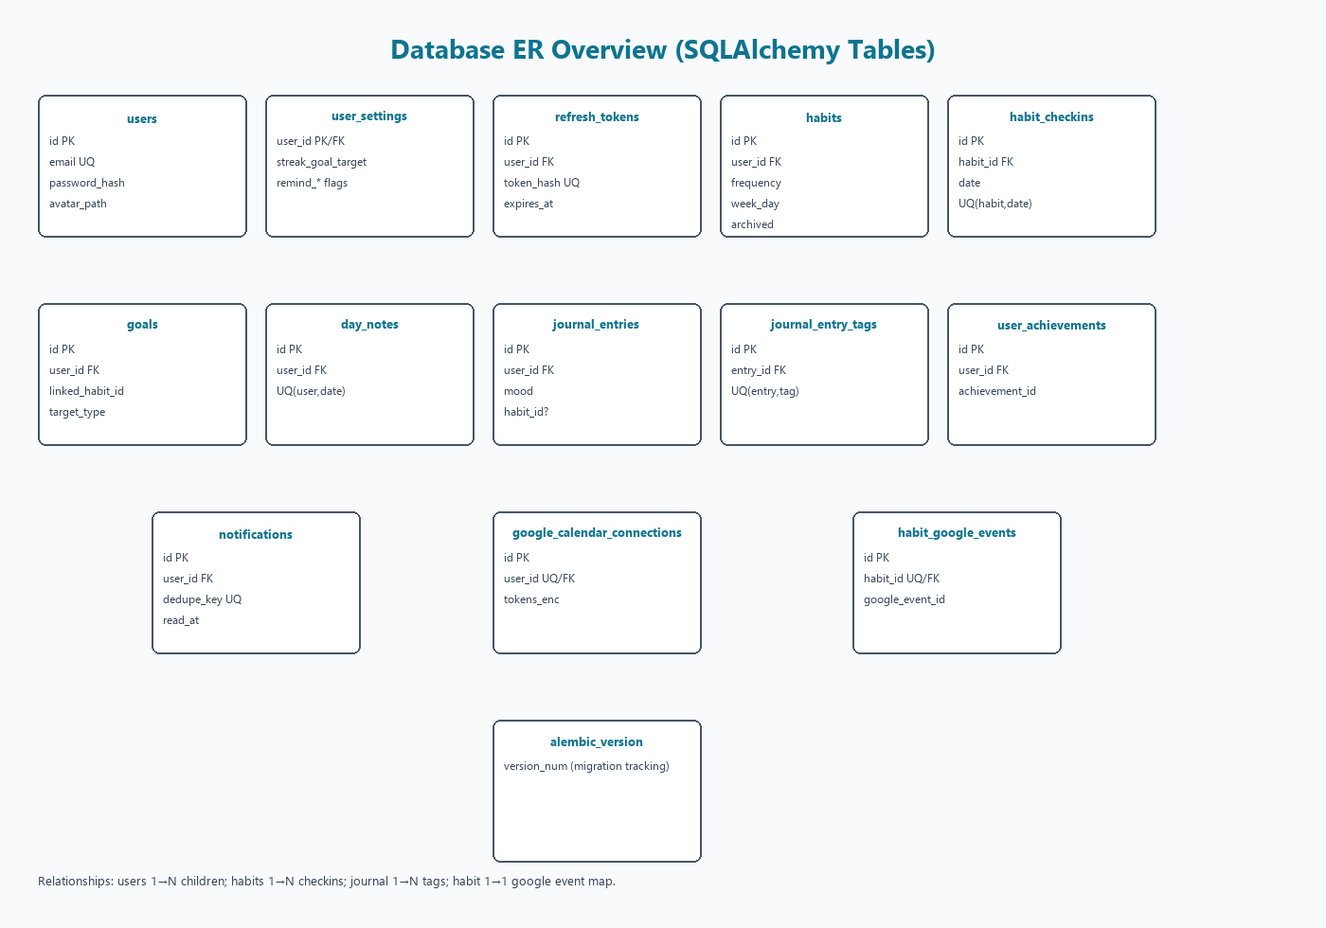
Figure 10.1 — ER overview
Persistence uses SQLAlchemy ORM against SQLite (DATABASE_URL, commonly sqlite:///./habit_hero.db). Alembic tracks schema via alembic_version. Four migration revisions create the tables below.
Table | Purpose | PK | Important columns / constraints
users | Accounts | id | email unique; password_hash; avatar_path
user_settings | Prefs / reminder flags | user_id PK/FK | streak_goal_target; remind_* integers
refresh_tokens | Refresh token hashes | id | token_hash unique; expires_at; revoked_at
habits | Habit definitions | id | frequency; week_day; archived; FK user
habit_checkins | Daily completions | id | UQ(habit_id,date); completed 0/1
goals | Personal goals | id | target_type/value; linked_habit_id
day_notes | Calendar notes | id | UQ(user_id,date)
journal_entries | Journal | id | mood; optional habit_id
journal_entry_tags | Tags | id | UQ(journal_entry_id,tag)
user_achievements | Unlocked badges | id | UQ(user_id,achievement_id)
notifications | In-app inbox | id | UQ(user_id,dedupe_key)
google_calendar_connections | OAuth connection | id | user_id unique; token ciphertext
habit_google_events | Habit↔event map | id | habit_id unique; google_event_id
alembic_version | Migration pointer | version_num | Alembic bookkeeping

10.1 ORM interaction
Services obtain a Session via FastAPI dependencies, query mapped classes under app/models, and commit unit-of-work changes. Cascades are declared on relationships (e.g., user delete orphans).

11. Authentication and Security
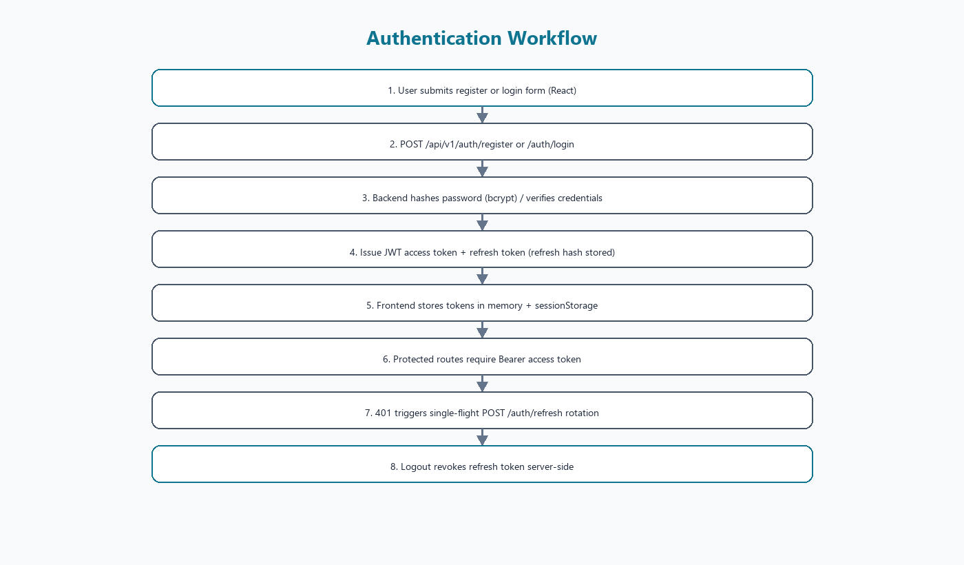
Figure 11.1 — Auth workflow
- Registration stores bcrypt password hashes (passlib CryptContext).
- Login returns JWT access (type=access) and refresh (type=refresh, jti).
- Refresh tokens persisted as SHA-256 hashes; rotation revokes prior row.
- Protected APIs depend on HTTPBearer + get_current_user.
- All domain queries scope by authenticated user_id.
- Pydantic validates payloads; many write schemas forbid unknown fields.
- Google OAuth state is HMAC-signed and user-bound.
- Google tokens encrypted with Fernet (TOKEN_ENCRYPTION_KEY).
- CORS origins configured via CORS_ORIGINS.
- Secrets belong in backend/.env (gitignored); only .env.example placeholders are committed.

11.1 Example environment placeholders
SECRET_KEY=change-me-in-production
GEMINI_API_KEY=
GEMINI_MODEL=gemini-3.8-flash
GEMINI_TIMEOUT_SECONDS=90
GOOGLE_CLIENT_ID=
GOOGLE_CLIENT_SECRET=
GOOGLE_REDIRECT_URI=http://127.0.0.1:8010/api/v1/calendar/google/callback
TOKEN_ENCRYPTION_KEY=
FRONTEND_APP_URL=http://127.0.0.1:5173
VITE_API_BASE_URL=http://127.0.0.1:8010/api/v1

12. Habit Tracking Algorithms
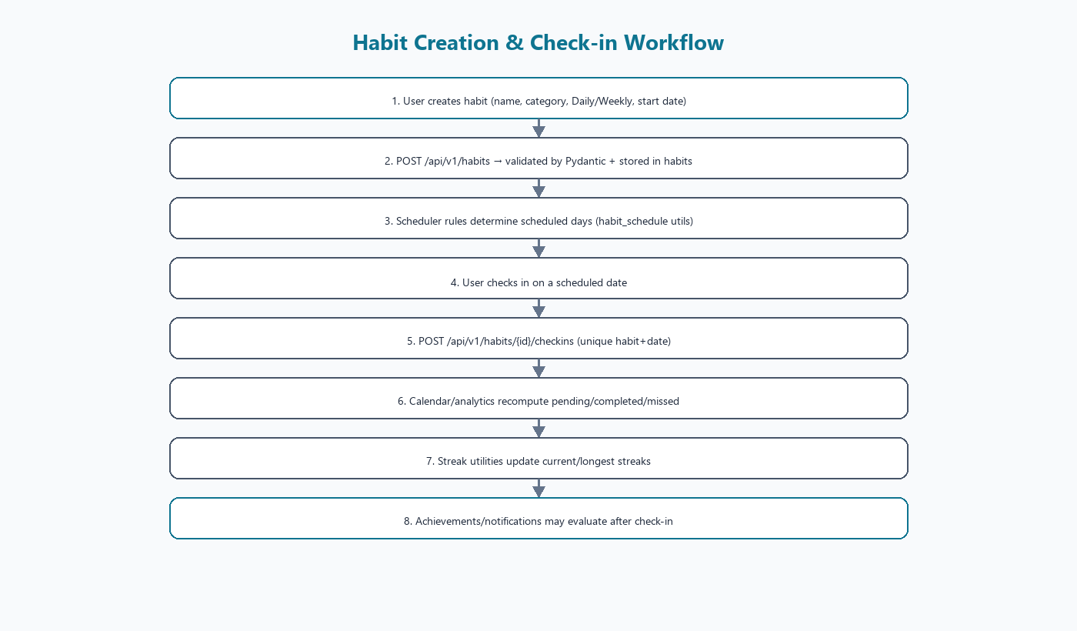
Figure 12.1 — Habit & check-in flow

12.1 Scheduling
utils/habit_schedule.py decides whether a habit is scheduled on a date. Daily habits are scheduled each day on/after start_date. Weekly habits match week_day where Sunday=0 … Saturday=6. Archived habits are excluded unless explicitly included.

12.2 Day status
calendar_service / analytics map a scheduled day to completed (check-in completed=1), pending (today or future), or missed (past incomplete). Unscheduled days are not_scheduled.

12.3 Completion percentage
completion_percentage = round((completed / scheduled) * 100)
# if scheduled <= 0: return 0
Implemented in app/utils/streak_calculations.py::completion_percentage.

12.4 Streaks
- Current streak walks backward from as_of.
- Days with no scheduled habits are skipped (do not break streak).
- Any incomplete scheduled day breaks the streak.
- Longest streak scans a lookback window (default 365 days).

12.5 Example
If a user has two daily habits and completes both on Mon–Wed, skips Thu (incomplete), then completes Fri, the current streak as of Friday is 1 (Thursday broke continuity). Unscheduled Sunday for a Mon-only weekly habit does not break a weekly streak calculation that skips unscheduled days.

13. Notifications and Reminders
Habit Hero implements an in-app notification inbox only. Email and push delivery are not implemented. notification_generator.py creates idempotent rows keyed by dedupe_key.
Type (generator) | Intent
habit_daily_reminder | Daily habit reminder
habit_weekly_reminder | Weekly habit reminder
habit_upcoming | Upcoming habit reminder
habit_overdue | Overdue habit reminder
goal_deadline / goal_overdue | Goal deadline reminders
streak_milestone | Streak milestone
weekly_summary | Weekly summary

User settings expose toggles for these reminder categories. An optional asyncio scheduler exists (NOTIFICATIONS_SCHEDULER_ENABLED, default false; interval default 900 seconds). Listing notifications defaults to refresh=true which regenerates before returning the inbox.

14. Complete User Workflow
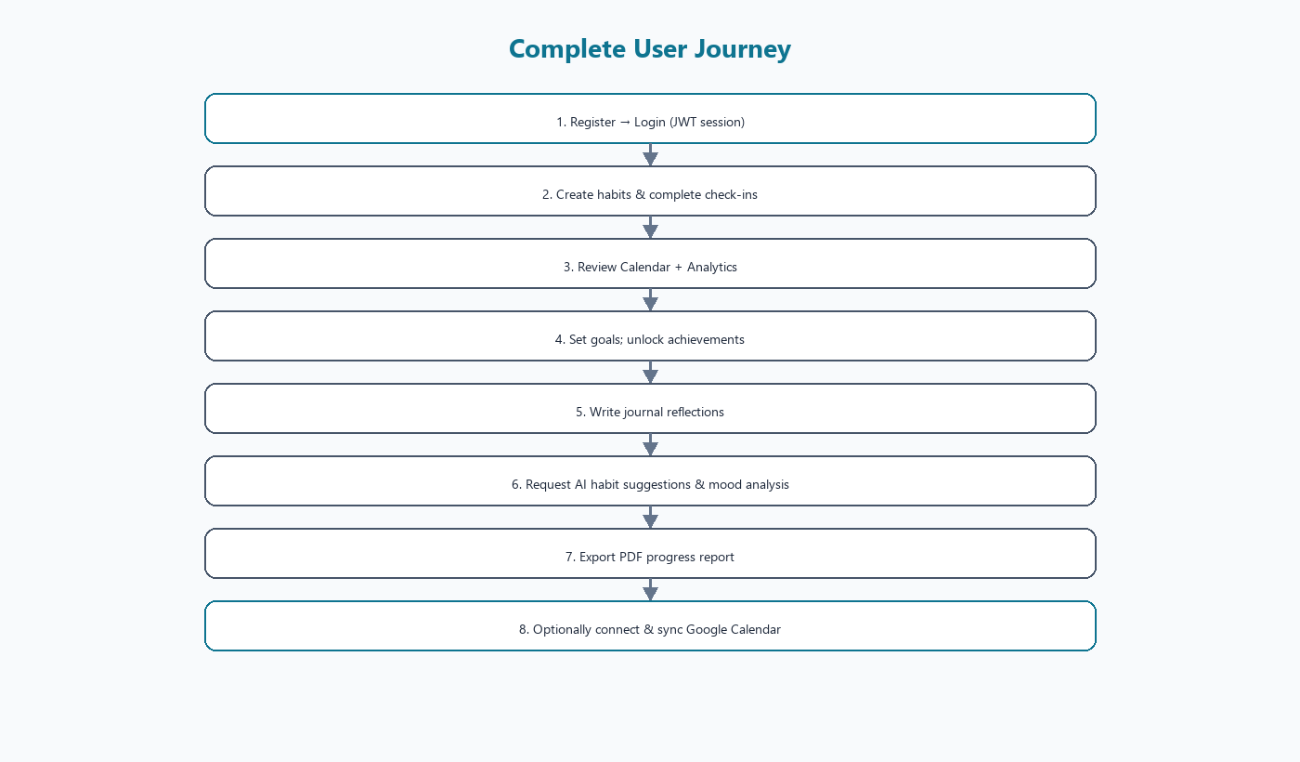
Figure 14.1 — User journey
- Register an account
- Log in and receive JWT session
- Create Daily/Weekly habits
- Complete check-ins on scheduled days
- Review Calendar statuses and day notes
- Monitor Analytics and streaks
- Create goals and earn achievements
- Write journal entries
- Request AI habit suggestions
- Run journal mood analysis
- Export PDF progress report
- Optionally connect and sync Google Calendar

15. Project Advantages
Advantage | Real-world value
Centralized habit management | One workspace for routines instead of spreadsheets
Daily + weekly scheduling | Supports both frequent and weekly cadences
Visual analytics/calendar | Makes consistency measurable
Personalized Gemini suggestions | Suggestions grounded in existing habits/goals
Journal mood insights | Structured reflection aids self-review
Goals + achievements | Motivation via targets and unlocks
Google Calendar sync | External visibility of routines
PDF reports | Shareable progress artifacts
JWT + user isolation | Multi-user safety on shared deployments
Modular API/services | Extensible backend for new features

16. Testing and Validation
FINAL_PROJECT_VALIDATION_REPORT.md (2026-11-11) recorded 200 pytest passed after Stage G. A later collect-only inspection of backend/tests reported 203 collected tests after additional Gemini error-classification coverage. Operators should re-run pytest locally for the latest number.

16.1 Backend pytest modules
- test_auth, test_users, test_habits, test_checkins, test_calendar
- test_analytics, test_goals, test_achievements, test_journal
- test_notifications (+ migration test)
- test_gemini_config, test_ai_habit_suggestions, test_ai_journal_analysis
- test_pdf_export, test_google_calendar

16.2 Distinguishing test types
Type | What it proves | What it does not prove
Mocked pytest (Gemini/Google HTTP) | App error handling & contracts | Live upstream availability
Live smoke scripts (frontend/scripts) | End-to-end against local API when run | CI guarantee unless executed
npm run build | Frontend bundles | Runtime UX quality
Manual browser checks | UI presence of routes/panels | Full regression alone

16.3 Known testing limitations
- Live Gemini may return 504/503 under load.
- Live Google OAuth requires real Cloud credentials + browser consent.
- Notification scheduler disabled by default in config.

17. Installation and Execution (Windows PowerShell)

17.1 Prerequisites
- Python 3.12+ recommended
- Node.js + npm
- Git
- Optional Google Cloud project for Calendar

17.2 Backend
cd E:\Habit_Tracker\backend
python -m venv .venv
.\.venv\Scripts\Activate.ps1
pip install -r requirements.txt
copy .env.example .env
# Edit .env — set SECRET_KEY and optional integrations (never commit secrets)
$env:PYTHONPATH = (Get-Location).Path
alembic upgrade head
uvicorn app.main:app --reload --host 127.0.0.1 --port 8010
Port note: README historically documents 8000. On some Windows setups port 8000 raised socket permission errors; 8010 was verified successfully. Align VITE_API_BASE_URL and GOOGLE_REDIRECT_URI with the chosen port. Swagger: http://127.0.0.1:8010/docs

17.3 Frontend
cd E:\Habit_Tracker\frontend
npm install
# Ensure .env has VITE_API_BASE_URL=http://127.0.0.1:8010/api/v1
npm run dev
App: http://localhost:5173

17.4 Troubleshooting
- 401 loops: check token refresh and SECRET_KEY stability.
- AI timeouts: inspect backend logs for Gemini 504/503; configuration may be correct while upstream is slow.
- Google connect disabled: ensure all GOOGLE_* and TOKEN_ENCRYPTION_KEY are set.
- CORS errors: include the Vite origin in CORS_ORIGINS.

18. GitHub and Version Control
Item | Verified value
Remote | https://github.com/vishnuk29072004-prog/Habit-Hero-.git
Default branch | main
Recent commits (sample) | Initial commit; AI/PDF/Calendar feature commit; validation doc commit
.gitignore | Excludes .env, *.db, .venv, node_modules, dist, caches

Development workflow: feature work locally → pytest/smoke → commit without secrets → push main. Do not commit backend/.env or frontend/.env.

19. Limitations
- Gemini upstream latency/timeouts (504 DEADLINE_EXCEEDED) and occasional 503 high demand.
- Live Google OAuth requires operator Cloud credentials and browser consent.
- Calendar sync uses all-day recurring events (no per-habit time-of-day in schema).
- AI outputs and PDFs are generated dynamically and not permanently stored as artifacts.
- Notifications are in-app only (no email/push).
- Notification scheduler disabled by default.
- Progress.jsx page exists but is not routed.
- Single SQLite file is suitable for local/demo deployments; horizontal scaling would need further work.
These are current limitations, not future roadmap items.

20. Future Enhancements (not implemented)
- Native mobile applications
- Deeper AI personalization and scheduled recommendations
- Email and push notification channels
- Social habit challenges and shared goals
- Advanced analytics / additional report formats
- Cloud deployment automation
- Additional calendar providers
Clearly labeled as future work — not present features.

21. Conclusion
Habit Hero demonstrates a complete full-stack personal growth platform: a React/Vite client, a FastAPI service layer, SQLite persistence with Alembic migrations, JWT security, analytics and streak algorithms, Gemini-powered coaching features, ReportLab PDF export, and Google Calendar OAuth sync with Fernet-encrypted tokens. The architecture keeps secrets on the server, validates inputs with Pydantic, isolates user data, and backs critical paths with automated tests while honestly documenting live third-party limitations.
As a portfolio and academic artifact, the project evidences API design, ORM modeling, authentication, frontend state management, third-party integration discipline, and documentation hygiene suitable for technical interviews and project reviews. Future enhancements can extend delivery channels and deployment topology without abandoning the modular service boundaries already in place.

22. Appendices

Appendix A — Diagram index
A.1 docs/diagrams/01_system_architecture.png
A.2 docs/diagrams/02_api_communication.png
A.3 docs/diagrams/03_database_er.png
A.4 docs/diagrams/04_auth_workflow.png
A.5 docs/diagrams/05_habit_checkin_workflow.png
A.6 docs/diagrams/06_gemini_habit_suggestions.png
A.7 docs/diagrams/07_mood_analysis_workflow.png
A.8 docs/diagrams/08_google_calendar_oauth.png
A.9 docs/diagrams/09_pdf_report_workflow.png
A.10 docs/diagrams/10_user_journey.png

Appendix B — Key source paths
- frontend/src/App.jsx — routes
- frontend/src/services/api/ — Axios modules
- backend/app/api/v1/endpoints/ — routers
- backend/app/services/ — business logic
- backend/app/models/ — SQLAlchemy tables
- backend/alembic/versions/ — migrations
- docs/FINAL_PROJECT_VALIDATION_REPORT.md — validation snapshot

Appendix C — References
- Project README.md and backend/README.md
- FastAPI / OpenAPI Swagger UI at runtime /docs
- Google Gemini API via google-genai SDK
- Google Calendar API OAuth 2.0 documentation
- ReportLab documentation
- GitHub repository Habit-Hero-

Appendix D — Verification statement
This document was generated from inspection of the Habit_Tracker codebase. Secret values from .env files were not read into the document. Where live third-party behavior could not be permanently guaranteed (Gemini availability, Google consent), limitations are stated explicitly.

