📘 HTML FOR BEGINNERS — COMPLETE NOTES
1️⃣ Introduction to HTML
What is HTML?
- HTML stands for HyperText Markup Language
- It is used to create web pages
- HTML defines the structure of a webpage
- CSS is used for design
- JavaScript is used for behavior
👉 Think of HTML as the skeleton of a website 🦴

2️⃣ History of HTML

- Created by Tim Berners-Lee in 1989
- Used to share documents on the internet
- Latest version: HTML5
- HTML allows:
  - Links (Hypertext)
  - Structured content (Markup)

3️⃣ HTML Tags & Attributes
What are HTML Tags?
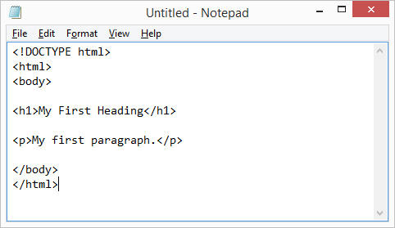
- Tags define elements
- Written inside angle brackets
Example:
<h1>Hello World</h1>
- <h1> → opening tag
- </h1> → closing tag

What are HTML Attributes?
- Attributes give extra information
- Written inside opening tag
Example:
<img src="dog.jpg" alt="My Dog">
Attribute | Meaning
src | Image location
alt | Text if image not visible

Golden Rules ✅
- Most tags need opening + closing
- Close tags in correct order
Correct:
<strong><em>Important</em></strong>

4️⃣ HTML Editors

Recommended Editors
Editor | Platform | Notes
Sublime Text | Win/Mac/Linux | Beginner friendly
Notepad++ | Windows | Lightweight
Komodo Edit | All | Open-source
❌ Never use MS Word

5️⃣ Basic HTML Page Structure
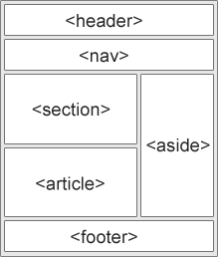
<!DOCTYPE html>
<html>
<head>
<title>My First Webpage</title>
<meta charset="UTF-8">
</head>
<body>

Content goes here

</body>
</html>
Tag Purpose
Tag | Use
<!DOCTYPE> | HTML5 declaration
<html> | Root element
<head> | Metadata
<body> | Visible content

6️⃣ Headings in HTML
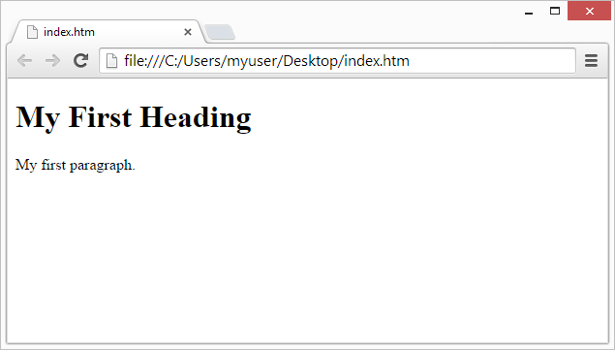
<h1>Main Title</h1>
<h2>Sub Title</h2>
<h3>Section</h3>
- <h1> → most important
- <h6> → least important
- Search engines use headings for SEO

7️⃣ Paragraphs & Text Formatting
Paragraph
<p>This is a paragraph</p>
Text Formatting Tags
Tag | Meaning
<b> | Bold
<strong> | Important
<i> | Italic
<em> | Emphasis
<u> | Underline
<mark> | Highlight
<sup> | Superscript
<sub> | Subscript
Example:
<p>This is <strong>important</strong> text</p>

8️⃣ Links (Anchor Tag)

<a href="https://google.com">Google</a>
Internal Link
<a href="page2.html">Page 2</a>
- <a> → anchor
- href → destination

9️⃣ Images in HTML
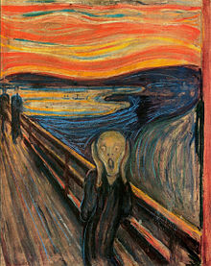
<img src="photo.jpg" alt="My Photo" width="200">
Image File Types
- .jpg
- .png
- .gif
⚠️ Alt text is important for SEO & accessibility

🔟 Lists in HTML
Ordered List
<ol>
<li>Item One</li>
<li>Item Two</li>
</ol>
Unordered List
<ul>
<li>Apple</li>
<li>Banana</li>
</ul>
Definition List
<dl>
<dt>HTML</dt>
<dd>Markup language</dd>
</dl>

1️⃣1️⃣ Tables in HTML

<table>
<tr>
<td>Name</td>
<td>Age</td>
</tr>
<tr>
<td>Vishnu</td>
<td>22</td>
</tr>
</table>
Table Tags
Tag | Use
<table> | Table
<tr> | Row
<td> | Cell
<th> | Header
⚠️ Never use tables for layout

1️⃣2️⃣ Closing an HTML Document
</body>
</html>
Always close:
- <body>
- <html>

1️⃣3️⃣ Troubleshooting Template (Correct Code)
<!DOCTYPE html>
<html>
<head>
<title>My First Webpage</title>
<meta charset="UTF-8">
</head>
<body>

<h1>Welcome</h1>
<p>This is my website</p>

<img src="testpic.jpg" alt="Test Image">

<a href="page2.html">Page 2</a>

</body>
</html>

1️⃣4️⃣ What’s Next?
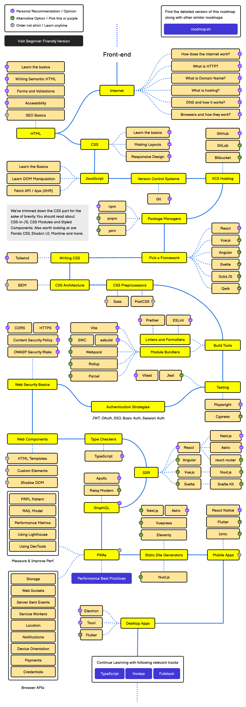
Learn next:
- CSS (design)
- JavaScript (interaction)
- Hosting & Domains
- Responsive Design

1️⃣5️⃣ HTML.com Guide to Web Hosting (Summary)
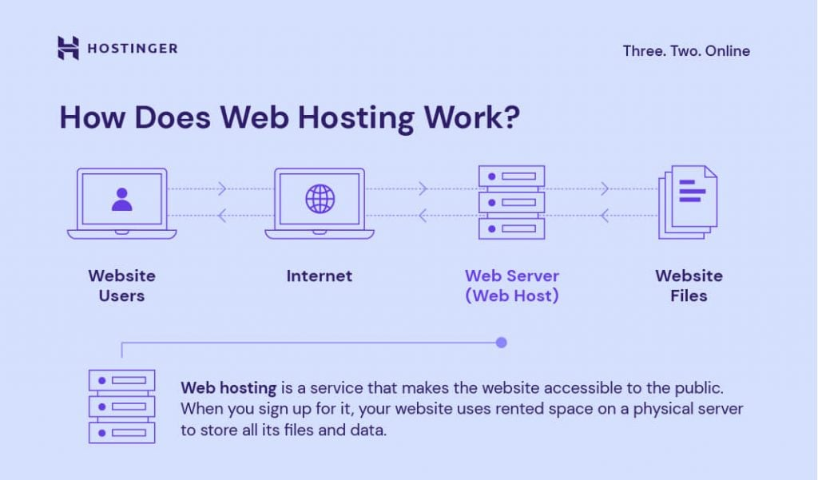
- Hosting stores your website files
- Makes site available online
- Providers:
  - SiteGround
  - Bluehost
  - HostGator
  - iPage
  - WP Engine

✅ FINAL SUMMARY
- HTML builds structure
- Tags + attributes create content
- Easy to learn
- Foundation of all websites
- Combine with CSS & JS for full power 💪

