**BRAIN TUMOR DETECTION USING MRI BRAIN IMAGES**

**SWE4010**

**ARTIFICIAL INTELLIGENCE**

**J Component paper**

K. Vishnu Vardhan J.V.S. Tharun Kousik

18MIS1098 18MIS1073

P. Guru Pavan Kumar N. Bhanu Prakash

18MIS1062 18MIS1057

Abstract**—** Diagnosis of brain tumour is indeed a challenging task in the early stages of life. But now it has developed with various machine learning algorithms. Now the issue of automatic brain tumor screening day is very interesting. To diagnose a patient's brain tumor we consider patient data as MRI images of the patient's brain. The main goal is to check the tumor is present or not. It is very important to find the tumors at the first stage of a healthy patient's life. There is a lot of literature for discovering these types of brain plants and improving the accuracy of detection. In this paper, we measure brain tumor mass using the Convolutional Neural Network algorithm that provides accurate results

**Index Terms**: Tumour Detection, Convolutional Neural Network, Gaussian Filters.

**Introduction**

Magnetic resonance Imaging (MRI) provides a brief overview of anatomy of the brain, cell formation and vascular resection, making it an important tool for effective diagnosis, treatment and monitoring of the disease. Magnetic resonance imaging (MRI) is a noninvasive medical examination that helps doctors diagnose and treat medical conditions. MRI uses a powerful magnetic field, radio waves, and a computer to produce detailed images of organs, tissues, bones, and all the other internal organs. Images can then be viewed on computer monitors, transmitted electronically, printed or copied to a CD. MRI does not use ionizing radiation (x-rays). Detailed MRI images allow doctors to locate different parts of the body and resolve the presence of specific diseases. Automatic detection of brain tumors on MRI scans is one of the most sought-after tasks in modern medical imaging studies.

Automatic detection requires the division of the brain image, which is the process of splitting the image into separate regions, is one of the most important and sought-after feature of computer-assisted clinical diagnostic tools. The sounds present in Brain MRI images are repetitive sounds and the reduction of these sounds is a daunting task. This makes `classification of brain images difficult. However, accurate diagnosis of MRI images is very important and very important for accurate diagnosis with computer-assisted clinical tools. A wide variety of MRI imaging algorithms have been developed. Scheduling surgery, postoperative testing, abnormal detection, and many other medical applications require the separation of a medical image. Despite the wide range of automatic and semi-automatic image separation techniques, they often fail mainly due to unfamiliar and unusual sound, variety, good contrast.

.

**problem statement**

Detection and Classification of Brain tumor from images of MRI using Convolutional Neural Networks.

**Literature survey**

One of the most challenging and difficult tasks is to isolate the area you are interested in and to identify the tumor in the MRI Brain image is aspiration. Researchers around the world are working in this field to find a ROI that is well-suited to a wide range of different models that are simulated with a different perspective. Nowadays segregation based Neural Network provides outstanding results, and the flow of using this model is increasing day by day.

In the paper of R. B. Dubey, extract audio from MRI image input using Gaussian filter. The Weierstrass Transform is almost identical to a Gaussian filter, which incorporates integration using the Gaussian Activity. The purpose of using the Gaussian filter is to turn the image into a smooth image. Viewing an image is similar to looking at a bright screen. Gaussian filter is a type of low pass filter, so by moving the filter to the most common areas of the image remove the sounds. But it takes a lot of time to complete the process and no further details will be provided.

Bahadure et al. Proposed SVM and BWT techniques to analyze MRI-based image detection and classification of brain tumors. 95 percent accuracy is achieved using this method, used to remove the skull that destroys all non-brain tissue for the purpose of detection.

Joseph et al. proposed a K-compound algorithm for MRI brain imaging and morphological filters to obtain tumor images. Vector Support Machine for automatic brain tissue segregation of MRI images was proposed by Alfonse and Salem.

Author Sachdeva et al. use Artificial Neural Network (ANN) and PCA – ANN to differentiate MRI imaging of multi-stage brain tumors, image classification of 428 MRI images with 75–90% accuracy achieved.

Dina et al. introduced a model based on the Negative Nerve Network model related to Learning Vector Quantization. The model was tested on 64 MRI images, among which 18 MRI images were used as a test set, and the other was used as a training set. Gaussian filter makes images smoother. 79% of processing time has been reduced by a modified PNN method. The Probabilistic Neural Network based on the separation strategy used by Othman et al. Principal Component Analysis (PCA) has been used to extract the feature and to reduce the size of the data [12]. MRI images are converted to matric, and then the Probabilistic Neural network is used for fragmentation. Finally, performance analysis is performed. The training data set contained 20 subjects, and the experimental data included 15 subjects. Based on the distribution value, the accuracy ranged from 73% to 100%.

The method used in this paper is based on Hough's vote, a strategy that allows for fully automated localization and classification of interested anatomy elements. It also adopted a classification approach based on robust, multi-regional, flexible and adaptable learning strategies. Different amounts of training data and different data sizes (2D, 2.5D and 3D) are used to predict final results. Convolutional neural networks, Hough voting with CNN, Voxel-wise segregation and intelligent intelligence analysis with CNN are used in image analysis.

The brain is an important part of the human body that regulates and coordinates the functions of other parts of the body. It is primarily the central nervous system control center and is responsible for performing voluntary and artificial daily activities in the human body. A tumor is a fibrous molecule that grows in unwanted tissue within our brain that grows in an uncontrolled way. To prevent and treat the tumor, magnetic resonance imaging (MRI) is widely used by radiologists to analyze the phases of brain tumors. The result of this analysis reveals the presence of a tumor in the brain.

Hong Men, et al. introduces a dual machine learning neural network and SVM for brain MRI separation. They have used two types of vector support machine based on the polynomial kernel and the radial base function of different parameter values. The results of this test indicate that the vector mechanism of support is superior to the neural network algorithm

Dahshan et al. MRI of the brain is the inclusion in the system; the features are extracted by a different wavelet conversion, reduced by the process of analyzing the main component

**CONVOLUTIONAL NEURAL NETWORK**

In neural networks, the input is in vector mode, and in CNN the input is an image with multiple channels i.e. three channels. At CNN, the input image is integrated with the kernel matrix (dot product functionality) or filter and the effect will be scale. The filter is moved closer to the input image to achieve duplicate flexibility thus providing an output matrix called the feature map.

The Convolutional Neural Network is widely used in the field of medical imaging. Over the years many researchers have tried to come up with a ingenious solution to this problem. We have tried to come up with an example that can accurately identify a tumor in 2D Brain MRI images. A fully connected neural network can detect a tumor, but due to the parameter sharing and minimal communication, we have adopted CNN for our model.

A Five-Level Network of Emotional Transformation is introduced and used to detect the tumor. An integrated model consisting of seven sections comprising hidden layers gives us the most striking effect of plant capture. The following is the proposed short story

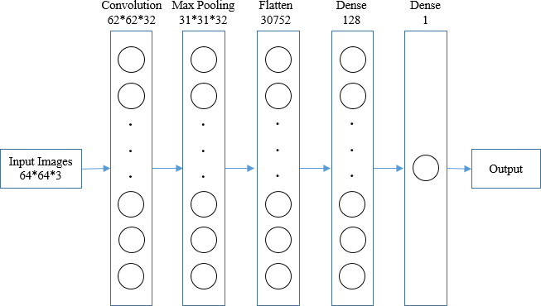

Using a convolutional layer as a starting layer, a 64 * 64 * 3 MRI imaging input is produced that converts all images into a homogeneous dimension. After collecting all the images in the same element, we created a conversion kernel integrated with the input layer - which works with 32 convolutional filters of size 3 * 3 each supported by 3 tensor channels. ReLU is used as an activation function so that it does not match the output.

In this ConvNet architecture, gradually reduce the image size of the image to reduce part of the parameters and network calculation time. Brain MRI imaging can also be costly to implant in excess and in this Max Pooling layer works well in this concept. For location data related to our input image, we use MaxPooling2D in the model. This convolutional layer works at 31 * 31 * 32 dimension. Because of the separation of input images on both sides of the surface, the size of the pool is (2, 2) which means a copy of two whole values ​​to be reduced vertically and horizontally.

After the merge layer, a compiled feature map is obtained. Flatening is one of the most important steps after assembling because we have to convert the entire matrix representing the included images into a single column vector and it is important that it is processed. It is then submitted to the Neural Network for processing.

Two fully integrated layers are used by Dense-1 and Dense-2 represents a dense layer. Overcrowding is used in Keras to process the Neural Network, and the acquired vector is a function of the input of this layer. There are 128 nodes in the hidden layer. Because the size of the nodes or nodes corresponds to the computer resources we need to fit our model we keep it as central as possible and in this view of the 128 nodes gives the most important result. ReLU is used as an activation function due to its better integration performance. After the first dense layer, the second fully integrated layer was used as the final layer of the model. In this layer, we used the sigmoid function as activation when the total number of nodes is unique because we need to reduce the use of computer resources so that the most important value can measure performance time. Although there is a possibility of impairing learning in deep networks of sigmoid use such as activation, we measure sigmoid activity, and the number of nodes is very small and easy to manage in this deep network. In short, Fig. showed the working flow of the proposed CNN model

**SYSTEM BLOCK DIAGRAM**

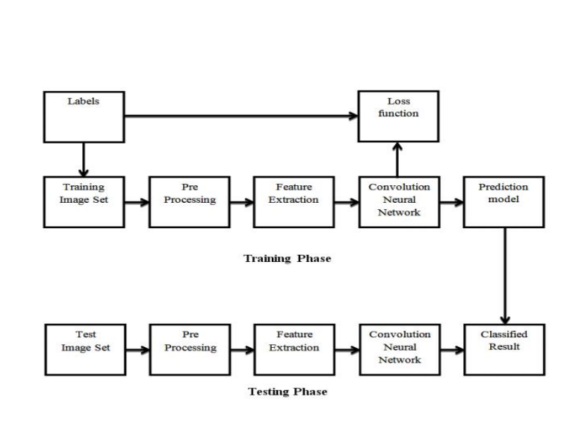

**IMPLEMENTATION DETAILS**

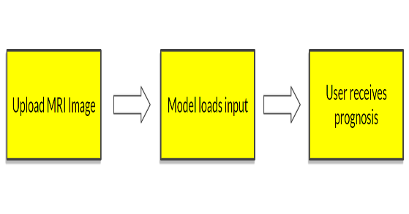

Also we have developed a front end part using html java scrip,css.user friendly html page where we can add a MRI images and click predict button so that it will show the uploaded image is having brain tumour or not

1. Data Collection: - We collect MRI images in kaggle. We use labeled data that creates two image folds for positive brain tumors.

1. Data Augmentation: - Import all required libraries using Tenserflow based. We made many copies of the provided images. Which helps to increase the accuracy of the model. In that process of adding data. We have made the same number of copies of the positive and negative images of the brain in the brain. It helps to increase the variability of the model.

2. Data Processing: - To reduce the part that only contains the image brain, I used the cropping method to get the highest, lowest, left and right brain points.

3. Upload Data: - First we read the image in a folder and then cut out the part of the image that represents the brain only. Then we resize the image with standard adjustments. Then use to make it normal because we want pixel values ​​to be measured in the range of 0-1. Finally place an image on X and label Y

.

4. Data Classification: - As we know we divide data into 80% and 20% training phase testing.

5. Model Training: - We start training our model 10 times. If we increase the number of epochs it may increase the accuracy but delay the calculation of the model.

Data sets-

In evaluating the effectiveness of our proposed model, we used a benchmark database in the Brain Tumor Segmentation category, and that BRATS data set, comprising two classes— class-0 and class-1 represents Non-Tumor and Tumor images MRI.

**References**

1. Kasban, Hany & El-bendary, Mohsen & Salama, Dina. (2015). “A Comparative Study of Medical Imaging Techniques”. International Journal of Information Science and Intelligent System. 4. 37-58.J. Clerk Maxwell, A Treatise on Electricity and Magnetism, 3rd ed., vol.

2. Oxford: Clarendon, 1892, pp.68–73.

1. D. Surya Prabha and J. Satheesh Kumar, “Performance Evaluation of Image Segmentation using Objective Methods”, Indian Journal of Science and Technology, Vol 9(8), February 2016.
2. Brain Tumor: Statistics[, Cancer.Net Editorial Board,](https://www.cancer.net/about-us) 11/2017 (Accessed on 17th January 2019)
3. Kavitha Angamuthu Rajasekaran and Chellamuthu Chinna Gounder, Advanced Brain Tumour Segmentation from MRI Images, 2018.
4. [General Information About Adult Brain Tumors".](http://www.cancer.gov/cancertopics/pdq/treatment/adultbrain/Patient/page1/AllPages) *NCI*. 14 April 2014. Archived from the original on 5 July 2014. Retrieved 8 June 2014. (Accessed on 11th January 2019)
5. M. Young, The Technical Writer’s Handbook. Mill Valley, CA: University Science, 1989.
6. B. Devkota, Abeer Alsadoon, P.W.C. Prasad, A. K. Singh, A. Elchouemi, “Image Segmentation for Early Stage Brain Tumor Detection using Mathematical Morphological Reconstruction,” 6th International Conference on Smart Computing and Communications, ICSCC 2017, 7-8 December 2017, Kurukshetra, India.
7. Song, Yantao & Ji, Zexuan & Sun, Quansen & Yuhui, Zheng. (2016). “A Novel Brain Tumor Segmentation from Multi-Modality MRI via A Level-Set-Based Model”. Journal of Signal Processing Systems. 87. 10.1007/s11265-016-1188-4.
8. Ehab F. Badran, Esraa Galal Mahmoud, Nadder Hamdy, “An Algorithm for Detecting Brain Tumors in MRI Images”, 7th International Conference on Cloud Computing, Data Science & Engineering - Confluence, 2017.
9. Pei L, Reza SMS, Li W, Davatzikos C, Iftekharuddin KM. “Improved brain tumor segmentation by utilizing tumor growth model in longitudinal brain MRI”. *Proc SPIE Int Soc Opt Eng*. 2017.

Dina Aboul Dahab, Samy S. A. Ghoniemy, Gamal M. Selim, “Automated Brain Tumor Detection and Identification using Image Processing and Probabilistic Neural Network Techniques”, IJIPVC, Vol. 1, No. 2, pp. 1-8, 2012.