SSM INSTITUTE OF ENGINEERING AND TECHNOLOGY
Dindigul, Tamil Nadu
Department of Artificial Intelligence and Data Science
MINI PROJECT REPORT
on
AI-POWERED SMART AGRICULTURE
AN INTELLIGENT AGRICULTURAL DECISION-SUPPORT SYSTEM
Submitted by
VISHNU K
Register Number: ____________________
in partial fulfilment of the requirements for the award of the degree of
BACHELOR OF TECHNOLOGY
in
ARTIFICIAL INTELLIGENCE AND DATA SCIENCE
Project Guide: ____________________
Academic Year: 2026–2027

CERTIFICATE
This is to certify that the mini project report entitled
“AI-POWERED SMART AGRICULTURE – AN INTELLIGENT AGRICULTURAL DECISION-SUPPORT SYSTEM”
is a bonafide record of the work carried out by Vishnu K, Register Number ____________, a student of B.Tech Artificial Intelligence and Data Science, SSM Institute of Engineering and Technology (SSMIET), Dindigul, during the academic year 2026–2027, in partial fulfilment of the requirements for the award of the degree of Bachelor of Technology.
The report has not been submitted to any other university or institution for the award of any degree or diploma.

Project Guide Head of the Department
(Name and Signature) (Name and Signature)
Submitted for the viva-voce examination held on __ / / ______

Internal Examiner External Examiner

DECLARATION
I, Vishnu K, hereby declare that the mini project report entitled “AI-Powered Smart Agriculture – An Intelligent Agricultural Decision-Support System” submitted to SSM Institute of Engineering and Technology (SSMIET), Dindigul, in partial fulfilment of the requirements for the degree of Bachelor of Technology in Artificial Intelligence and Data Science, is a record of original work done by me under the guidance of the project guide.
I further declare that this work has not been submitted, in part or in full, to any other university or institution for the award of any degree, diploma, or similar title, and that all sources of information used have been duly acknowledged.

Place: Dindigul Vishnu K
Date: ____ / ____ / ________

ACKNOWLEDGEMENT
I express my sincere gratitude to the management and the Principal of SSM Institute of Engineering and Technology, Dindigul, for providing the facilities and a supportive environment to carry out this mini project.
I am thankful to the Head of the Department of Artificial Intelligence and Data Science and to my project guide for their valuable guidance, encouragement, and constructive suggestions throughout the work. I also thank all the faculty members of the department for their support.
I acknowledge the open-source communities behind Python, FastAPI, NumPy, scikit-learn, TensorFlow/Keras, and the other tools and documentation used in this project. Finally, I thank my family and friends for their constant motivation and support.
Vishnu K

ABSTRACT
Farming decisions such as selecting a crop, planning irrigation, correcting nutrient deficiencies, and recognising plant disease depend on many interacting factors and are often made without structured support. This mini project presents AI-Powered Smart Agriculture, a web-based decision-support prototype that brings several of these aids together in one application. The system uses a browser interface built with HTML, CSS, and JavaScript and a Python backend built with FastAPI.
The live decision services use transparent methods. Crop recommendation uses normalised nearest-profile matching against predefined profiles, scoring each crop as 1/(1+d). Yield estimation multiplies a crop-specific base yield by nutrition, water, and heat factors and reports a fixed, uncalibrated uncertainty band. Fertilizer guidance computes nutrient gaps against target values for nitrogen, phosphorus, and potassium, and irrigation planning estimates water from the soil-moisture deficit with weather adjustments. Threshold rules raise sensor alerts. Leaf-image disease screening follows an EfficientNetB0 transfer-learning workflow with 224 × 224 inputs and a softmax output, and is active only when a trained model is available. A local assistant retrieves relevant Markdown documents using TF-IDF similarity and is not a generative language model. A separate training script builds Random Forest models, which are not loaded by the live services.
The report documents the architecture, algorithms, API design, implementation steps, and a testing plan, and clearly separates the implemented local prototype from the proposed AWS target architecture. No accuracy figures or field trials are claimed. The prototype is intended for learning and decision support, and its outputs require validation by agricultural experts before practical use.
Keywords: smart agriculture, decision support, FastAPI, crop recommendation, EfficientNetB0, transfer learning, TF-IDF, Random Forest.

TABLE OF CONTENTS

Note: in Microsoft Word, right-click the table above and choose “Update Field” → “Update entire table” to refresh page numbers.

LIST OF FIGURES
Figure 5.1: System architecture of the prototype (current design, local deployment)
Figure 5.2: Level-1 data-flow diagram
Figure 5.3: Use-case diagram of the prototype
Figure 5.4: Activity diagram for a typical prediction request
Figure 5.5: Module interaction diagram (route names to be verified)
Figure 5.6: Proposed (not implemented) AWS target architecture
Figure 6.1: Flow of the crop-scoring algorithm

LIST OF TABLES
Table 2.1: Mapping of objectives to project modules
Table 3.1: Comparison of approaches considered in this project
Table 4.1: Functional requirements
Table 4.2: Software requirements and technology stack (from project brief)
Table 4.3: Verification status of key project details
Table 5.1: Layers of the system
Table 5.2: Implementation status of components
Table 5.3: Proposed AWS services and their possible roles
Table 6.1: Variables in the crop-scoring formula
Table 6.2: Illustrative nutrient-gap example (assumed observed values)
Table 6.3: EfficientNetB0 disease-screening model design
Table 6.4: Random Forest training configuration (from project brief)
Table 6.5: Sensor alert rules (from project brief; to be verified)
Table 7.1: Module specification: Authentication
Table 7.2: Module specification: Farm management
Table 7.3: Module specification: Crop recommendation
Table 7.4: Module specification: Yield estimation
Table 7.5: Module specification: Fertilizer guidance
Table 7.6: Module specification: Irrigation planning
Table 7.7: Module specification: Disease screening
Table 7.8: Module specification: Weather
Table 7.9: Module specification: Analytics and sensor alerts
Table 7.10: Module specification: Local AI assistant
Table 8.1: Test-case table
Table 8.2: Illustrative examples (assumed values; not verified experimental results)
Table 8.3: Summary of evidence
Table 9.1: Security considerations
Table A.1: Candidate API endpoints
Table B.1: Sample inputs and outputs (illustrative)
Table C.1: Pre-submission testing checklist

LIST OF ABBREVIATIONS
Table D.1: Abbreviations
Abbreviation | Full form
AI | Artificial Intelligence
API | Application Programming Interface
AWS | Amazon Web Services
CNN | Convolutional Neural Network
CORS | Cross-Origin Resource Sharing
CSS | Cascading Style Sheets
DSS | Decision-Support System
HTML | HyperText Markup Language
HTTP | HyperText Transfer Protocol
IAM | Identity and Access Management
JSON | JavaScript Object Notation
K | Potassium
LLM | Large Language Model
MAE | Mean Absolute Error
ML | Machine Learning
N | Nitrogen
P | Phosphorus
REST | Representational State Transfer
S3 | Simple Storage Service
TF-IDF | Term Frequency – Inverse Document Frequency

1. INTRODUCTION

1.1 Background
Agriculture remains one of the most important economic and social activities in India and many other countries. Farming decisions such as which crop to grow, how much water to apply, and which nutrients are lacking in the soil are usually taken using personal experience, local advice, and seasonal habit. These decisions are influenced by many interacting factors: soil nutrients, soil acidity, temperature, rainfall, soil moisture, and the presence of pests or diseases. When several of these factors change at the same time, it becomes difficult for a farmer or a student of agriculture to estimate their combined effect without a structured method.
Software-based decision-support systems can help by collecting field parameters in one place, applying documented rules or trained models, and presenting the result in a clear form. Recent progress in machine learning (ML), image classification, and information retrieval has made it practical to build small prototypes of such systems using open-source tools. This mini project, AI-Powered Smart Agriculture – An Intelligent Agricultural Decision-Support System, is one such prototype.

1.2 Motivation
The motivation for this project comes from three observations. First, many farm-level decisions are taken with incomplete information, and a quick, consistent second opinion can be valuable. Second, agricultural knowledge is often scattered across documents, so a searchable assistant can reduce the effort needed to find relevant guidance. Third, as a B.Tech Artificial Intelligence and Data Science student, the author wished to apply classroom concepts such as feature scaling, transfer learning, ensemble learning, and text retrieval to a realistic domain problem and to understand how these components are wired together in a working web application.

1.3 Overview of the Project
The project is a web-based smart agriculture decision-support application. It combines a browser-based frontend, a Python backend built with FastAPI, machine-learning components, and agricultural decision logic. According to the project information supplied for this report, the application is intended to assist users with the following tasks:
- crop recommendation from soil and climate parameters;
- yield estimation for a selected crop and farm area;
- fertilizer guidance based on nutrient gaps;
- irrigation planning based on soil-moisture deficit;
- leaf-image disease screening using an EfficientNetB0 transfer-learning workflow;
- weather information, farm management, and analytics views; and
- agricultural question answering through a local knowledge-base assistant.
The application is described throughout this report as a decision-support prototype. It does not guarantee crop yield, does not provide a certified disease diagnosis, and does not promise financial benefit or successful farming outcomes. All outputs are meant to support, and never replace, field inspection and advice from qualified agricultural experts.
Important note on evidence: this report was prepared from the written project information supplied by the student. The project source-code archive was not available while writing, so implementation details were not independently checked against the code. Every statement that depends on the code is therefore marked “to be verified” or listed in Section 4.7 (Verification Status). No test results, accuracy figures, screenshots, or deployment claims have been invented.

1.4 Scope of the Work
The scope of this mini project covers the design and documentation of a local, single-machine prototype that can be run using Python and a web browser. The work includes the user interface, the API layer, formula-based and rule-based decision services, an optional image-classification component, a retrieval-based assistant, and offline model-training scripts. Large-scale deployment, real-time sensor integration, mobile applications, and statistical validation on real farms are outside the present scope and are discussed as future work.

1.5 Organisation of the Report
The report contains ten chapters. Chapter 2 states the problem and objectives. Chapter 3 reviews related literature and existing approaches. Chapter 4 presents the proposed system and its requirements. Chapter 5 explains the architecture and design diagrams, including the proposed AWS target architecture. Chapter 6 describes each algorithm in detail. Chapter 7 covers implementation. Chapter 8 discusses testing and illustrative results. Chapter 9 covers security, limitations, and future scope, and Chapter 10 concludes the report. Four appendices give the API reference, sample inputs and outputs, a testing checklist, and viva questions.

2. PROBLEM STATEMENT AND OBJECTIVES

2.1 Problem Statement
Small and medium farmers, agricultural students, and extension workers often lack a single, easy-to-use tool that can (i) suggest a suitable crop for given soil and weather conditions, (ii) estimate the likely yield, (iii) point out probable nutrient deficiencies, (iv) estimate irrigation needs, (v) screen a leaf photograph for possible disease, and (vi) answer routine agronomy questions from trusted notes. Existing resources are usually separate: soil-test reports, weather websites, printed manuals, and expert visits. Combining them manually is slow and error-prone.
The problem addressed by this project is therefore: to design and implement a lightweight web-based decision-support prototype that combines several agricultural decision aids behind one interface, using transparent algorithms where data is limited and machine-learning models where they are appropriate, while clearly communicating the limits of each output.

2.2 Objectives
The main objectives of the project are:
- To build a FastAPI backend that exposes agricultural decision services through documented REST endpoints.
- To implement crop recommendation using normalised nearest-profile matching against predefined ideal crop profiles.
- To implement a formula-based yield estimator that adjusts a crop-specific base yield using nutrient, water, and heat factors.
- To implement threshold-based nutrient-gap analysis for fertilizer guidance.
- To implement moisture-deficit-based irrigation planning with weather adjustments.
- To build an EfficientNetB0 transfer-learning workflow for leaf-image disease screening that is used only when a trained model is available.
- To include a Random Forest training script as an offline model-training component and future integration option.
- To provide a retrieval-based local assistant using TF-IDF over Markdown documents.
- To present results through an HTML, CSS, and JavaScript user interface with threshold-based sensor alerts.
- To document the system honestly, separating implemented features from proposed future work.

2.3 Mapping of Objectives to Modules
Table 2.1: Mapping of objectives to project modules
Objective area | Module | Technique used | Status in this report
Crop selection | Crop recommendation | Normalised nearest-profile matching | Described from project brief; code to be verified
Production estimate | Yield estimation | Formula with base yield and factors | Described from project brief; code to be verified
Nutrient advice | Fertilizer guidance | Threshold-based nutrient gap | Described from project brief; code to be verified
Water planning | Irrigation planning | Moisture-deficit formula | Described; exact constants to be verified
Plant health | Disease screening | EfficientNetB0 transfer learning | Active only if trained model is present
Knowledge access | Local assistant | TF-IDF retrieval | Retrieval-based, not generative
Monitoring | Sensor alerts / analytics | Threshold rules | Thresholds to be verified in code
Model training | Training script | Random Forest (offline) | Not used by live services

2.4 Expected Outcomes
The expected outcome is a working local prototype that demonstrates how several agricultural decision aids can be integrated, together with a report that explains the algorithms, the architecture, the testing approach, and the limitations. The prototype is not expected to deliver validated agronomic accuracy; validation with domain experts and real field data is identified as essential future work.

3. LITERATURE REVIEW AND EXISTING SYSTEM

3.1 Decision Support in Agriculture
A decision-support system (DSS) combines data, models, and a user interface to help a person choose between alternatives. In agriculture, DSS tools range from simple spreadsheets for fertilizer calculation to complex crop-simulation systems. Simple rule-based tools are easy to understand and audit, but they depend on the quality of the underlying rules. Data-driven tools can capture complex relationships, but they require representative training data. A practical prototype for a student project must balance these two ideas, which is why this project uses transparent formulas for most services and reserves machine learning for image screening and for an offline training component.

3.2 Crop Recommendation Approaches
Crop recommendation is commonly treated as a classification problem: given soil nutrients (nitrogen, phosphorus, potassium), pH, temperature, and rainfall, predict the most suitable crop. Ensemble methods such as Random Forests, introduced by Breiman (2001), are popular for this task because they handle mixed feature scales, reduce over-fitting by averaging many decision trees, and are available in scikit-learn (Pedregosa et al., 2011). A different and simpler approach is nearest-profile matching, in which each crop is represented by an ideal parameter vector and the crop whose vector is closest to the field measurements is recommended. This project uses the second approach at run time and keeps the first approach as an offline training component.

3.3 Plant Disease Detection and Transfer Learning
Image-based plant disease detection using deep convolutional networks has been demonstrated on public leaf-image collections (Mohanty, Hughes and Salathé, 2016). Training a deep network from scratch needs a large labelled dataset and considerable computing power. Transfer learning reduces this requirement by re-using a network pre-trained on a large dataset such as ImageNet (Deng et al., 2009) and training only a small new classification head (Pan and Yang, 2010). EfficientNet (Tan and Le, 2019) is a family of convolutional networks that scale depth, width, and input resolution together; EfficientNetB0 is the smallest baseline model and uses 224 × 224 pixel inputs, which makes it suitable for modest hardware. A known caution from the literature is that models trained on clean, laboratory-style leaf images may perform worse on photographs taken in real fields, so any disease screening result must be treated as a preliminary indication only.

3.4 Irrigation Scheduling
Irrigation planning is often based on the balance between crop water demand and available water. The FAO Irrigation and Drainage Paper No. 56 (Allen et al., 1998) describes standard methods for estimating crop evapotranspiration and irrigation requirements. Those methods use detailed climate data and crop coefficients. The project uses a much simpler moisture-deficit estimate with heat, humidity, and rainfall adjustments, which is suitable for a teaching prototype but is not a replacement for the full FAO procedure.

3.5 Retrieval-Based Question Answering
Term frequency–inverse document frequency (TF-IDF) is a classical term-weighting scheme in which a word receives a high weight if it occurs often in a document but rarely across the document collection (Sparck Jones, 1972; Salton and Buckley, 1988). A question and every document are converted into TF-IDF vectors, and the document with the highest cosine similarity is returned. Such retrieval is fast, runs fully offline, and always points back to a source document. Its weakness is that it can only return what is present in the knowledge base; it cannot reason or compose new answers the way a generative language model can.

3.6 Existing Systems and Their Limitations
Typical existing solutions available to farmers include weather portals, soil-health advisory reports, government extension services, and standalone mobile applications that offer one function each, such as disease identification or weather alerts. Common limitations are that they are fragmented across several tools, may need continuous internet access, may not explain how a recommendation was produced, and may not be adapted to local conditions. No specific commercial product is evaluated in this report, because doing so would require verified, up-to-date information that is outside the supplied project material.
Table 3.1: Comparison of approaches considered in this project
Task | Alternative approach | Approach used at run time | Reason
Crop recommendation | Trained Random Forest classifier | Nearest-profile matching | Transparent, needs no large dataset
Yield | Trained regressor on field records | Base yield × adjustment factors | No real yield records available
Fertilizer | Soil-test lab dosage tables | Nutrient-gap thresholds | Simple and explainable
Disease | Training CNN from scratch | EfficientNetB0 transfer learning | Less data and compute needed
Assistant | Generative LLM | TF-IDF retrieval over local files | Offline, source-traceable

3.7 Research Gap Addressed
The gap addressed by this mini project is not a new algorithm but an integration: bringing several established techniques into one openly documented prototype whose behaviour is fully explained, whose limits are stated clearly, and whose proposed cloud deployment is kept separate from what is actually implemented.

4. PROPOSED SYSTEM AND REQUIREMENTS

4.1 Proposed System
The proposed system is a web application with a clear separation between the user interface and the decision logic. The user enters field or farm information in the browser. The frontend sends the data as JSON to a FastAPI backend. The backend validates the request, forwards it to the relevant service, and returns a structured JSON response that the interface displays. A separate offline workflow trains models and stores them as files; only the optional disease model is intended to be consulted at run time.

4.2 Advantages of the Proposed System
- Integration: several decision aids are available in one interface.
- Transparency: formulas and thresholds are simple enough to be explained and reviewed by a domain expert.
- Low data requirement: the live services do not depend on a large training dataset.
- Offline capability: the prototype can run on a single local machine, and the assistant needs no external AI service.
- Extensibility: crop profiles, thresholds, and knowledge-base documents can be changed without redesigning the system.
- Honest communication: results are labelled as estimates and decision support.

4.3 Functional Requirements
Table 4.1: Functional requirements
ID | Requirement
FR1 | The system shall accept soil and climate inputs and return a ranked crop recommendation.
FR2 | The system shall accept crop, area, and field conditions and return an estimated yield with an uncertainty band.
FR3 | The system shall compare nitrogen, phosphorus, and potassium with target values and report nutrient gaps.
FR4 | The system shall estimate irrigation water from the soil-moisture deficit and weather adjustments.
FR5 | The system shall accept a leaf image and return a predicted class with probabilities when a trained model is available.
FR6 | The system shall return a clear message when the disease model is unavailable.
FR7 | The system shall answer a text question by retrieving the most relevant knowledge-base document and its source.
FR8 | The system shall raise threshold-based sensor alerts.
FR9 | The system shall provide weather, farm management, and analytics views (to be verified against the code).

4.4 Non-Functional Requirements
- Usability: a simple form-based interface understandable by non-programmers.
- Performance: formula-based services should respond almost instantly on a normal laptop; no benchmark has been measured.
- Reliability: invalid input should produce an error response instead of a crash.
- Maintainability: modular services that can be changed independently.
- Portability: runs on any operating system that supports Python and a modern browser.
- Security: basic input validation and controlled handling of uploaded images (see Chapter 9).

4.5 Software Requirements
Table 4.2: Software requirements and technology stack (from project brief)
Component | Technology | Role | Verified in code?
Language | Python | Backend and ML scripts | To be verified
Web framework | FastAPI | REST API and request validation | To be verified
Frontend | HTML, CSS, JavaScript | User interface | To be verified
Numerical | NumPy | Array and numeric operations | To be verified
ML library | scikit-learn | Random Forest training, TF-IDF | To be verified
Persistence | Joblib | Saving trained Random Forest artifacts | To be verified
Deep learning | TensorFlow/Keras | EfficientNetB0 disease model | To be verified
Pre-trained model | EfficientNetB0 (ImageNet) | Feature extractor | To be verified
Speech | Browser speech recognition / synthesis | Optional voice input and output | Only if present in code

The following technologies are not claimed to be part of the prototype unless the source code confirms them: React, any database system, any external large language model, and any AWS service.

4.6 Hardware Requirements
A standard laptop or desktop with at least 8 GB RAM, a multi-core processor, and about 5 GB of free disk space is sufficient for running the backend and the optional TensorFlow model for inference. A GPU is not required for the live prototype but would speed up training of the image model. A modern web browser such as Chrome or Edge is required for the interface and for optional speech features.

4.7 Verification Status of Project Information
Table 4.3: Verification status of key project details
Item | Source of information | Status
Formulas for crop, yield, fertilizer, irrigation | Project brief | Not verified against code
Fertilizer targets N=90, P=42, K=43 | Project brief | Not verified against code
Irrigation constant 45 and exact heat/humidity factors | Project brief (approximate) | Exact code formula pending
Alert thresholds (moisture < 28, temperature > 38) | Project brief | Not verified against code
API endpoint list | Project brief (candidates) | Not verified against code
Random Forest settings (200 trees, 75/25 split, seed 42) | Project brief | Not verified against code
Size of training dataset (15 synthetic rows) | Project brief (conditional) | Not verified
Disease class names and model file path | Not supplied | Unknown
Authentication and farm-data storage mechanism | Not supplied | Unknown
Weather data source | Not supplied | Unknown
AWS services | Project brief | Proposed only; no integration claimed

5. SYSTEM ARCHITECTURE AND DESIGN

5.1 Architectural Overview
The prototype follows a layered client–server architecture. The browser hosts the user interface, the FastAPI backend handles communication and validation, a set of service modules implements the decision logic, and a small number of local resources (an optional trained image model and a folder of Markdown knowledge-base files) are consulted when required. Offline training scripts and their saved artifacts sit outside the live request path. Figure 5.1 shows the architecture as implemented in the prototype; no cloud services appear in it because none are claimed to be integrated.
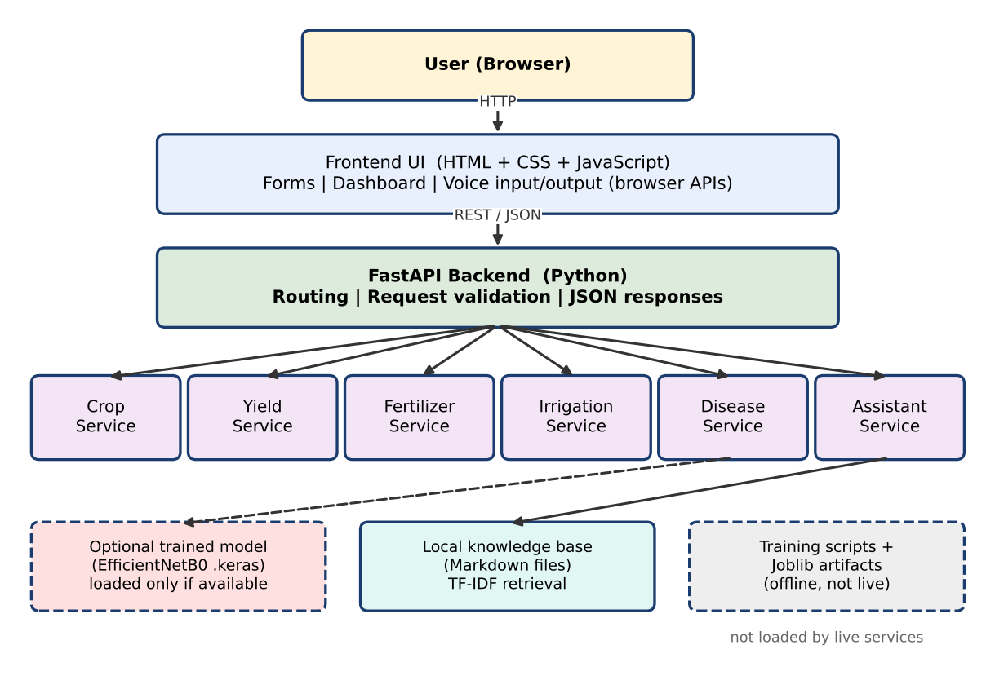
Figure 5.1: System architecture of the prototype (current design, local deployment)

5.2 Layers and Their Responsibilities
Table 5.1: Layers of the system
Layer | Technology | Responsibility
Presentation | HTML, CSS, JavaScript | Collect inputs, call the API using HTTP requests, display results and alerts, optional voice features
API | FastAPI (Python) | Define routes, validate request data, return JSON responses and error codes
Decision services | Python functions and NumPy | Crop matching, yield formula, nutrient gaps, irrigation estimate, alert rules
ML inference | TensorFlow/Keras | Leaf-image classification, only when a trained model file is available
Retrieval | TF-IDF (scikit-learn) | Find the most relevant Markdown document for a question
Offline training | scikit-learn, Joblib, Keras | Train Random Forest models and the disease model; save artifacts

5.3 Data-Flow Diagram
Figure 5.2 shows a level-1 data-flow diagram. The user submits a request; process 1.0 validates it; process 2.0 applies the decision logic using constants and profiles that are stored in the program itself; process 3.0 performs image screening using the trained model file if it exists; and process 4.0 retrieves documents from the knowledge base. The result is returned to the interface as JSON.
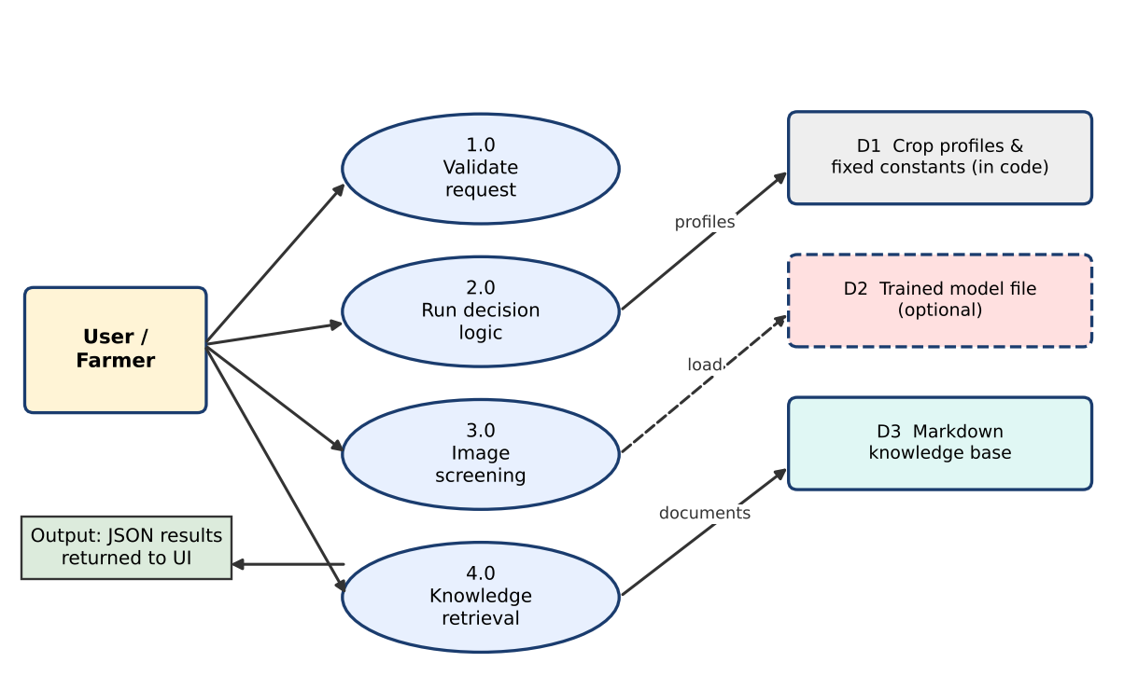
Figure 5.2: Level-1 data-flow diagram

5.4 Use-Case Diagram
The main actor is the farmer or user (which may also be a student or extension worker). Figure 5.3 lists the use cases offered by the interface. The module list is based on the project brief; any module that is not found in the final source code should be removed from this diagram.
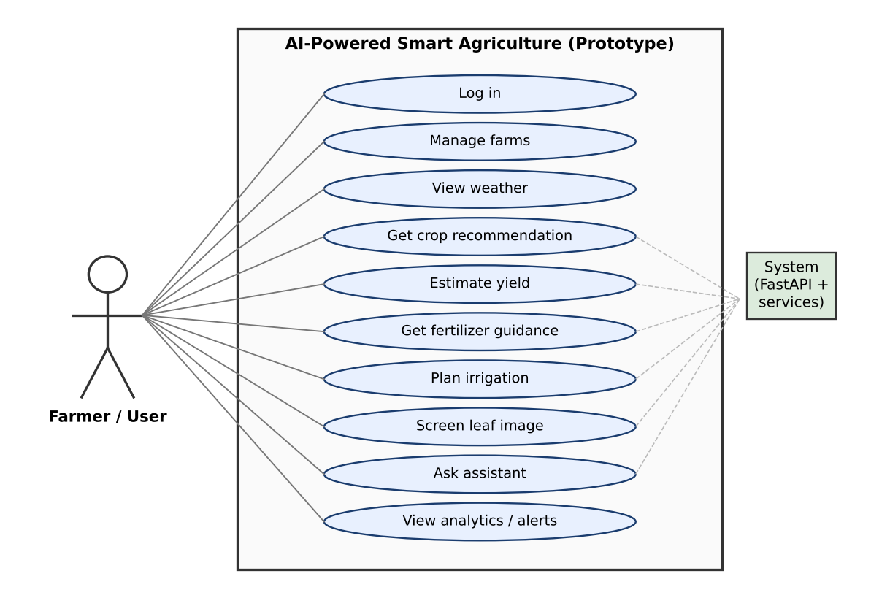
Figure 5.3: Use-case diagram of the prototype

5.5 Activity Diagram
Figure 5.4 shows the generic activity flow shared by all prediction services. The same pattern of input, validation, processing, and display is repeated for every module, which keeps the backend design uniform.
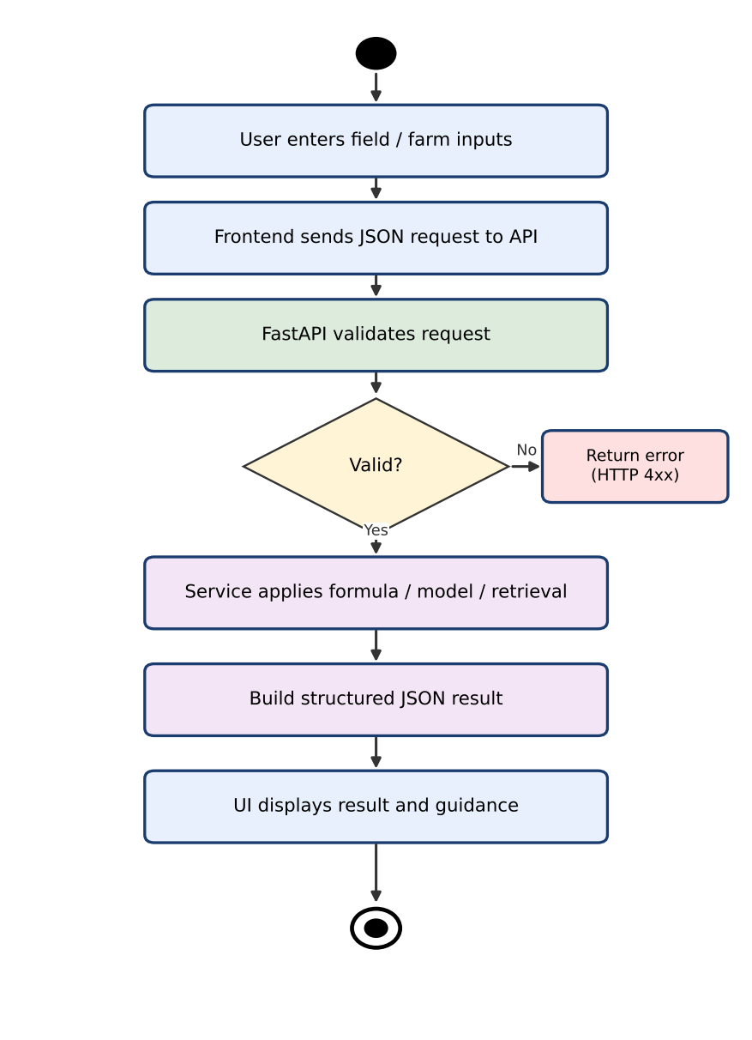
Figure 5.4: Activity diagram for a typical prediction request

5.6 Module Interaction Diagram
Figure 5.5 shows how the frontend, the API router, and the functional modules interact. The route names are the candidate endpoints listed in the project brief and must be confirmed against the source code before submission.
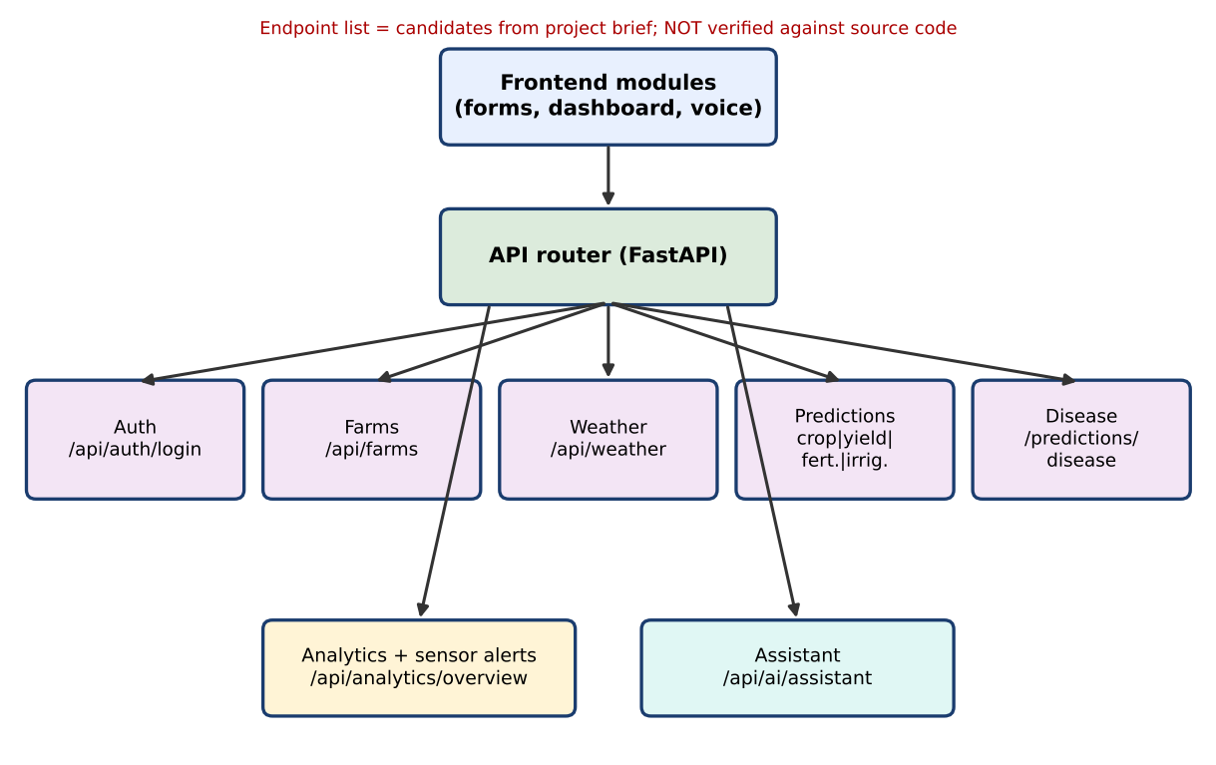
Figure 5.5: Module interaction diagram (route names to be verified)

5.7 Data Handling and Storage
The live decision services use values that are stored in the program itself: crop profiles, scale factors, base yields, nutrient targets, and alert thresholds. The assistant reads Markdown files from a local knowledge-base folder. Trained model files may be saved on disk by the training scripts (Joblib files for Random Forest models and a Keras model file for disease screening). The project information does not confirm any database, so none is claimed. How user accounts and farm records are stored (in memory, in a file, or elsewhere) is not verified and must be stated by the student after inspecting the code.

5.8 Implementation Status of Components
To avoid overstating the work, the table below separates what exists in the current code from what is configured for deployment and what is only proposed.
Table 5.2: Implementation status of components
Category | Components
1. Implemented in current code (per project brief) | Frontend interface; FastAPI backend; crop, yield, fertilizer and irrigation services; sensor alert rules; EfficientNetB0 workflow (runs only with a trained model); TF-IDF local assistant; Random Forest training script
2. Configured for deployment | None confirmed. The prototype runs locally.
3. Proposed for future integration | Amazon API Gateway, AWS Lambda, Amazon S3, Amazon DynamoDB, AWS IAM, Amazon CloudWatch, Amazon Bedrock (optional); loading of Random Forest artifacts by the live services
4. Not used | All AWS services listed above; any external generative AI service; any database

5.9 Proposed AWS Target Architecture
AWS is the intended cloud-learning platform for this project, and the following design describes how the prototype could be hosted in the cloud in the future. This is a proposed design only. None of these services has been deployed or integrated in the current prototype. Figure 5.6 is therefore drawn with dashed outlines and an explicit label.
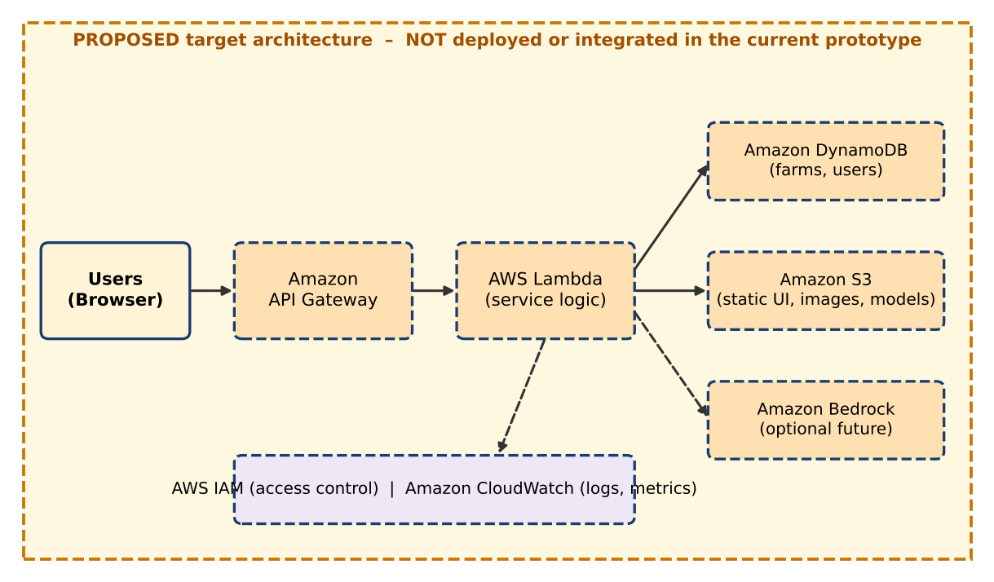
Figure 5.6: Proposed (not implemented) AWS target architecture
Table 5.3: Proposed AWS services and their possible roles
Service | Possible role in a future deployment | Current status
Amazon S3 | Host static frontend files; store leaf images and trained model files | Proposed
Amazon API Gateway | Public HTTPS entry point that routes requests to backend functions | Proposed
AWS Lambda | Run service logic without managing servers; note that TensorFlow models may need container-image packaging | Proposed
Amazon DynamoDB | Store user and farm records in a managed NoSQL table | Proposed
AWS IAM | Give each component least-privilege permissions | Proposed
Amazon CloudWatch | Collect logs and metrics, create alarms | Proposed
Amazon Bedrock | Optional generative answers on top of retrieved documents | Optional future

Because the student holds the AWS Certified AI Practitioner credential, this section also serves as a learning exercise in mapping a local application to managed cloud services. It should not be read as evidence that the system runs on AWS.

6. ALGORITHMS AND MODEL METHODOLOGY
This chapter explains the algorithm behind each module. The formulas are those supplied in the project brief; wherever the brief says a formula is approximate, the exact code expression must be checked before submission. Numerical examples in this chapter are illustrative: they use assumed values and are not outputs recorded from the running system.

6.1 Crop Recommendation: Normalised Nearest-Profile Matching

6.1.1 Concept
Each supported crop (for example Rice, Maize, Cotton, Chickpea, and Banana) is stored as an ideal profile containing typical values of nitrogen (N), phosphorus (P), potassium (K), temperature, rainfall, and soil pH. The system measures how far the user’s field values are from each profile and recommends the crop with the smallest distance. This is rule-based matching; it is not a trained Random Forest prediction.

6.1.2 Formula
d = Σ ( |x_i − p_i| / scale_i ) score = 1 / (1 + d)
Table 6.1: Variables in the crop-scoring formula
Symbol | Meaning
x_i | Observed value of parameter i (N, P, K, temperature, rainfall, pH) entered by the user
p_i | Ideal value of parameter i in the crop’s predefined profile
scale_i | Normalising constant that puts all parameters on a comparable scale (exact values to be taken from the code)
d | Total normalised distance; 0 means a perfect match
score | Similarity between 0 and 1; larger is better

Dividing by scale_i is essential. Rainfall is measured in hundreds of millimetres while pH lies between about 4 and 9; without normalisation, rainfall would dominate the distance.

6.1.3 Workflow
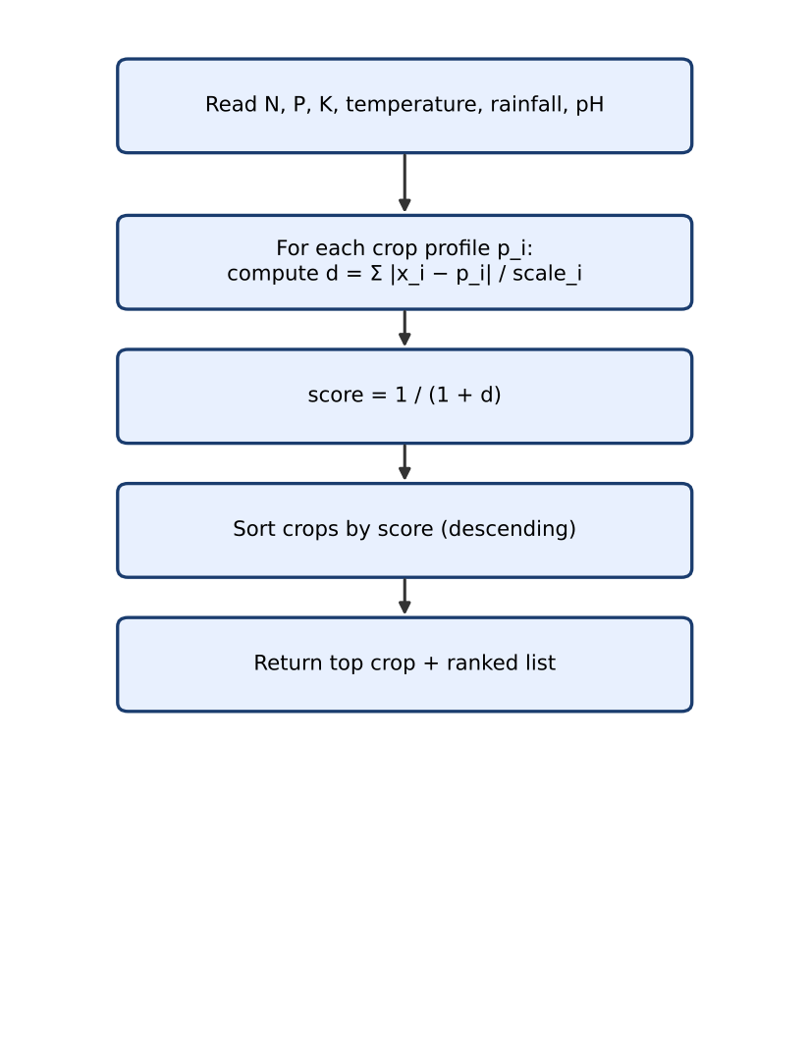
Figure 6.1: Flow of the crop-scoring algorithm
function recommend_crop(x):
for each crop c in profiles:
d = 0
for each parameter i:
d += abs(x[i] - profile[c][i]) / scale[i]
score[c] = 1 / (1 + d)
return crops sorted by score (highest first)

6.1.4 Illustrative Worked Example
Assume scale values N=100, P=50, K=50, temperature=20, rainfall=200, pH=2 and two assumed profiles: Rice (N=80, P=48, K=40, T=23, rain=236, pH=6.4) and Maize (N=80, P=48, K=20, T=24, rain=85, pH=6.2). For a field with N=85, P=45, K=42, T=25, rain=220, pH=6.5, the distance to Rice is 0.05+0.06+0.04+0.10+0.08+0.05 = 0.38, giving a score of 1/1.38 ≈ 0.725. The distance to Maize is 0.05+0.06+0.44+0.05+0.675+0.15 = 1.425, giving a score of 1/2.425 ≈ 0.412. Rice would therefore rank first. These numbers demonstrate the method only.

6.1.5 Advantages and Limitations
- Advantages: easy to understand, no training data needed, deterministic, and easy to extend by adding a new profile.
- Limitations: profiles are predefined and cover only a few crops; all parameters are weighted equally; there is no learning from data; and the recommendation ignores soil type, market price, season, and farmer preference.

6.2 Yield Estimation: Formula-Based Estimator
The live implementation estimates yield with a mathematical formula rather than a trained regression model. A base yield is chosen for the selected crop and is multiplied by three adjustment factors:
yield_per_acre = base_yield × nutrition_factor × water_factor × heat_factor
total_yield = yield_per_acre × farm_area
- nutrition_factor reduces the estimate when nutrient levels are below the crop’s needs.
- water_factor depends on rainfall and soil moisture.
- heat_factor reduces the estimate when temperature is outside a comfortable range.
The service returns the estimated yield together with a fixed uncertainty band (a lower and upper value around the estimate). This band is not statistically calibrated: it is not a confidence interval computed from data and must not be interpreted as a probability statement. Illustratively, if an assumed base yield is 2.0 tonnes per acre and the factors are 0.95, 0.90, and 1.00, then yield per acre is 2.0 × 0.95 × 0.90 × 1.00 = 1.71 tonnes, and for 2 acres the total is 3.42 tonnes. Real validation with local yield records is required before any practical use.

6.3 Fertilizer Guidance: Nutrient-Gap Analysis
The fertilizer module compares the observed N, P, and K values with fixed demo target values: N = 90, P = 42, K = 43. For each nutrient the gap is calculated as:
gap = max(0, target − observed)
A gap greater than 10 is treated as a priority nutrient. A nutrient that is at or above its target has a gap of zero. The result is a list of potential nutrient shortfalls and their priority; the module does not compute exact fertilizer-product quantities (such as kilograms of urea per acre) unless the final code is found to do so.
Table 6.2: Illustrative nutrient-gap example (assumed observed values)
Nutrient | Target | Observed | Gap | Priority (gap > 10)
Nitrogen (N) | 90 | 60 | 30 | Yes
Phosphorus (P) | 42 | 40 | 2 | No
Potassium (K) | 43 | 30 | 13 | Yes

The targets are the same for every crop in the demo configuration, which is a major simplification: real nutrient needs depend on crop, soil type, growth stage, and local recommendations.

6.4 Irrigation Planning: Moisture-Deficit Calculation
The irrigation module first computes the moisture deficit:
deficit = max(0, target_moisture − current_moisture)
Heat and humidity adjustments and a rainfall credit are then applied. The approximate water requirement given in the project brief is:
water_litres = (deficit − rain_credit) × 45 × area × heat_factor
Here, 45 is a conversion constant, area is the farm area, rain_credit reduces the requirement when rainfall is expected or has occurred, and heat_factor increases the requirement on hot days. The exact definitions of rain_credit, heat_factor, and the humidity adjustment, and whether the result is clamped at zero, must be copied from the source code because the brief describes the formula as approximate. As an illustration with assumed values deficit = 20, rain_credit = 5, area = 2, and heat_factor = 1.2, the estimate is (20 − 5) × 45 × 2 × 1.2 = 1,620 litres. The output is a decision-support estimate and is not a substitute for field inspection of soil and crop condition.

6.5 Disease Image Screening: EfficientNetB0 Transfer Learning

6.5.1 Why Transfer Learning
A network trained from scratch needs many thousands of labelled leaf images. Transfer learning starts from an EfficientNetB0 model that has already learned general visual features (edges, textures, shapes) from ImageNet. Only a small new classification head is trained for the plant-disease classes, which reduces training time and data needs.

6.5.2 Model Design
Table 6.3: EfficientNetB0 disease-screening model design
Stage | Description
Input | Leaf photograph resized to 224 × 224 pixels
Preprocessing | EfficientNet preprocessing function applied to pixel values
Base model | ImageNet-pretrained EfficientNetB0 without its original top layer
Training stage 1 | Base layers frozen so that the pretrained features are kept intact
Pooling | Global average pooling converts feature maps to a single vector
Regularisation | Dropout layer reduces over-fitting
Output | New dense layer with softmax activation, one unit per disease class

6.5.3 Inference
At run time the uploaded image is decoded, resized to 224 × 224, preprocessed, and passed to the model. The softmax layer converts the final scores into probabilities that sum to one. The class with the highest probability is selected as the predicted class, and the probability (or a ranked list of top classes) is shown as the model’s confidence. A high probability expresses the model’s relative preference between its known classes; it is not proof that the diagnosis is correct, and images of unknown diseases or non-leaf objects can still receive a confident wrong label.

6.5.4 Behaviour When the Model Is Unavailable
Disease screening is not always active. The service depends on a trained model file. If the file is missing or cannot be loaded, the service is expected to report that the model is unavailable instead of producing a prediction. The exact response text, file path, and class labels must be confirmed from the loading logic in the source code, and the disease results in this report must be treated as unavailable until a trained model is present.

6.6 Random Forest Training Component
The project contains a training script, separate from the live API, that trains two scikit-learn models: a RandomForestClassifier for crop classification and a RandomForestRegressor for yield estimation. A Random Forest builds many decision trees on random subsets of the data and features and combines their outputs by majority vote (classification) or averaging (regression) (Breiman, 2001).
Table 6.4: Random Forest training configuration (from project brief)
Setting | Value
Classifier | RandomForestClassifier (crop)
Regressor | RandomForestRegressor (yield)
Number of trees | 200
Data split | 75% training, 25% testing
Random seed | random_state = 42
Classification metric | Accuracy
Regression metric | Mean Absolute Error (MAE)
Saved artifacts | Joblib files

Important: the trained Random Forest artifacts are not loaded by the live prediction services. The component is therefore a model-training exercise and a future integration option, not the active prediction engine. If the training data is confirmed to contain only 15 synthetic rows, then accuracy or MAE values computed on a 25% test split (about 4 rows) would be statistically meaningless and cannot support claims about real-world performance. No accuracy or MAE value was supplied, so none is reported here; if the training script prints evaluation output, it should be copied into Chapter 8 with a clear note about the dataset size.

6.7 Local AI Assistant: TF-IDF Retrieval
The assistant answers questions by retrieving text from a local knowledge base. It is retrieval-based and is not a generative language model; no ChatGPT, OpenAI, Groq, Gemini, or Amazon Bedrock service is claimed to be active. The workflow is:
- Load all Markdown documents from the knowledge-base folder.
- Convert the documents and the user’s question into TF-IDF vectors.
- Calculate the similarity (typically cosine similarity) between the question and each document.
- Select the most relevant document.
- Return a text excerpt and the source information.
tfidf(t, d) = tf(t, d) × idf(t) similarity = (q · d) / (|q| |d|)
Limitations of this approach are important. The assistant cannot answer a question whose subject is absent from the knowledge base; it may return the “closest” document even when that document is not relevant; it understands words, not meaning, so synonyms may be missed; and it does not combine information from several documents. Answer quality therefore depends entirely on the coverage and quality of the Markdown files.

6.8 Sensor Alerts: Threshold Rules
The sensor-alert logic uses simple rules that compare a reading with a fixed threshold:
Table 6.5: Sensor alert rules (from project brief; to be verified)
Condition | Severity | Alert type
Soil moisture < 28 | High | Low-moisture alert
Temperature > 38 | Medium | Heat alert

Threshold rules are easy to audit but do not account for crop type, growth stage, or trends over time. Additional rules, if present in the code, should be listed in this table.

7. IMPLEMENTATION

7.1 Development Workflow
The prototype is developed in Python for the backend and in HTML, CSS, and JavaScript for the frontend. Development proceeds module by module: first the decision logic is written as plain Python functions, then each function is wrapped by a FastAPI route, and finally the frontend form and result view are connected to the route using the browser’s fetch mechanism. Model-training scripts are kept separate from the API so that long-running training does not affect the running application.

7.2 Project Setup and Dependency Installation
The commands below show the typical setup for a Python web project of this kind. Folder names, module names, and the requirements file name are placeholders and must be replaced by the names used in the actual project.
# create and activate a virtual environment
python -m venv venv
venv\Scripts\activate # Windows
# source venv/bin/activate # Linux / macOS

# install dependencies
pip install fastapi uvicorn numpy scikit-learn joblib tensorflow
# or: pip install -r requirements.txt

7.3 Starting the Backend
FastAPI applications are normally served by an ASGI server such as Uvicorn. FastAPI also generates interactive API documentation automatically (Swagger UI), which is convenient for testing every endpoint without writing a client.
uvicorn <package>.main:app --reload --port 8000
# Interactive documentation: http://127.0.0.1:8000/docs

7.4 Starting the Frontend
The frontend consists of static HTML, CSS, and JavaScript files. Depending on how the project is organised, they are either served by the FastAPI application itself or opened through a simple static server. Which method the project uses is to be confirmed from the source code.

7.5 Functional Modules
Each module below is described using the same specification table. Only the modules listed in the project brief are documented; any module that is absent in the final code should be deleted from this section. Endpoint paths are candidates to be verified.

7.5.1 Authentication
Table 7.1: Module specification: Authentication
Purpose | Allow a user to log in before using the application
Inputs | Credentials (for example username and password)
Processing | Credential check by the backend; mechanism (token, session, fixed demo account) not verified
Algorithm | Not applicable
Output | Login success or failure response
Endpoint | /api/auth/login (candidate)
Example | Not available until the code is inspected
Limitations | Security strength unknown; demo-level authentication must not be used for real users without hardening
Testing | Login with valid and invalid credentials (TC-01, TC-02)

7.5.2 Farm Management
Table 7.2: Module specification: Farm management
Purpose | Store and show details of the user’s farms
Inputs | Farm name, location, area, and related fields (to be verified)
Processing | Create or list farm records; storage mechanism not verified
Algorithm | Not applicable
Output | List or confirmation of farm records
Endpoint | /api/farms (candidate)
Example | Not available until the code is inspected
Limitations | No database is claimed; persistence is unknown
Testing | Add and list a farm (TC-03)

7.5.3 Crop Recommendation
Table 7.3: Module specification: Crop recommendation
Purpose | Suggest the most suitable crop for given field conditions
Inputs | N, P, K, temperature, rainfall, soil pH
Processing | Distance to every crop profile, then ranking
Algorithm | Normalised nearest-profile matching, score = 1/(1+d)
Output | Highest-scoring crop and ranked scores
Endpoint | /api/predictions/crop (candidate)
Example | See Section 8.3 (illustrative)
Limitations | Few crops; equal weights; predefined profiles
Testing | Known-profile input should rank its own crop first (TC-04)

7.5.4 Yield Estimation
Table 7.4: Module specification: Yield estimation
Purpose | Estimate expected production for a crop and area
Inputs | Crop, farm area, nutrient levels, rainfall, soil moisture, temperature
Processing | Base yield multiplied by three factors, then by area
Algorithm | Formula-based estimator with fixed uncertainty band
Output | Estimated yield per acre, total yield, lower and upper band
Endpoint | /api/predictions/yield (candidate)
Example | See Section 8.3 (illustrative)
Limitations | Not calibrated; no real yield data; band is not a confidence interval
Testing | Check that worse conditions give lower yield (TC-05)

7.5.5 Fertilizer Guidance
Table 7.5: Module specification: Fertilizer guidance
Purpose | Identify possible nutrient shortages
Inputs | Observed N, P, K
Processing | gap = max(0, target − observed); priority if gap > 10
Algorithm | Threshold-based nutrient-gap analysis
Output | Gap per nutrient and priority flag
Endpoint | /api/predictions/fertilizer (candidate)
Example | See Sections 6.3 and 8.3
Limitations | Single set of targets for all crops; no product-level dosage
Testing | Inputs equal to targets should give zero gaps (TC-06)

7.5.6 Irrigation Planning
Table 7.6: Module specification: Irrigation planning
Purpose | Estimate the water required to cover a moisture deficit
Inputs | Current moisture, target moisture, area, temperature, humidity, rainfall
Processing | Deficit, rain credit, heat and humidity adjustment
Algorithm | Moisture-deficit formula with constant 45
Output | Estimated litres of water
Endpoint | /api/predictions/irrigation (candidate)
Example | See Section 8.3 (illustrative)
Limitations | Simplified; ignores soil type, crop stage, evaporation detail
Testing | No deficit should give zero water (TC-07)

7.5.7 Disease Screening
Table 7.7: Module specification: Disease screening
Purpose | Give a preliminary class prediction for a leaf photograph
Inputs | Image file upload
Processing | Resize to 224×224, EfficientNet preprocessing, model inference
Algorithm | EfficientNetB0 transfer learning with softmax output
Output | Predicted class and probabilities, or a model-unavailable message
Endpoint | /api/predictions/disease (candidate)
Example | Not available; no model output supplied
Limitations | Needs trained model; may fail on field photographs; not a diagnosis
Testing | Upload a valid leaf image, an invalid file, and run with the model absent (TC-08 to TC-10)

7.5.8 Weather
Table 7.8: Module specification: Weather
Purpose | Show weather information relevant to farming
Inputs | Location (to be verified)
Processing | Data source not verified (may be static demo data or an external service)
Algorithm | Not applicable
Output | Weather summary
Endpoint | /api/weather (candidate)
Example | Not available until the code is inspected
Limitations | Source and update frequency unknown
Testing | Request weather and check response structure (TC-11)

7.5.9 Analytics and Sensor Alerts
Table 7.9: Module specification: Analytics and sensor alerts
Purpose | Summarise farm data and raise alerts
Inputs | Stored or supplied farm and sensor readings
Processing | Aggregate values; apply threshold rules (moisture < 28, temperature > 38)
Algorithm | Threshold-based rules
Output | Overview data and alert list with severity
Endpoint | /api/analytics/overview (candidate)
Example | Moisture 20 gives a high-severity alert (illustrative)
Limitations | Fixed thresholds; no trend analysis
Testing | Moisture 20 and temperature 40 should raise two alerts (TC-12)

7.5.10 Local AI Assistant
Table 7.10: Module specification: Local AI assistant
Purpose | Answer agricultural questions from local notes
Inputs | Text question (voice input through browser speech recognition only if present in the code)
Processing | TF-IDF vectors, similarity, best document selection
Algorithm | TF-IDF retrieval
Output | Text excerpt with source document
Endpoint | /api/ai/assistant (candidate)
Example | See Section 8.3 (illustrative)
Limitations | Cannot answer topics absent from the knowledge base; not generative
Testing | One in-scope and one out-of-scope question (TC-13, TC-14)

7.6 Error Handling
FastAPI validates request bodies and parameters against declared types and returns an HTTP 422 response for malformed input. The services should additionally reject values outside sensible ranges (for example a negative area or a pH above 14) with a clear message, and the disease service should return a controlled response when no model is available. Which of these checks exist in the code is to be confirmed.

7.7 Model Training Workflow
The offline training workflow reads the training data, splits it into 75% training and 25% testing parts with random_state = 42, fits the Random Forest classifier and regressor with 200 trees, evaluates accuracy and MAE on the test part, and saves the models with Joblib. The disease model is trained separately by building the EfficientNetB0 base, freezing it, adding the pooling, dropout, and softmax layers, and training on labelled leaf images. Training must be run by the student; no training output was supplied for this report.
# schematic training outline (Random Forest)
X_train, X_test, y_train, y_test = train_test_split(X, y, test_size=0.25, random_state=42)
clf = RandomForestClassifier(n_estimators=200, random_state=42).fit(X_train, y_train)
reg = RandomForestRegressor(n_estimators=200, random_state=42).fit(X_train, y_yield_train)
joblib.dump(clf, 'crop_model.joblib') # artifact names are placeholders

8. RESULTS AND TESTING

8.1 Testing Approach
Testing of a decision-support prototype has three levels. Unit testing checks each formula with hand-calculated inputs. API testing sends requests to each endpoint, using either the automatically generated Swagger interface or a client such as curl or Postman, and checks status codes and response structure. Interface testing checks that the browser form sends correct data and displays the response and error messages. Model testing for the disease module additionally needs a held-out set of labelled leaf images.
No test execution results were supplied. Every test below is therefore marked “Not Tested”. After running the tests, the student must replace the “Actual output” and “Status” columns with real observations.

8.2 Test Cases
Table 8.1: Test-case table
ID | Description | Input | Expected output | Actual output | Status
TC-01 | Login with valid credentials | Valid username and password | Success response | – | Not Tested
TC-02 | Login with invalid credentials | Wrong password | Error response, no access | – | Not Tested
TC-03 | Add and list a farm | Farm name and area | Farm appears in list | – | Not Tested
TC-04 | Crop recommendation for a profile-like input | Values close to the Rice profile | Rice ranked first | – | Not Tested
TC-05 | Yield decreases under poor conditions | Low nutrients, heat | Lower yield than ideal case | – | Not Tested
TC-06 | No nutrient gap | N=90, P=42, K=43 | All gaps zero, no priority | – | Not Tested
TC-07 | No irrigation deficit | Current moisture ≥ target | Zero or minimal water | – | Not Tested
TC-08 | Disease screening with model | Valid leaf image | Class and probabilities | – | Not Tested
TC-09 | Disease screening without model | Valid leaf image, no model file | Model-unavailable message | – | Not Tested
TC-10 | Invalid image upload | Text file as image | Validation error | – | Not Tested
TC-11 | Weather request | Location | Weather data structure | – | Not Tested
TC-12 | Sensor alerts | Moisture 20, temperature 40 | High and medium alerts | – | Not Tested
TC-13 | Assistant in-scope question | Question covered by a document | Relevant excerpt and source | – | Not Tested
TC-14 | Assistant out-of-scope question | Unrelated question | Low-relevance or no-answer handling | – | Not Tested
TC-15 | Invalid numeric input | pH = 20 or negative area | Validation error | – | Not Tested
TC-16 | Random Forest training script | Training data file | Models and metrics produced | – | Not Tested

8.3 Illustrative Examples
The examples below are illustrative worked examples that follow the formulas of Chapter 6 using assumed constants. They are not outputs captured from the running application and must not be presented as experimental results.
Table 8.2: Illustrative examples (assumed values; not verified experimental results)
Module | Illustrative input | Illustrative result
Crop recommendation | N=85, P=45, K=42, T=25 °C, rain=220 mm, pH=6.5 | Rice score ≈ 0.725 vs Maize ≈ 0.412 under assumed profiles; Rice ranked first
Yield estimation | Base 2.0 t/acre, factors 0.95, 0.90, 1.00, area 2 acres | 1.71 t/acre; 3.42 t total; fixed band around it
Fertilizer guidance | N=60, P=40, K=30 | Gaps 30, 2, 13; priority nutrients: N and K
Irrigation | Deficit 20, rain credit 5, area 2, heat factor 1.2 | ≈ 1,620 litres
Disease screening | Leaf photograph | If a model is present: predicted class and probability; otherwise model-unavailable message
Local assistant | “How can I manage low soil nitrogen?” | Most similar Markdown document, an excerpt, and its file name (only if such a document exists)

8.4 Verified Versus Unverified Results
Table 8.3: Summary of evidence
Item | Evidence available | Statement allowed in report
Model accuracy / MAE | None supplied | No figure reported
Screenshots | None supplied | None included; placeholders may be added by the student
Real farm trials / user study | None | Not claimed
Cloud performance | None; AWS not integrated | Not claimed
Formulas and constants | Project brief | Described as supplied; exact values to be verified

8.5 Discussion
The prototype can demonstrate how decision aids are structured, how they can be exposed through a REST API, and how a transfer-learning model and a retrieval assistant can be added to a web application. Its main strength is clarity: each output can be traced to a formula, a threshold, or a document. Its main weakness is that none of the numeric outputs has been validated against real agricultural data. The following limitations should be stated whenever results are presented:
- Crop recommendation depends on a small set of predefined profiles.
- Yield and irrigation values come from simplified formulas, not calibrated models.
- The Random Forest component is trained on limited, possibly synthetic data and is not part of the live services.
- Disease screening requires a trained model and is unavailable without it.
- The assistant is limited by the coverage of the knowledge base.
- All outputs need validation by local agricultural experts.
- AWS services are a proposal; the system runs locally.

9. SECURITY, LIMITATIONS, AND FUTURE SCOPE

9.1 Security Considerations
Table 9.1: Security considerations
Area | Risk | Recommended practice
Authentication | Weak or demo credentials | Hash passwords, use expiring tokens, avoid hard-coded accounts
Input validation | Out-of-range or malformed values | Declare types and ranges for every field in the API
File upload | Malicious or oversized files | Check file type and size, process images in memory, never execute uploads
Transport | Data sniffed on network | Serve through HTTPS in any real deployment
CORS and access | Unwanted web origins calling the API | Restrict allowed origins
Secrets | API keys in source code | Use environment variables or a secrets service
Privacy | Farm and location data | Collect only necessary data, state how it is stored
Cloud (future) | Over-broad permissions | Least-privilege IAM roles, CloudWatch logging and alarms

9.2 Limitations
- Crop recommendation uses predefined profiles for a small number of crops.
- Yield estimation is formula-based and its uncertainty band is fixed, not statistically derived.
- Fertilizer guidance reports nutrient gaps against demo targets, not product dosages.
- Irrigation estimates ignore soil texture, crop stage, and detailed evapotranspiration.
- Disease screening is available only when a trained model exists and may not generalise to field photographs.
- Random Forest artifacts are not used by the live services, and the training data may be small and synthetic.
- The assistant is retrieval-based and cannot answer topics missing from the knowledge base.
- No real-world validation, user study, or deployment has been carried out.

9.3 Future Scope
- Integrate the validated Random Forest or another model into the live services after collecting real, region-specific data.
- Calibrate yield uncertainty using historical yield records.
- Extend the crop profile set and use region-specific nutrient targets and crop-wise fertilizer recommendations.
- Use sensor hardware and live weather services for automatic readings.
- Fine-tune the EfficientNetB0 model (unfreezing top layers) on a larger, field-condition image dataset and report proper evaluation metrics.
- Add a database for users and farms, and multilingual (including Tamil) interface and voice support.
- Deploy on AWS using the proposed architecture; consider Amazon Bedrock only as an optional generation layer on top of retrieved documents, with citations.
- Conduct pilot validation with agricultural experts and farmers.

10. CONCLUSION
This mini project presented the design of an AI-powered smart agriculture decision-support prototype that brings crop recommendation, yield estimation, fertilizer guidance, irrigation planning, leaf-image disease screening, and a retrieval-based knowledge assistant into one web application built with FastAPI and standard web technologies. The report explained each algorithm in simple language, showed how the components are connected, and separated the implemented prototype from the proposed AWS architecture and from future work.
The most important lesson of the project is that a useful decision-support system needs honest boundaries. Transparent formulas and thresholds are suitable when data is limited, machine learning is appropriate where data and models exist, and every output must be labelled as an estimate that needs validation. With real field data, expert review, proper testing, and secure cloud deployment, the prototype can be developed further into a more dependable tool for farmers and agricultural students.

REFERENCES
[1] Allen, R.G., Pereira, L.S., Raes, D. and Smith, M. (1998) Crop Evapotranspiration: Guidelines for Computing Crop Water Requirements. FAO Irrigation and Drainage Paper 56. Rome: Food and Agriculture Organization of the United Nations.
[2] Amazon Web Services (n.d.) AWS Documentation: Amazon S3, AWS Lambda, Amazon API Gateway, Amazon DynamoDB, AWS IAM, Amazon CloudWatch and Amazon Bedrock. Available at: https://docs.aws.amazon.com/ (Accessed: October 2026).
[3] Breiman, L. (2001) ‘Random Forests’, Machine Learning, 45(1), pp. 5–32.
[4] Deng, J., Dong, W., Socher, R., Li, L.-J., Li, K. and Fei-Fei, L. (2009) ‘ImageNet: A large-scale hierarchical image database’, Proceedings of the IEEE Conference on Computer Vision and Pattern Recognition (CVPR), pp. 248–255.
[5] FastAPI (n.d.) FastAPI Documentation. Available at: https://fastapi.tiangolo.com/ (Accessed: October 2026).
[6] Harris, C.R. et al. (2020) ‘Array programming with NumPy’, Nature, 585, pp. 357–362.
[7] Joblib Developers (n.d.) Joblib Documentation. Available at: https://joblib.readthedocs.io/ (Accessed: October 2026).
[8] Keras (n.d.) Keras Applications: EfficientNet. Available at: https://keras.io/api/applications/efficientnet/ (Accessed: October 2026).
[9] Mohanty, S.P., Hughes, D.P. and Salathé, M. (2016) ‘Using deep learning for image-based plant disease detection’, Frontiers in Plant Science, 7, Article 1419.
[10] NumPy (n.d.) NumPy Documentation. Available at: https://numpy.org/doc/ (Accessed: October 2026).
[11] Pan, S.J. and Yang, Q. (2010) ‘A survey on transfer learning’, IEEE Transactions on Knowledge and Data Engineering, 22(10), pp. 1345–1359.
[12] Pedregosa, F. et al. (2011) ‘Scikit-learn: Machine learning in Python’, Journal of Machine Learning Research, 12, pp. 2825–2830.
[13] Python Software Foundation (n.d.) Python 3 Documentation. Available at: https://docs.python.org/3/ (Accessed: October 2026).
[14] Salton, G. and Buckley, C. (1988) ‘Term-weighting approaches in automatic text retrieval’, Information Processing & Management, 24(5), pp. 513–523.
[15] scikit-learn (n.d.) scikit-learn User Guide: Ensemble methods and Text feature extraction. Available at: https://scikit-learn.org/stable/ (Accessed: October 2026).
[16] Sparck Jones, K. (1972) ‘A statistical interpretation of term specificity and its application in retrieval’, Journal of Documentation, 28(1), pp. 11–21.
[17] Tan, M. and Le, Q.V. (2019) ‘EfficientNet: Rethinking model scaling for convolutional neural networks’, Proceedings of the 36th International Conference on Machine Learning (ICML), PMLR 97, pp. 6105–6114.
[18] TensorFlow (n.d.) TensorFlow Documentation. Available at: https://www.tensorflow.org/ (Accessed: October 2026).
Reference note: the sources above are standard publications and official documentation. Please confirm bibliographic details and access dates against your college’s citation style before submission. Project-specific information (formulas, thresholds, endpoints) comes from the student’s project brief, not from these references.

APPENDIX A: API DOCUMENTATION
The endpoints below are the candidates named in the project brief. The HTTP methods and field names are expectations based on typical REST design and must be confirmed from the FastAPI source code (FastAPI’s /docs page lists the real routes automatically).
Table A.1: Candidate API endpoints
Route | Expected method | Purpose | Request | Response
/api/auth/login | POST | User login | JSON credentials | Success or error
/api/farms | GET / POST | List or add farms | JSON farm details | Farm list or confirmation
/api/weather | GET | Weather information | Location parameter | Weather summary
/api/predictions/crop | POST | Crop recommendation | N, P, K, temperature, rainfall, pH | Best crop and ranked scores
/api/predictions/yield | POST | Yield estimate | Crop, area, nutrients, climate, moisture | Estimate and uncertainty band
/api/predictions/fertilizer | POST | Nutrient gaps | Observed N, P, K | Gaps and priorities
/api/predictions/irrigation | POST | Water estimate | Moisture, area, weather | Litres estimate
/api/predictions/disease | POST | Leaf screening | Image upload | Class and probabilities or unavailable message
/api/analytics/overview | GET | Analytics and alerts | – | Overview data, alerts
/api/ai/assistant | POST | Local assistant | Text question | Excerpt and source

A.1 Validation and Error Handling
FastAPI returns HTTP 422 when the request body does not match the declared schema. Services should return 4xx responses with a readable message for invalid values and for unavailable resources such as a missing disease model. The exact status codes used by the code are to be verified.

A.2 Schematic Request and Response (Field Names Illustrative)
POST /api/predictions/crop
{ "N": 85, "P": 45, "K": 42, "temperature": 25,
"rainfall": 220, "ph": 6.5 }

-> { "recommended_crop": "<crop>", "scores": { "<crop>": 0.0 } }

APPENDIX B: SAMPLE INPUTS AND OUTPUTS
The following samples are illustrative and follow the formulas in Chapter 6 with assumed constants. They are not recorded system outputs.
Table B.1: Sample inputs and outputs (illustrative)
Module | Sample input | Sample output
Crop | N=85, P=45, K=42, T=25, rain=220, pH=6.5 | Rice (score ≈ 0.725) ranked above Maize (≈ 0.412) under assumed profiles
Yield | Base 2.0, factors 0.95/0.90/1.00, 2 acres | 1.71 t/acre, 3.42 t total
Fertilizer | N=60, P=40, K=30 | Gaps N=30, P=2, K=13; priority N, K
Irrigation | Deficit 20, rain credit 5, area 2, heat 1.2 | ≈ 1,620 L
Alerts | Moisture 20, temperature 40 | High low-moisture alert; medium heat alert
Assistant | Question about nitrogen deficiency | Best-matching document excerpt with source name (if present)

APPENDIX C: TESTING CHECKLIST
Table C.1: Pre-submission testing checklist
Item | Done?
Backend starts without errors | ☐
/docs page lists all expected endpoints | ☐
Each formula checked with a hand calculation | ☐
Alert thresholds confirmed in code | ☐
Invalid inputs return clear errors | ☐
Disease screening tested with and without a model file | ☐
Assistant tested with in-scope and out-of-scope questions | ☐
Training script run and metrics copied into Chapter 8 | ☐
Screenshots captured and inserted by the student | ☐
Test table “Actual output” and “Status” columns completed | ☐
Table of contents updated in Word | ☐

APPENDIX D: VIVA QUESTIONS AND ANSWERS
Q1. What is the aim of the project?
Ans: To build a decision-support prototype that combines crop, yield, fertilizer, irrigation, disease, and assistant functions in one web application.
Q2. Why FastAPI?
Ans: It is a fast Python framework with automatic request validation and interactive API documentation.
Q3. How does crop recommendation work?
Ans: It computes a normalised distance between field values and each crop profile, converts it to a score 1/(1+d), and ranks crops.
Q4. Why is scaling needed in the distance?
Ans: Parameters have different units and ranges; scaling prevents one parameter, such as rainfall, from dominating.
Q5. Is crop recommendation a Random Forest?
Ans: No. The live method is rule-based profile matching. Random Forest is a separate offline training component.
Q6. How is yield estimated?
Ans: Base yield × nutrition × water × heat factors, then multiplied by farm area.
Q7. Is the uncertainty band statistical?
Ans: No. It is fixed and not calibrated.
Q8. How is a fertilizer priority decided?
Ans: Gap = max(0, target − observed); a gap above 10 is a priority.
Q9. What is transfer learning?
Ans: Re-using a network pretrained on ImageNet and training only a new classification head.
Q10. Why 224 × 224?
Ans: It is the standard input size of EfficientNetB0.
Q11. What does softmax do?
Ans: It converts scores into probabilities that sum to one; the largest is the predicted class.
Q12. What if the disease model is missing?
Ans: The service reports that the model is unavailable instead of predicting.
Q13. What is TF-IDF?
Ans: A weighting that favours words frequent in a document but rare across documents.
Q14. Is the assistant an LLM?
Ans: No. It is retrieval-based and returns excerpts from local Markdown files.
Q15. Is the system deployed on AWS?
Ans: No. AWS is a proposed target architecture; the prototype runs locally.
Q16. Can the system guarantee yield or diagnosis?
Ans: No. It is a decision-support prototype and needs expert and field validation.

