* How should the notifications look like (single & grouped notification)?

Notification will look as bellow screenshot

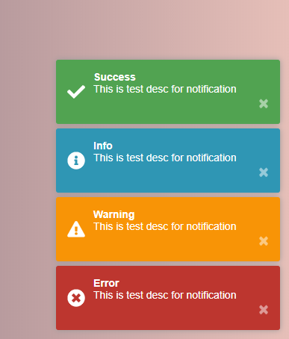

* Where should the notifications appear?

Notification will be appearing on the screen “Bottom-right” side

* How do new notifications appear?

New Notification will be pushed from “Bottom” of the screen and old notification will be pushed up.

* How should the user interact with the notifications?

User can see notification but his work won’t be distracted, If he want to close he can close by click on X icon.

Directory List:

