import pandas as pd

import numpy as np

import joblib

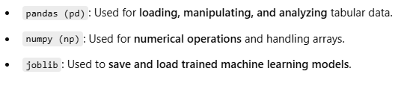

from sklearn.model_selection import train_test_split, GridSearchCV

from sklearn.preprocessing import LabelEncoder

from sklearn.ensemble import VotingClassifier, RandomForestC lassifier, AdaBoostClassifier

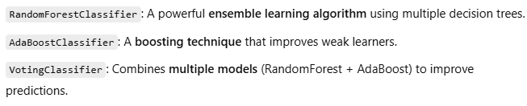

from sklearn.metrics import accuracy_score



from sklearn.impute import SimpleImputer

from imblearn.over_sampling import RandomOverSampler

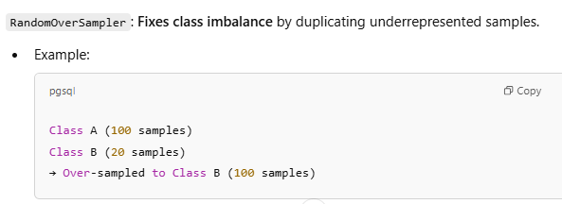

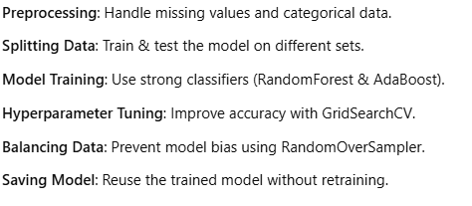

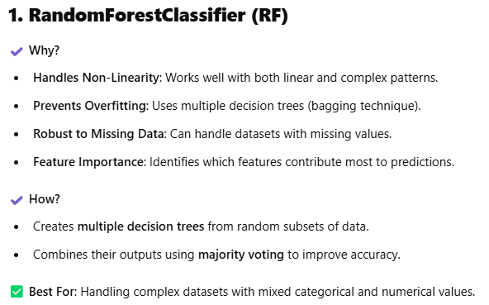

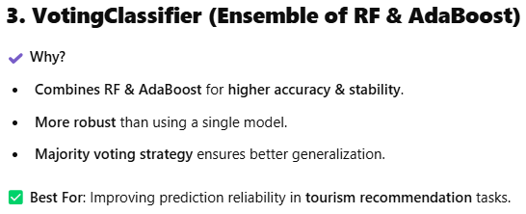

**Tourism Advisor – Project Presentation Guide**

**📌 Project Overview**

The **Tourism Advisor** project is an **AI-powered recommendation system** that suggests **ideal travel destinations** based on user preferences, such as **budget, type of trip, and mode of transport**. The system is built using **Machine Learning (ML) models** trained on historical travel data.

**1️⃣ Problem Statement**

Many travelers struggle to find the best destinations within their budget while considering their preferences.  
👉 Our system solves this by analyzing past travel data and predicting the best **tourist destination** for a user.

**2️⃣ Technologies Used**

🔹 **Programming Language**: Python 🐍  
🔹 **ML Libraries**: Scikit-Learn, Imbalanced-Learn  
🔹 **Cloud Storage**: AWS S3  
🔹 **ML Models**:

* **Random Forest Classifier** 🌳 (for handling complex data)
* **AdaBoost Classifier** 🚀 (for boosting weak learners)
* **Voting Classifier** ✅ (to combine RF and AdaBoost for better accuracy)  
  🔹 **Data Handling**: Pandas, NumPy  
  🔹 **Hyperparameter Tuning**: GridSearchCV  
  🔹 **Model Deployment**: AWS SageMaker (optional)

**3️⃣ Dataset Details**

📌 **Source**: Stored in AWS S3 (TourismAdvisorDataset.csv)  
📌 **Features Used**:

* **Budget** 💰: How much the user is willing to spend
* **Type of Trip** 🏖️: Adventure, Beach, Cultural, etc.
* **Mode of Transport** ✈️🚗: Road or Flight  
  📌 **Target Variable**: **Destination** (Recommended travel location)

**4️⃣ Model Training & Optimization**

✅ **Data Preprocessing**:  
✔ Standardized destination names 📌  
✔ Handled missing values using **SimpleImputer** 🛠️  
✔ Encoded categorical data using **LabelEncoder** 🔠  
✔ Balanced dataset using **RandomOverSampler** ⚖️

✅ **Model Selection & Training**:  
✔ **RandomForestClassifier** – Handles large data & prevents overfitting  
✔ **AdaBoostClassifier** – Boosts weak classification areas  
✔ **VotingClassifier** – Combines both for better accuracy

✅ **Hyperparameter Tuning**:  
✔ **GridSearchCV** used for fine-tuning RF & AdaBoost hyperparameters

✅ **Model Performance**:  
✔ **Accuracy Score** printed to evaluate performance

**5️⃣ User Interaction & Prediction**

📌 **Input**:

* User enters **budget, trip type, and mode of transport**  
  📌 **Processing**:
* ML model **predicts the best destination** based on input  
  📌 **Output**:
* Recommended **travel destination** displayed 🎯

**6️⃣ Deployment & Future Scope**

✔ **Model Saved**: tourism_model.pkl uploaded to AWS S3  
✔ **Future Enhancements**:

* 🏆 **Web App** for user-friendly interaction
* 📲 **Mobile App Integration**
* 🌍 **Expand dataset for international travel recommendations**

**🎤 Conclusion**

✅ Our Tourism Advisor **helps users make informed travel decisions**  
✅ Uses **ML-powered recommendation** for a **personalized experience**  
✅ Future scope includes **real-time data updates & app integration**

**🚀 Ready to revolutionize travel planning with AI!**