NOISEPASSPORT-Q
Hackathon Implementation Guide & Technical Evaluation Report
Project Q Q3 — Noise-Resilient Classifier | Prepared 12 October 2026

IMPORTANT — DATA STATUS: All numerical examples and charts in this guide use synthetic illustrative values to demonstrate the reporting workflow. They are NOT results from your implementation and must NOT be submitted or described as experimental findings. Replace them with values generated by your own run.

Source analysed: Prototype_Plan.docx (Project Q Q3 Noise-Resilient Classifier — Prototype Design Brief, Implementation Plan & Evaluation Protocol).
Scope caveat: the supplied plan states that the detailed official Q3 specification/rubric was not available for inspection. Check the official Q3 instructions before finalizing model, data, noise channels, and submission requirements.

1. Executive decision: what to build first
The supplied plan defines NoisePassport-Q as an evaluation layer around a classifier that the team designs. The contribution is the transparent combination of a noise-response curve, robustness retention, a failure fingerprint, optional uncertainty/defer analysis, a resource ledger, and a reproducible run record. It does not claim a new classifier algorithm or quantum advantage.
Priority | Build item | Acceptance evidence
P0 — must work | One team-implemented quantum classifier, end-to-end | A clean run produces predictions and metrics
P0 — must work | Fixed binary dataset split + classical reference model | Same test samples and comparable preprocessing
P0 — must work | Ideal, gate-only and readout-only evaluation | Noise type and rates recorded; CSV rows saved
P0 — must work | Primary performance-vs-noise graph | Generated directly from measured CSV
P0 — must work | README, dependencies, report and clean rerun | Commands work in a fresh environment
P1 — if time permits | Repeated seeds and uncertainty bars | Mean/std or intervals from actual repeats
P1 — if time permits | Combined noise and abstention policy | Coverage-risk results; threshold selected on validation only
P2 — defer until core is stable | Frontend, dashboard, API, elaborate model search | Do not let these delay the reproducible experiment
The source plan says the event permits generative AI only for syntax support, documentation, and troubleshooting; the team must independently implement and understand its circuit architecture and core algorithm. Treat this guide as documentation/planning support, not as a substitute for team-owned implementation.

2. Project question, hypothesis, and success criteria
Research question: Can a small QML classifier be characterized and selected by performance across controlled noise conditions rather than by ideal-simulation accuracy alone?
Hypothesis to test: the model that scores best in ideal simulation may not be the most stable under noise; a transparent noise sweep and optional defer policy may help characterize reliable predictions. The experiment may fail to support this hypothesis, and that outcome must be reported honestly.
Question | Evidence to show
How quickly does performance deteriorate? | Accuracy/balanced accuracy/Macro-F1 by declared noise level
Which noise source hurts most? | Matched gate-only vs readout-only comparison
Are individual predictions unstable? | Prediction flip rate against ideal predictions on paired test examples
Does defer/abstention help? | Selective risk together with coverage; validation-only threshold selection
What does resilience cost? | Qubits, depth, two-qubit gates, shots, circuit evaluations and runtime

3. Architecture and data flow
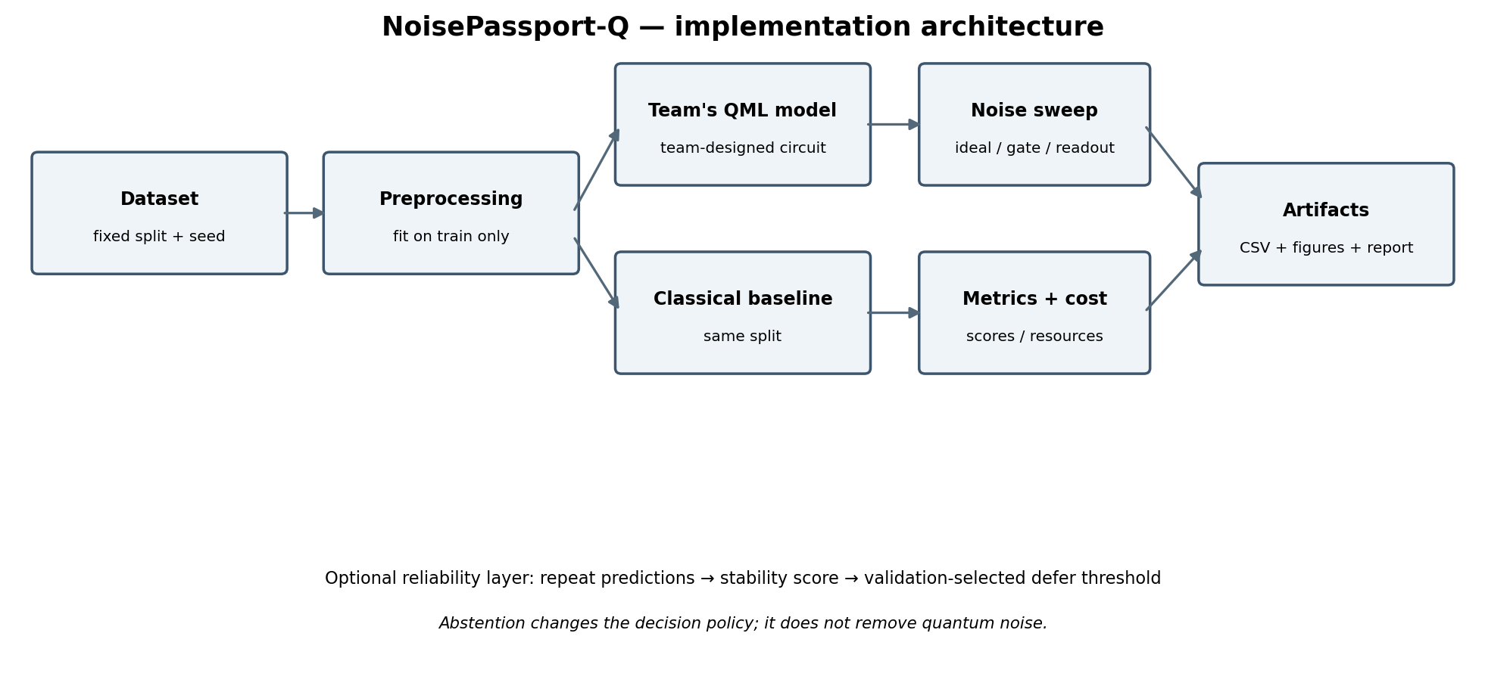
Figure 1. Proposed architecture. The team owns the quantum classifier; shared evaluation code measures it and the classical baseline on the same split.
Implementation principle: separate the classifier from the evaluation harness. The harness should receive a model, dataset split and noise configuration, then return predictions, metrics and resource metadata. Avoid scattering metric calculations across notebook cells.
Module | Responsibility | Expected output
main.py or main.ipynb | Orchestrate a full reproducible run | One documented entry point
src/classifier.py | Team's own circuit/model implementation | Predict function + circuit metadata
src/noise_configs.py | Named, explicit noise conditions | Noise type, channel and parameters
src/evaluation.py | Metrics, repeated runs, CSV writing | One row per model/condition/seed
results/metrics.csv | Raw evaluation results | Auditable numeric source for plots
results/figures/ | Plot scripts or generated plots | Figures reproducible from CSV
README.md + environment.txt | Install/run steps and versions | Fresh-start reproducibility

4. Model and dataset decisions — fill these in before coding
Decision | Required record | Guardrail
Task / labels | What the two classes mean | Avoid vague task definition
Dataset | Name/source or exact synthetic generator; sample count | If synthetic, say results demonstrate pipeline behaviour only
Split | Train/validation/test proportions and seed | Stratify where appropriate; test labels stay untouched until final evaluation
Preprocessing | Scaling and feature selection | Fit transformations on training data only
Quantum model family | Quantum kernel or variational classifier, unless official Q3 says otherwise | Team must independently design/understand circuit and algorithm
Circuit design | Encoding, qubits, entanglement, depth, parameterization | Record why each choice was made
Training | Optimizer, initialization, stopping rule, training-noise condition if applicable | Do not tune on test results
Classical baseline | e.g., RBF SVM, selected on training/validation only | Same split and comparable preprocessing
Primary metric | Prefer balanced accuracy if class imbalance matters; also report Macro-F1 | Choose before final test run
Do not assume the illustrative figures below tell you which model or circuit to choose. They only show how to report the experiment once your implementation runs.

5. Noise plan and experiment matrix
Run ID | Execution | Condition | Purpose | Minimum log fields
A | Ideal simulator | No injected noise | Reference score | seed, shots, metrics, runtime, circuit metadata
B1–B3 | Noisy simulator | Gate noise: low / medium / high | Gate-noise sensitivity | channel, exact parameter, seed, shots
C1–C3 | Noisy simulator | Readout noise: low / medium / high | Measurement sensitivity | readout matrix/probability, seed, shots
D (stretch) | Noisy simulator | Combined gate + readout | Interaction of channels | both parameter sets
E | Repeated evaluations | Selected fixed conditions across seeds | Estimate stochastic variability | run seed, repeat index
F | Classical | Baseline on same held-out split | Reference performance and runtime | model settings, runtime, scores
Label low/medium/high as synthetic stress levels unless rates are taken from a named backend and its calibration record. The values must be numeric and explicit in the code/report; the words alone are not reproducible.
A small pilot can use three noise levels and three independent seeds for selected conditions. If runtime is too high, reduce the number of samples or conditions and state the exact reduction rather than silently omitting cases.

6. Metrics: formulas and how to interpret them
Metric | Formula / meaning | Common trap
Accuracy | Correct predictions / all predictions | Can hide poor minority-class performance
Balanced accuracy | Mean recall across classes | Still report class-level scores when possible
Macro-F1 | Unweighted mean of per-class F1 scores | Do not confuse with weighted F1
Performance drop (pp) | Ideal score − noisy score, in percentage points | 0.90 − 0.80 = 0.10 = 10 percentage points
Accuracy retention | Noisy accuracy / ideal accuracy, if ideal accuracy > 0 | A ratio, not percentage-point drop
Prediction flip rate | Count(prediction_noisy != prediction_ideal) / test sample count | Pair predictions for the same test examples
Coverage | Number assigned a class / all test examples | Must be reported beside selective risk
Selective risk | Errors among assigned examples / assigned examples | Lower risk can be achieved by rejecting more cases
Runtime | Wall-clock duration with stated timing boundary | State whether compile/training/setup is included
Run variability | Mean ± standard deviation across independent repeats | One run cannot estimate between-run variation

7. Illustrative performance data and graphs
The next figures use invented demonstration values (stored in the accompanying CSV) so you can see the expected graph shape and report layout. These are not measured, sourced, or predicted results. Do not copy them into the hackathon's findings as if your model produced them.
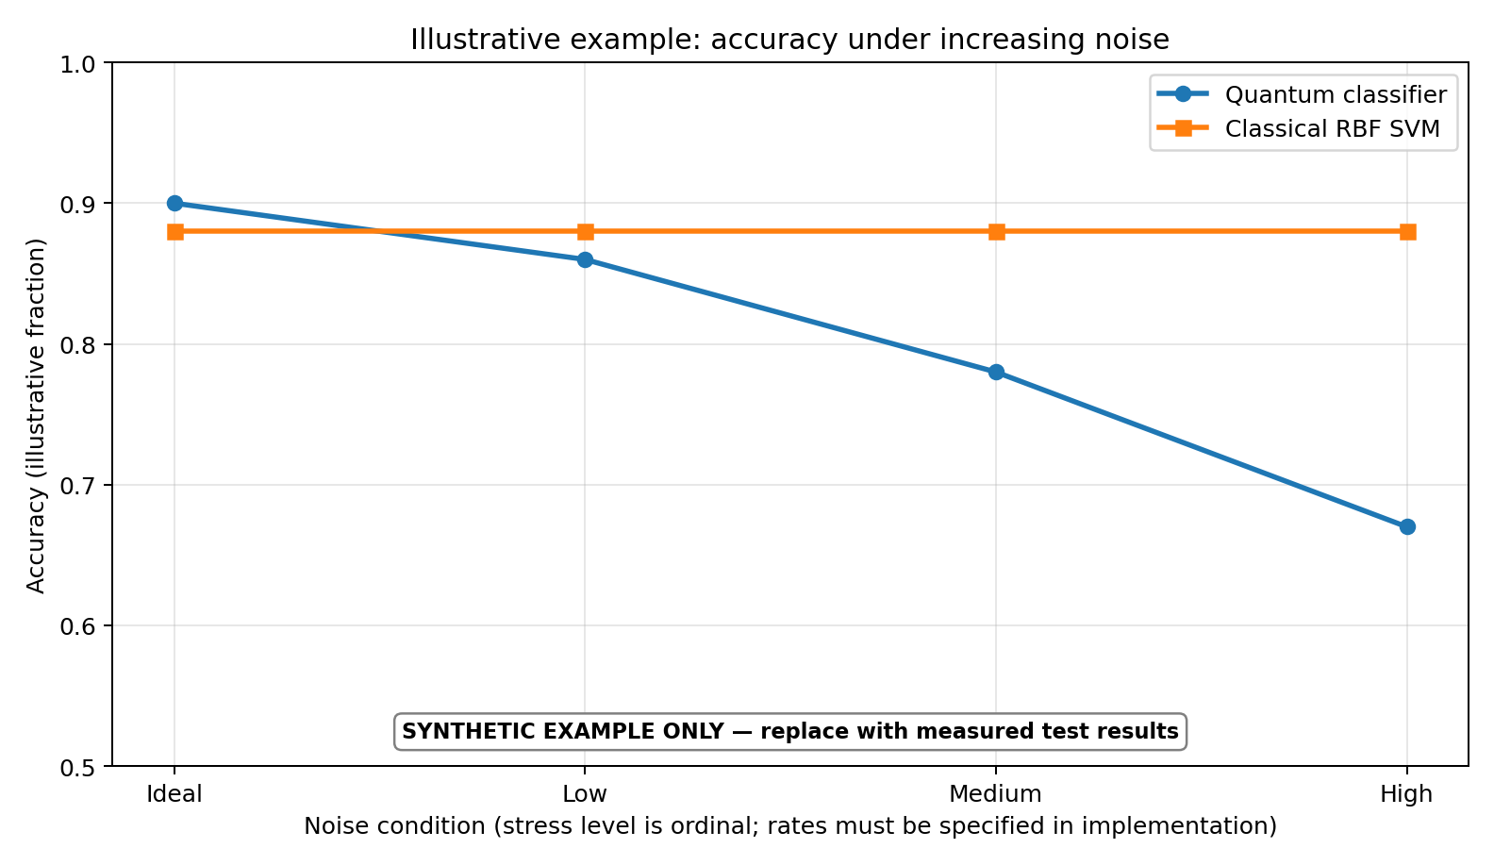
Figure 2. Example accuracy-versus-noise chart. Illustrative values only; replace with measured metrics.csv data.
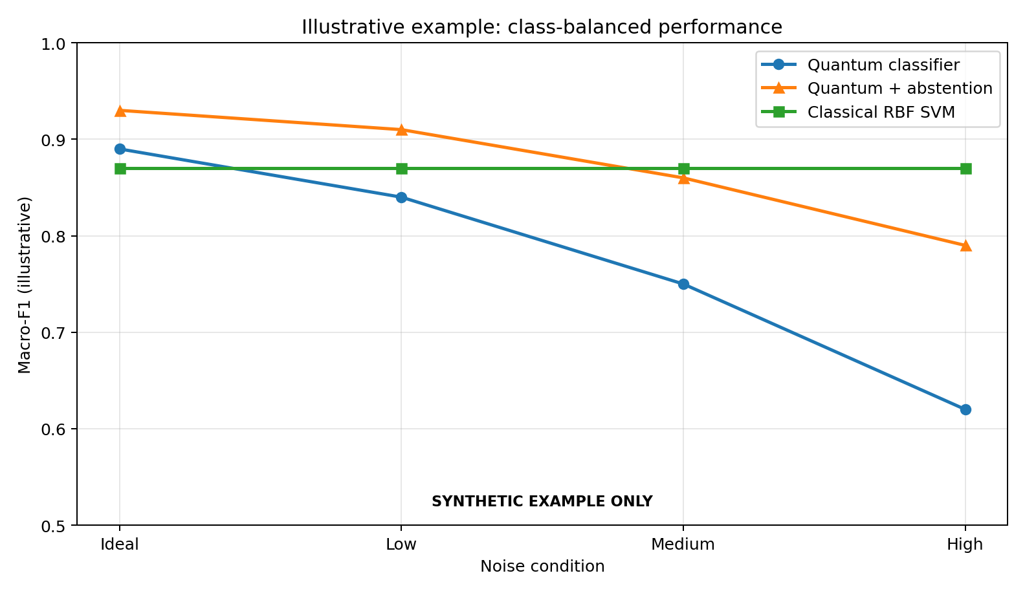
Figure 3. Example Macro-F1 comparison, including a hypothetical abstention variant. Illustrative values only.
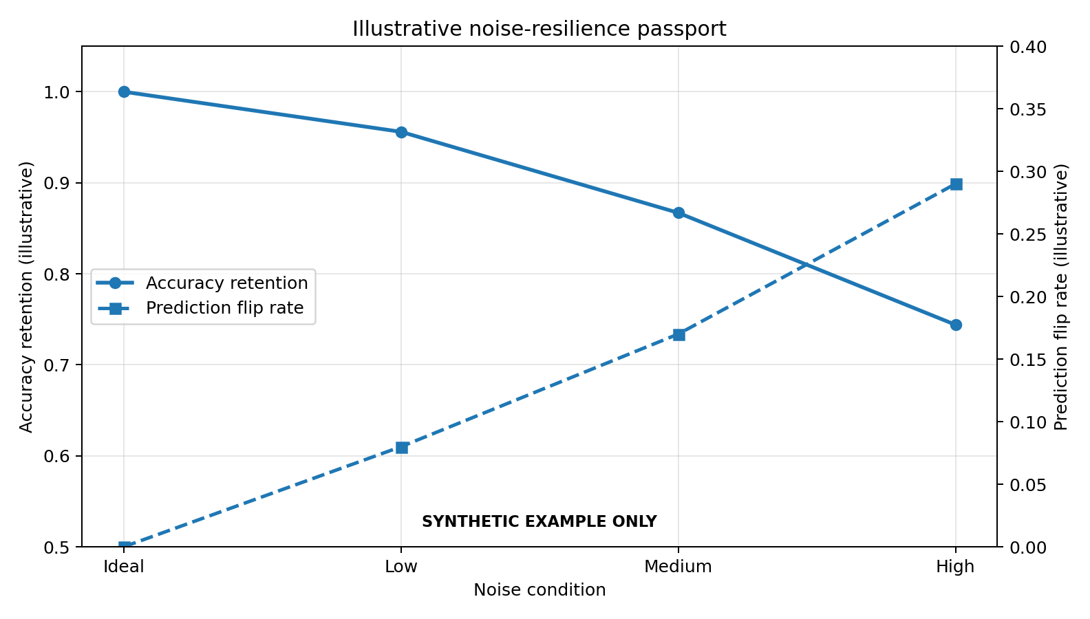
Figure 4. Example retention and prediction-flip view. Illustrative values only.
Example condition | Quantum accuracy | Classical SVM accuracy | How to interpret if this were real
Ideal | 0.90 | 0.88 | Quantum starts slightly higher in this invented example only
Low noise | 0.86 | 0.88 | The ordering reverses under this illustrative stress
Medium noise | 0.78 | 0.88 | The gap widens as the synthetic noise level rises
High noise | 0.67 | 0.88 | This would indicate sensitivity in the tested range, not universal failure
Example conclusion wording after replacing with real values: “On this dataset and under the tested simulator settings, the quantum model's [metric] changed from [x] in the ideal case to [y] under [named noise condition]. The classical baseline scored [z] on the same test split. These results are limited to the selected dataset, circuit, simulator and noise parameters.”
Do not write “quantum is worse/better in general” or claim quantum advantage from this experiment. A simulator comparison on a small task is a controlled robustness study, not proof of general advantage.

8. Resource usage and architecture impact
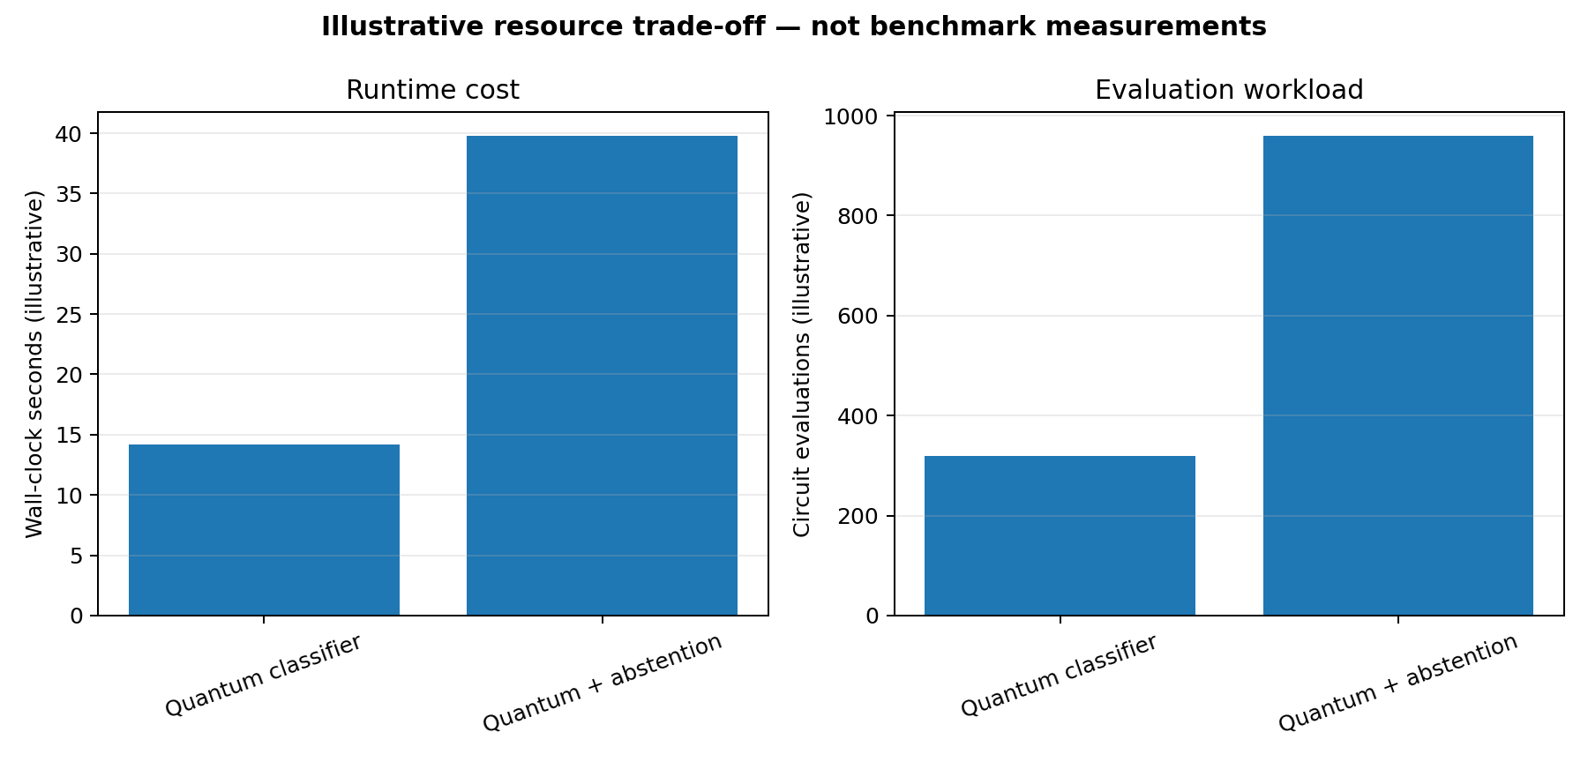
Figure 5. Illustrative runtime and circuit-evaluation workload. Synthetic values only; your machine, backend, circuit and shots will change these.
Resource | Quantum model | Classical baseline | What to report
Qubits | Measure/count circuit qubits | N/A | Logical qubit count and encoding
Circuit depth | Record transpiled depth if available | N/A | Backend/basis assumptions if transpiled
Two-qubit gates | Count after transpilation where possible | N/A | Often important for noise exposure
Shots | Actual shots per circuit | N/A | Report for every condition
Circuit evaluations | Count all evaluations, including repeats | Model-specific evaluations | Include training/evaluation boundary
Runtime | Measure with a monotonic timer | Measure on same machine/session if practical | Separate setup, training and inference if feasible
Peak memory | Optional measured value | Optional measured value | Do not infer it from model size
Architecture choice | Potential benefit | Potential cost / risk | Test that can support a claim
More qubits / features | Richer representation may be possible | More simulation cost; encoding overhead | Same split, score and runtime by qubit/feature setting
Deeper circuit / more entanglers | More expressive transformations may be possible | More opportunities for gate error; longer execution | Depth/gate count vs performance under matched noise
More shots | More precise probability estimates on average | More circuit executions and time | Metric variability and runtime versus shot budget
Repeated runs | Shows stochastic variability | Extra total runtime | Mean/std across seeds
Abstention / defer | May reduce error among accepted predictions | Coverage falls; added decision logic | Coverage-risk curve with validation-chosen threshold
Noise-aware training/mitigation, if implemented | May help in a target noise regime | Extra implementation/training cost; may not generalize | Matched baseline, test performance and resource ledger
A useful architecture claim must name the change, keep other variables fixed, and report both score and cost. If circuit A has better accuracy but uses many more shots/evaluations, describe the trade-off instead of calling it an unqualified improvement.

9. Optional reliability / abstention layer
- Run repeated predictions for each test sample under a predeclared set of repetitions or conditions.
- Choose and document a stability score, such as the proportion of repeated predictions matching the modal class. Do not change the definition after viewing test outcomes.
- Use the validation set to choose the defer threshold. Never select it using test labels.
- On the held-out test set, report coverage and selective risk together, plus the baseline without abstention.
- State clearly that abstention is a classical decision-policy layer. It does not correct the physical quantum circuit or eliminate noise.
Only implement this after the core classifier, noise sweep, and CSV/plot pipeline are working. If time is short, describe it as future work rather than presenting a simulated policy as implemented.

10. CSV schema and reproducible chart workflow
Store one row per model × noise condition × run seed. Recommended columns:
data_status, model, dataset, split_seed, run_seed, noise_type, noise_level, noise_parameter, shots, n_samples, accuracy, balanced_accuracy, macro_f1, performance_drop_pp, accuracy_retention, prediction_flip_rate, coverage, selective_risk, n_qubits, circuit_depth, two_qubit_gates, circuit_evaluations, runtime_seconds, peak_memory_mb, python_version, qiskit_version, aer_version
The supplied example file NoisePassport_Q_illustrative_model_data.csv uses a data_status column set to ILLUSTRATIVE_SYNTHETIC_NOT_MEASURED. A separate resource example CSV is also provided. Use these to inspect the schema and plot layout only; replace rows with real outputs.
Artifact | Required content | Quick validation
metrics.csv | Raw measured row-level data | No blank required metrics; all conditions and seeds represented
plot script/notebook cell | Reads CSV and plots primary metric against noise | No hand-entered chart data
README.md | Environment, run command, dataset, noise settings, outputs, limitations | A new user can follow it from a clean start
environment.txt | Python and actual package versions | Versions match the successful run
technical report | Method, real results, resource cost, architecture impact, limits | Every numeric claim traces to CSV/logs

11. Implementation sequence and troubleshooting
Step | Do this | Stop/go check
1. Verify official task | Open official Q3 specification and rubric | Resolve any required dataset/model/backend/metric conflict
2. Freeze scope | Pick small binary task, split, one model, one baseline, noise grid | Choices documented before test evaluation
3. Environment smoke test | Fresh Python 3.11 environment; install compatible Qiskit/Aer/ML dependencies | Imports and a tiny simulator circuit run
4. Team classifier | Implement circuit and core algorithm in a clear module/notebook section | Team can explain encoding, gates, parameters and prediction mapping
5. Ideal run | Run one end-to-end training/inference path | Predictions and metrics produced
6. Add noise | Add gate-only then readout-only conditions | Each noise parameter is explicit and logged
7. Baseline | Train/evaluate classical SVM on same split | Same test samples; preprocessing fit on training data
8. Log and plot | Append raw rows to CSV; create graphs from CSV | Figures regenerate from saved data
9. Clean rerun | Restart kernel or new process and run entry point | No hidden notebook state or local-only file dependency
10. Final audit | Check claims, dependency file, README, plots, report, repository URL | No synthetic demo values described as real findings

Troubleshooting priorities
- Qiskit/Aer version mismatch: use a clean environment, check imports, record the versions that actually work; do not install qiskit-terra separately into a modern Qiskit environment.
- Training too slow: reduce samples/features and keep the circuit shallow; reduce the experiment matrix transparently, not the integrity of the reporting.
- Unstable results: fix seeds where possible and repeat selected conditions; report the number of repeats.
- Noise effect unclear: confirm that the noise model is actually attached to the simulator/backend and that the chosen gates are affected by the channel.
- Metric inconsistency: calculate every model's scores from the same held-out labels and label ordering.
- Plot appears smooth despite few points: do not interpolate or draw a hand-made curve; show the actual measured points and uncertainty only when supported.

12. Submission-ready repository layout
noise-passport-q/
├── README.md
├── main.py (or main.ipynb; choose the one that works)
├── requirements.txt
├── environment.txt
├── src/
│ ├── classifier.py
│ ├── evaluation.py
│ └── noise_configs.py
├── data/README.md
├── results/
│ ├── metrics.csv
│ └── figures/
├── report/technical_report.md
└── LICENSE (optional)
Do not commit API keys, access tokens, credentials, or unnecessary large datasets. Keep the working entry point obvious and ensure README commands match the actual repository.

13. Results discussion template

Performance
On the held-out test set, [model] scored [metric] = [value] in the ideal condition and [value] under [noise channel/parameter]. The change was [difference] percentage points.

Failure fingerprint
Among the tested conditions, [channel] caused the largest observed drop in [metric]. This conclusion applies only to the noise levels and circuit tested.

Stability
The prediction flip rate relative to ideal predictions was [value] under [condition], computed on [N] paired test samples.

Resource impact
The tested quantum circuit used [qubits], depth [depth], [two-qubit gates] two-qubit gates, [shots] shots and [runtime] seconds under the stated timing boundary.

Abstention (if implemented)
At a validation-selected threshold, test coverage was [value] and selective risk was [value]. Compare both with no-abstention results.

Limitations
The evaluation used [dataset] and [simulator/backend], with [number] runs. It does not establish hardware performance, quantum advantage, or generalization beyond the tested setup.

14. Final acceptance checklist
- Official Q3 task/rubric checked; any conflict with this guide resolved in favour of official instructions.
- Team independently implemented and understands the quantum circuit and core algorithm.
- main.py or main.ipynb runs from a clean start.
- Dataset source/generator, classes, split and seed are documented.
- Gate and readout channels and exact parameters are recorded.
- Classical baseline uses the same split and comparable preprocessing.
- Measured results are saved to CSV and all final charts are generated from that CSV.
- Performance, resource usage and architecture impact are all discussed.
- Any abstention threshold was selected on validation data only; coverage and risk both reported.
- All illustrative data in this guide has been removed/replaced in the submission report.
- README, requirements, environment and report match the implementation that actually ran.
- No unsupported claims of quantum advantage, noise elimination, real-hardware validation, or statistical significance.

15. Source references from the prototype plan
- Qiskit Aer — Noise models: https://qiskit.github.io/qiskit-aer/apidocs/aer_noise.html
- Qiskit Machine Learning — Quantum Kernel Machine Learning tutorial: https://qiskit-community.github.io/qiskit-machine-learning/tutorials/03_quantum_kernel.html
- Qiskit Machine Learning — Neural Networks tutorial: https://qiskit-community.github.io/qiskit-machine-learning/tutorials/01_neural_networks.html
- Ahmed et al. (2025), “A comparative analysis and noise robustness evaluation in quantum neural networks,” Scientific Reports 15, 33654. https://doi.org/10.1038/s41598-025-17769-6
- Cincio et al. (2020), “Machine learning of noise-resilient quantum circuits.” https://arxiv.org/abs/2007.01210
- Sheoran et al. (2025), “Robust evaluation of classical and quantum machine learning under noise, imbalance, feature reduction and explainability,” Scientific Reports 15, 45714. https://doi.org/10.1038/s41598-025-28412-9
- Project Q / Qiskit Fall Fest 2026 event page cited in the supplied brief: https://www.qffsrmap2026.com/learning/hackathon
Final recommendation: submit a small working experiment with an honest evidence trail. The most persuasive result is not the prettiest curve; it is a graph that can be regenerated from logged predictions and settings, accompanied by a clear explanation of what was and was not tested.

