NOISEPASSPORT-Q
Noise-Resilient Quantum Classifier
Prototype Evaluation Report
Project Q / Qiskit Fall Fest 2026 • Prepared 12 October 2026

Evidence status: The supplied Prototype_Plan.docx describes a proposed experiment, but does not include a runnable implementation, results/metrics.csv, measured classifier scores, runtime logs, or circuit metadata. Accordingly, this report does not invent performance or resource values. Figures marked as templates are intentionally not experimental results.

1. Executive summary
This report translates the supplied prototype plan into an evaluation-ready technical report for NoisePassport-Q, a proposed evaluation layer around a team-designed quantum machine-learning (QML) classifier. The aim is to measure how predictive performance changes under controlled gate noise, readout noise, and finite-shot variation, then make the associated resource cost visible. A classical baseline (for example, an RBF-kernel SVM) should use the same data split and comparable preprocessing.
The differentiator is the evidence trail: noise-response curves, performance retention, prediction-flip rate, repeated-run variation, resource accounting, and—if implemented—a validation-selected abstention policy with coverage and selective risk. The concept is not itself evidence of robustness or quantum advantage; those conclusions require measured results.

Key conclusions supported at this stage
- The design is testable with a small binary task, a fixed seed, a few input features, one team-owned quantum model, and one classical baseline.
- The minimum comparison should include ideal simulation, gate-noise-only and readout-noise-only conditions at declared low/medium/high stress levels; combined noise is an extension.
- No measured performance winner, resource advantage, or architecture benefit can yet be identified from the supplied plan alone.
- Any synthetic noise levels must be labelled as stress-test settings, not as measured properties of a physical quantum device.

2. Scope and evidence boundary
Source basis: Prototype_Plan.docx. This report preserves its proposed scope and terminology. The supplied file contains a plan and evaluation protocol, not experiment outputs. The official detailed Q3 specification/rubric was also noted as unavailable in the plan; confirm it before finalizing the experiment.
Item | Status in supplied plan | Report treatment
Classifier implementation | Team decision / to be implemented | No architecture-specific claims beyond proposed design
Dataset and split | To be selected and frozen | No dataset-specific accuracy claims
Noise settings | Proposed experiment matrix | Described as planned conditions
Performance metrics | Defined in plan | Metric definitions included; values pending
Resource usage | Metrics specified, logs absent | Measurement table provided
Hardware validation | Not established | No real-hardware claim

3. Proposed system architecture
The pipeline uses a frozen dataset split and train-only preprocessing, then evaluates the team-designed quantum classifier and a classical reference model. The noise harness controls the simulation condition; a common logging/evaluation layer records scores and costs. An optional reliability layer can defer unstable predictions, with its threshold selected on validation data only.
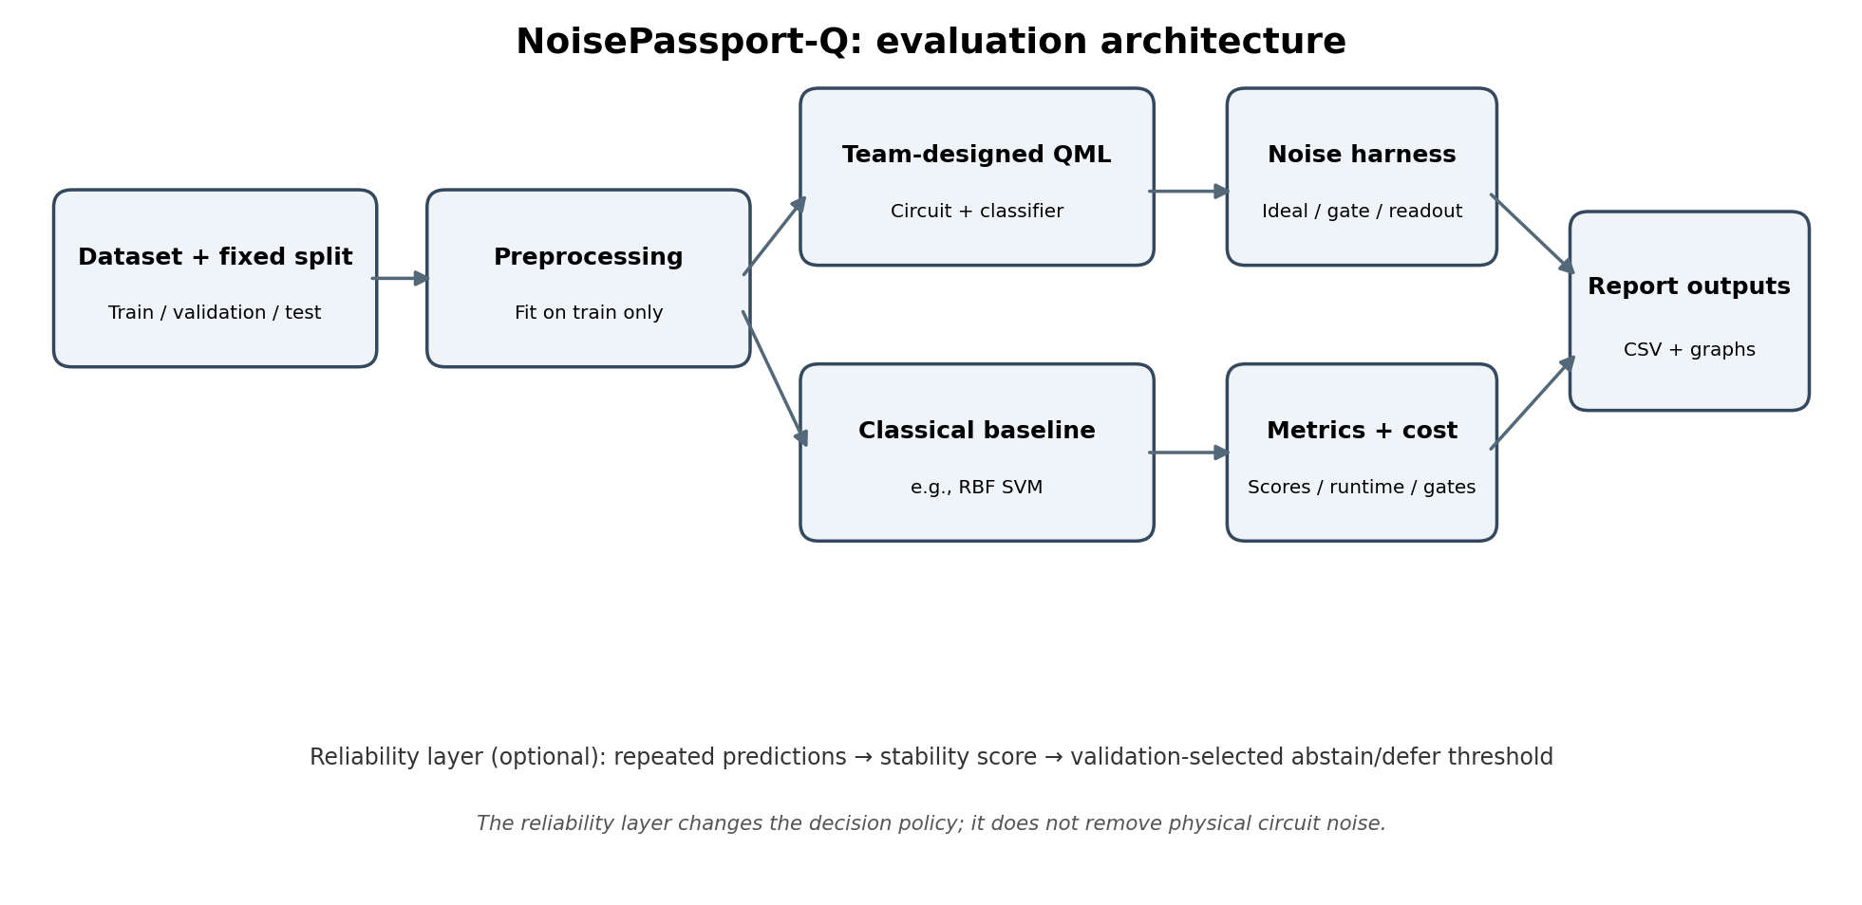
Figure 1. Proposed architecture derived from the supplied plan; it depicts intended components, not a verified running implementation.

4. Experimental design and fair comparison
- Task: small binary classification problem, using a clearly cited dataset or reproducible synthetic data. If synthetic, state that results demonstrate pipeline behaviour rather than real-world application performance.
- Split: freeze a stratified train/validation/test split (for example, 60/20/20 or 70/15/15) and store the seed. Fit preprocessing on training data only.
- Quantum conditions: ideal; gate noise only; readout noise only. Add combined gate + readout noise only after the minimum cases work. Use three declared stress levels and repeat a small subset across independent seeds.
- Baseline: a classical model such as an RBF-kernel SVM using the same split and comparable preprocessing.
- Validity: choose the model, noise grid, and abstention threshold without test labels. Record failed runs, package versions, shots, sample counts, circuit metadata, and wall-clock time.

5. Performance metrics and reporting formulas
Metric | Definition / formula | Interpretation
Accuracy | Correct predictions / all predictions | Overall correctness; can mislead with class imbalance.
Balanced accuracy | Mean recall across classes | Useful when class frequencies differ.
Macro-F1 | Unweighted mean of per-class F1 | Highlights class-wise performance.
Performance drop | Ideal score − noisy score (percentage points) | Direct measure of degradation.
Accuracy retention | Noisy accuracy / ideal accuracy, if ideal accuracy > 0 | Fraction of ideal accuracy retained.
Prediction flip rate | Changed labels vs ideal predictions / paired samples | Prediction instability under noise.
Selective coverage | Number labelled / total samples | How often the policy returns a class.
Selective risk | Errors among labelled samples / labelled samples | Error rate on accepted predictions.
Run variability | Mean ± standard deviation across repeated runs | Shows stochastic variation; small pilots are not proof of significance.

6. Performance comparison
The supplied plan contains no measured scores, so a numerical comparison would be unsupported. Use the table below after running the experiment. Report mean and standard deviation across repeats where available, and keep the classical baseline separate from quantum noise conditions.
Model / condition | Accuracy | Balanced accuracy | Macro-F1 | Runtime (s)
Quantum — ideal | Pending | Pending | Pending | Pending
Quantum — gate noise (low/med/high) | Pending | Pending | Pending | Pending
Quantum — readout noise (low/med/high) | Pending | Pending | Pending | Pending
Quantum — combined noise (optional) | Pending | Pending | Pending | Pending
Classical baseline (e.g., RBF SVM) | Pending | Pending | Pending | Pending
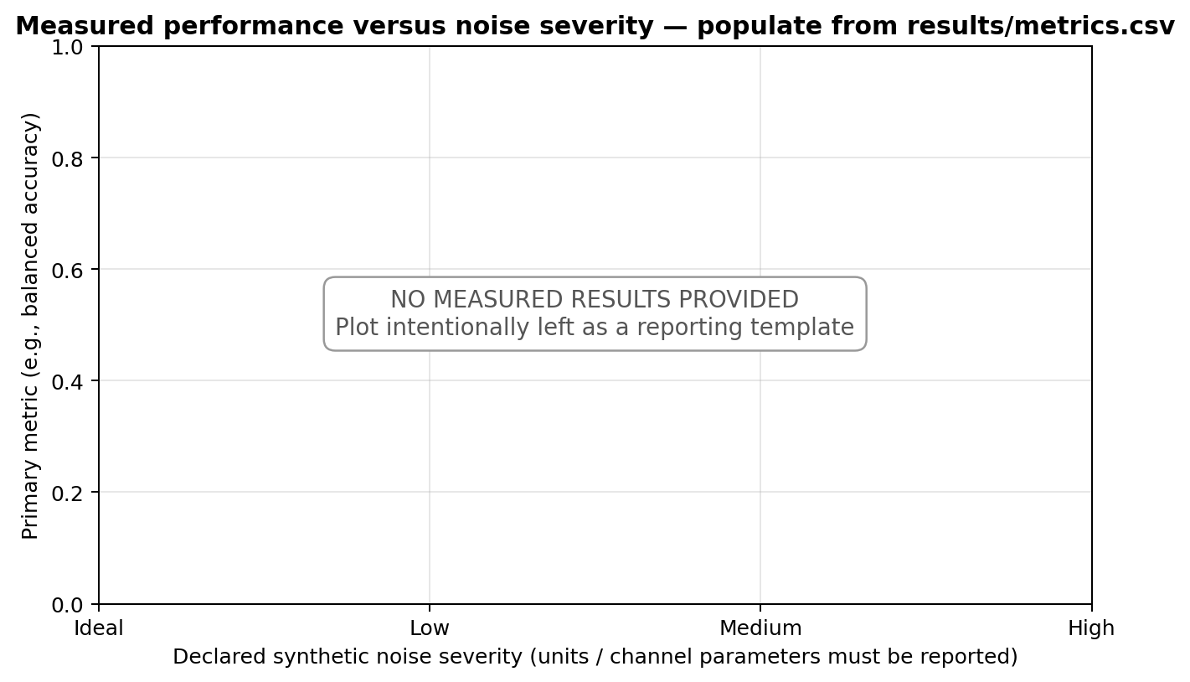
Figure 2. Performance-versus-noise chart template. Replace with a plot generated directly from actual results/metrics.csv; do not treat this empty template as data.

7. Resource usage comparison
Accuracy alone is insufficient: the plan explicitly requires reporting circuit depth and shots alongside performance. Resource indicators should be logged for each quantum condition; the classical baseline should report runtime and any relevant model-size or evaluation-cost information. Values are pending because the supplied file contains no execution logs.
Resource indicator | Quantum classifier | Classical baseline | How to compare
Qubits | Pending / N/A for classical | N/A | Record logical qubits used by the circuit.
Circuit depth | Pending / N/A for classical | N/A | Report transpiled depth and basis/backend assumptions if available.
Two-qubit gate count | Pending / N/A for classical | N/A | Especially relevant to circuit execution cost and noise exposure.
Shots per circuit | Pending / N/A for classical | N/A | State shots for every reported condition.
Circuit evaluations | Pending / N/A for classical | N/A | Include repeated runs and kernel evaluations where relevant.
Wall-clock runtime | Pending | Pending | Use the same machine/session where practical; report setup/training/inference boundaries.
Peak memory | Optional measurement | Optional measurement | Measure rather than estimate if included.
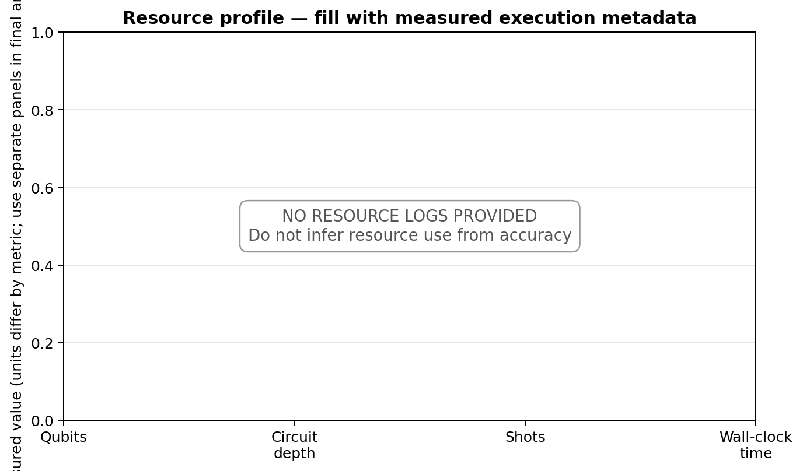
Figure 3. Resource-log template, not measured values. Since units differ, the final results should use separate, correctly labelled plots or a table rather than a misleading single shared scale.

8. Architecture impact and trade-offs
Architecture changes should be treated as experimental factors, not assumed improvements. A wider or deeper circuit may represent richer feature interactions, but can also increase simulation cost and exposure to gate errors. More shots or repeated runs can improve estimation of sampling variability, but increase total circuit executions. Abstention can lower error among accepted predictions only by potentially reducing coverage; both must be reported.
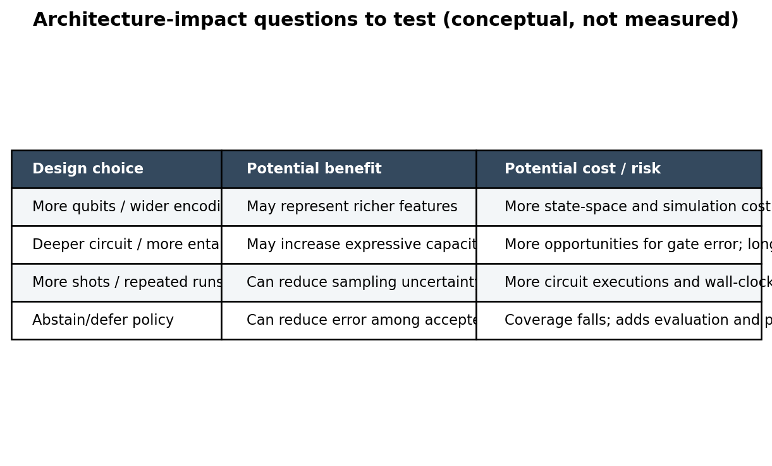
Figure 4. Qualitative trade-off map based on the proposed design; these are hypotheses to test, not measured architecture effects.
Architecture / policy choice | Potential positive impact | Potential negative impact | Evidence needed
Qubit count / feature encoding | Feature representation capacity | More state/simulation cost; encoding overhead | Qubit count, runtime, score on same split
Circuit depth / entanglement | Potentially richer transformations | More gate opportunities for error; slower execution | Depth, two-qubit count, noise-response curves
Shot budget / repeated runs | More stable estimates of probabilities and variability | More circuit executions and elapsed time | Score variance vs shots; total executions
Noise-aware training or mitigation (if implemented) | May improve performance under target noise | Added complexity and training/evaluation cost | Matched baseline; held-out test results; added resource ledger
Abstain/defer policy | May lower selective risk | Lower coverage; extra decision logic | Coverage-risk curve with validation-selected threshold

9. Results interpretation framework
- Noise sensitivity: identify which tested channel produces the largest drop, and only generalize to the tested settings.
- Class-wise behaviour: inspect per-class recall/F1; overall accuracy may hide a failure concentrated in one class.
- Stability: compare predictions with the ideal reference using a paired test set and report flip rate.
- Reliability policy: show selective coverage and selective risk together. A lower error at very low coverage is not automatically a practical improvement.
- Resource trade-off: quantify any score improvement against extra shots, circuit evaluations, depth, gates, and runtime.
- Statistical caution: report repeated-run mean and standard deviation; avoid claims of statistical significance from one run.

10. Minimum results schema
Save one row per model / seed / noise condition in results/metrics.csv. Recommended fields:
model, dataset, split_seed, run_seed, noise_type, noise_level, shots, n_samples, accuracy, balanced_accuracy, macro_f1, performance_drop_pp, accuracy_retention, prediction_flip_rate, coverage, selective_risk, n_qubits, circuit_depth, two_qubit_gates, circuit_evaluations, runtime_seconds, peak_memory_mb, python_version, qiskit_version, aer_version
Keep raw row-level results and derive all graphs from the CSV so the figures are reproducible.

11. Limitations and claims policy
- This is a plan-based report. No experimental results were supplied; all result cells remain pending.
- Simulator noise is a controlled model and does not by itself establish real-device behaviour.
- A synthetic dataset can validate the pipeline but does not demonstrate application performance on real data.
- The report does not claim quantum advantage, error-free execution, broad generalization, statistical significance, or hardware validation.
- The detailed official Q3 task requirements should be checked before final submission.

12. Action checklist to complete the evidence
- Confirm the official Q3 requirements and freeze the dataset, split, model family, primary metric, and noise grid.
- Run an end-to-end smoke test and save the exact software environment.
- Run ideal, gate-only, and readout-only cases; repeat selected conditions across seeds.
- Run the classical baseline on the same split and preprocessing.
- Log circuit metadata, shots, circuit evaluations, runtime, and all primary metrics to CSV.
- Generate final performance/noise and resource figures directly from measured CSV data.
- If using abstention, choose the threshold on validation data and report coverage and selective risk on the test set.
- Rerun from a clean start and ensure the repository README matches the actual working entry point.

References carried forward from the prototype plan
- Qiskit Aer noise models: https://qiskit.github.io/qiskit-aer/apidocs/aer_noise.html
- Ahmed, T. et al. (2025). “A comparative analysis and noise robustness evaluation in quantum neural networks.” Scientific Reports 15, 33654. https://doi.org/10.1038/s41598-025-17769-6
- Qiskit Machine Learning quantum-kernel tutorial: https://qiskit-community.github.io/qiskit-machine-learning/tutorials/03_quantum_kernel.html
- Qiskit Machine Learning neural-network tutorial: https://qiskit-community.github.io/qiskit-machine-learning/tutorials/01_neural_networks.html
- Project Q / Qiskit Fall Fest 2026 event page cited in the supplied plan: https://www.qffsrmap2026.com/learning/hackathon
- Cincio, L. et al. (2020). “Machine learning of noise-resilient quantum circuits.” https://arxiv.org/abs/2007.01210
- Sheoran, S. K. et al. (2025). “Robust evaluation of classical and quantum machine learning under noise, imbalance, feature reduction and explainability.” Scientific Reports 15, 45714. https://doi.org/10.1038/s41598-025-28412-9

