AI-POWERED TRAFFIC FLOW OPTIMIZATION SYSTEM
Congestion Reduction and Adaptive Traffic Signal Timing Using YOLO and SUMO Simulation

MAJOR PROJECT REPORT

Submitted in partial fulfilment of the requirements for the award of the degree of
BACHELOR OF TECHNOLOGY

Submitted by

NAME: Vedagiri.Vishnu Lavanya Supraja
Roll No.: 24F01A4264
Department of CSE-AIML (ARTICIAL INTELLIGENCE AND MACHINE LEARNING) IN ST.ANN’S COLLEGE OF ENGINEERING AND TECHNOLOGY, AUTONOMUS

ACADEMIC YEAR 2026–2027
TEAM MEMBER’S NAMES:
V.VISHNU LAVANYA SUPRAJA
V.PALLAVI
B. SIRISHA

ABSTRACT
Traffic congestion is a major problem in urban areas, leading to increased travel time, fuel consumption, and vehicle waiting time. Traditional traffic signal systems generally use fixed signal timings, which may not respond effectively to changing traffic conditions.
This project presents an AI-Powered Traffic Flow Optimization System that uses YOLO-based vehicle detection, computer vision, congestion analysis, adaptive signal timing, and SUMO simulation. The system detects vehicles from traffic video using a pretrained YOLO11n model and determines the level of traffic congestion based on the number of detected vehicles. According to the congestion level, an appropriate green-light duration is selected.
The proposed traffic-control logic is evaluated using the Simulation of Urban Mobility (SUMO) platform. In the implemented simulation scenario, the fixed-signal system produced a measured total waiting time of 2600 seconds, while the adaptive-signal system produced 2376 seconds. This represents a reduction of 224 seconds, or 8.62%, for the measured waiting-time metric in this particular simulation scenario.
The project demonstrates how artificial intelligence, computer vision, and traffic simulation can be combined to develop an adaptive approach to traffic signal control.
Keywords: Artificial Intelligence, YOLO, Vehicle Detection, Traffic Congestion, Adaptive Traffic Signals, OpenCV, SUMO, Traffic Optimization.
1. INTRODUCTION
Rapid urbanization and increasing vehicle ownership have resulted in growing traffic congestion in cities. Congestion causes delays, unnecessary fuel consumption, increased vehicle emissions, and poor road utilization. Conventional traffic signals often operate using predefined timing plans and may not match changing traffic demand.
Artificial intelligence and computer vision provide an opportunity to make traffic control more responsive. A camera can provide traffic video, a vehicle-detection model can identify vehicles, and the detected traffic level can be used to determine a suitable signal duration.
This project develops a prototype AI-based traffic flow optimization system. YOLO11n is used for vehicle detection, Python is used for processing and control logic, and SUMO is used to evaluate signal-control behaviour in a simulated road network.

2. PROBLEM STATEMENT
Fixed-time traffic signals may allocate the same or similar green duration even when traffic demand changes significantly between directions. A lightly loaded road may receive unnecessary green time while a congested road continues to experience vehicle queues.
The main problem addressed by this project is the inability of traditional fixed-time traffic signals to respond dynamically to changing traffic conditions.
The proposed system addresses this problem by detecting vehicles, estimating the congestion level, and adapting the selected green-light duration according to the detected traffic condition.

3. OBJECTIVES
The main objectives of the project are:
- To detect vehicles from traffic video using a pretrained YOLO model.
- To count relevant vehicle classes such as cars, buses, trucks, and motorcycles.
- To classify traffic conditions into LOW, MEDIUM, and HIGH congestion levels.
- To select an appropriate green-light duration according to the detected traffic condition.
- To connect the traffic-control logic with SUMO through the TraCI Python interface.
- To compare fixed-signal and adaptive-signal behaviour using a common simulation scenario.
- To measure and report traffic waiting-time results from the simulation.

4. EXISTING AND PROPOSED SYSTEM
4.1 Existing System
In a conventional fixed-time traffic signal system, traffic signal phases operate using predetermined durations.
The signal controller does not directly respond to the actual number of vehicles waiting on the road. As a result, some directions may receive unnecessary green time while another direction may have a larger queue.
Disadvantages of Existing System
- Fixed signal timings
- Does not respond to changing traffic conditions
- Can increase vehicle waiting time
- Can cause unnecessary congestion
- Limited use of real-time traffic information
4.2 Proposed System
The proposed system uses artificial intelligence and computer vision to make traffic signal control more adaptive.
The system follows the process:
Traffic Video → YOLO Vehicle Detection → Vehicle Counting → Congestion Classification → Green-Time Selection → SUMO Simulation → Performance Evaluation
The system detects vehicles and determines the traffic condition. Based on the congestion level, an appropriate green-light duration is selected.

5. SYSTEM REQUIREMENTS
5.1 Hardware Requirements
- Computer or laptop
- Modern multi-core processor
- Minimum 8 GB RAM recommended
- Traffic video or camera
- Internet connection for initial software/model downloads
5.2 Software Requirements
- Windows Operating System
- Python 3.14.8
- Python Virtual Environment
- Ultralytics YOLO
- YOLO11n model
- PyTorch
- OpenCV
- SUMO 1.27.1
- TraCI Python interface
- Visual Studio Code

6. METHODOLOGY
The proposed system consists of the following stages.
6.1 Traffic Video Input
A traffic video is provided as the input to the system. The video contains vehicles moving through a traffic environment.
6.2 Vehicle Detection
The YOLO11n object detection model is used to detect objects in the traffic video.
YOLO identifies vehicles in individual video frames and provides their bounding boxes and class information.
6.3 Vehicle Counting
The detected vehicles are counted according to their classes.
The project considers:
- Cars
- Motorcycles
- Buses
- Trucks
Traffic lights and other objects are not included in the vehicle count.
6.4 Congestion Classification
The vehicle count is converted into a congestion level.
The prototype uses three levels:
- LOW
- MEDIUM
- HIGH
6.5 Adaptive Signal Timing
The congestion level is used to determine the green-light duration.
Higher traffic congestion receives a longer green duration.
6.6 SUMO Simulation
The traffic-control logic is connected to SUMO using the TraCI Python interface.
SUMO simulates the movement of vehicles through the intersection.
6.7 Performance Evaluation
The adaptive signal is compared with a fixed signal.
The measured waiting time is used as the main comparison metric.

7. SYSTEM ARCHITECTURE
The overall architecture of the proposed system is:
TRAFFIC VIDEO
↓
OPENCV / VIDEO PROCESSING
↓
YOLO11n VEHICLE DETECTION
↓
VEHICLE COUNT
↓
CONGESTION CLASSIFICATION
↓
ADAPTIVE SIGNAL TIMING LOGIC
↓
SUMO + TraCI
↓
TRAFFIC SIMULATION RESULTS
↓
PERFORMANCE EVALUATION

8. IMPLEMENTATION
8.1 Vehicle Detection
The project uses the pretrained YOLO11n model for vehicle detection.
The model is loaded using the Ultralytics Python library and applied to the traffic video.
The project uses a pretrained model instead of training a YOLO model from scratch.
8.2 Vehicle Classes
The implementation counts the following vehicle classes:
- Car
- Motorcycle
- Bus
- Truck
These detected vehicles are used to calculate the traffic level.
8.3 Python Modules
The project contains several Python modules.
File | Purpose
vehicle_counter.py | Detects and counts vehicles
congestion.py | Determines congestion level
signal_control.py | Selects green-light duration
adaptive_signal.py | Implements adaptive traffic control
fixed_signal.py | Runs fixed-signal simulation
compare_results.py | Compares fixed and adaptive results
test_traci.py | Tests Python-SUMO connection
read_signal.py | Reads traffic-light state

9. CONGESTION AND SIGNAL CONTROL LOGIC
For the prototype, the following congestion thresholds are used:

Vehicle Count | Congestion Level | Green Time
0–5 | LOW | 20 seconds
6–10 | MEDIUM | 40 seconds
11 or more | HIGH | 60 seconds

For example, if the detected vehicle count is 7, the congestion level is MEDIUM, and the selected green time is 40 seconds.
If the vehicle count is greater than 10, the system considers the traffic condition HIGH and selects 60 seconds of green time.
These thresholds and timings are prototype control parameters used for the implemented simulation and are not universal real-world traffic-engineering standards.

10. SUMO SIMULATION
The Simulation of Urban Mobility (SUMO) platform is used to evaluate the proposed traffic-control system.
A four-way intersection was created with a traffic signal at the center.
The simulation contains four main traffic directions:
- North → South
- South → North
- East → West
- West → East
Vehicle flows are generated for a 300-second simulation period.
Python communicates with SUMO through the TraCI interface.
TraCI allows the Python program to interact with the SUMO simulation and modify traffic-light timing.

11. RESULTS AND DISCUSSION
The fixed-signal and adaptive-signal controllers were evaluated using the same implemented SUMO scenario.
The simulation was performed for 300 steps.
11.1 Comparison Results
Control Method | Measured Waiting Time
Fixed Signal | 2600 seconds
Adaptive Signal | 2376 seconds
Difference
2600 − 2376 = 224 seconds
Therefore, the adaptive system reduced the measured waiting time by:
224 seconds
Percentage Reduction
Percentage Reduction =
((Fixed Waiting Time - Adaptive Waiting Time)
/ Fixed Waiting Time) × 100

= ((2600 - 2376) / 2600) × 100

= 8.62%
Therefore, the adaptive signal system achieved an 8.62% reduction in the measured waiting-time metric for this particular simulation scenario.
Discussion
The result shows that the adaptive signal controller produced lower measured waiting time than the fixed signal controller in the implemented simulation.
This demonstrates the potential benefit of adapting signal timing according to traffic conditions.
However, the result represents the specific simulation scenario and configuration used in this project. It should not be interpreted as a guaranteed real-world improvement.

11.2 Results Graph
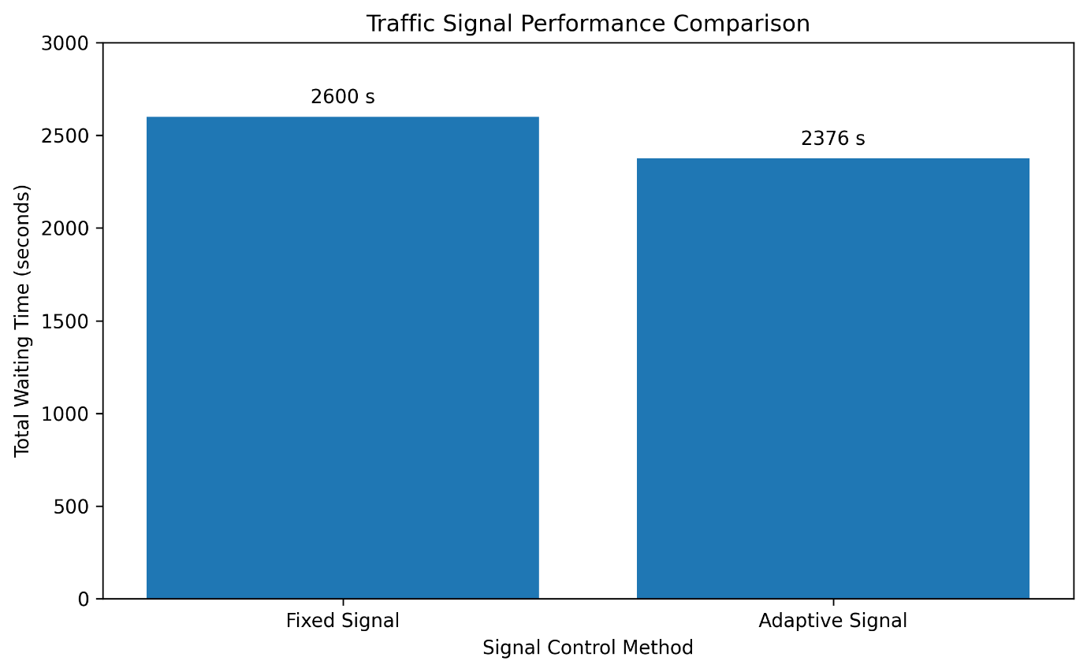

AI-Powered-Traffic-Flow-Optimization-System
└── results
└── traffic_signal_results.png
Under the image write:
Figure 1: Traffic Signal Performance Comparison

12. ADVANTAGES
The proposed system provides the following advantages:
- Uses AI-based vehicle detection.
- Can respond to changing simulated traffic demand.
- Combines computer vision with traffic simulation.
- Uses a modular Python implementation.
- Can be extended to real-time camera feeds.
- Provides measurable simulation results.
- Reduces measured waiting time in the implemented simulation scenario.
- Provides a foundation for future intelligent traffic-control systems.

- Real-world deployment would require traffic-engineering validation and safety testing.
- Using reinforcement learning for traffic signal control.
- Developing a real-time traffic dashboard.
- Integrating real road-network data into SUMO.
- Testing the system using real-world traffic data.
- Expanding the system to multiple connected intersections.
- Adding emergency vehicle priority.

15. CONCLUSION
The AI-Powered Traffic Flow Optimization System demonstrates a practical prototype for adaptive traffic signal control.
The system combines YOLO11n vehicle detection, vehicle counting, congestion classification, adaptive signal timing, Python programming, SUMO simulation, and TraCI communication.
The implemented simulation comparison produced a measured waiting time of 2600 seconds for the fixed signal and 2376 seconds for the adaptive signal.
This resulted in a measured reduction of 224 seconds, corresponding to an 8.62% reduction for the selected simulation scenario.
The project demonstrates that artificial intelligence and traffic simulation can be combined to create a more responsive approach to traffic signal control. With further development using real-time traffic data, vehicle tracking, larger road networks, and advanced optimization techniques, the system could be extended toward a more realistic intelligent traffic-management solution.

16. REFERENCES
- Ultralytics YOLO Documentation — Python Usage and YOLO Tasks.
- Ultralytics YOLO Documentation — Object Detection and Tracking.
- Eclipse SUMO Documentation — Traffic Lights.
- Eclipse SUMO Documentation — TraCI Python Interface.
- OpenCV Documentation — Computer Vision Library.
- Python Documentation — Python Programming Language.

