angularJS

week-1

directives-

ng-app,ng-init,ng-repeat,ng-model,ng-click

ng-class=can adds a class to any inside your html code

controllers

var app=angular.module('ngapp name',[empty array]);

app.controller('controller name',callback function(){

//do what ever

});

filters::

orderby:

week -2

task runners grunt and gulp

grunt-configuarationn over code ,

* first configure package.json,
* install grunt(npm install grunt),both globally and locally.
* Creating grunt file.
* Configuring the project
  + 1.(<!-- --> for links and scripts)
  + 2.creating app.js
* The JShint task
  + (set up jshint by installing modules(commands))
  + Configure the jshint task in gruntfile
  + Create .jshintrc
* Copying the Files and Cleaning Up the Dist Folder
  + Install modules
  + Configure the tasks in gruntfile
  + Update the grunt build task
* Preparing distribution folder and files(only main files that is put it in server)
  + Install corresponding modules(usemin along with cocncat,cssmin,uglify,flerev) using commands
  + Configure the tasks in gruntfile
  + Update jit-grunnt config to inform useminprepare task depends on usemin
  + Update the grunt build task
* Now try run grunt in cmd prompt if no errors it will create dist folder with files structed correctly to be distributed to server to host our website.
* Watch,connect and server task
  + Install corresponding modules using commands
  + Configure those
  + Grunt.registertask(‘serve’, [‘build’, 'connect:dist','watch']);])
* Run grunt serve

gulp-code over configuration

steps:

1. Create package.json with this code
   1. { "name": "conFusion", "private": true, "devDependencies": { }, "engines": { "node": ">=0.10.0" } }
2. Install gulp globally (through this you can use gulp in all projeccts)
   1. Npm install -g gulp
3. Install gulp locally(this install can use in our project)
   1. Npm install gulp –save -dev
4. Install gulp plugins in a single shot
   1. npm install jshint gulp-jshint jshint-stylish gulp-imagemin gulp-concat gulp-uglify gulp-minify-css gulp-usemin gulp-cache gulp-changed gulp-rev gulp-rename gulp-notify browser-sync del --save-dev
5. create gulpfile.js
   1. (loading gulp plugins)paste this code
   2. var gulp = require('gulp'), minifycss = require('gulp-minify-css'), jshint = require('gulp-jshint'), stylish = require('jshint-stylish'), uglify = require('gulp-uglify'), usemin = require('gulp-usemin'), imagemin = require('gulp-imagemin'), rename = require('gulp-rename'), concat = require('gulp-concat'), notify = require('gulp-notify'), cache = require('gulp-cache'), changed = require('gulp-changed'), rev = require('gulp-rev'), browserSync = require('browser-sync'), del = require('del');
   3. Adding gulp tasks (paste this code in gulp.js)
   4. gulp.task('jshint', function() { return gulp.src('app/scripts/**/*.js') .pipe(jshint()) .pipe(jshint.reporter(stylish));});// Cleangulp.task('clean', function() { return del(['dist']);});// Default taskgulp.task('default', ['clean'], function() { gulp.start('usemin', 'imagemin','copyfonts');});
   5. Adding usemin,imagemin,copyfonts(paste this code in gulp.js)
   6. gulp.task('usemin',['jshint'], function () { return gulp.src('./app/menu.html') .pipe(usemin({ css:[minifycss(),rev()], js: [uglify(),rev()] })) .pipe(gulp.dest('dist/'));});// Imagesgulp.task('imagemin', function() { return del(['dist/images']), gulp.src('app/images/**/*') .pipe(cache(imagemin({ optimizationLevel: 3, progressive: true, interlaced: true }))) .pipe(gulp.dest('dist/images')) .pipe(notify({ message: 'Images task complete' }));});gulp.task('copyfonts', ['clean'], function() { gulp.src('./bower_components/font-awesome/fonts/**/*.{ttf,woff,eof,svg}*') .pipe(gulp.dest('./dist/fonts')); gulp.src('./bower_components/bootstrap/dist/fonts/**/*.{ttf,woff,eof,svg}*') .pipe(gulp.dest('./dist/fonts'));});
   7. Code for watch
   8. // Watch gulp.task('watch', ['browser-sync'], function() { // Watch .js files gulp.watch('{app/scripts/**/*.js,app/styles/**/*.css,app/**/*.html}', ['usemin']); // Watch image files gulp.watch('app/images/**/*', ['imagemin']);});gulp.task('browser-sync', ['default'], function () { var files = [ 'app/**/*.html', 'app/styles/**/*.css', 'app/images/**/*.png', 'app/scripts/**/*.js', 'dist/**/*' ]; browserSync.init(files, { server: { baseDir: "dist", index: "menu.html" } }); // Watch any files in dist/, reload on change gulp.watch(['dist/**']).on('change', browserSync.reload); });
   9. Save gulpfile.js
6. At cmd prmpt run this cmd(runs the first clean taks and then default tasks(jshint,…))
   1. Gulp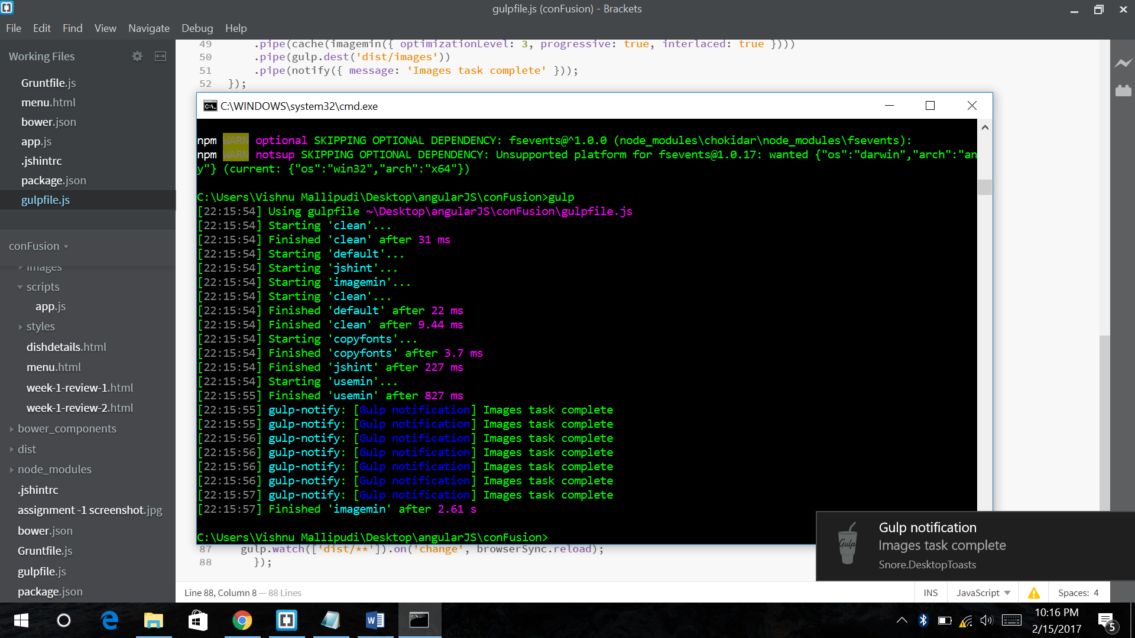
7. Now finally run this cmd
   1. Gulp watch