Air Quality Analysis

And

Prediction in Tamil Nadu

Introduction:-

Air Quality Forecasts, if they are reliable and sufficiently accurate, can play an important role as part of an air quality management system.

The air quality (AQ) Forecast lets the public know expected air quality conditions for next 72 hours so that Government authorities can take action to manage the air quality and issue health advisories.

Local air quality affects how you live and breathe. Like the weather, it can change from day to day or even hour to hour.

The Graded Response Action Plan (GRAP) ensures that air pollution control actions are taken in Delhi-National Capital Region (NCR) based on the different air quality index categories namely, Moderate & Poor, Very Poor, and Severe as per National Air Quality Index.

Ambient Air Pollutants and their Concentration Measurement:-

Under the provisions of the Air (Prevention & Control of Pollution) Act, 1981, the CPCB has notified fourth version of National Ambient Air Quality Standards (NAAQS) in 2009. The national standard aims to provide uniform air quality criteria for all, irrespective of land use pattern, across the country.

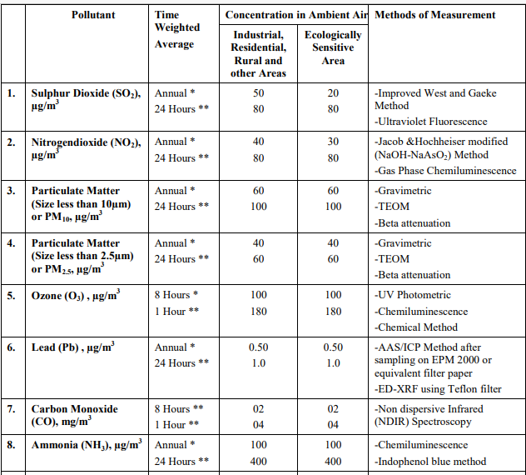

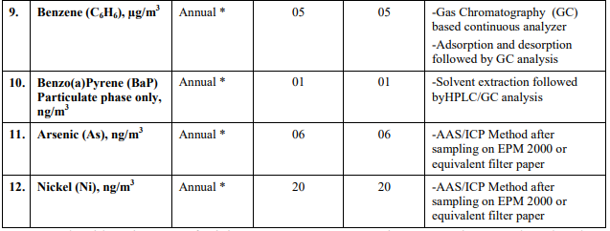

Air Quality Index:-

Air Quality Index (AQI) is a tool for effective communication of air quality status to people can easily understand and take action. The AQI is used by agencies to communicate to the public how polluted the air currently is or how polluted it is forecast to become.Public health risks increase as the AQI rises.

AQI is intended to enhance public awareness and involvement in efforts to improve air quality. It transforms complex air quality data of various pollutants into a single number (index value), nomenclature and colour.

1. There are six AQI categories, namely Good, Satisfactory, Moderate, Poor, Very Poor, and Severe. Each of these categories is decided based on ambient concentration values of air pollutants and their likely health impacts (known as health breakpoints). AQ sub-index and health breakpoints are evolved for eight pollutants (PM10, PM2.5, NO2, SO2, CO, O3, NH3, and Pb) for which short-term (upto 24-hours) National Ambient Air Quality Standards are prescribed.
2. Based on the measured ambient concentrations of a pollutant, sub-index is calculated, which is a linear function of concentration. The worst sub-index determines the overall AQI.
3. All the criteria pollutants may not be monitored at all the locations. Overall AQI is calculated only if data are available for minimum three pollutants out of which one should necessarily be either PM2.5 or PM10. Else, data are considered insufficient for calculating AQI. Similarly, a minimum of 16 hours’ data is considered necessary for calculating subindex.
4. Note that AQI is based on 24 hour or 8 hour average pollutant concentration and not on hourly concentration.
5. The web-based system designed to provide AQI on real time basis is an automated system that captures data from monitoring stations on a continuous basis without human intervention, and displays AQI based on running average values. The near real time AQI based on monitoring data.
6. (vi)AQI categories and health breakpoints for the eight pollutants are as follow:

Breakpoints for AQI Scale 0-500 (units: µg/m3 unless mentioned otherwise):-

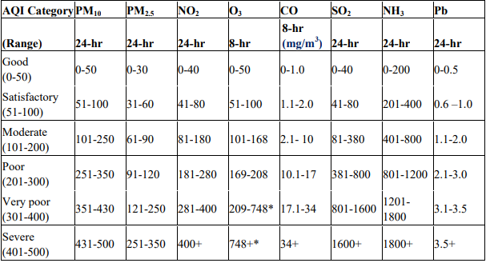

Colour Coding for different AQ Index categories:-

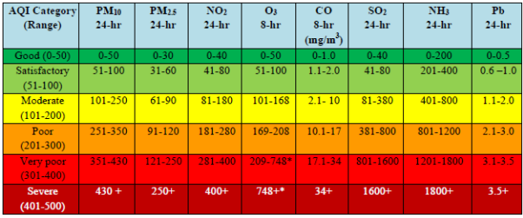

AQI and Associated Health Impact:-

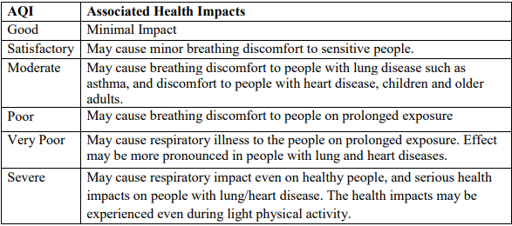

Air Quality Monitoring :-

The methods of measurement prescribed by CPCB for respective parameters are the combination of physical method, wet-chemical method and continuous online method. The continuous online ambient air quality monitoring systems are equipped with analyzers for measurement of PM10, PM2.5, SO2, CO, NO2, O3, NH3 and Benzene. The metallic parameters Pb, Ni, As are measured offline using filter based air samplers.

The ambient air quality monitoring station (AQMS) consists of following systems:

• PM10 & PM2.5: Operates on the principle of Beta Ray Attenuation and measures Particle Mass concentration ranging from 0 to 5 mg/m3 with Minimum detection limit 1 µg/m3 . The equipment includes a PM10 inlet and PM2.5 inlet.

• NOx and NH3: Operates on the principle of Chemiluminescence method, ranging from 0 to 2000µg/m3 with minimum detection limit 0.5µg/m3 .

• SO2 Analyser: Operates on the principle of UV Fluorescence method, ranging from 0 to 2000 µg/m3 with minimum detection limit 0.5 µg/m3.

• CO Analyser: Operates on the principle of Non-Dispersive Infrared Spectrometry (NDIR) method, ranging from 0 to 100 mg/m3 with minimum detection limit 0.03 µg/m3.

• O3 Analyser: Operates on the principle of UV Photometry method, range : 0 to 2500µg/m3 with minimum detection limit 0.5 µg/m3 .

• Benzene, Toluene, Ethylbenzene, Xylene (BTEX): GC/PID for automatic monitoring of BTEX in air with minimum detection level as low as 10 ppt in ambient air

• Multigas Calibrator: to calibrate gas analyzers manually, remotely controlled or automatically, for quality assurance. Multi Calibration upto 20 points.

• Automatic Weather Station (AWS): Ultrasonic Wind Sensor, Barometric Pressure, Temperature, Relative Humidity, Rainfall, Solar Radiation etc.

All these instruments except AWS are housed in a room or walk-way shelter with proper sampling system for gaseous and particulate matter parameters. AQMS should have the calibration facility for onsite calibration with zero and standard gases.

Beta Ray Attenuation for the measurement of PM10 and PM2.5 should be calibrated with standard filters. The detailed guideline for site selection, measurement frequency, reporting etc has been notified by CPCB. Each AQMS should also have a PC for recording and transmission of the data via internet

Air Quality Early Warning System:-

Short-term air quality forecasts can provide timely information about forthcoming air pollution episodes that the decision-makers can use to reduce public exposure to extreme air pollution events.

In this perspective, the Air Quality Early Warning System (AQ-EWS) has been developed under the aegis of Ministry of Earth Sciences, jointly by Indian Institute of Tropical Meteorology (IITM), Pune, India Meteorological Department, and National Centre for Medium-Range Weather Forecasting (NCMRWF). The System is designed to predict air pollution events and give alerts to take necessary steps for air pollution control.

The Early Warning System consists of:

a) Air Quality forecast for Delhi region for 3-days and outlook for next 7-days from different air quality prediction systems based on state-of-the-art atmospheric chemistry transport models

b) Air Quality Forecast for entire India and specifically for several non-attainment cities

c) Real time observations of air quality over Delhi region, fire counts, AOD

d) Details about natural aerosols like dust (from satellite and model forecast)

e) Near real-time fire information over India

f) Generation of Warning Messages, Alerts and Bulletins for Air Quality and Weather. g) Forecast of the contribution of non-local fire emissions

h) Weather Information i) Day to day verification of forecast product.

Air Quality Prediction Models:-

There are different Air Quality Prediction Models operationally run under the air quality early warning system (AQ-EWS):-

1. Weather Research and Forecasting model coupled with chemistry (WRF-Chem)
2. System for Integrated modeLling of Atmospheric composition (SILAM)
3. High resolution model ENvironmental information FUsion SERvice (ENFUSER)
4. NCMRWF Unified Model (NCUM) Dust-Forecast
5. HYSPLIT Backward and Forward Trajectories

General Schematic of the Air Quality Early Warning System:-

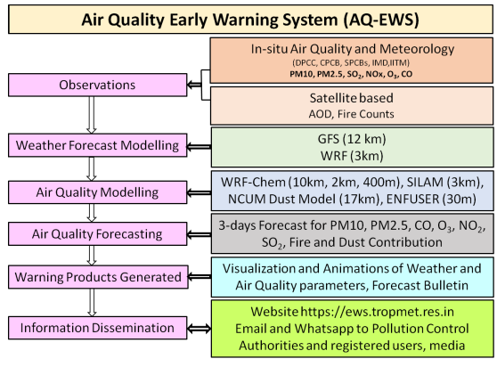

System for Integrated modeLling of Atmospheric coMposition (IMD SILAM):-

System for Integrated modeLling of Atmospheric coMposition (SILAM) is a globalto-meso-scale dispersion model developed for atmospheric composition, air quality, and emergency decision support applications, as well as for inverse dispersion problem solution.

The model incorporates both Eulerian and Lagrangian transport routines, 8 chemicophysical transformation modules (basic acid chemistry and secondary aerosol formation, ozone formation in the troposphere and the stratosphere, radioactive decay, aerosol dynamicsin the air, pollen transformations), 3- and 4-dimensional variational data assimilation modules.

SILAM source terms include point- and area- source inventories, sea salt, windblown dust, natural pollen, natural volatile organic compounds, nuclear explosion, as well as interfaces to ship emission system STEAM and fire information system IS4FRIES.

The regional SILAM model generates 3 days forecasts over a domain covering whole India at 3 km horizontal resolution. The meteorological forcing is provided from the operational 3 km WRF model.

The initial condition is derived from the forecast of the previous cycle of regional SILAM model and boundary condition is supplied from global version of the model. The SILAM model setup for India is as follows:

Running:

• Hourly AQ Forecast of all criteria pollutants (PM10, PM2.5, O3, CO, NOx, SO2 and other species) for 72 hours.

• Domain: 60-100E, 0-40N, 3km x3km grid, 15 hybrid layers up to ~10km (~270hpa).

Driving Meteorology:

• Hourly 3-km WRF forecasts (IMD)

AQ Boundary conditions:

• 3 hourly SILAM Global Suit forecasts Emissions:

• CAMS-GLOB v2.1 0.1-deg supplemented with EDGAR v4.3.2 for coarse and mineral-fine anthropogenic PM.

• GEIA v1 lightning climatology

• MEGAN-MACC biogenic climatology for isoprene and mono-terpene.

• Natural (dynamic): Silam desert dust, Silam sea salt, Silam marine DMS

• Delhi 400m emissions

Aerosol Process:

• Simple equilibrium scheme for secondary inorganic aerosols, Volatile Basis-Set (VBS) for secondary organic aerosol module

• CBM5 chemistry supplemented with secondary organics, DMAT_SULPHUR sulphur oxidation. Validation

• In-situ air quality data from SAFAR, CPCB, DPCC and SPCBs

Schematic diagram of IMD SILAM:-

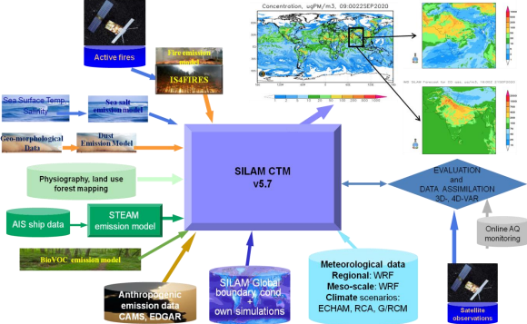

Program:

def calculate_si(so2):

si=0

if (so2<=40):

si= so2*(50/40)

if (so2>40 **and** so2<=80):

si= 50+(so2-40)*(50/40)

if (so2>80 **and** so2<=380):

si= 100+(so2-80)*(100/300)

if (so2>380 **and** so2<=800):

si= 200+(so2-380)*(100/800)

if (so2>800 **and** so2<=1600):

si= 300+(so2-800)*(100/800)

if (so2>1600):

si= 400+(so2-1600)*(100/800)

return si

data['si']=data['so2'].apply(calculate_si)

df= data[['so2','si']]

df.head()

output:

| so2 | si | f |
| --- | --- | --- |
| 0 | 4.8 | 6.000 |
| 1 | 3.1 | 3.875 |

def calculate_spi(spm):

spi=0

if(spm<=50):

spi=spm

if(spm<50 **and** spm<=100):

spi=spm

elif(spm>100 **and** spm<=250):

spi= 100+(spm-100)*(100/150)

elif(spm>250 **and** spm<=350):

spi=200+(spm-250)

elif(spm>350 **and** spm<=450):

spi=300+(spm-350)*(100/80)

else:

spi=400+(spm-430)*(100/80)

return spi

data['spi']=data['spm'].apply(calculate_spi)

df= data[['spm','spi']]

df.tail()

output:

| spm | spi |
| --- | --- |
| 435737 | 0.0 | 0.0 |
| 435738 | 0.0 | 0.0 |
| 435739 | 0.0 | 0.0 |
| 435740 | 0.0 | 0.0 |
| 435741 | 0.0 | 0.0 |