Automated Optimization Strategy Selection System
Choosing the next compiler optimization from static features of three-address code

Vishnu Menon · B.Tech Computer Science and Engineering, VIT Vellore · Compiler Design Project 2

Summary
A compiler that applies its optimizations in a fixed order wastes work on passes a given program cannot benefit from, and applies others too late to matter. This project builds a system that instead looks at the program: it extracts a numeric feature vector from three-address code, scores all six candidate optimizations, applies the highest-scoring one, re-measures, and repeats until nothing improves further.
The corpus is 240 generated programs, each labelled by actually applying all six passes and recording which helped most. Every one of the 1440 pass applications used to build the corpus was checked by executing the transformed program and comparing its output against the original; none changed behaviour.
The best classifier reaches 84.7% accuracy and 0.838 macro-F1 on held-out programs, against 58.3% for a calibrated rule-based baseline. Driving the loop with it recovers 77.5% of the improvement an oracle could achieve, versus 36.8% for the baseline.
Two findings are worth stating up front. First, raw instruction count cannot serve as the objective: loop-invariant code motion relocates instructions without deleting any, so its instruction-count reduction is always exactly zero and it could never be selected. The system therefore optimizes a loop-weighted cost, and reports instruction count alongside it. Second, the eight features named in the specification contain nothing that separates constant folding from constant propagation — both are driven by num_constants — which caps accuracy at 75.0% and holds those two classes below the 0.70 per-class F1 target. Six additional features fix this.

1 Aim and objectives
To design a fully automated system that analyses a program's intermediate code, extracts measurable features, and intelligently selects the most beneficial optimization strategy to apply next, instead of blindly applying all optimizations in a fixed order.
The objectives and where each is met:
Objective | Where it is met
Parse input programs and generate TAC | optselect/frontend.py — lexer, recursive-descent parser, syntax-directed TAC generator
Extract a numeric feature vector from each TAC | optselect/features.py — 8 required features plus 6 extended
Compute an opportunity score for each of the six strategies | optselect/selectors.py — RuleBasedSelector, MLSelector, OracleSelector
Select the best strategy (rule-based or trained model) | Selector.select() returns strategy, confidence and all six scores
Apply, measure the improvement, re-analyse | optselect/driver.py — optimize()
Repeat until no further improvement | The loop halts when no strategy reduces the weighted cost
Report the decision and confidence at each step | driver.format_run(); output in out/example_traces.txt

2 System architecture
The system is a pipeline of seven stages. Stages 2 to 5 form the loop; everything inside it is recomputed from the current instruction list on every pass, because the optimizations rewrite the program and any cached analysis would go stale and quietly corrupt later decisions.
source ──► lexer ──► parser ──► TAC generator (stage 1)
│
▼
┌─────────────── three-address code ───────────────┐
│ │
│ CFG · dominators · natural loops · liveness · │
│ reaching constants (stage 2: analysis) │
│ │ │
│ ▼ │
│ feature vector (stage 3: 8 or 14 numbers) │
│ │ │
│ ▼ │
│ selector → six scores + confidence (stage 4) │
│ │ │
│ ▼ │
│ apply chosen pass; re-measure cost (stage 5) │
│ │ │
└───────── improved? yes → loop back ───────────────┘
│ no
▼
optimized TAC + decision trace
Module | Responsibility
ir.py | Instruction representation; operator semantics shared by the folder and the interpreter
frontend.py | Lexer, parser, TAC generation
cfg.py | Basic blocks, CFG, dominators, natural loops, liveness, reaching constants
optimizations.py | The six passes and the loop-weighted cost metric
features.py | Feature extraction
selectors.py | Rule-based, ML and oracle strategy selectors
driver.py | Ground-truth labelling and the iterative optimization loop
interp.py | Reference interpreter used for correctness verification
datagen.py | Synthetic program generator for the corpus

3 Front end and intermediate representation
The accepted language is a small C-like subset: integer and float declarations, assignment, if/else, while, for, print, and read for input. Expressions are side-effect free, so && and || are evaluated without short-circuiting — semantically identical here, and it keeps control flow out of expressions.
The read() construct matters more than it looks. Without a source of values the analyses cannot see, every variable in every program traces back to a literal, constant propagation dissolves almost anything, and it wins the label on nearly every program. Opaque inputs keep the six strategies in genuine competition.
The IR is structured rather than string-based: each instruction is a record with a kind, a destination, an operator and up to two operands, where an operand is either a variable name or a literal. Passes can then reason about instructions without re-parsing text.
The TAC generator is deliberately naive — a fresh temporary for every interior expression node, no folding, no reuse. All improvement has to come from the optimization passes, which is what makes the selection experiment meaningful.
Source Generated three-address code

int a = 2 * 3 + 4; t1 = 2 * 3
read(b); t2 = t1 + 4
int c = a * b; a = t2
print(c); b = read()
t3 = a * b
c = t3
print c

4 The six optimization strategies
Each pass is self-contained: it performs its characteristic transformation and the immediate clean-up that transformation makes possible, so that applying it alone produces a measurable change. A pass never runs another pass's analysis to do that clean-up — that is what keeps the six distinguishable and the selection problem non-trivial.
Strategy | What it does | Analysis it needs
CF — constant folding | Evaluates expressions whose operands are all literals; resolves branches on literal conditions; substitutes and deletes a folded single-definition temporary | none (local)
CP — constant propagation | Replaces variable uses by values the variable is proved to hold, then deletes constant definitions left with no users | forward reaching-constants dataflow over the CFG
CSE — common subexpression elimination | Value-numbers each basic block; a recomputed expression is replaced by the variable already holding it | basic blocks; availability killed on redefinition
DCE — dead code elimination | Deletes computations whose result is never read, plus unreachable blocks and orphaned labels | backward liveness dataflow
AS — algebraic simplification | Applies x+0, 0+x, x−0, x*1, 1*x, x*0, 0*x, x/1, x−x, 0−x, then forwards and deletes the resulting copy | none (local)
LICM — loop-invariant code motion | Hoists invariant computations into a freshly created preheader | dominators, natural loops, liveness

4.1 Two design decisions worth defending
Constant propagation does not evaluate. The obvious lattice transfer function evaluates a binary operation when both operands are known constants. That makes constant propagation subsume constant folding — and the first version of this system did exactly that, which is why constant folding never once won a label. Propagation here means only "replace a variable use by a value the variable is known to hold"; evaluating the expression is folding's job.
Dead code elimination runs a single pass, not to a fixed point. A fixed-point DCE clears an entire chain of dead definitions in one call and is far more powerful than one application of any other strategy, which distorts the labels toward it. Restricting it to one pass makes the six comparable, and lets the outer loop do the iterating.

4.2 Safety conditions on code motion
Hoisting is the one transformation here that can change behaviour in a way that ordinary testing might miss, because the danger case is a loop that executes zero times. An instruction is hoisted only when all four of these hold:
- every operand is a literal, defined outside the loop, or defined by an instruction already proved invariant;
- its destination is assigned exactly once inside the loop;
- its defining block dominates every in-loop use of that destination;
- the destination is not live on any edge leaving the loop — without this, a loop that never executes would see the destination take the hoisted value instead of keeping its previous one.
Jumps into the header from outside the loop are retargeted to the preheader; back edges are left pointing at the header. There is a dedicated test for each of the last two conditions.

5 The objective: why not instruction count
The specification labels each program with the optimization giving the greatest instruction-count reduction. That metric cannot work here, for a specific and unavoidable reason: loop-invariant code motion moves instructions out of loops without deleting any of them. Its instruction-count reduction is exactly zero on every program, so under that objective it can never be the best strategy, would never appear as a label, and no classifier could ever learn to select it. Figure 5 shows this directly — the LICM box sits flat on zero.
The system therefore optimizes a loop-weighted static cost: an instruction at loop nesting depth d counts 10^d, capped at depth 3. This is the standard static estimate of dynamic execution frequency. Deleting an instruction still reduces it, so the other five strategies score exactly as before; and hoisting an instruction from depth 1 to depth 0 now scores a saving of 9 units, which is a fair reflection of what it buys at run time. Raw instruction count is reported throughout as a secondary metric, so nothing the specification asks for is lost.

6 Feature extraction
The eight features named in the specification are implemented exactly as described. Three of them (repeated expressions, dead statements, loop instructions) are computed from real analyses rather than pattern matching on text, so they agree with what the passes will actually find.
Feature | Definition | Set
num_statements | TAC instructions, excluding label pseudo-instructions | required
num_constants | Instructions whose operands are all numeric literals | required
num_repeated_expr | Redundant computations found by local value numbering | required
num_dead_stmts | Assignments whose destination is not live afterwards | required
num_algebraic_ops | Instructions matching an arithmetic identity pattern | required
num_loop_ops | Instructions inside a natural loop body | required
num_tmp_vars | Distinct compiler-generated temporaries | required
const_ratio | num_constants / num_statements | required
num_foldable | Computations with all-literal operands — folding opportunities alone | added
num_const_defs | Assignments of a literal to a variable | added
num_prop_sites | Variable uses the dataflow proves constant — propagation opportunities alone | added
num_loop_invariant_ops | Loop instructions whose operands are all defined outside the loop | added
max_loop_depth | Deepest loop nesting in the program | added
num_distinct_vars | Distinct variable names | added
Why six were added. Constant folding and constant propagation are both driven by num_constants and const_ratio, and the required set contains nothing else that distinguishes them. num_foldable counts only what folding can do and num_prop_sites only what propagation can do; num_loop_invariant_ops is a cheap structural signal for hoisting that stops short of running the safety analysis. Section 8 measures what this is worth.

7 Dataset construction and labelling
Programs are grown from snippet templates, each planting one kind of opportunity. A generation bias adds extra helpings of one kind, but every program also receives a background of all five, so several strategies are in genuine competition and the label is not a foregone conclusion. The bias never dictates the label: the label always comes from applying all six passes and measuring.
Property | Value
Programs in the corpus | 240
Mean program size | 69.0 TAC instructions
Mean loop-weighted cost | 222.2
Pass applications verified during the build | 1440
Semantic violations found | 0
Programs dropped as already optimal | 0
Class distribution | CF 38 · CP 51 · CSE 36 · DCE 43 · AS 43 · LICM 29
Two generator faults were found and fixed by looking at the label distribution. Leaving some result variables unprinted made almost every program a dead-code program by accident, so every ordinary variable is now printed and the only dead code is what the dead snippets deliberately plant. And building the shared subexpression in a CSE loop body out of variables defined outside the loop made it loop-invariant, so hoisting beat eliminating it and those programs were really LICM examples; the shared expression now involves the loop counter.
A note on difficulty. An earlier corpus planted one kind of opportunity almost exclusively per program. Every model scored 100% on it — which measures the generator, not the selector. The mixture above was chosen deliberately to make the problem hard enough to be informative.

8 Strategy selection

8.1 Rule-based baseline
Each strategy is scored as an estimate of the weighted cost it will save: its driving feature, times the cost that feature typically yields, times a loop amplification factor. Since opportunities are spread through the program, a fraction num_loop_ops / num_statements of them sit inside a loop and are worth ten times as much; without that amplification the five deletion strategies are scored on a different scale from hoisting and the comparison is meaningless.
The per-unit yields are the only quantities the baseline takes from data — each is the mean observed gain per unit of driver across the corpus. Calibrating them rather than guessing is what makes this a fair baseline: an uncalibrated set of weights would lose to the classifiers for the trivial reason that its scores were on incomparable scales, which would prove nothing. If anything this favours the baseline.

8.2 Learned predictor
Four classifiers are trained on a stratified 70/30 split, with five-fold stratified cross-validation over the whole corpus as a second estimate. Logistic regression and the MLP are wrapped in a standardising pipeline. Confidence is the winning class probability, and for the rule-based selector the winning score's share of the total, so the two are comparable.

9 Results

9.1 Classification accuracy
Selector / model | Features | Test accuracy | Macro-F1 | 5-fold CV accuracy
Rule-based baseline | n/a (8) | 58.3% | 0.549 | —
DecisionTree | 8 | 66.7% | 0.685 | 69.2% ± 7.3
RandomForest | 8 | 65.3% | 0.669 | 74.2% ± 2.1
LogisticRegression | 8 | 70.8% | 0.688 | 77.1% ± 4.6
MLP | 8 | 75.0% | 0.753 | 75.0% ± 4.0
DecisionTree | 14 | 70.8% | 0.702 | 73.8% ± 7.0
RandomForest | 14 | 80.6% | 0.802 | 83.8% ± 4.2
LogisticRegression | 14 | 77.8% | 0.759 | 82.5% ± 3.6
MLP | 14 | 84.7% | 0.838 | 82.5% ± 2.8
Test set: 72 held-out programs. The specification's target of >75% accuracy is met by the MLP on the required eight features (75.0%, exactly at the line) and comfortably by three of the four models on the extended set, the best reaching 84.7%.

9.2 Per-class precision, recall and F1
Class | Support | Rule-based F1 | ML F1 (8 feat.) | Precision (14) | Recall (14) | F1 (14)
CF | 11 | 0.000 | 0.571 | 0.875 | 0.636 | 0.737
CP | 15 | 0.643 | 0.688 | 0.833 | 1.000 | 0.909
CSE | 11 | 0.533 | 0.870 | 0.917 | 1.000 | 0.957
DCE | 13 | 0.818 | 0.720 | 0.786 | 0.846 | 0.815
AS | 13 | 0.880 | 0.846 | 0.909 | 0.769 | 0.833
LICM | 9 | 0.419 | 0.824 | 0.778 | 0.778 | 0.778
The >0.70 per-class F1 target is met for all six classes on the extended feature set. On the required eight it fails for exactly the two classes predicted in section 6 — constant folding (0.571) and constant propagation (0.688) — and is met for the other four. The rule-based baseline scores 0.000 on constant folding, which is structural rather than accidental: folding and propagation share a driving feature, so a linear rule that prefers one must prefer it on every program.
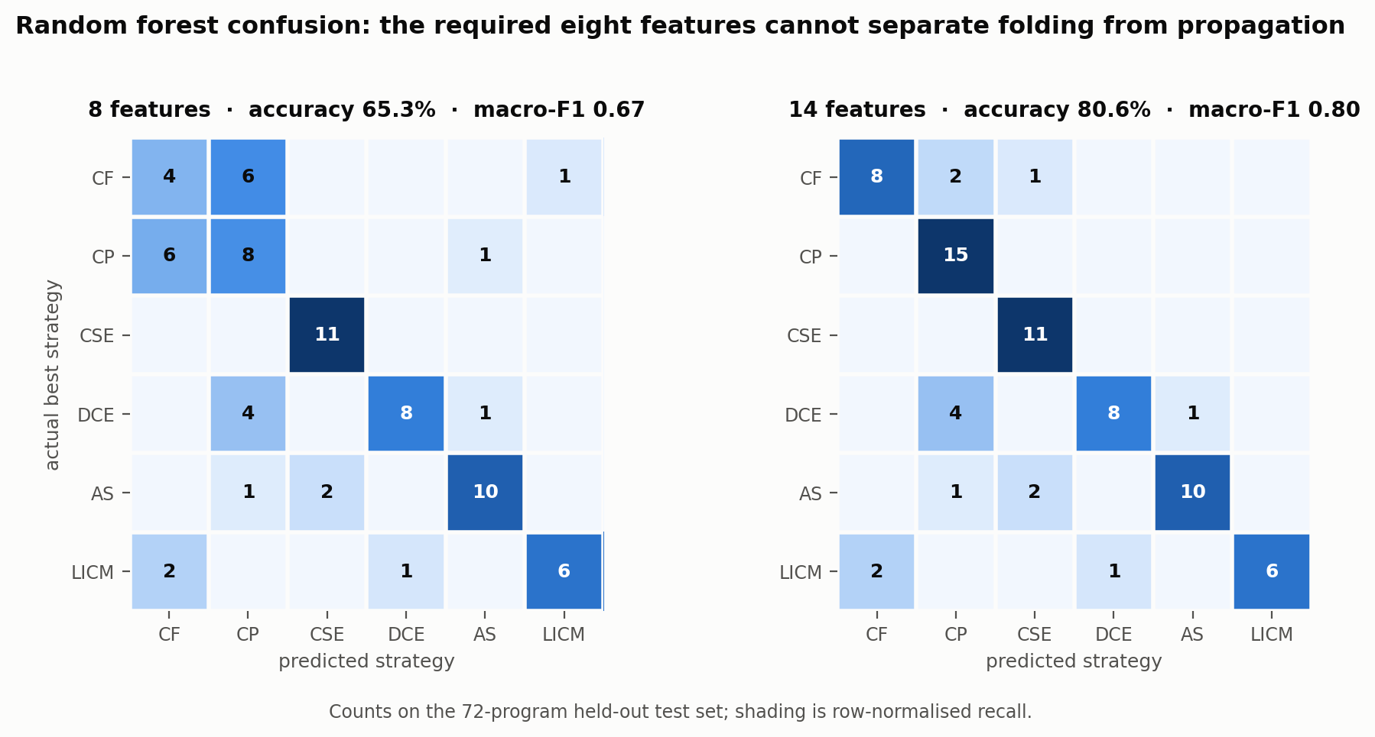
Figure 1 — Confusion matrices for the random forest on both feature sets. The 6-cell CF↔CP block on the left is the required feature set's blind spot; it largely disappears on the right.
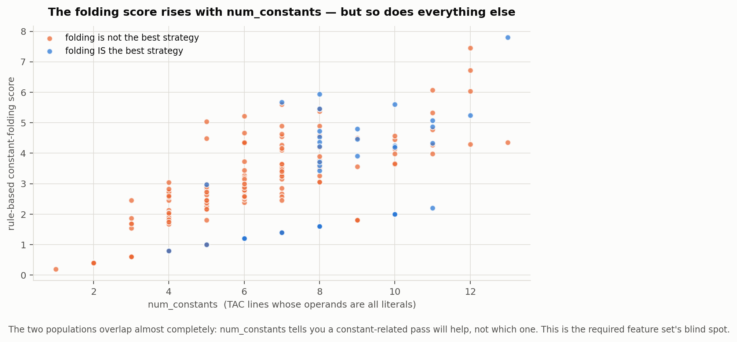
Figure 2 — The same blind spot at the level of a single feature. Programs where folding is best and programs where it is not occupy the same region of the num_constants / folding-score plane.
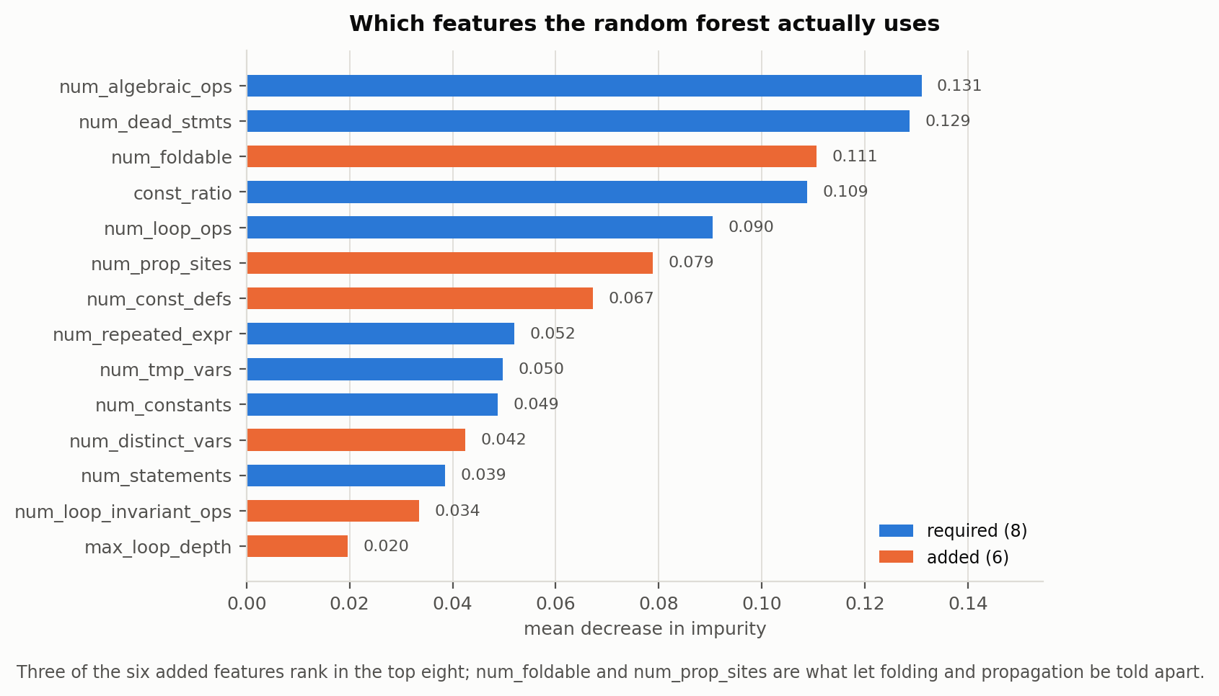
Figure 3 — Random forest feature importance. Three of the six added features rank in the top eight, and the two that separate folding from propagation are the ones the model leans on.

9.3 End-to-end optimization
Single-shot classification accuracy is not the quantity that matters; what matters is how much better the code gets. The loop was run over all 240 programs under each selector, in two modes. In strict mode the loop stops as soon as the selected strategy fails to improve the program, so the result reflects selection quality directly. In fallback mode it tries the next-highest-scoring strategy instead, and stops only when no strategy improves anything.
Selector | Mode | Instr. reduction | Cost reduction | Iterations | Fallbacks | Oracle gain captured
Rule-based | strict | 8.8% | 11.5% | 2.58 | 0.00 | 36.8%
ML, 8 features | strict | 15.6% | 15.0% | 3.80 | 0.00 | 55.5%
ML, 14 features | strict | 25.9% | 21.7% | 6.52 | 0.00 | 77.5%
Rule-based | fallback | 35.5% | 27.6% | 11.28 | 7.32 | —
ML, 8 features | fallback | 35.5% | 27.6% | 11.10 | 5.46 | —
ML, 14 features | fallback | 35.6% | 27.7% | 10.97 | 3.52 | —
Oracle (upper bound) | fallback | 35.5% | 27.5% | 10.72 | 0.00 | —
Two things stand out. In strict mode, selector quality translates almost linearly into optimization achieved: the learned selector on 14 features removes 25.9% of instructions against 8.8% for the baseline, roughly three times as much, and captures 77.5% of what an oracle could get versus 36.8%.
In fallback mode every selector converges to essentially the same code — about 35.5% smaller — because with fallback the loop keeps going until the fixed point regardless of who chose first. What differs is the cost of getting there. The baseline wastes 7.32 rejected pass applications per program; the learned selector wastes 3.52. So a better selector buys either much better code for a fixed budget, or the same code for roughly half the wasted compilation work.
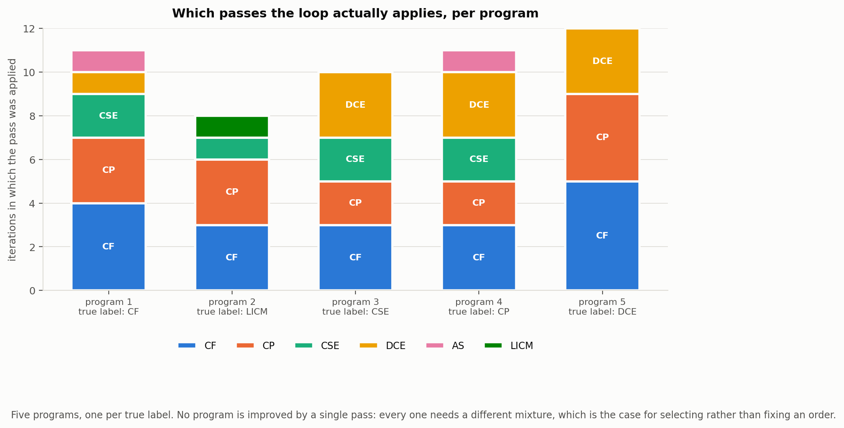
Figure 4 — Passes applied per iteration for five programs, one per true label. No program is improved by a single pass; each needs its own mixture, which is the case for selecting rather than fixing an order.
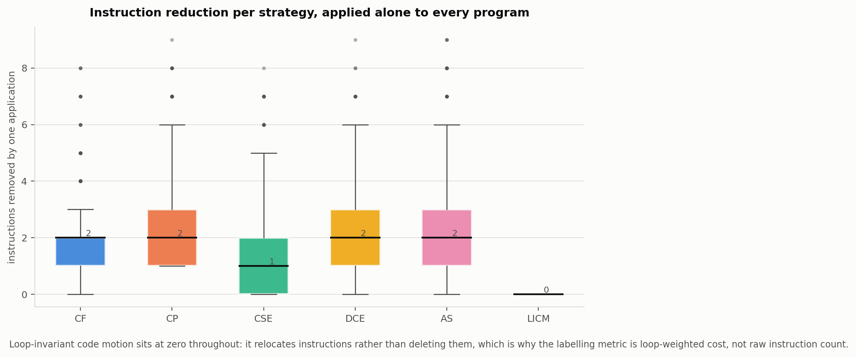
Figure 5 — Instruction reduction from applying each strategy alone. LICM is flat at zero throughout, which is why the objective is loop-weighted cost.
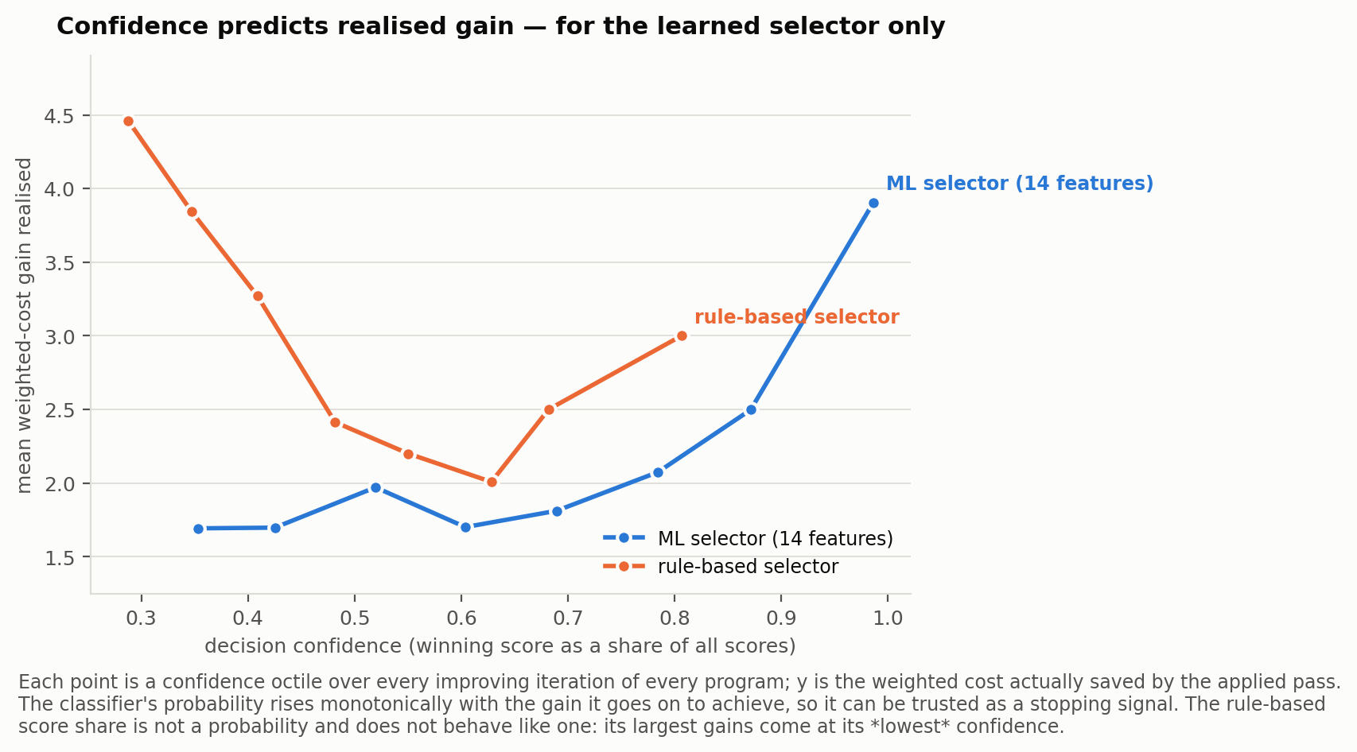
Figure 6 — Realised gain against decision confidence. The classifier's probability rises with the gain it goes on to achieve; the rule-based score share does not.

10 Correctness verification
An optimizer that produces smaller but wrong code has optimized nothing, so correctness is checked rather than assumed. The interpreter and the constant folder call the same operator-semantics function, so a pass cannot silently disagree with execution about what an operator means.
Check | Scope | Result
Corpus gate: each pass applied to each program, output compared | 1440 pass applications | 0 violations
Loop runs: final program compared against the original | 1680 runs across four selectors and two modes | 0 violations
Randomised differential testing: random pass sequences, 5 input streams | 60 programs × 6-pass sequences × 5 streams | pass
Loop termination and monotonicity | 36 unseen programs × 2 selectors × 2 modes | pass
Fixed point: no strategy improves a converged program | 6 programs | pass
Unit tests for each pass and its refusal cases | 15 tests | pass
Reported metrics recomputed from raw predictions | both feature sets | pass
Dataset labels and features re-derived from source | 35 sampled programs | pass
The differential layer is the one that earns its keep. The corpus gate only ever applies one pass to a fresh program, so a pass that is correct alone but wrong after another has run would slip past it. Random pass sequences catch exactly that. Several input streams are used because a single fixed stream can hide a transformation that is only wrong on some inputs.
A real bug this caught: algebraic simplification recorded each rewritten value during its scan and forwarded the recorded value afterwards. When two simplifications chained (t10 = 6 * 1 feeding t11 = t10 * 1), forwarding the stale name left a reference to a definition that had already been deleted, and the program silently read zero. The fix is to read the operand back off the instruction at forwarding time. Constant folding had the same latent fault and was fixed with it.

11 Findings and limitations
- Selecting the next optimization from static features works. On held-out programs the learned selector picks the genuinely best of six strategies 84.7% of the time, and driving the loop with it captures 77.5% of the improvement an oracle could achieve.
- The feature set is the binding constraint, not the model. Across four very different classifiers the extended set beats the required set by 10 to 15 points; no model overcomes a feature set that cannot represent the distinction it is being asked to make.
- The objective function has to match the transformations. Loop-invariant code motion is invisible to instruction count, and any pipeline scored that way would silently never select it.
- Order matters, and no fixed order is right for every program. Figure 4 shows five programs each needing a different mixture and sequence of passes.
- Confidence from the classifier is usable as a signal; the rule-based score share is not, despite being normalised the same way.

Limitations
- The corpus is synthetic. Programs are grown from templates, so the feature distribution is narrower than real code, and the accuracy figures should be read as a comparison between selectors rather than an absolute expectation.
- The classifier is trained on unoptimized programs but queried at every iteration on partly optimized ones. That distribution shift is measured end-to-end in section 9.3 rather than assumed away, but training on intermediate states would likely improve strict-mode results.
- CSE is local to basic blocks and constant propagation does not use branch conditions to prune unreachable paths; a sparse conditional implementation would find more.
- The cost model is a static estimate. Weighting by 10 per loop level assumes a typical trip count and ignores actual bounds, which are known for these counted loops.
- Loop-invariant code motion handles one loop per application, innermost first, so deeply nested programs need more iterations than strictly necessary.

12 Reproducing the results
python3 scripts/build_dataset.py --per-class 40 --seed 7 # corpus + labels + verification
python3 scripts/train.py # classifiers + metrics.json
python3 scripts/run_pipeline.py # iterative loop + traces
python3 scripts/make_plots.py # the six figures
python3 tests/test_all.py # 21-check verification suite
node scripts/build_report.js # this document
All seeds are fixed, so the numbers in this report are reproducible exactly. Outputs land in out/: dataset.csv, strategy_gains.csv, metrics.json, loop_runs.csv, loop_iterations.csv, loop_summary.json, example_traces.txt and figures/.

Appendix Sample decision trace
The per-iteration report required by section 7 of the specification: the extracted features, the score of every candidate strategy, the strategy selected with its confidence, and the resulting instruction-count change. Full traces for five programs are in out/example_traces.txt.
=== constant_folding_000 (selector: rule_based) ===
-- iteration 1 --
features : const_ratio=0.0909091 max_loop_depth=0 num_algebraic_ops=2 num_const_defs=3
num_constants=6 num_dead_stmts=1 num_distinct_vars=44 num_foldable=3
num_loop_invariant_ops=0 num_loop_ops=0 num_prop_sites=7 num_repeated_expr=2
num_statements=66 num_tmp_vars=27
scores : CP=2.040 AS=1.500 CSE=1.340 CF=1.200 DCE=0.710 LICM=0.000
selected : CP (confidence 0.30)
applied : CP instructions 66 -> 64 (-2), weighted cost 66 -> 64 (-2)
-- iteration 2 --
features : const_ratio=0.09375 max_loop_depth=0 num_algebraic_ops=2 num_const_defs=1
num_constants=6 num_dead_stmts=1 num_distinct_vars=42 num_foldable=3
num_loop_invariant_ops=0 num_loop_ops=0 num_prop_sites=0 num_repeated_expr=2
num_statements=64 num_tmp_vars=27
scores : CP=2.040 AS=1.500 CSE=1.340 CF=1.200 DCE=0.710 LICM=0.000
selected : CP (confidence 0.30) [selection CP gave no gain; fell back to AS]
applied : AS instructions 64 -> 62 (-2), weighted cost 64 -> 62 (-2)
-- iteration 3 --
features : const_ratio=0.0967742 max_loop_depth=0 num_algebraic_ops=0 num_const_defs=1
num_constants=6 num_dead_stmts=1 num_distinct_vars=40 num_foldable=3
num_loop_invariant_ops=0 num_loop_ops=0 num_prop_sites=0 num_repeated_expr=2
num_statements=62 num_tmp_vars=25
scores : CP=2.040 CSE=1.340 CF=1.200 DCE=0.710 AS=0.000 LICM=0.000
selected : CP (confidence 0.39) [selection CP gave no gain; fell back to CSE]
applied : CSE instructions 62 -> 60 (-2), weighted cost 62 -> 60 (-2)
-- iteration 4 --
features : const_ratio=0.1 max_loop_depth=0 num_algebraic_ops=0 num_const_defs=1
num_constants=6 num_dead_stmts=1 num_distinct_vars=38 num_foldable=3
num_loop_invariant_ops=0 num_loop_ops=0 num_prop_sites=0 num_repeated_expr=2
num_statements=60 num_tmp_vars=23
scores : CP=2.040 CSE=1.340 CF=1.200 DCE=0.710 AS=0.000 LICM=0.000
selected : CP (confidence 0.39) [selection CP gave no gain; fell back to CSE]
applied : CSE instructions 60 -> 58 (-2), weighted cost 60 -> 58 (-2)
-- iteration 5 --
features : const_ratio=0.103448 max_loop_depth=0 num_algebraic_ops=0 num_const_defs=1
num_constants=6 num_dead_stmts=1 num_distinct_vars=36 num_foldable=3
num_loop_invariant_ops=0 num_loop_ops=0 num_prop_sites=0 num_repeated_expr=0
num_statements=58 num_tmp_vars=21
scores : CP=2.040 CF=1.200 DCE=0.710 CSE=0.000 AS=0.000 LICM=0.000
selected : CP (confidence 0.52) [selection CP gave no gain; fell back to CF]
applied : CF instructions 58 -> 55 (-3), weighted cost 58 -> 55 (-3)
-- iteration 6 --
features : const_ratio=0.109091 max_loop_depth=0 num_algebraic_ops=0 num_const_defs=1
num_constants=6 num_dead_stmts=1 num_distinct_vars=33 num_foldable=3

